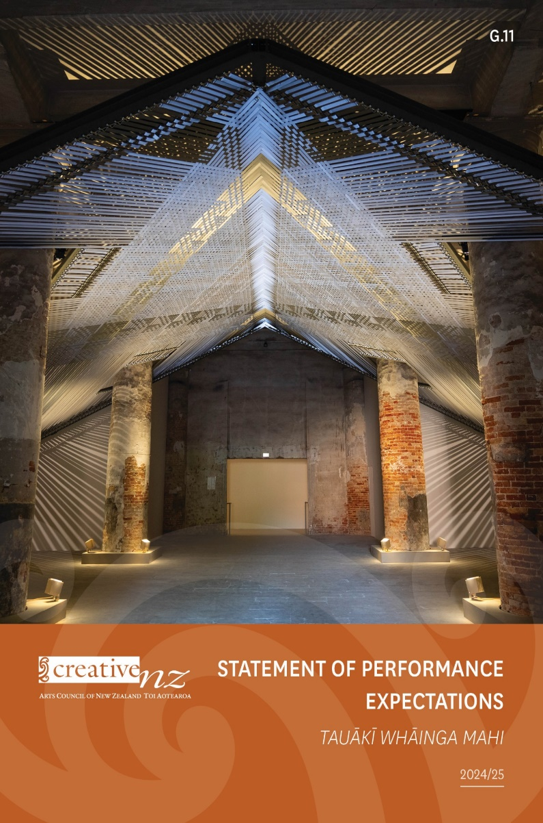
z

Contact us
Website: www.creativenz.govt.nz
Wellington office
Level 2, 2–12 Allen Street
PO Box 3806
Wellington 6011
T: 04 473 0880
E: info@creativenz.govt.nz
Auckland office
First Floor
Southern Cross Building
Cnr High and Victoria Streets
PO Box 1425
Auckland 1140
T: 09 373 3066
E: northern@creativenz.govt.nz
Te Wai Pounamu South Island contact
E: southern@creativenz.govt.nz
Crown copyright © This work is licensed under the Creative Commons Attribution 4.0 International licence. You are free to copy, distribute and adapt the work as long as you attribute the work to the Arts Council of New Zealand Toi Aotearoa (Creative New Zealand) and abide by the other licence terms. To view a copy of this licence, visit: www.creativecommons.org/licences/by/4.0
Image: Mataaho Collective, Takapau 2022. Venice Biennale.
Photography: Ben Stewart.
ISSN 2463-3127 (Print)
ISSN 2463-3135 (Online)

This Statement of Performance Expectations documents planned activity, performance targets and forecast financial information for the Arts Council of New Zealand Toi Aotearoa (Creative New Zealand) for the period 1 July 2024 to 30 June 2025.
We have updated the Statement of Performance Expectations as at 6 June 2025 to improve performance reporting requirements under the Service Reporting Performance Standard (PBE FRS 48). Refer to pages 29 and 30 for additional notes.
It is presented in accordance with sections 149B to 149M of the Crown Entities Act 2004.
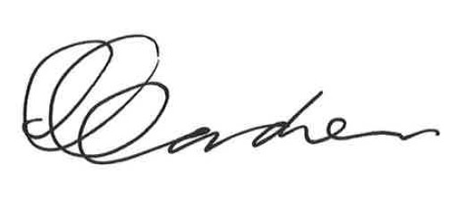
Kent Gardner
Manukura—Chair
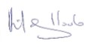
Hilary Poole
Mema o Te Kaunihera Toi o Aotearoa—Arts Council Member
Contents
Ngā ihirangi
Foreword 5
Kupu Whakataki
About our plan 7
Mō tā mātou mahere
Part One: Our strategic context 8
Wāhanga Tuatahi: Te horopaki ā-rautaki e hāngai ana ki a mātau
Our strategic direction for 2019–2029 10
Te ara ā-rautaki e whāia ana e mātau i ngā tau 2019–2029
Our strategic focus areas for 2022–2026 14
Ngā aronga ā-rautaki e arohia ana e mātau i ngā tau 2022–2026
Our main strategies and policies 16
Ko ā mātau rautaki me ā mātau kaupapa here matua
Part Two: The year ahead 19
Wāhanga Tuarua: Te tau e haere ake nei
Ministerial expectations for 2024/25 20
Ngā kawatau ā-Minita nei i ngā tau 2024/25
Challenges and opportunities in 2024/25 22
Ngā wero me ngā huarahi i ngā tau 2024/25
Our performance framework for 2024/25 26
Tā mātau anga ā-whāinga mahi i ngā tau 2024/25
Financial planning and performance in 2024/25 43
Te whakamahere pūtea me te whakatutuki mahi i ngā tau 2024/25
Part Three: Our organisation 62
Wāhanga Tuatoru: Tō mātau whakahaere

Foreword
Kupu Whakataki
We present our Statement of Performance Expectations (SPE) for 2024/25. This is the final plan under our current Statement of Intent (SOI) 2022–2026 and the sixth under our long-term strategic direction for 2019–2029.
Our long-term strategic direction—Te whakaputa hua ki te hunga o Aotearoa—Creating value for New Zealanders—sets out our vision:
Dynamic and resilient New Zealand arts, valued in Aotearoa and internationally.
Achieving our three outcomes—Stronger arts, Stronger arts sector, and Greater public engagement with the arts—is central to the value we create for New Zealanders.
As we head into 2024/25, we face another year of important development and change.
Financially, our investment in the arts sector is reduced to broadly pre-pandemic levels. However, since 2018/19, the landscape has changed. Significant COVID-19 recovery investment has increased demand for our funding and created new expectations, and high inflation has reduced the purchasing power of funding.
In response, we’re looking hard at where we invest our resources, to achieve the greatest value for the arts community and the public. We’ll also review how we organise ourselves, to ensure we can operate as effectively and efficiently as possible and be sustainable into the future.
We’ve begun this journey through our review of contestable grant programmes. The new For the arts programmes are in place and supporting arts communities in ways that better reflect their needs. This year we’ll be looking at how we can best support arts organisations.
The changes we’ve made reflect what we heard from the arts sector through engagement at a series of workshops across Aotearoa, as we embarked on a journey to reimagine the future of arts development and arts funding in New Zealand.
We heard that artists and arts organisations wanted deeper connections to us, with relationships based on trust, respect and longevity. We heard that an intentional and significant shift was needed both in the way we fund the sector and the way we work with the sector.
We heard clearly that the sector did not want us to limit the number of applications we accept. We have simplified our processes, removed application caps, and we are now receiving more proposals than ever.
We also know the sector is looking to us to advocate more effectively so the value of the arts and of artists are better understood.
Working in this way may be more resource-intensive so we need to look hard at how we can do this effectively and efficiently. However, we believe this relational way of working will deliver greater value for the sector and ultimately for New Zealand communities.
Despite the changes we’ve made, we remain concerned about the sustainability of the arts community, with public funding from both central and local government under pressure. Challenging economic conditions are also putting pressure on other funding sources, such as local councils and community trusts, with pressing infrastructure and social needs taking priority. The economic climate is also affecting the ability of arts organisations to increase their earned revenue.
Given this, we’re planning to look afresh at the role private philanthropy and investment can play in supporting the arts.
We’ll also continue to support New Zealand artists to present their work and our culture on the global stage. Mataaho Collective demonstrated the success our artists can achieve by winning the prestigious Golden Lion Award at the 60th Venice Biennale.
While the year ahead will be challenging, we know how important the arts are to New Zealanders and the extent to which they are valued for their contribution to people’s wellbeing, identity and the economy. We’re encouraged by New Zealanders continued participation, engagement and support for the arts, as highlighted in our recent New Zealanders and the Arts—Ko Aotearoa me ōna Toi research.
This research shows participation in the arts is at the highest level since we began surveying in 2005. It has increased from 37 percent to 54 percent over this period, and attendance and positive attitudes are strong. Over 60 percent of New Zealanders agree that the arts help improve New Zealand society and the arts help define who we are as New Zealanders. We’ve also seen significant increases to agreement with these and other statements over the past decade.
While the arts funding system delivers well for the public, it does less well for those working in the sector. The median income of creative professionals remains stubbornly low at $37,000 (including $19,500 of creative income) compared with $61,800 for salary and wage earners.
We’re committed to ensuring the arts continue to play a vital role in improving the lives of New Zealanders and to improving the working conditions of the artists and arts practitioners on which the public experience relies.
Inspired by our arts communities, we are committed to working hard over the next year to meet the challenges—and opportunities—that exist with dedication, heart and manaaki.
Kent Gardner
Manukura—Chair
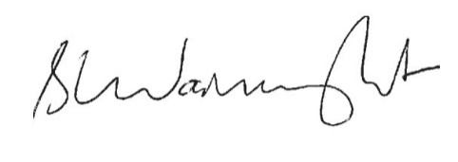
Stephen Wainwright
Tumu Whakarae—Chief Executive

About our plan
Mō tā mātou mahere
This SPE sits under the SOI 2022–2026. As our annual plan, the SPE describes how this year’s work will contribute to achieving the strategic direction set out in the SOI. Each year, our SPE outlines our planned activity, performance targets and forecast financial information for the relevant performance year.
This SPE covers the 2024/25 financial year (1 July 2024 to 30 June 2025).
The plan has three parts.
- Part One: Our strategic context—covering our strategic direction for 2019–2029, our strategic focus areas for 2022–2026, and including the main strategies and policies that guide our work.
- Part Two: The year ahead—covering the Minister for Arts, Culture and Heritage’s expectations of Creative New Zealand; challenges and opportunities; our performance framework; our focus for 2024/25; and our financial planning and performance.
- Part Three: Our organisation—covering information about the Arts Council (our governing board) and Creative New Zealand (the organisation).
We will report against the SPE in the Annual Report for 2024/25.
Creative New Zealand operates under one central government output expense: Promotion and Support of the Arts and Film, for which we have one output class: Promotion and support of the arts. This is a reportable class for the purposes of the Crown Entities Act 2004.
No output classes have been given reporting exemptions by the Minister of Finance. We do not propose supplying any output classes in 2024/25 that are not a reportable class of outputs.
The Ministry for Culture and Heritage Manatū Taonga is our monitoring department.
We are mainly funded through the New Zealand Lottery Grants Board (NZLGB) Te Puna Tahua and the Crown through Vote: Arts, Culture and Heritage.
In 2024/25, Creative New Zealand will receive:
- $52.789 million from the NZLGB
- $16.689 million from the Crown through Vote: Arts, Culture and Heritage.

Part One:
Our strategic context
Wāhanga Tuatahi:
Te horopaki ā-rautaki e hāngai ana ki a mātau

Our vision
Our vision describes our ambition for the arts and what we want to achieve.
Dynamic and resilient New Zealand arts, valued in Aotearoa and internationally.

Our purpose
Our purpose is set out in the Arts Council of New Zealand Toi Aotearoa Act 2014.
To encourage, promote and support the arts in New Zealand for the benefit of all New Zealanders.

Our values
Our eight values describe the actions and behaviours the arts sector, our partners and the public can expect from us as we work with them.
Mana Toi—we champion the role of the arts and the contribution artists make to our lives.
Tauiwi—we recognise New Zealand’s distinctive cultural and social diversity and work to make sure arts opportunities are available for all.
Mana Māori—we recognise and support the role of Māori as tangata whenua in the arts.
Mana Pasifika—we recognise the arts of the Pacific peoples of New Zealand.
Mahitahi—we work together with others so we can achieve more, including exploring the big picture and sharing what we learn.
Te Taumata—we set high standards for our work.
Tauutuutu—we are open, frank and respectful in our relationships.
Manaakitanga—we are welcoming and responsive to all.

Our strategic direction for
2019–2029
Te ara ā-rautaki e whāia ana e mātau i ngā tau 2019–2029
Our strategic direction to 2029, Te whakaputa hua ki te hunga o Aotearoa—Creating value for New Zealanders, describes how we create long-term value for New Zealanders through our support for the arts and ngā toi.
Te whakaputa hua ki te hunga o Aotearoa—Creating value for New Zealanders provides an ecosystem view. It describes, through four perspectives, the environment we operate in, the relationships between the parts of the system, and how they work together to deliver value.
The model should be read as a ‘virtuous circle’ where strengthening one segment leads to the strengthening of the next and so on. Over time, this strengthening will increase the value the arts deliver for all New Zealanders.
For each perspective, we have identified a goal we want to achieve by 2029. We have developed our workplan for 2024/25 in line with these goals.
For more detail on our strategic direction, see page 13 and our Statement of Intent 2022–2026.
OUTCOMES AND VALUE PERSPECTIVE
The difference we want our work to make and the value we create for New Zealanders through our support for the arts and ngā toi.
Our goal: We can clearly articulate how our work and engagement in the arts and ngā toi deliver value for all New Zealanders.
MANA AND SUPPORT PERSPECTIVE
The mechanisms and entities that guide our strategic intentions and whose support influences our resources and authority.
Our goal: We grow the confidence of others in us and attract greater resources for the arts and ngā toi, recognising their contribution to the wellbeing of New Zealanders.
CREATIVE NEW ZEALAND PERSPECTIVE
The strategies and policies that guide our work and strategic intentions, the resources we have and the services we deliver.
Our goal: We have the strategies, services and operational capacity to drive the development of the arts and ngā toi in New Zealand.
SECTOR PERSPECTIVE
The artists and arts organisations, collaborators and partners we work with and who contribute to our outcomes.
Our goal: We work collaboratively with others developing a dynamic and resilient arts sector and building support for New Zealand arts and ngā toi in Aotearoa, Te Moana-nui-a-Kiva and the world.

Te Kaupapa o Toi Aotearoa—the Creative New Zealand way
At the heart of Te whakaputa hua ki te hunga o Aotearoa—Creating value for New Zealanders is Te Kaupapa o Toi Aotearoa, the Creative New Zealand way.
Our strategic direction to 2029 and our SOI 2022–2026 set out what we want to achieve. Te Kaupapa o Toi Aotearoa helps guide how and why we do this. It considers the people and communities we serve, our vision, purpose, values, Te Waka Toi Pātaka (our Mātauranga Māori Framework) and the social context of our work within Aotearoa New Zealand.
Through Te Kaupapa o Toi Aotearoa, we want to enhance the mana of people and communities. Our work will be guided by the intellectual traditions, knowledge and tikanga of tangata whenua—alongside tangata Tiriti and Crown approaches—acknowledging our aspirations for Te Tiriti o Waitangi.
This work is guided by three principles.
- Whakamana i te Tiriti: Giving effect to both Māori sovereignty and partnership aspirations embedded in Te Tiriti.
- Tuku Rauemi: Empowering and enabling the communities we work with to determine their futures.
- Mana aki i te Tangata: Amplifying reciprocity and wellbeing in the way we work.
Under our Te Kaupapa o Toi Aotearoa programme, we are developing our organisational culture and capability to work well in te ao Māori, be more responsive to diverse world views and perspectives, and support the wellbeing of artists, arts practitioners, communities and the arts sector.
Our thinking under Te Kaupapa o Toi Aotearoa will inform how we articulate our strategic intentions in the future, including our long-term strategic direction.
Our Te Kaupapa programme has three phases to build staff capability and develop and embed Te Kaupapa in the way we work.
Pou Tuatahi: Understanding Te Kaupapa o Toi Aotearoa.
Pou Tuarua: Building our organisational capacity to be multi-lensed.
Pou Tuatoru: Embedding Te Kaupapa o Toi Aotearoa into significant governance and management policies and ways of working—this remains our focus for 2024/25.
We are privileged to work with mana whenua partners in the locations where our offices are based (Tāmaki Makaurau and Te Whanganui-a-Tara) as well as the many tohunga and mātanga around the motu who have generously shared their mātauranga to support us as we chart our course for the future.

Te Waka Toi Pātaka
Te Waka Toi Pātaka—our Mātauranga Māori Framework—enables a Māori worldview to guide how we work.
Developed in 2018, Te Waka Toi Pātaka anticipates a wider view of wellbeing. It incorporates the social, cultural, environmental and economic value of ngā toi Māori, and responds to the aspirations of the ngā toi Māori sector.
Together, the elements of the Pātaka ask us to consider how Creative New Zealand contributes to the following.
Manahau—resilience.
Kawenga—our collective responsibilities to nurture and protect the arts and culture for future generations.
Whakarite—balance—the relationship between the past and present and the importance of engagement and connection.
Hononga Whenua—connection to Papatūānuku and those things that anchor us together.
Whanaketanga—development, including adaption and innovation.
Hononga Tīpuna—whakapapa and the ancestral connections that make our artforms distinctive.
Maiatanga—potential.
Hapori—communities that uphold the integrity of the arts.
Āwhina me te Ākina—the role of the public sector in strengthening and advocating for the arts.

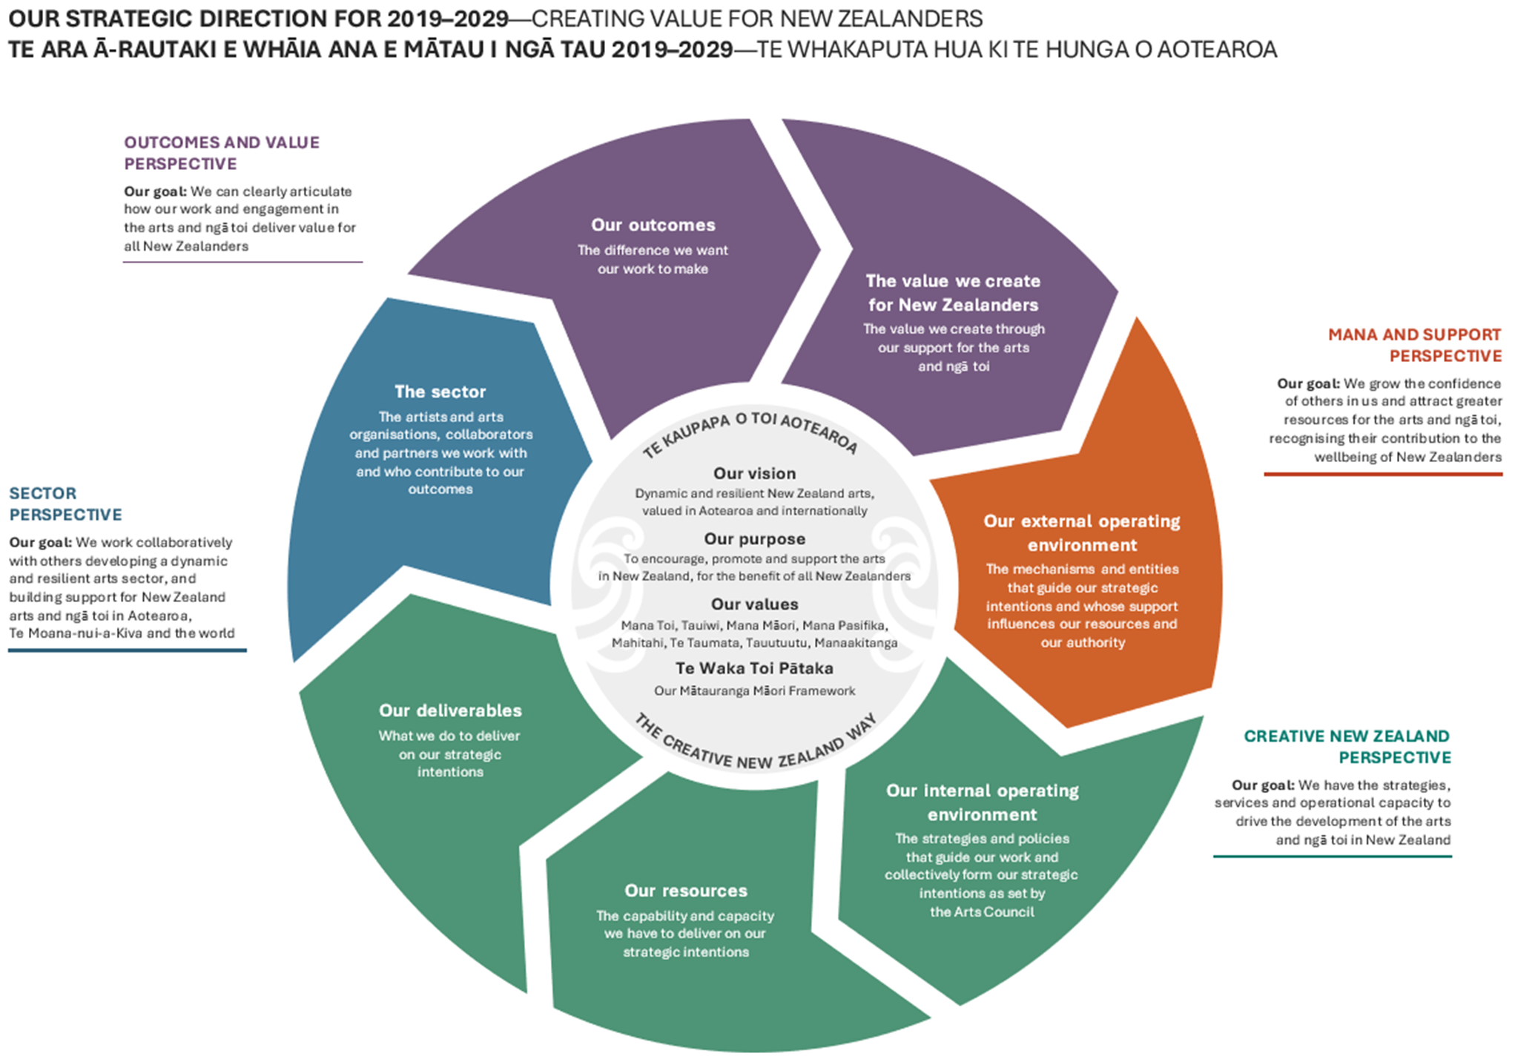

Our strategic focus areas for 2022–2026
Ngā aronga ā-rautaki e arohia ana e mātau i ngā tau 2022–2026
In our SOI 2022–2026, we identified three focus areas we believe will contribute to the goals established in our long-term strategic direction.
For more information on our strategic focus areas, and the links between them and our long-term strategic direction to 2029, see our SOI 2022–2026.

Our strategic focus areas for 2022–2026
Creative New Zealand’s three strategic focus areas for 2022–2026 are as follows.
Resilience—developing a resilient and sustainable arts sector, including sustainable arts sector careers.
Access, inclusion and equity—ensuring our services and the arts are accessible to, inclusive of and equitable for all New Zealanders.
Wellbeing—embedding a recognition of the role of the arts and ngā toi in contributing to the wellbeing of New Zealanders.
Although these are broad areas, they speak to the wide reach each has for the sector, for New Zealanders, for us as an organisation and for those who support us to do our work (including government).

Resilience
Over the period to 2026, under this focus area, we plan to:
- advance our sustainable careers work programme and monitor the sustainability of arts sector careers
- develop a work programme aimed at improving the resilience of the arts sector, by which we mean the sector’s ability to respond and adapt to challenges, and to embrace opportunities
- work with others to consider the need for longer term systemic change to the way in which the arts sector is supported, including considering how we support independent artists and arts practitioners as the most vulnerable workers in the sector
- develop new partnerships across the public and private sectors aimed at co-investment and improving sector sustainability.

Access, inclusion and equity
Over the period to 2026, under this focus area, we plan to:
- implement a programme of work aimed at making sure our services are accessible to and reflective of different communities, as identified through our diversity reporting (against our Diversity in the Arts Policy)
- advance Te Kaupapa o Toi Aotearoa, aimed at making sure we have the organisational culture, competencies and practices to meet our aspirations under Te Tiriti o Waitangi and adopt a multi-lensed approach to how we work
- review our Diversity in the Arts Policy to reflect a focus on equity.

Wellbeing
Over the period to 2026, under this focus area, we plan to:
- develop new frameworks for measuring the impact of the arts and ngā toi on New Zealanders
- embed a widespread recognition of the role of the arts and ngā toi in contributing to the wellbeing of New Zealanders
- explore the potential for the arts and ngā toi to deliver to objectives across government, including in physical and mental health, education, justice, corrections, tourism and in our relationships with other countries.

Change we want to see
Looking ahead, by focusing on these strategic focus areas, we want to see change in:
- how we deliver our services
- how the arts sector operates
- how society values and supports the arts and ngā toi.
Our SOI 2022–2026 outlines the changes we are seeking across the four years to 2026 and the period of our long-term strategic direction.

Our main strategies and policies
Ko ā mātau rautaki me ā mātau kaupapa here matua
Alongside the strategic focus areas set out in our SOI 2022–2026, we have other strategies and policies that guide our work in specific areas.
These strategies and policies are available at: www.creativenz.govt.nz/About-Creative-NZ/Corporate-documents.

Investment priorities
The following strategies outline our priorities for how we will invest in the arts, including how we will recognise in the arts the role of Māori as tangata whenua and advance ngā toi Māori, and how we will recognise and advance the arts of the Pacific peoples of Aotearoa New Zealand.

Interim Investment Intentions
Our Interim Investment Intentions 2023–2025 document outlines the direction for Creative New Zealand’s investment in the arts, carrying forward the direction established in our Investment Strategy Te Ara Whakamua 2018–2023.
The updated Investment Intentions comprise seven investment principles and three investment features.
The aim is that, over time, our investment will increasingly emphasise the three investment features—Diversity and reach, Dynamic arts, Resilient arts sector—and be characterised by seven investment principles.
- Our investment delivers cultural, social and economic value to New Zealanders.
- Our investment recognises in the arts the role of Māori as tangata whenua and advances ngā toi Māori.
- Our investment recognises and advances the arts of the Pacific peoples of New Zealand.
- Our investment reflects the demography of New Zealand.
- Our investment supports New Zealand’s arts infrastructure and complements investment by local and central government and the private sector.
- Our investment is grown through partnerships and co-investment.
- Our investment reflects a people-centred approach.

Te Hā o ngā Toi—Māori Arts Strategy
Te Hā o ngā Toi—Māori Arts Strategy 2019–2024 describes how we will work to advance the aspirations of ngā toi Māori artists and practitioners, for the benefit of all New Zealanders. This is consistent with our legislative mandate to recognise in the arts the role of Māori as tangata whenua and to allocate funding for Māori arts.
The strategy’s moemoeā, or vision, is: Ngā toi Māori is visible everywhere and highly valued, as part of New Zealand’s distinct identity, which is admired globally.
The strategy has two strands.
- Joining with others
- Partner with other Crown organisations and leading cultural agencies: Working together to co-create an ecosystem that supports ngā toi Māori.
- Effecting change ourselves
- Advance ngā toi Māori practice development: Strengthening ngā toi Māori and ngā toi Māori practitioners’ reputation for excellence.
- Increase public engagement with ngā toi Māori: Promoting engagement, access and visibility.
- Build a stronger sector to advance ngā toi Māori aspirations: Developing the sector’s support for ngā toi Māori and mātauranga Māori.

Pacific Arts Strategy
The Pacific Arts Strategy 2023–2028 informs how we direct and prioritise our support for Pacific arts. This is consistent with our legislative mandate to recognise, and allocate funding for, the arts of the Pacific peoples of New Zealand. The strategy embraces the essence of Pacific peoples and cultures, with a vision for: Powerful and resilient Pacific arts, led by passionate and enterprising Pasifika people, for Aotearoa, Te Moana-nui-a-Kiva and the world.
The strategy includes three outcomes.
- Pacific arts are bold and enterprising.
- Pacific arts are powerfully connected through resilient ecosystems of creative communities.
- Pacific arts inspire and influence people everywhere.
The strategy embraces the essence of Pacific peoples and cultures, grouped around four focus areas or ‘guiding stars’. These provide a living map to guide us in a continuing journey, from ancient navigation towards the future.
- Tagata: Pasifika artists and arts practitioners are resourced to develop their practice and deliver outstanding work.
- Vaka: Pacific arts groups, collectives and organisations are supported to help lead and grow Pacific arts in Aotearoa.
- Va: An innovative and networked Pacific arts environment exists, so that Pacific arts are strengthened for future success.
- Moana: Meaningful connections, across Aotearoa, Oceania and globally, make sure Pacific arts are further enriched.

Other strategies and policies

Advocacy Strategy
Our Advocacy Strategy sets the high-level direction Creative New Zealand will take—working together with the arts sector—to make the case for the arts.
The strategy has three aims.
- New Zealanders are highly engaged with the arts.
- Support for the arts is broadened.
- The arts sector’s voice is further empowered.
Under the strategy, we work with our allies to deliver messages around the value of the arts to our identified audiences. These messages aim to positively influence our audiences’ actions, and, in turn, help meet the strategy’s purpose. The strategy outlines the main advocacy messages that cover the positive effects the arts have on our lives.

Diversity in the Arts Policy
Our Diversity in the Arts Policy 2015 states Creative New Zealand’s commitment to recognise, promote and celebrate diversity in the arts. It has two main components, each with specific actions.
- Creative New Zealand encourages, promotes and supports a diverse range of arts, and seeks to:
- make sure that funding and services are fair, equitable and non-discriminatory and keep pace with rapid demographic changes in New Zealand society
- acknowledge the increasingly diverse ethnic make-up of communities in New Zealand and the way individual New Zealanders may relate to multiple ethnicities while maintaining our special recognition for ngā toi Māori and Pacific arts.

- Creative New Zealand encourages, promotes and supports the arts for the benefit of all New Zealanders, and seeks to make sure that:
- the benefits of the arts it supports are available to all New Zealanders, irrespective of age, gender, ethnic affiliations, physical or other disability, sexual orientation or religion
- diversity in the arts applies both to the artists and practitioners it supports along with the individuals, groups and communities that access and benefit from participating in, and experiencing, the arts activities it supports.

Remuneration Policy for Artists and Arts Practitioners
Our Remuneration Policy for Artists and Arts Practitioners 2022 states Creative New Zealand’s commitment to supporting and promoting the rights of artists and arts practitioners to fair remuneration for their work. The policy recognises the value of the arts, creative and cultural practice to the social, cultural, economic and environmental wellbeing of Aotearoa New Zealand.
The policy outlines principles and practice guidelines that artists and arts practitioners, arts organisations, and those engaging artists can use to do work.

Accessibility Policy
Tapatahi – Creative New Zealand’s Accessibility Policy and Action Plan 2023–2028, guides our work with and for Deaf and disabled artists and arts practitioners, tāngata turi, tāngata whaikaha Māori and disability communities. It ensures we are accessible to all New Zealanders.
It is a means by which we give effect to our Diversity in the Arts Policy.
The policy follows the framework of the New Zealand Disability Strategy and the ‘social model’, acknowledging that people are disabled by society’s physical and social barriers.
The policy aims to make sure that:
- our information, services and spaces can be accessed with ease and dignity
- our services and funding are fair, equitable and non-discriminatory
- Deaf and disabled artists and arts practitioners are visible, acknowledged, valued and respected on an equal basis with others
- the benefits of the arts and ngā toi that we support are accessible to all New Zealanders.
Four principles express Creative New Zealand’s commitment to working accessibly and will guide how we undertake our mahi (work) and make decisions.
- Mana Tautika—Equity: We remove barriers so Deaf and disabled people, turi Māori and tāngata whaikaha Māori have equitable opportunities to access, participate and engage in the arts and ngā toi.
- Te Mana Whaikaha Hei Kaihautū—Leadership by Deaf and disabled people: We actively involve turi Māori, tāngata whaikaha Māori, Deaf and disabled artists in decisions that will affect them, and we promote their artistic contributions to Aotearoa New Zealand.
- Iti Kahurangi—Value: We value the lived experience and diverse cultures and identities of turi Māori, tāngata whaikaha Māori, Deaf and disabled people.
- Ngākau Pono—Integrity: We build accessibility into the way we work as an organisation. We meet our responsibilities and have the right skills and attitudes.

Part Two:
The year ahead
Wāhanga Tuarua:
Te tau e haere ake nei

Ministerial expectations for 2024/25
Ngā kawatau ā-Minita nei i ngā tau 2024/25
By convention, the Minister for Arts, Culture and Heritage writes to the Arts Council each year, outlining the Government’s expectations of Creative New Zealand for the upcoming performance year.

Aligning with government and sector priorities
We recognise we have a significant role in delivering to the Government’s desired outcomes, including the Ministers’ priorities for arts, culture and heritage.
The Government has identified the following priorities for 2024/25:
- lifting New Zealand's productivity and economic growth to increase opportunities and prosperity for all New Zealanders
- improving the efficiency and effectiveness of the public service and of government funded services.
The Government has also established the following expectations of Crown entities through its Enduring Letter of Expectations.
- To drive greater value from our funding, including using reprioritisation to achieve better results for the communities we serve.
- Understand our cost drivers and performance against key outcomes and be able to clearly report on these.
- Take a continuous improvement approach to the activities and programmes we deliver, incorporating strong evidence and evaluation practices and seeking to improve the efficiency and responsiveness of the services we deliver.
In response to these priorities, the Minister expects the Arts Council to:
- help the Government in achieving its fiscal sustainability goals.
- work alongside stakeholders and build connections to focus resources, minimise costs, and deliver improved performance.
- set ambitious targets and ensure robust performance measures are in place to monitor progress.
We will also contribute to the identified arts, culture and heritage sector priorities.
- Culture is inclusive and reflective, supporting people to connect and engage with each other, their community and society.
- Iwi and Māori are supported to achieve their cultural aspirations and Māori culture is recognised, valued and embraced.
- People can access and are participating in cultural activities and experiences.
- Cultural activity is valued, supported and nurtured.
- The cultural system is resilient and sustainable.
We have a vital role in contributing to these sector priorities, both independently and in collaboration with others.

Creative New Zealand-specific priorities
The Minister has outlined the following specific expectations for Creative New Zealand in 2024/25.
- Ensure we operate efficiently and effectively and maintain a focus on driving down costs and seeking operational improvements whenever we can, to best achieve sustainable cost-effective delivery of services.
- Contribute to work led by Manatū Taonga to develop a shared vision for the arts and creative sector.
- Support Manatū Taonga to undertake policy work on strategy, and legislative and regulatory reform, as required, including collaborative policy work to support self-sustaining creative careers.
- Investigate leveraging government funding to attract greater philanthropic and private investment.
- Ensure that the new contestable funding programmes have robust supporting processes for funding decisions, and management of any associated risks.

Challenges and opportunities in 2024/25
Ngā wero me ngā huarahi i ngā tau 2024/25
In our SOI 2022–2026, we identify the main challenges that Creative New Zealand and the arts community face, and the three strategic areas we will focus on for the period: Resilience; Access, inclusion and equity; and Wellbeing.
This section sets out the factors informing what we do this year.

Towards a new direction
As we look ahead, we know it will be a year of change.
Creative New Zealand will have new leadership at both the governance and management level. We are also embarking on a process to review our strategic direction as we develop our next SOI, to apply from 1 July 2025.
This review will take account of the context we’re operating in, including our financial position and the demand pressures we’re experiencing. It will also consider the expectations established for the public sector and for Creative New Zealand as outlined on pages 20–21.
We anticipate our new direction will result in significant change, including to the services we offer and at what levels, as well as the way we work.
It is expected to reflect shifts we have been signalling over recent years, including a focus on:
- embedding the principles of our Te Kaupapa o Toi Aotearoa programme (see page 11) across our work, including, as appropriate, devolving planning and decision-making closer to the communities that are intended to benefit from the investment
- moving towards a practitioner or artist-centric approach, including supporting people rather than activity
- investing our resources in what we can uniquely do, for example, maintaining a national overview of arts infrastructure
- acting as a bridge builder (a Teu le Va or ‘adorn the space’ approach) – building and expanding relationships, partnerships, and networks to leverage and harness the resources of others
- articulating the value of the arts (including the value it contributes to individuals’ and our collective wellbeing).
These shifts are already being used to guide work under our three-stage Future of arts development programme as set out below.
Ahead of the implementation of our new direction, we continue to focus on achieving our outcomes and advancing work under the three focus areas in our SOI.

Challenges
The main challenges we expect to affect how we operate and the value we can deliver over 2024/25 are as follows.
- Changes to our funding context: From 2024/25, Creative New Zealand’s investment in the arts sector will reduce due to:
- the end of COVID-19 funding, which contributed significant additional funding to Creative New Zealand and the wider sector over the past five years
- reducing our reliance on running previously affordable operating deficits to maintain service levels; we have been able to do this as a legacy of managing variable NZLGB funding over time.
High inflation over recent years has also affected the purchasing power of our funding.
Changes to how NZLGB allocates funding to Creative New Zealand are also affecting our funding outlook. NZLGB funding comprises around 75 percent of our revenue. The allocation model used by NZLGB is a significant factor in how we plan our investment in the arts sector and the certainty we have in relation to our revenue.
In 2022/23, NZLGB advised of changes to its funding allocation model for entities funded through lottery profits, including Creative New Zealand.
From 2024/25, NZLGB will provide Creative New Zealand with a set funding amount, being $52.789 million, for four years.
This change will increase funding stability and enable us to plan with greater certainty over a longer period. We will no longer benefit from ‘windfall profits’ nor will we be exposed to the risk of a decrease in lottery profits.
Taking account of these changes, as we advance work on a new strategic direction we will consider where we can use the resources we have to best effect. Our aim will be to ensure the organisation is set up to deliver optimal results for the communities we serve.
- High demand for our services and less funding available: Creative New Zealand has experienced a significant increase in demand for funding over recent years. This has occurred in the context of high levels of time-bound funding as part of the COVID-19 Arts and Culture Recovery Programme.
This funding has been used to support the development of new or grow existing infrastructure, such as sustainable funding for creative spaces. With COVID-19 funds ending, organisations will be looking for new funding sources to maintain their operations and capability.
Under our own contestable grant programmes, over $100 million was sought in 2023/24, an increase from around $25 million in 2018/19. With available funding reducing from around $26 million in 2023/24 to around $12 million in 2024/25, we are expecting significant pain in the sector.
Given the gap between demand and what we can fund, we expect some organisations and practitioners will not be able to sustain their practice or services. This may lead to people leaving the sector for more secure employment and organisations stopping operations. This is already evident; with a small number of organisations that have received regular funding over the years closing in some areas.
The reduction in resources available from Creative New Zealand is being exacerbated by pressures on other funding sources. This includes local government, as infrastructure challenges come to the fore and councils focus on maintaining fixed assets, and community trusts and foundations, which are increasingly focusing on social services.
- Ongoing difficult economic conditions: As well as pressure on funding sources, the arts sector continues to be affected by wider economic conditions. These include increases in the cost of delivering arts experiences because of high inflation, general cost of living pressures, high interest rates and a tightening labour market.

Opportunities
The main areas we will focus on in 2024/25 are as follows:
- Supporting the future of arts development: Following the implementation of new contestable grant programmes which opened in March 2024, over 2024/25 and under our three-stage Future of arts development programme, we will continue to work with the arts sector to develop better approaches to supporting arts development. At the heart of what we are trying to achieve is a belief that to create the best conditions for arts, culture and creativity to thrive, we need to place artists and their communities at the centre of our decision-making.
Over this year we’ll consider how we can best support arts organisations, including those funded through the Toi Tōtara Haemata and Toi Uru Kahikatea Investment programmes. We expect this review to change how we support and work with arts organisations from 2025/26.
We currently allocate around 60 percent of what we invest in the sector to the 80 organisations receiving multi-year funding through the Investment programmes. This makes it critical that our investment delivers a high level of value for the public and the sector.
The third stage of the Future of arts development programme will look at how we can increasingly support communities to make decisions about the arts development that has the greatest results for them.
- Contributing to the development of a shared vision for the arts and creative sector: Creative New Zealand welcomes the opportunity to support work led by Manatū Taonga to develop a shared vision for the sector.
The arts sector has been calling for the development of a national strategy, with the aim of realising the transformative potential of arts, culture and creativity to the creative economy and the social and cultural wellbeing of New Zealanders.
We have supported these calls and set out in our Briefing to the Incoming Minister the elements we believe such a strategy should encompass.
- Investigating the role of private philanthropy: Over 2024/25, Creative New Zealand will investigate ways to leverage government funding to attract greater philanthropic and private investment in the arts.
This could include looking at regulatory or tax barriers to greater levels of private investment. It could also include amplifying initiatives such as Boosted X Moana, a partnership between Creative New Zealand and the Arts Foundation’s Boosted NZ platform, aimed at supporting Pasifika creatives to achieve their fundraising goals.
- Embedding Te Kaupapa o Toi Aotearoa into our new strategic direction: Over recent years we have done significant work at the management and governance level to increase our understanding of and capability to work well in te ao Māori, be more responsive to other world views and perspectives, and deliver value for all New Zealanders.
We will focus over the year on articulating our organisational response and approach to Te Tiriti o Waitangi and embedding this into the new strategic direction we are developing.
Alongside this work, we will continue to consider how we can embed our Te Kaupapa o Toi Aotearoa principles across the breadth of our work.
Our three strategic focus areas for 2022–2026 (see pages 14–15) provide the opportunity to address significant kaupapa in a more purposeful way. Work is under way across these three areas.
- Focusing on Resilience: Over the year, we will advance what we have previously termed a ‘sustainable careers roadmap’. Our aim is to identify barriers to artists and arts practitioners achieving more sustainable careers. We will also consider what actions might be taken to improve sustainability and increase remuneration levels across the sector.
From our research, we know New Zealand’s creative professionals’ median income is $37,000, compared with the median of $61,800 for salary and wage earners. Forty four percent of creative professionals supplement their creative income with other work, with the median income from creative work alone being $19,500.
For the arts sector to start operating sustainability, we need to focus on lifting incomes and ensuring better working conditions for artists and arts practitioners.
We will also continue supporting New Zealand artists and arts organisations to develop international markets and audiences to expand their reach onto the global stage.
- Focusing on Access, inclusion and equity: We have completed and started putting in place Tapatahi – Creative New Zealand’s Accessibility Policy and Action Plan 2023–2028. Over 2024/25 we will use the insights gained from our Diversity Report 2022/23 (which identifies who is and who isn’t benefiting from our services), to determine priorities for action.
An important area of work is expected to be exploring ways to increase the number of Asian New Zealanders accessing our services.
We are also planning to start a review of our Diversity in the Arts Policy developed in 2015, to reflect our position relating to Te Tiriti o Waitangi and with greater focus on equity and inclusion.
- Focusing on Wellbeing: Over this year, we will continue working with Te Rōpū Mana Toi, an independent group of sector leaders that advises and helps us to advance our arts advocacy work. A major part of this work is promoting the value of the arts to New Zealanders and building a collective arts advocacy movement led by the sector.
We will also use the outcomes of research undertaken over 2023/24, including Value of the arts, culture and creativity, and ngā toi to New Zealanders (2023) and the seventh iteration of New Zealanders and the Arts—Ko Aotearoa me ōna Toi (2023), to advocate for the role arts and creativity can play across various domains, including education, the economy, mental health and social cohesion.

Our performance framework for 2024/25
Tā mātau anga ā-whāinga mahi i ngā tau 2024/25
Our performance framework stems from our long-term strategic direction, Te whakaputa hua ki te hunga o Aotearoa—Creating value for New Zealanders. The performance framework on page 28 outlines what we will be measuring in 2024/25.
We will monitor the progress of our work throughout the year and report against these measures in our Annual Report for 2024/25, including how our work contributes to our outcomes. We will also report on how our day-to-day work links to our vision, to the priorities for Arts, Culture and Heritage, and how they contribute to creating public value through the Creating value for New Zealanders model.
For 2024/25, in response to feedback from our auditors, we have:
- explained why the performance measures we are using are the most important
- focused on measures relating to actions that will contribute to the changes we are seeking to achieve over the medium term (ie, by 2026), under the strategic focus areas in our SOI 2022–2026.
As we develop a new SOI to apply from 1 July 2025, we will review our performance framework to take account of further feedback from our auditors, including:
- developing longer–term measures that provide greater clarity about what we are trying to achieve in the medium to longer term, for inclusion in the SOI
- considering how we can apply controls over the data received from third parties that are used to support performance reporting
- reducing the overall number of performance measures.
Judgements made in the selection of our performance measures
In 2021, the New Zealand Accounting Standards Board issued a Standard for Service Reporting: Public Benefit Entity Financial Reporting Standard 48 Service Performance Reporting (PBE FRS 48) to apply to all annual reporting beginning on or after 1 January 2022. The standard provides requirements for selecting and presenting service performance information, so it is appropriate and meaningful to users. It requires agencies like Creative New Zealand to present information that is useful for accountability and decision-making purposes.
PBE FRS 48 requires the disclosure of the judgements used in preparing service performance information under the Standard.
In selecting performance measures for 2024/25, Creative New Zealand has made the following judgements about what information to present.
- In our view, the performance measures selected for the SPE 2024/25 document will meet the expectations of Creative New Zealand’s stakeholders.
- We consider that the Outcome and Deliverable performance measures and selected Key strategic focus area activities provide the most appropriate and meaningful information to users when assessing the work we do to achieve our outcomes. They align with management’s assessment of where we expect to invest the most time and resources in the period (based on budget information and strategic importance).
- The selected performance measures will adequately inform users of the progress made against achieving the outcomes presented in our SOI 2022–2026.
Our ability to meet our measures is affected by the level of revenue we receive from the NZLGB and the Government.
When forecasting our performance targets for 2024/25, we considered the following factors:
- available budget
- the potential number of applications and activities supported across programmes (eg, the number of new New Zealand works developed)
- the result of activity in the arts sector outside of our direct control (eg, New Zealanders participating in or experiencing the arts).
In March 2024, we introduced new contestable grant programmes replacing Arts Grants, Annual Arts Grants and Special Opportunities for Artists and Arts Practitioners. This may lead to greater volatility in results over the coming years as changes in fund settings influence activity levels and outcomes.

Creative New Zealand‘s performance framework 2024/25
 | Our vision | Dynamic and resilient New Zealand arts, valued in Aotearoa and internationally
 |  | ▲ ▲ ▲
 | Our outcomes | Stronger arts  as shown by  High-quality New Zealand art is developed  New Zealand arts gain international success | Greater public engagement  as shown by  New Zealanders participate in the arts  New Zealanders experience  high-quality arts |  |  | Stronger arts sector  as shown by  New Zealand arts sector is resilient  New Zealand arts are valued and supported
 | Our strategic focus areas | Resilience |  | Access, inclusion and equity |  |  | Wellbeing
 |  | ▲ ▲ ▲
 | Our deliverables | Investing in the arts |  | Developing the arts |  |  | Advocating for the arts
 | Our deliverables | Leadership in the arts |  |  | Partnering for the arts

Our outcomes
Our three outcomes describe the difference we want our work to make. Several of these targets are affected by available funding and the nature of funding applications received.
Our outcomes |  | Measures | 2021/22 Actual | 2022/23 Actual | 2023/24 Forecast | 2024/25 Target
Stronger arts: Strong arts come from an arts sector that has the ability and opportunity to generate high-quality work, reflecting who we are as a nation and engaging audiences nationally and internationally.
1.1 | High-quality New Zealand art is developed | Number of new New Zealand works developed (across all funding programmes) | 6,486 | 5,275 | ≥6,000 | ≥2,500
1.2 | New Zealand arts gain international success | Number of international arts activities and events funded by Creative New Zealand (across all funding programmes) | 367 | 2,248 | ≥1,500 | ≥1,500
Greater public engagement with the arts: We are seeking to increase public engagement with the arts, recognising their ability to improve our personal wellbeing and that of whānau, communities and our society.
1.3 | New Zealanders participate in the arts | - Number of grants made to artists, practitioners and organisations that enable participation in arts activities. | 494 | 421 | 494 | 560
1.4 | New Zealanders experience high-quality arts | - Number of Toi Tōtara Haemata and Toi Uru Kahikatea Investment Programmes organisations supported to enable the delivery of arts activities or services. | 81 | 81 | 80 | 80
Stronger arts sector: A stronger arts sector is the foundation from which the arts sector can produce high-quality arts and provide opportunities for public engagement with the arts.
1.5 | New Zealand’s arts sector is resilient | Percentage of organisations receiving multi-year funding through the Toi Tōtara Haemata and Toi Uru Kahikatea Investment programmes that meet financial expectations set out in their funding agreements. | 96.3% | 92.6% | ≥87.6% | ≥90%
1.6 | New Zealand arts are valued and supported | Index rating for how New Zealanders perceive the value of the arts to New Zealand (New Zealanders and the Arts—Ko Aotearoa me ōna Toi survey data). | 59% | 59% | ≥59% | 59%
1.7 | New Zealand arts are valued and supported | Average percentage of ‘other’ (non-Creative New Zealand) investment across organisations receiving multi-year funding through the Toi Tōtara Haemata and Toi Uru Kahikatea Investment programmes. | 61.7% | 67.1% | ≥63% | ≥67%

Our deliverables
Our deliverables are what we will do to achieve our outcomes and support our strategic focus areas, as set out in our SOI 2022–2026.
Investing in the arts—Investing in artists, arts practitioners and arts organisations in a fair, transparent and strategic way
Funding from Creative New Zealand supports the creation, presentation and distribution of art—across community and professional arts—throughout New Zealand and overseas.
Most of Creative New Zealand’s work is delivered through Investing in the arts and the main funding programmes are outlined below. In total, $51.998 million (over 85 percent of Creative New Zealand’s total investment) is budgeted across our funding programmes in 2024/25.
More information about funding programmes is available on our website: Funding and support | Creative New Zealand
Programmes |  | Budget 2024/25 | Timeframes | Description | Link to primary outcome(s)
Investment programmes
 | Toi Tōtara Haemata Investment programme | $16.516 million | Funding for six years | Contestable longer-term funding to 80 arts organisations (22 Tōtara and 58 Toi Uru Kahikatea) to support the continuous delivery of arts programmes. | Activities contribute to all outcomes
 | Toi Uru Kahikatea Investment programme | $18.487 million | Funding for three years |  | Activities contribute to all outcomes
Contestable grant programmes |  | $12.108 million
 | Creative Impact Fund |  | Up to 18 months | Up to $125,000 to develop work that enriches audiences and communities, encouraging understanding and participation. | Activities contribute to all outcomes
 | Creative Fellowship Fund |  | Funding for up to 18 months and six months respectively | Up to $50,000 to support artists, practitioners and collaboratives to develop, innovate, create and take risks within their work. | Activities contribute to all outcomes
 | Early Career Fund |  | No specified timeframe | Up to $10,000 to support artists, practitioners, and collaboratives at the early stage of their career who wish to learn, create, and share their work with their communities. | Activities contribute to all outcomes
 | Arts Organisations and Groups Fund |  | Funding for up to two years | Up to $125,000 for arts organisations and groups to deliver a programme of work for up to two years. | Activities contribute to all outcomes
 | Special opportunities |  | Varies | Various targeted opportunities including residencies, fellowships and scholarships. | Activities contribute to all outcomes
Creative Communities Scheme | Devolved funding administered by 67 territorial authorities | $3.969 million | Funding for three years | Small grant funding that supports local arts projects. | New Zealanders participate in the arts
International programme | Various funding programmes including the Festival of Pacific Arts, the Venice Biennale, and indigenous exchanges | $0.620 million | Varies | International presentation and exchange initiatives that support the presentation of New Zealand arts internationally. | New Zealand arts gain international success
Initiatives and pilots | Niu Dawn Raids Funding Initiative | $0.038 million | Funding for two years (2022/23, 2023/24) | Reporting on $2 million allocated in 2023/24 as part of the Government’s Dawn Raids Package (Budget 2022) through a funding agreement between Creative New Zealand and the Ministry for Culture and Heritage Manatū Taonga. | Stronger arts sector

Programmes |  | Budget 2024/25 | Timeframes | Description | Link to primary outcome(s)
 | Pasifika Festivals Initiative – Fa Wave | $0.260 million | Funding for three years (2023/24, 2024/25, 2025/26) | Investment in a new national service organisation for Pasifika festivals, to be known as Pasifika Festivals Aotearoa. | Stronger arts sector
Investing in the arts performance measures
No. | Activity | Measure | Rationale | 2021/22 Actual | 2022/23 Actual | 2023/24 Forecast | 2024/25 Target
2.1 | Support for organisations under the Toi Tōtara Haemata and Toi Uru Kahikatea Investment programmes to deliver an annual programme of activity | Organisations meet expectations against measures set out in individual funding agreements | Toi Tōtara Haemata and Toi Uru Kahikatea Investment programmes comprise around 60 percent of our investment in the arts.  This measure recognises the significant contribution successful programme delivery by these organisations makes to the achievement of our outcomes. | 100% | 98.8% | ≥99% | ≥98%
2.2 | Delivery of various contestable grant funding opportunities | Completed projects meet delivery expectations | Contestable grant programmes comprise around 20 percent of our investment in the arts.  This measure recognises the significant contribution successful delivery of activities supported under these programmes make to the achievement of our outcomes. | 97% | 99% | ≥99% | ≥99%
2.3 | Annual client satisfaction survey of applicants for contestable grant funding to determine whether we are meeting identified service standards | Overall satisfaction with Creative New Zealand’s service | This measure shows the extent to which applicants are experiencing the service standards we seek to uphold and how well programmes are meeting the needs of target groups. | 46% | 48% | ≥65% | ≥65%
2.4 | Support for local arts projects through the Creative Communities Scheme | Percentage of city and district councils that meet or exceed Creative Communities Scheme delivery expectations | Creative Communities Scheme comprises around 7 percent of our investment in the arts.  This measure shows the extent to which territorial authorities are meeting delivery expectations for the benefit of local arts communities. | 91% | ≥90% | ≥90% | ≥90%
2.5 | Maintain operating costs in line with policy set by the Arts Council | Operating costs as a percentage of total expenditure | This shows the proportion of expenditure invested in the arts sector relative to expenditure on Creative New Zealand’s operations. | 14.9% | 15.5% | ≤16% | ≤18%
Developing the arts—Helping arts organisations and individual artists and arts practitioners to develop their skills and capability
Creative New Zealand delivers funding and initiatives aimed at helping artists, arts practitioners and arts organisations to build their skills and capability, with the goal of developing the arts sector’s capacity to succeed.
More information about development programmes is available on our website: Funding and support| Creative New Zealand
Programmes |  | Budget | Timeframes | Description | Link to primary outcome/s
Contestable grant programmes |  | $1.690 million
 | Residencies, Internships and Fellowships Fund |  | Varies | To support providers to offer a residency, fellowship, or internship for New Zealand artists and practitioners for up to three years. | Stronger arts sector
 | Development Fund for Artists and Practitioners |  | No specified timeframe | Up to $8,000 to expand skills and careers through specific professional and creative development initiatives. | Stronger arts sector
 | Development Fund for Arts Organisations and Groups |  | No specified timeframe | Up to $20,000 towards the cost of capability building initiatives for arts organisations against identified priorities. | Stronger arts sector
 | New Leaders Programme |  | Offered every second year, for one year | For new and emerging leaders in arts organisations or communities. | Stronger arts sector
Initiatives and pilots |  | $4.120 million | Varies | Various targeted initiatives under Te Hā o ngā Toi—Māori Arts Strategy and the Pacific Arts Strategy. | Stronger arts sector
International capability building |  | $0.755 million | Varies | Various initiatives to enable members of the arts sector to benchmark their skills and capability, build relationships and gain inspiration from international experiences to develop their work back in New Zealand, including attendance at international fairs, festivals, markets and other platforms and opportunities. | Stronger arts sector  New Zealand arts gain international success
Developing the arts performance measures
No. | Activity | Measure | Rationale | 2021/22 Actual | 2022/23 Actual | 2023/24 Target | 2024/25 Target
2.6 | Delivery of opportunities for arts organisations, individual artists and arts practitioners to build their skills and capability | Capability building initiatives delivered to the sector meet expectations | This measure recognises the contribution successful delivery of initiatives makes to the achievement of our outcomes. | 97% | 99% | ≥97% | ≥97%
Advocating for the arts—Promoting the value of the arts and empowering the arts sector to make the case for the arts
Creative New Zealand advocates for the benefits of the arts to different audiences including government agencies and local authorities, and to New Zealanders. We also provide resources to help the arts sector and allies carry out their own advocacy.
Programme | Description | Budget | Link to primary outcome(s)
Advocacy initiatives | Various advocacy initiatives, including public-facing campaigns and engagement, and work with local government aimed at highlighting the positive effect of the arts on the wellbeing of New Zealand communities. | $1.305 million | Stronger arts sector
Awards events and sponsorships | Annual awards events and sponsorships acknowledging our artists, arts practitioners and arts organisations. | $0.230 million | Stronger arts sector

Advocating for the arts performance measures
No. | Activity | Measure | Rationale | 2021/22 Actual | 2022/23 Actual | 2023/24 Target | 2024/25 Target
2.7 | Delivery of an annual advocacy programme | Annual advocacy actions meet expectations as set out in our annual advocacy action plan | This measure recognises the contribution successful delivery of these initiatives makes to the achievement of our outcomes, principally our Stronger arts sector outcome. | 75% | 77% | ≥75% | ≥75%
Leadership in the arts—Providing leadership to ensure the arts sector is well positioned collectively to respond to change
As a national body, we have a role in providing leadership in the arts, by tracking trends and developments across the sector, identifying and responding to issues, and bringing the sector together to address challenges or respond to opportunities (including through our biennial leadership event, Nui Te Kōrero, which next occurs in the 2025/26 financial year).
Programme | Description | Budget | Link to primary outcome(s)
Research | Creative New Zealand-commissioned research projects that advance knowledge or discussion about the arts in New Zealand. | $0.200 million | Stronger arts sector
Leadership in the arts performance measures
No. | Activity | Measure | Rationale | 2021/22 Actual | 2022/23 Actual | 2023/24 Target | 2024/25Target
2.8 | Delivery of Creative New Zealand-commissioned research | Number of Creative New Zealand-commissioned research projects completed | This measure demonstrates timely project delivery. | 2 | 2 | 1 | 2
Partnering for the arts—Developing reciprocal relationships and partnerships that increase the impact of our collective work for the arts
Relationships and partnerships included under this measure may focus on short-term kaupapa-based initiatives or more enduring relationships that recognise long-term value.
Over 2024/25, partnerships will include the following.
Partnership | Description | Link to outcome
Organisations funded through the Toi Tōtara Haemata and Toi Uru Kahikatea Investment programmes | Support for 80 organisations to deliver an annual programme of activity. | Activities contribute to all outcomes
Territorial authorities | Support for 67 territorial authorities to administer contestable funding rounds in their communities through the Creative Communities Scheme. | New Zealanders participate in the arts
Foundation North Pūtea Hāpai Oranga | Partnership with Foundation North to deliver the Asian Artists’ Fund. | Stronger arts sector
The Arts Foundation Te Tumu Toi | Partnership with The Arts Foundation to deliver public engagement and/or matched funding initiatives (eg, All in for Arts, Boosted X Moana). | Stronger arts sector
Te Hā o ngā Toi—Māori Arts Strategy partners | Various partnerships to advance ngā toi Māori objectives under Te Hā o ngā Toi. | Stronger arts sector
Pacific Arts Strategy partners | Various partnerships to advance Pacific arts objectives under the Pacific Arts Strategy using the Teu le Va way of working. For example, delivering the Fa Wave of the Pasifika Festivals Initiative. | Stronger arts sector
International arts organisations | Collaborating with international arts councils across multiple areas as well as being an active member of the International Federation of Arts Councils and Culture Agencies. | Stronger arts sector
Partnering for the arts performance measures
No. | Activity | Measure | Rationale | 2021/22 Actual | 2022/23 Actual | 2023/24 Target | 2024/25 Target
2.9 | Developing and maintaining reciprocal relationships and partnerships with organisations with shared interests | Number of active relationships and partnerships (including co-investment, regular meetings, shared projects) maintained | This measure demonstrates the volume (and breadth) of relationships being maintained aimed at delivering benefits to the arts sector. | 157 | 192 | ≥175 | ≥165

Our strategic focus areas for 2024/25
Creative New Zealand has committed to three strategic focus areas for the four financial years from 1 July 2022 to 30 June 2026.
This section explains why we are focusing on these areas. It outlines the activities we will prioritise in 2024/25 to work toward the changes we seek, and how we intend to measure success.
Each strategic focus area guides our deliverables in 2024/25 and contributes to achieving our long-term outcomes.
Resilience • Manahau—Developing a resilient and sustainable arts sector, including sustainable arts sector careers
A focus on Resilience supports our outcome, Stronger arts sector. In our SOI 2022–2026, we said that under this focus area, by 2026, we want to see the following.
- Creative New Zealand’s Remuneration Policy for Artists and Arts Practitioners is recognised as an ‘industry standard’ and widely adopted by the arts sector and those engaging artists and arts practitioners.
- Working with others, Creative New Zealand has developed a roadmap for improving the sustainability of arts sector careers.
- Creative New Zealand and the arts sector are developing and trialling new models (operating, funding and monetisation) aimed at improving the resilience and sustainability of the sector.
The activities we will prioritise in 2024/25 are listed below.
No. | Activity | Key milestones in 2024/25
3.1 | Review support for arts organisations to ensure programmes meet the needs of organisations and improve sector sustainability and resilience. | - Implement a new approach to supporting arts organisations by 30 June 2025.
3.2 | Advance a programme of work aimed at improving the working lives and conditions of creative professionals. | - Start the development of a roadmap for improving the sustainability of arts sector careers by 31 December 2024.
Access, inclusion and equity • Te uru, te whakauru me te mana taurite—Ensuring our services and the arts are accessible to, inclusive of and equitable for all New Zealanders
A focus on Access, inclusion and equity supports our outcomes Greater public engagement in the arts and Stronger arts sector. In our SOI 2022–2026, we said that under this focus area, by 2026, we want to see the following.
- New Zealand artists and arts practitioners from diverse communities can access Creative New Zealand’s services and our services are enabling.
- Through our diversity reporting, we can accurately identify who is and who isn’t benefiting from our services and implement initiatives that seek to address gaps.
- Our policies reflect our aspirations under Te Tiriti o Waitangi, address equity alongside access and inclusion, and are widely reflected in the practices of those in whom we invest.
- Te Kaupapa o Toi Aotearoa is embedded across our organisational processes, policies and structures, and Creative New Zealand has the capability and capacity to operate effectively in te ao Māori and take a multi-lensed approach to its work.
The activities we will prioritise in 2024/25 are listed below.
No. | Activity | Key milestones in 2024/25
3.3 | Develop a position statement in relation to Te Tiriti o Waitangi to underpin the development of our new SOI. | - Reflect our position and aspirations in relation to Te Tiriti o Waitangi in our new SOI by 30 June 2025.
3.4 | Review our Diversity in the Arts Policy (2015) to reflect a focus on equity alongside access and inclusion. | - Start a review of our Diversity in the Arts Policy by 31 December 2024.
Wellbeing • Oranga—Embedding a recognition of the role of the arts and ngā toi in contributing to the wellbeing of New Zealanders
A focus on Wellbeing supports our outcome, Stronger arts sector. In our SOI 2022–2026 we said that under this focus are, by 2026, we want to see the following.
- Working with others, we will have developed a strong evidence base for how the value of the arts and ngā toi contribute to New Zealanders and New Zealand society.
- Creative New Zealand and the arts sector will be powerful advocates for the value of the arts and ngā toi.
- Increasingly, partnerships exist across various sectors that provide investment into the arts and increase the recognition of the value they deliver.
Along with our Leadership in the arts and Partnering for the arts deliverables, the actions we will prioritise in 2024/25 are listed below.
No. | Activity | Key milestones in 2024/25
3.5 | Develop relationships and partnerships aimed at increasing the recognition of the value the arts contribute to New Zealand society. | - Develop two new relationships aimed at advancing the recognition of the value of the arts in other sectors by 30 June 2025.
3.6 | Promote the value of the arts through public campaign work, with specific recognition of wellbeing. | - Deliver campaign activity that highlights both the value of the arts to the public, and the role that artists play in delivering that value, by 30 June 2025.

Financial planning and performance in 2024/25
Te whakamahere pūtea me te whakatutuki mahi i ngā tau 2024/25
This section provides our prospective financial statements for 2024/25 and the notes to those statements.
The prospective financial statements in this section are based on policies and approvals in place as at 30 June 2024. The statements are exclusive of goods and services tax (GST) (except for payables and receivables, which are GST inclusive).
The prospective financial statements form part of the SPE and the basis for end-of-year reporting in the financial statements contained in the Annual Report. Actual results presented in the Annual Report may vary from the information presented here, and the variations may be material.
Figures shown in these prospective financial statements are based on the following:
- 2023—actual figures from the 2022/23 Annual Report
- 2024—forecast figures based on the actual figures as of 30 April 2024
- 2025—budget based on the budget approved by the Arts Council on 19 June 2024.

Financial planning and performance context

Forecast for 2023/24
Creative New Zealand expects to end the 2023/24 year with a net deficit of $6.4 million, against the net operating deficit budget of $10 million, a positive variance of $3.6 million.
Total revenue for the year has tracked close to the budget, with the expected positive variance of $0.6 million (less than 1 percent). Total expenses for the year are expected to be lower than the budget by $3.0 million, which can be attributed to:
  - lower investment in the Toi Tōtara Haemata Investment programme by $0.5 million due to Capital E, The National Theatre for Children, stopping its funded activity
  - lower Grants and Special Opportunities (Arts Grants and Festivals Grants) by $0.8 million due to the changes in spending pattern of the one-off Reprioritised Cultural Recovery Package (see note 3)
  - lower spend in Initiatives and Pilots by $1.4 million mostly related to deprioritised initiatives within Te Hā o ngā Toi—Māori Arts Strategy ($0.9 million) and Pacific Arts Strategy ($0.4 million), due to external and internal capacity
  - lower spend within the Pasifika Festivals Initiative by $0.5 million, with the balance carried over as deferred revenue into 2024/25
  - lower spend within Advocacy initiatives by $0.6 million
  - slightly higher operating costs by $0.3 million because of the Future of arts development programme.
Total investment in the arts sector for 2023/24 is higher than in 2022/23 by $6.5 million ($80.1 million compared with $73.6 million), as shown in figure 1. This investment includes the significant one-off Crown investment in Creative New Zealand of $19 million in 2023/24 ($12.5 million in 2022/23) related to the COVID-19 recovery response and other one-off funding, as shown in figure 2. The breakdowns of the one-off funding received and expensed are detailed in the notes to the prospective financial statements (notes 2 and 3).
Of the total expenses, 15.1 percent was spent on Creative New Zealand’s operations, within the minimum range of its operating cost practice of 15 percent to 16 percent (figure 1). Our operating costs have increased in relative terms in the past five years, having remained at the same level for 11 years, from 2007/08 to 2017/18. This increase is attributable to the following.
- Due to increased investment in the sector in the past four years, we brought in additional resources to deliver the COVID-19 recovery response funding, respond to the new context, and address the continuity of Creative New Zealand’s core work.
- Along with addressing capacity and capability needs, we established an Advocacy team, strengthened the Māori Strategy and Partnerships team, created a new Pacific Arts team, and gave specific mana and focus to a role driving our organisational culture change programme, Te Kaupapa o Toi Aotearoa.
- In 2021/22, we also started developing a new public-facing digital customer experience (CX) platform. This integrates the website, portal and online knowledge bases and allows us to develop and deliver best practice digital services ($1.1 million over two financial years).
- Over 2022/23, we started a review titled the Future of arts development. The initial focus was on reviewing contestable grant programmes in response to sector feedback, resulting in a funding and Arts Development Services restructure to support human-centred arts investment.
Creative New Zealand’s accumulated funds are forecast to decrease to $12.7 million at the end of 2023/24, as shown in figure 3.

Budget 2024/25
The current budgeting process is being run in the context of significant challenges and opportunities, as outlined on pages 22–25. The plan and budget for 2024/25 were developed considering the following:
- the change to the NZLGB funding allocation model and the confirmation of fixed revenue from the NZLGB for the four financial years from 2024/25, at $52.789 million
- no change in the baseline revenue through Vote: Arts, Culture and Heritage, at $16.689 million
- the end of the one-off COVID-19 and other funding in 2023/24 resulting in a significant decrease in investment into the arts sector, after five years of elevated funding
- reduced reliance on maintaining service levels through previously affordable operating deficits, largely as a result of managing variable NZLGB funding over time
- the contracted budget of around $39 million, or 64 percent in 2024/25 that includes all of the Toi Tōtara Haemata and Toi Uru Kahikatea investment programme, and Creative Communities Scheme budget
- maintaining the minimum equity level of $6 million at the end of the budgeting period
- a temporary increase in the operating costs range to under 18 percent for the 2024/25 financial year and review of the range ahead of planning for 2025/26, once the strategic reset has occurred by quarter 4 of the 2024 calendar year
- the ongoing inflation that continues to affect our own operational costs, including personnel costs, and will continue affecting those we fund.
With NZLGB funding now set for the next four years, we can plan over a longer time horizon with greater certainty. While this is good news, we are facing a period with significantly less to invest in the arts sector than we have for the past five years. We are also facing record demand for funding through contestable grants, and it is evident that demand far outstrips the resources we have.
We are taking a prudent approach to the longer-term planning and budgeting horizon enabled by changes to the NZLGB allocation model. The budget for 2024/25 reflects an intention to spread the upside across the four-year period, to ensure we arrive at a sustainable level of investment in the sector. As a result, total investment in the arts sector for 2024/25 is budgeted at $60.5 million, $19.7 million below the 2023/24 level, as shown in figure 1, as the significant one-off Crown investment deferred from prior years ends, as shown in figure 2 and detailed in notes 2 and 3.
Creative New Zealand’s accumulated funds are budgeted to decrease to $9.9 million as at 30 June 2025, as shown in figure 3.
Operating costs are budgeted at 17.9 percent of the total expenditure range. The presented budget reflects a $1.0 million or 7.2 percent reduction in operating costs (from 2023/24 levels) consistent with the imperative to reflect our new financial context and the expectations of the Government.
Figure 1: Revenue and expense trends 2015/16–2024/25
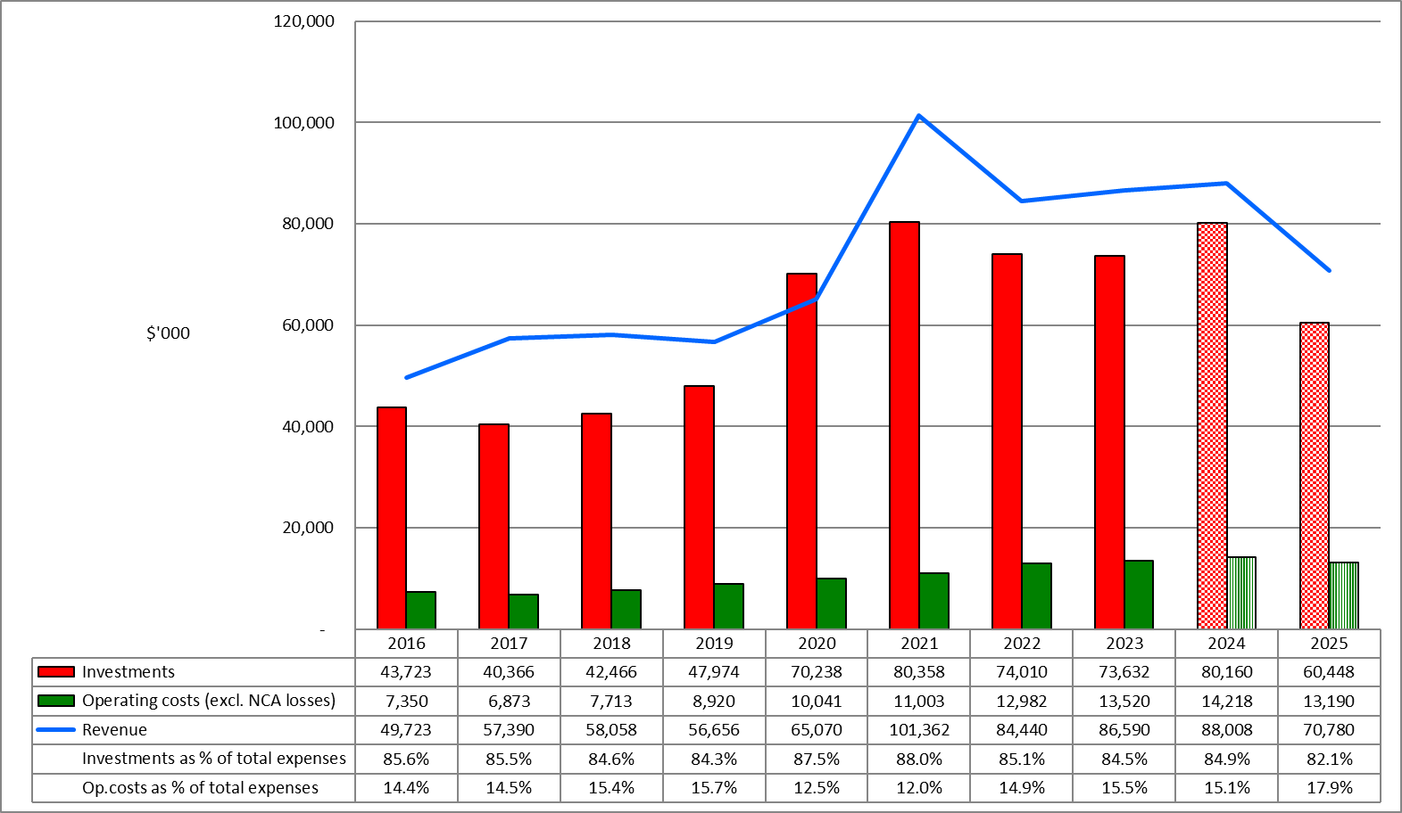
Note: Investments include our deliverables: Investing in the arts, Developing the arts, Advocating for the arts, Leadership in the arts and Partnering for the arts. NCA = Non-current assets.
2024 = forecast result for 2023/24
2025 = current budget for 2024/25—subject to change

Figure 2: Investment into the arts sector 2015/16–2024/25 – COVID-19 and non-COVID-19 specific
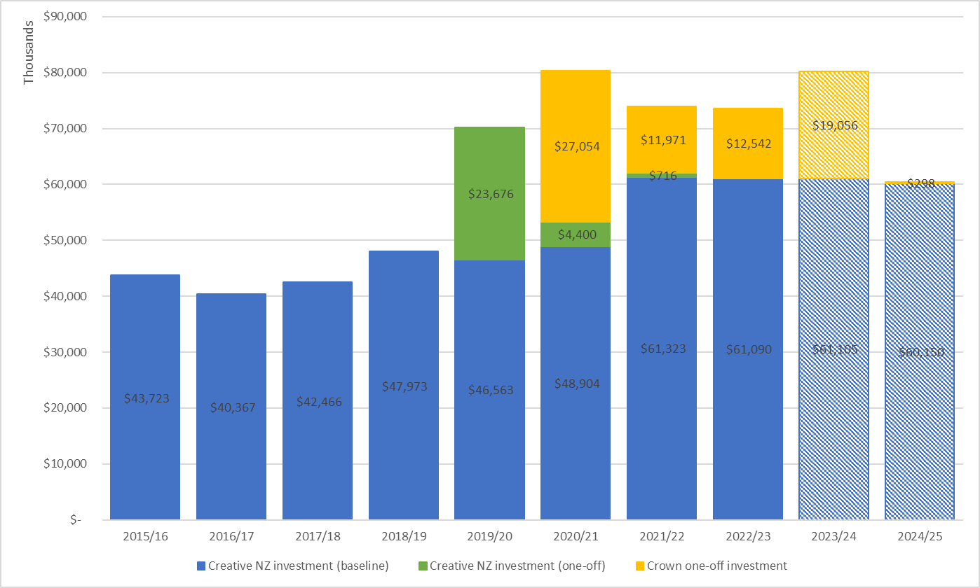
Figure 3: Surplus/(deficit), minimum equity and accumulated funds 2015/16–2024/25
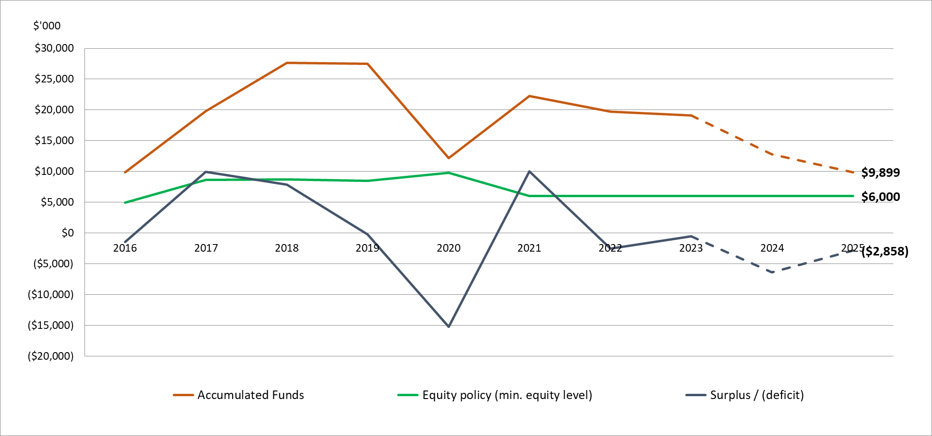

Prospective financial statements

Whakatakoto pūrongo pūtea

Prospective statement of financial performance

FOR THE YEAR ENDING 30 JUNE

 | NOTE | ACTUAL | FORECAST | BUDGET
 |  | 2023 | 2024 | 2025
 |  | $000 | $000 | $000
Revenue
Revenue from the Crown | 2 | 29,434 | 35,764 | 16,987
Revenue from the New Zealand Lottery Grants Board |  | 54,649 | 49,500 | 52,789
Interest revenue |  | 1,864 | 2,252 | 800
Other revenue |  | 643 | 492 | 204
TOTAL REVENUE |  | 86,590 | 88,008 | 70,780
Expenses
Investing in the arts | 3 | 64,139 | 70,493 | 51,998
Developing the arts | 3 | 7,395 | 7,550 | 6,565
Advocating for the arts | 3 | 1,354 | 1,564 | 1,535
Leadership in the arts | 3 | 744 | 553 | 350
Partnering for the arts | 3 | – | – | –
 |  | 73,632 | 80,160 | 60,448
Operating costs
Personnel expenses |  | 9,728 | 10,362 | 9,850
Depreciation and amortisation |  | 440 | 409 | 350
Other expenses |  | 3,352 | 3,447 | 2,990
 |  | 13,520 | 14,218 | 13,190
TOTAL EXPENSES |  | 87,152 | 94,378 | 73,638
NET OPERATING SURPLUS/(DEFICIT) |  | (562) | (6,370) | (2,858)

Prospective statement of comprehensive revenue and expense

FOR THE YEAR ENDING 30 JUNE
 | ACTUAL | FORECAST | BUDGET
 | 2023 | 2024 | 2025
 | $000 | $000 | $000
Net operating surplus/(deficit) for the year | (562) | (6,370) | (2,858)
Other comprehensive revenue and expense
Revaluation of works of art | 279 | – | –
Total other comprehensive revenue and expense | 210 | – | –
TOTAL COMPREHENSIVE REVENUE AND EXPENSE | (283) | (6,370) | (2,858)

Prospective statement of changes in net assets and equity

FOR THE YEAR ENDING 30 JUNE
 | ACTUAL | FORECAST | BUDGET
 | 2023 | 2024 | 2025
 | $000 | $000 | $000
Total equity as at 1 July | 22,479 | 22,196 | 15,826
Net operating surplus/(deficit) for the year | (562) | (6,370) | (2,858)
Other comprehensive revenue and expense | 279 | – | –
Total comprehensive revenue and expense | (283) | (6,370) | (2,858)
TOTAL EQUITY AS AT 30 JUNE | 22,196 | 15,826 | 12,968

Prospective statement of financial position

AS AT 30 JUNE
 | ACTUAL | FORECAST | BUDGET
 | 2023 | 2024 | 2025
 | $000 | $000 | $000
ASSETS
Current assets
Cash and cash equivalents | 12,220 | 8,389 | 3,005
Investments in term deposits | 39,000 | 14,000 | 14,000
Receivables | 14,970 | 12,871 | 13,497
Prepayments | 317 | 200 | 200
Total current assets | 66,507 | 35,460 | 30,702
Non-current assets
Property, plant and equipment | 606 | 480 | 400
Works of art | 2,262 | 2,262 | 2,262
Intangible assets | 424 | 200 | 20
Total non-current assets | 3,292 | 2,942 | 2,682
TOTAL ASSETS | 69,799 | 38,402 | 33,384
LIABILITIES
Current liabilities
Grants payable | 23,598 | 20,664 | 18,853
Payables and deferred revenue | 23,228 | 1,218 | 873
Employee entitlements | 679 | 600 | 600
Total current liabilities | 47,505 | 20,482 | 20,326
Non-current liabilities
Lease incentive | 19 | 13 | 9
Employee entitlements | 79 | 81 | 81
Total non-current liabilities | 98 | 94 | 90
TOTAL LIABILITIES | 47,603 | 22,576 | 20,416
NET ASSETS | 22,196 | 15,826 | 12,968
EQUITY
Accumulated funds | 19,127 | 12,757 | 9,899
Revaluation reserves | 2,262 | 2,262 | 2,262
Restricted reserves (special purpose funds) | 807 | 807 | 807
TOTAL EQUITY | 22,196 | 15,826 | 12,968

Prospective statement of cash flows

FOR THE YEAR ENDING 30 JUNE
 | ACTUAL | FORECAST | BUDGET
 | 2023 | 2024 | 2025
 | $000 | $000 | $000
CASH FLOWS FROM OPERATING ACTIVITIES
Cash was provided from:
Revenue from the Crown | 45,689 | 16,948 | 16,689
Revenue from the New Zealand Lottery Grants Board | 56,050 | 51,352 | 51,967
Interest received | 1,269 | 2,663 | 993
Grant retirements and gains | 106 | 73 | 103
Other revenue | 311 | 112 | 4
Net goods and services tax | 3,323 | – | –
Cash was applied to:
Payments of grants | (72,111) | (82,811) | (62,159)
Payments to employees | (9,717) | (10,439) | (9,850)
Payments of operating expenses | (3,327) | (3,411) | (2,996)
Net goods and services tax | – | (3,259) | (45)
NET CASH FLOWS FROM OPERATING ACTIVITIES | 21,593 | (28,772) | (5,294)
CASH FLOWS FROM INVESTING ACTIVITIES
Cash was provided from:
Term deposits maturing (with maturities over 3 months) | 22,000 | 39,000 | 14,000
Cash was applied to:
Purchase of property, plant, equipment and intangible assets | (40) | (59) | (90)
Investment in term deposits (with maturities over 3 months) | (39,000) | (14,000) | (14,000)
NET CASH FLOWS FROM INVESTING ACTIVITIES | (17,040) | 24,941 | (90)
NET INCREASE (DECREASE) IN CASH HELD | 4,553 | (3,831) | (5,384)
Cash and cash equivalents at the beginning of the year | 7,667 | 12,220 | 8,389
CASH AND CASH EQUIVALENTS AT THE END OF THE YEAR | 12,220 | 8,389 | 3,005

Notes to the prospective financial statements

1. Statement of accounting policies

FOR THE YEARS ENDING 30 JUNE 2024 AND 30 JUNE 2025

Reporting entity
The Arts Council of New Zealand Toi Aotearoa was established on 1 July 1994 by the Arts Council of New Zealand Toi Aotearoa Act 1994. The Council has chosen to operate under the name Creative New Zealand.
Creative New Zealand is a Crown entity, as defined by the Crown Entities Act 2004, and is domiciled and operates in New Zealand. As such, Creative New Zealand’s ultimate parent is the New Zealand Crown.
Its purpose, as defined under the current governing legislation, the Arts Council of New Zealand Toi Aotearoa Act 2014, is to encourage, promote and support the arts in New Zealand for the benefit of all New Zealanders. Creative New Zealand does not operate to make a financial return. Accordingly, Creative New Zealand has designated itself as a public benefit entity (PBE) for financial reporting purposes.

Basis of preparation
These prospective financial statements have been prepared on a going concern basis, and the accounting policies have been applied consistently throughout the period.

Statement of compliance
These prospective financial statements have been prepared in accordance with the Crown Entities Act 2004, which includes the requirement to comply with generally accepted accounting practice in New Zealand (NZ GAAP) and Financial Reporting Standard 42.
They have been prepared in accordance with Tier 1 PBE accounting standards and comply with PBE accounting standards.

Presentation currency and rounding
These prospective financial statements are presented in New Zealand dollars (NZ$) and are rounded to the nearest thousand dollars ($000), unless otherwise stated.

Significant accounting policies
The following specific accounting policies, which materially affect the measurement of financial performance and financial position, have been applied consistently to all periods presented in these prospective financial statements.

Revenue
The specific accounting policies for significant revenue items are explained below.

Revenue from the Crown (Vote: Arts, Culture and Heritage—core funding)
Creative New Zealand receives funding from the Crown, which is restricted in its use for the purpose of Creative New Zealand meeting the objectives specified in its governing legislation and the scope of the relevant appropriations of the funder.
Creative New Zealand considers no conditions are attached to the core funding (a condition refers to an enforceable legal right of return of the transferred asset if it is not used for the specific intended purpose) and it is recognised as revenue at the point of entitlement. This is considered to be the start of the appropriation period to which the funding relates. The fair value of the revenue from the Crown has been determined to be equivalent to the amounts due in the funding arrangements.

Revenue from the Crown (COVID-19 recovery response and one-off funding)
Revenue from the Crown related to the COVID-19 recovery response is recorded as grants received in advance (deferred revenue) in the Statement of Financial Position and recognised as revenue when conditions of the grant are satisfied, because there is an obligation in substance to return the funds if conditions of the grant are not met.

Revenue from the New Zealand Lottery Grants Board
Creative New Zealand receives most of its funding from the NZLGB. The NZLGB allocates part of Lotto NZ’s profit to Creative New Zealand through the Gambling Act 2003. The annual funding allocation until 30 June 2023 was based on 15 percent of Lotto NZ’s profit for the financial year. In 2023/24, NZLGB shifted from providing Creative New Zealand with a percentage of Lotto NZ profits to a fixed funding amount.
Creative New Zealand uses the funding for the purpose of meeting its objectives, as specified in the governing legislation. Creative New Zealand considers that no conditions are attached to the funding. The funding is recognised as revenue at the point of entitlement. The fair value of revenue from the NZLGB has been determined to be equivalent to the amounts due in the funding arrangements.

Other grants
Grants are recognised as revenue when they become receivable unless an obligation in substance is in place to return the funds if conditions of the grant are not met. If such an obligation is in place, the grants are initially recorded as grants received in advance and are recognised as revenue when conditions of the grant are satisfied.

Interest revenue

Interest revenue is recognised by accruing on a time proportion basis the interest due for the investment.

Donated assets
Where a physical asset is gifted to or acquired by Creative New Zealand for nil consideration or at a subsidised cost, the asset is recognised at fair value and the difference between the consideration provided and fair value of the asset is recognised as revenue.
The fair value of donated assets is determined as follows.
- For new assets, fair value is usually determined by reference to the retail price of the same or similar assets at the time the asset was received.
- For used assets, fair value is usually determined by reference to market information for assets of a similar type, condition and age.

Grant retirements
Grants committed in previous years are retired and recognised as revenue in the Statement of Financial Performance when:
- they are not collected by the recipients within a year of being offered
- they are no longer required for the purpose for which they were approved
- partial or full repayment is received from a grant recipient.

Grant expenses
Discretionary grants are those which Creative New Zealand has no obligations to award on receipt of the grant application. For discretionary grants without substantive conditions, the total committed funding is expensed when the grant is approved by Creative New Zealand and the approval has been communicated to the applicant. Discretionary grants with substantive conditions are expensed at the earlier of the grant payment date or when the grant conditions have been satisfied. Conditions usually include milestones that must be met to be eligible for funding.
When multi-year funding agreements are entered into, amounts granted under these agreements are recognised in the Statement of Financial Performance to the extent that they relate to the current financial year. The agreed funding for the out years is conditional on the programme and budget being agreed within the timeframes and any special conditions for the drawdown of funding being met.
The liability disclosed in the Statement of Financial Position represents financial grants to New Zealand artists and arts organisations approved by Creative New Zealand but not paid at balance date.
Non-discretionary grants are awarded automatically if the grant application meets the specified criteria, that is, Creative Communities Scheme funding to territorial authorities. This funding is expensed annually when communicated and distributed because there is no application process, and no substantive conditions need to be fulfilled to receive the grant.

Personnel expenses

Salaries and wages
Salaries and wages are recognised as an expense because employees provide services.

Defined contribution scheme
Obligations for contributions to KiwiSaver and the State Sector Retirement Savings Scheme are accounted for as defined contribution superannuation schemes and are recognised as an expense in the Statement of Financial Performance as incurred.

Leases

Operating leases
An operating lease is a lease that does not transfer substantially all the risks and rewards incidental to ownership of an asset. Lease payments under an operating lease are recognised as an expense on a straight-line basis over the lease term.

Foreign currency transactions
Foreign currency transactions are translated into New Zealand dollars using the spot exchange rates at the dates of transactions. Foreign exchange gains and losses resulting from the settlement of such transactions and from the translation at year-end exchange rates of monetary assets and liabilities denominated in foreign currencies are recognised in the Statement of Financial Performance.

Cash and cash equivalents
Cash and cash equivalents include cash at bank and on hand, deposits held on call with banks, and other short-term highly liquid investments with original maturities of three months or less.

Investments in term deposits
Investments in bank term deposits with original maturities of between three months and one year are initially measured at the amount invested. Interest is subsequently accrued and added to the investment balance. A loss allowance for expected credit losses is recognised if the estimated loss allowance is not trivial.

Receivables
Short-term receivables are recorded at the amount due, less an allowance for credit losses. Creative New Zealand applies the simplified expected credit loss model of recognising lifetime expected credit losses for receivables.
In measuring expected credit losses, short-term receivables have been assessed on a collective basis because they possess shared credit risk characteristics. They have been grouped based on the days past due. Short-term receivables are written off when no reasonable expectation of recovery exists. Indicators that no reasonable expectation of recovery exists include the debtor being in liquidation.

Property, plant and equipment
Property, plant and equipment consist of the following asset classes: leasehold improvements, furniture, equipment and fittings, and computer equipment.
Property, plant and equipment asset classes are measured at cost, less accumulated depreciation and impairment losses.

Additions
The cost of an item of property, plant and equipment is recognised as an asset only when it is probable that future economic benefits or service potential associated with the item will flow to Creative New Zealand and the cost of the item can be measured reliably.
Work in progress is recognised at cost less impairment and is not depreciated.
In most instances, an item of property, plant and equipment is initially recognised at its cost. Where an asset is acquired through a non-exchange transaction, it is recognised at its fair value as at the date of acquisition.
Costs incurred after initial acquisition are capitalised only when it is probable that future economic benefits or service potential associated with the item will flow to Creative New Zealand and the cost of the item can be measured reliably.
The costs of day-to-day servicing of property, plant and equipment are recognised in the Statement of Financial Performance as they are incurred.

Disposals
Gains and losses on disposals are determined by comparing the proceeds with the carrying amount of the asset. Gains and losses on disposals are reported net in the Statement of Financial Performance.
When revalued assets are sold, the amounts included in asset revaluation reserves in respect of those assets are transferred to accumulated funds.

Depreciation
Depreciation is provided on a straight-line basis on all property, plant and equipment at rates that will write off the cost (or valuation) of the assets to their estimated residual value over their useful lives.
The useful lives and associated depreciation rates of major classes of assets have been estimated as follows.
Leasehold improvements (Auckland) | 6 years | 16.7%
Leasehold improvements (Wellington) | 9 years | 11.1%
Furniture, equipment and fittings | 10 years | 10.0%
Computer equipment | 4 years | 25.0%
Leasehold improvements are depreciated over the shorter of the unexpired period of the lease and the estimated useful life of the assets.

Works of art
Creative New Zealand owns a ‘furnishing works of art collection’ with items on display in Creative New Zealand offices. These items are rotated on a regular basis with items held in storage. Some items are also on loan to other organisations, including museums and other arts organisations.
Works of art are revalued with sufficient regularity to make sure the carrying amount does not differ materially from fair value and at least every three years. Fair value is determined from market-based evidence by an independent valuer. The results of revaluing works of art are credited or debited to an asset revaluation reserve for that class of asset, in the same way as land and buildings.
Works of art are not depreciated because they have an indeterminate useful life and may appreciate in value over time. The carrying values of revalued works of art are assessed annually to make sure they do not differ materially from the assets’ fair values.

Intangible assets

Software acquisition and development
Acquired computer software is capitalised based on the costs incurred to acquire and bring to use the specific software.
Costs directly associated with the development of software for internal use are recognised as an intangible asset. Direct costs include the software development costs.
Employee costs, staff training costs, and relevant overheads are recognised as an expense when incurred. Costs associated with maintaining computer software are recognised as an expense when incurred.

Amortisation
The carrying value of an intangible asset with a finite life is amortised on a straight-line basis over its useful life. Amortisation begins when the asset is available for use and stops at the date the asset is derecognised. The amortisation charge for each period is recognised in the surplus or deficit.
The useful lives and associated amortisation rates of major classes of intangible assets have been estimated as follows.
Computer software: Grants Management System and Customer Relationship Management system | 8 years | 12.5%
Computer software: other | 4 years | 25.0%

Impairment of property, plant, equipment and intangible assets
Creative New Zealand does not hold any cash-generating assets. Assets are considered cash-generating where their main objective is to generate a commercial return.

Non-cash generating assets
Property, plant, equipment and intangible assets held at cost that have finite useful lives are reviewed for impairment whenever events or changes in circumstances indicate that the carrying amount may not be recoverable. An impairment loss is recognised for the amount by which the asset’s carrying amount exceeds its recoverable amount. The recoverable amount is the higher of an asset’s fair value less costs to sell and value in use.
Value in use is determined using an approach based on either a depreciated replacement cost approach, restoration cost approach or a service units approach. The most appropriate approach used to measure value in use depends on the nature of the impairment and availability of information.
If an asset’s carrying amount exceeds its recoverable service amount, the asset is regarded as impaired and the carrying amount is written down to the recoverable amount. The total impairment loss is recognised in the surplus or deficit.
The reversal of an impairment loss is recognised in the Statement of Financial Performance.

Financial instruments
Creative New Zealand is party to non-derivative financial instruments as part of its normal operations. These financial instruments include cash at bank and on hand, deposits held on call with banks, short-term deposits, debtors and other receivables, and creditors and other payables.
Except for those items covered by a separate accounting policy, all financial instruments are initially recognised in the Statement of Financial Position at fair value, and all revenues and expenses in relation to financial instruments are recognised in the surplus or deficit.
Creative New Zealand does not use derivative financial instruments.

Payables and deferred revenues
Short-term payables are recorded at the amount payable. The amounts are unsecured and are usually paid within 30 days of recognition, therefore, the carrying value of creditors and other payables approximates their fair value.

Employee entitlements

Short-term employee entitlements

Employee entitlements expected to be settled within 12 months of balance date are measured at undiscounted nominal values based on accrued entitlements at current rates of pay. These include salaries and wages accrued up to balance date, annual leave earned but not yet taken at balance date, long service leave entitlements expected to be settled within 12 months, and time in lieu accrued up to balance date. Creative New Zealand has no liability for sick leave entitlements.

Long-term employee entitlements
Employee entitlements due to be settled beyond 12 months, such as long service leave, have been calculated on an actuarial basis. The calculations are based on:
- likely future entitlements accruing to staff, based on years of service, years to entitlement, the likelihood that staff will reach the point of entitlement, and contractual entitlements information
- the present value of the estimated future cash flows.
Expected future payments are discounted using the weighted average of interest rates for government stock with terms to maturity like those of the relevant liabilities. The inflation factor is based on the expected long-term increase in remuneration for employees.

Provisions
A provision is recognised for future expense of uncertain amount or timing when there is a present obligation (either legal or constructive) because of a past event, when it is probable that an outflow of future economic benefits will be required to settle the obligation, and when a reliable estimate can be made of the amount of the obligation.
Provisions are measured at the present value of the expense expected to be required to settle the obligation using a pre-tax discount rate that reflects current market assessments of the time value of money and the risks specific to the obligation. The increase in the provision due to the passage of time is recognised as an interest expense and is included in ‘finance costs’.

Goods and services tax
All items in the financial statements are exclusive of GST, except for receivables and creditors and other payables, which are stated inclusive of GST. GST is not recoverable because input tax is recognised as part of the related asset or expense.
The net amount of GST recoverable from, or payable to, the Inland Revenue Department is included as part of receivables or creditors and other payables in the Statement of Financial Position.
The net GST paid to, or received from, the Inland Revenue Department, including the GST relating to investing and financing activities, is classified as an operating cash flow in the Statement of Cash Flows.
Commitments and contingencies are disclosed exclusive of GST.

Income tax
Creative New Zealand is a public authority and consequently is exempt from the payment of income tax in accordance with the Income Tax Act 2007. Accordingly, no provision has been made for income tax.

Equity
Equity is measured as the difference between total assets and total liabilities. Equity is disaggregated and classified into the following components:
- accumulated funds
- revaluation reserve
- restricted reserve.
Revaluation reserve relates to the revaluation of works of art.
Restricted reserve consists of donations and bequests entrusted to Creative New Zealand to administer for a stipulated purpose (special purpose funds).

Changes in accounting policies
No changes have occurred in accounting policies since the date of the last audited financial statements, other than the impact of NZ GAAP. These policies have been applied on a basis consistent with previous years.

Significant estimates and assumptions concerning the future
Revenue from the NZLGB for 2024/25 is based on the amount confirmed by the NZLGB on 3 May 2024, together with the allocation model for the distribution of NZLGB funding for the four years from 2024/25.
It is assumed the timing of baseline funding will be the same for each of the financial years.
All significant assumptions relating to expenses have been based on historical data, existing business practices or actual business plan projections for each financial year.
The timing of expenses under Creative New Zealand’s funding programmes can be variable after each funding round. A best estimate of the timing of these expenses has been made, which may vary from the timing of the actual expenses.

Revenue from the Crown
 | ACTUAL | FORECAST | BUDGET
 | 2023 | 2024 | 2025
 | $000 | $000 | $000
Vote: Arts, Culture and Heritage—core funding | 16,689 | 16,689 | 16,689
COVID-19 recovery response funding
Cultural Sector Capability Fund | 874 | 760 | –
Pasifika Festivals Initiative | 4,603 | 340 | 260
Mātauranga Māori Te Awe Kōtuku Initiative | 1,002 | 20 | –
Reprioritised Cultural Recovery Package | 6,266 | 15,734 | –
Other one-off funding
Niu Dawn Raids | – | 1,962 | 38
Cultural Diplomacy International Programme—South by Southwest Sydney | – | 259 | –
 | 29,434 | 35,764 | 16,987
Creative New Zealand received significant one-off investment from the Crown in 2021, 2022 and 2023 related to the COVID-19 recovery response. This one-off investment is recorded as grants received in advance (deferred revenue) in the Statement of Financial Position and recognised as revenue when conditions of the grant are satisfied, because of an obligation in substance to return the funds if conditions of the grant are not met.
The remaining COVID-19 recovery response funding impacting these financial statements is restricted in its use towards achieving the following outcomes:
- deliver the objectives of the Cultural Sector Capability Fund so the arts sector has the necessary industry, technical and business capability to meet the challenges of a COVID-19 environment ($1 million per year in 2021 and 2022)
- manage the new Pasifika Culture and Heritage Fund to support Pasifika festivals throughout New Zealand that are facing financial hardship brought about by the COVID-19 pandemic, as well as develop their capability so they can operate in a COVID-19 environment ($4 million per year in 2021, 2022 and 2023)
- deliver to programmes under the Mātauranga Māori Te Awe Kōtuku Initiative, in particular: to support the retention and revitalisation of critically endangered Tārai Waka mātauranga (waka building knowledge), and Taonga Pūoro mātauranga, to boost the existing Toi Ake contestable fund to support the retention of mātauranga and heritage ngā toi Māori artforms, and to develop regional partnerships to support mātauranga Māori artform practitioners ($1.073 million in 2021, $2.255 million in 2022 and $1 million in 2023)
- enable the continued recovery of the arts, culture and heritage sector from the ongoing impacts of COVID-19 ($22 million reprioritised in 2023 from the Government’s Arts and Culture COVID Recovery Fund).
  - Additional support for festivals: $10 million to support established festivals that celebrate the life experiences, stories, cultures and regional identities of New Zealanders, and that continue to be affected by the effects of COVID-19 in 2023.
  - Additional support for artists, arts practitioners and arts organisations: $12 million to support artists, arts practitioners and arts organisations, including through Grants or other existing programmes that help the arts, culture and heritage sector to adapt and thrive in an ongoing COVID-19 environment.
Additional one-off funding of $2 million was allocated through Budget 2022 for the Niu Dawn Raids initiative, a contestable funding for Pacific artists and historians to capture and reflect community experiences of the Dawn Raids.
One-off project funding of $0.259 million was received from the Cultural Diplomacy International Programme to deliver a cross-sector Aotearoa New Zealand activation in October 2023 as part of the South by Southwest, in partnership with Te Māngai Pāho and the New Zealand Music Commission.
The reconciliation of COVID-19 recovery response funding received and deferred is detailed as follows.

 | ACTUAL | FORECAST | BUDGET
 | 2023 | 2024 | 2025
 | $000 | $000 | $000
Cash received from the Crown
Vote: Arts, Culture and Heritage—core funding | 16,689 | 16,689 | 16,689
COVID-19 recovery response funding
Pasifika Festivals Initiative | 4,000 | – | –
Mātauranga Māori Te Awe Kōtuku Initiative | 1,000 | – | –
Reprioritised Cultural Recovery Package | 22,000 | – | –
Other one-off funding
Niu Dawn Raids | 2,000 | – | –
Cultural Diplomacy International Programme—South by Southwest Sydney | – | 259 | –
 | 45,689 | 16,948 | 16,689
Less, revenue deferred (recognised in the Statement of Financial Position)
COVID-19 recovery response funding
Cultural Sector Capability Fund | 760 | – | –
Pasifika Festivals Initiative | 886 | 546 | 286
Mātauranga Māori Te Awe Kōtuku Initiative | 20 | – | –
Reprioritised Cultural Recovery Package | 15,734 | – | –
Other one-off funding
Niu Dawn Raids | 2,000 | 38 | –
 | 19,400 | 584 | 286
Plus, deferred revenue used from prior years
COVID-19 recovery response funding
Cultural Sector Capability Fund | 1,634 | 760 | –
Pasifika Festivals Initiative | 1,490 | 886 | 546
Mātauranga Māori Te Awe Kōtuku Initiative | 21 | 20 | –
Reprioritised Cultural Recovery Package | – | 15,734 | –
Other one-off funding
Niu Dawn Raids | – | 2,000 | 38
 | 3,145 | 19,400 | 584
Revenue from the Crown | 29,434 | 35,764 | 16,987

Expenses by investment category
 | ACTUAL | FORECAST | BUDGET
 | 2023 | 2024 | 2025
 | $000 | $000 | $000
INVESTING IN THE ARTS
Toi Tōtara Haemata Investment programme | 16,413 | 16,192 | 16,516
Toi Uru Kahikatea Investment programme | 18,467 | 17,981 | 18,487
Grants and Special Opportunities | 12,743 | 12,328 | 12,108
Creative Communities Scheme | 3,943 | 3,948 | 3,969
International programme | 1,334 | 1,749 | 620
Initiatives and pilots | 70 | – | –
COVID-19 Crown funding
Toi Tōtara Haemata and Toi Uru Kahikatea—one-off cost pressure top up | 1,386 | – | –
Creative Communities Scheme | – | 1,183 | –
Grants and special opportunities—Arts Grants | 4,500 | 4,758 | –
Grants and special opportunities—Festivals | 380 | 9,793 | –
Grants and special opportunities—Mātauranga Māori Te Awe Kōtuku (Toi Ake Fund) | 500 | – | –
Initiatives and pilots—Pasifika Festivals Initiative | 4,403 | 340 | 260
Other one-off funding
Niu Dawn Raids | – | 1,962 | 38
Cultural Diplomacy International Programme—South by Southwest Sydney | – | 259 | –
 | 64,139 | 70,493 | 51,998
DEVELOPING THE ARTS
Capability building—national programme | 842 | 1,791 | 1,690
Capability building—international programme | 538 | 745 | 755
Initiatives and pilots | 4,641 | 4,254 | 4,120
COVID-19 Crown funding
Capability building—Cultural Sector Capability Fund | 874 | 760 | –
Initiatives and pilots—Mātauranga Māori Te Awe Kōtuku (Tārai Waka and Taonga Pūoro) | 500 | – | –
 | 7,395 | 7,550 | 6,565
ADVOCATING FOR THE ARTS
Advocacy | 1,354 | 1,564 | 1,535
 | 1,354 | 1,564 | 1,535
LEADERSHIP IN THE ARTS
Capability building—national programme | 79 | 217 | –
Advocacy | 665 | 336 | 350
 | 744 | 553 | 350
PARTNERING FOR THE ARTS*
 | – | – | –
 | – | – | –
Creative New Zealand does not allocate personnel costs directly to deliverables: Investing in the arts, Developing the arts, Advocating for the arts, Leadership in the arts and Partnering for the arts.
* This new deliverable supports the ongoing imperative to collaborate more intentionally with others, to help grow resources and effect change.

Part Three:

Our organisation

Wāhanga Tuatoru:
Tō mātau whakahaere

Who we are
Governed by the Arts Council, Creative New Zealand is an autonomous Crown entity operating under the Arts Council of New Zealand Toi Aotearoa Act 2014.
We are committed to continually improving the capability of our organisation. This includes having a robust governance structure, appropriate operational policies, effective and efficient internal processes, and capable and engaged staff.

What we do
Our work is structured around eight investment categories. These represent the major programmes we run and our five deliverable areas of Investing in the arts, Developing the arts, Advocating for the arts, Leadership in the arts and Partnering for the arts. These categories include:
- Toi Tōtara Haemata Investment programme
- Toi Uru Kahikatea Investment programme
- Contestable grant funding, including special opportunities
- Creative Communities Scheme
- International programme
- Capability building programme
- Advocacy
- Initiatives and pilots.
We invest in arts activity by New Zealand artists, arts practitioners and arts organisations, both within New Zealand and internationally. This is where most of the money we get is spent.
We invest across a variety of artforms: craft/object, dance, inter-arts, literature, multi-disciplinary, music, ngā toi Māori (all forms of heritage and contemporary arts practice), Pacific arts (all forms, heritage and contemporary), theatre and visual arts.
Within our contestable grant funding, and our Toi Tōtara Haemata and Toi Uru Kahikatea investment categories, we allocate funding across three pools: General, Māori and Pacific. Proposals are assessed on their appropriateness to the artform and programme criteria.
Applications to the Māori and Pacific pools are also assessed on whether mātauranga Māori or kaupapa Pasifika is evident in the practice and the results of the proposal. Applicants can select whether they would like their application assessed in the General arts, ngā toi Māori or Pacific arts funding pools. Applicants must be tangata whenua Māori or part of a Māori-led organisation to apply to the ngā toi Māori pool.
More information about how we assess and make decisions on funding applications is available at: www.creativenz.govt.nz/funding-and-support/all-opportunities.
From time to time, special arts development opportunities are available that are open to all artists and practitioners. Others, such as internships and cultural exchanges, are specific to artforms (eg, the Prime Minister’s Awards for Literary Achievement), Māori or Pacific artists and practitioners (eg, the Te Waka Toi Awards and the Arts Pasifika Awards), or other criteria.
More information on our funding programmes is available at: www.creativenz.govt.nz/funding-and-support.
We develop the arts, by supporting artists, arts practitioners and arts organisations to build their capability across various areas, and from time to time by developing initiatives to address gaps.
To complement our funding and development work, we advocate for the value of the arts and provide leadership in the arts (eg, by making submissions on matters affecting the arts or convening the sector to address challenges or opportunities). We also partner with others to increase the impact we can have by working with those with similar aims.
In line with our legislation, in carrying out our work, we recognise:
- in the arts the role of Māori as tangata whenua
- the arts of the Pacific peoples of New Zealand
- the cultural diversity of the people of New Zealand.
We also recognise and uphold in our work the principles of participation, access, excellence and innovation, professionalism and advocacy.
Our work is also guided by the three principles of our Te Kaupapa o Toi Aotearoa programme (see page 11).

Our relationships
We work with many different stakeholders, including the Minister for Arts, Culture and Heritage; Manatū Taonga Ministry for Culture and Heritage; the NZLGB; mana whenua, iwi and Māori; Pasifika groups; local government; individual artists and arts practitioners; arts collectives, groups and organisations; and, more broadly, the diverse communities of Aotearoa New Zealand. We consult with stakeholder groups when developing strategy and reviewing policies that affect the arts sector and evaluating our programmes and initiatives.
We also have links to international arts councils, and we are an active member of the International Federation of Arts Councils and Culture Agencies.

Arts Council
Under the Act, the Arts Council, our governing board, has responsibility for:
- setting the strategic direction of Creative New Zealand and monitoring its performance
- setting guidelines for the allocation of funding and the implementation of initiatives
- establishing assessment processes for the allocation of funding
- maintaining relationships with other agencies and organisations.
Under its Governance Charter, the Council is guided by the following three phases, which broadly describe the Council’s distinct roles.
- Determining future focus and direction: ‘As a board, we are focused on the future, guided by the mahi and legacy of those who’ve come before us. Together, we develop, endorse and support Creative New Zealand’s strategic direction as the national arts development agency of Aotearoa. This helps guide our kaupapa, our waka and our mahi to future success.’
- Building culture: ‘As a board, we strive to set an effective and future-oriented governance culture for Creative New Zealand; one which upholds Te Kaupapa o Toi Aotearoa. This contributes to our roles of Determining future focus and direction and Holding to account.’
- Holding to account: ‘As a board, we oversee Creative New Zealand’s activities and progress made towards meeting the organisation’s goals. This helps give confidence to those who fund and support us that we’re responsible guardians of public money and that we work in the public interest.’
The Council is made up of 13 members who, between them, have a range of skills and experience.
The Council has a minimum of four members with knowledge of ngā toi Māori (Māori arts), te ao Māori (a Māori worldview) and tikanga Māori (Māori protocol and culture). These members are appointed in consultation with the Minister for Māori Development. Under our Act (the Arts Council of New Zealand Toi Aotearoa Act 2014), they form a committee—Te Komiti Māori—to advise the Council on matters relevant to the Council’s functions in relation to Māori, and any other functions the Council delegates to the committee.
Two Council members are appointed with knowledge of the arts and traditions, or cultures, of the Pacific peoples of New Zealand, in consultation with the Minister for Pacific Peoples.
The Arts Council operates three committees.
Komiti Māori—under our Act, Komiti Māori members advise the Council on matters relevant to Māori, and any other functions the Council delegates to the committee. The work of the Komiti includes:
- strategic advice and direction to grow ngā toi Māori nationally and internationally, noting the relationship between Te Waka Toi Pātaka (Mātauranga Māori Framework), Interim Investment Intentions and Te Hā o ngā Toi—Māori Arts Strategy
- how the Arts Council can best support ngā toi Māori development in Aotearoa New Zealand and internationally
- new relationships and collaborations across central and local government, and iwi
- the role Creative New Zealand plays in supporting specific-sector initiatives for ngā toi Māori.
Audit & Risk Committee—the Committee advises Council on audit, risk and finance matters. The functions of the Committee include:
- advice to the Arts Council on matters relating to the Council’s audit, risk and finance functions
- reviewing financial and performance reports before their consideration by the Council
- reviewing and endorsing corporate policies before their agreement by the Council (eg, sensitive expenditure)
- reviewing and recommending to the Council updates to the Council’s Governance Manual
- any other functions delegated to the Committee by the Council.
People & Culture Committee—the Committee provides advice on the Council’s people and culture responsibilities. The Committee is responsible for:
- advising and making recommendations to the Council on areas such as: organisational culture elements of the Te Kaupapa o Toi Aotearoa work programme
- setting annual performance expectations for the Chief Executive for each performance year, and reviewing the Chief Executive’s performance against these following the end of each performance year
- the process around amendments to the Chief Executive’s terms and conditions of employment, including amendments to the Chief Executive’s remuneration package
- material changes to Creative New Zealand’s organisational structure
- policy settings for Creative New Zealand staff remuneration, recruitment, appointment, and remuneration of Senior Leadership Team members if this falls outside of remuneration policies
- board-related people matters, including Council succession planning, annual Council self-evaluations, and any disciplinary or code of conduct matters.
We work to ensure that:
- Council members have appropriate and timely information to make decisions
- Council members are knowledgeable about and engaged with Creative New Zealand’s work
- decisions are made at the appropriate organisational level, reflecting their importance, risk, and the need for timeliness
- management and staff provide appropriate support to the Council.
Information on our current Council members is given on the next page. The Arts Council currently has one vacancy.

Arts Council Membership (30 June 2024)
Member |  | Current term started  First appointed | Current term expires
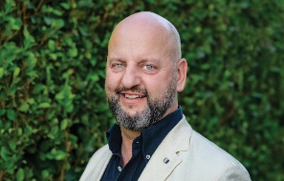 | Kent Gardner  Manukura—Chair  Auckland | 10 June 2024 | 31 May 2027
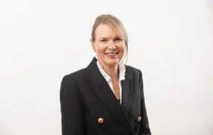 | Hilary Poole  Auckland | 1 November 2021 | 31 October 2024
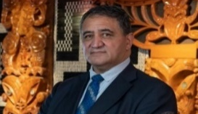 | Kura Moeahu  Co-Chair, Komiti Māori  Wellington  Māori representative | 1 February 2023  25 February 2020 | 31 January 2026
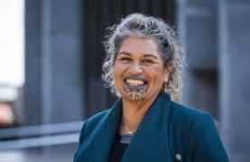 | Puamiria Parata-Goodall  Co-Chair, Komiti Māori  Christchurch  Māori representative | 24 October 2022 | 30 September 2025
 | Ane Tonga  Interim Chair, Audit and Risk Committee  Auckland  Pasifika representative | 1 November 2021 | 31 October 2024
 | John Ong  Interim Chair, People and Culture Committee  Wellington | 1 October 2022  9 December 2019 | 30 September 2025
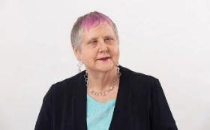 | Robyn Hunt  Wellington | 1 February 2023  25 February 2020 | 31 January 2026
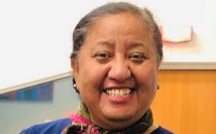 | Whetū Fela  Whanganui  Māori representative | 18 July 2022 | 30 June 2025
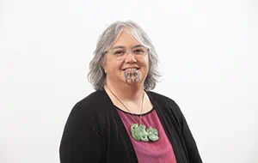 | Bonita Bigham  Taranaki  Māori representative | 8 August 2022 | 31 July 2025
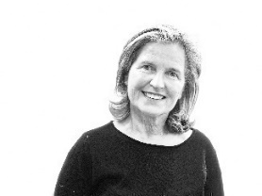 | Helen Klisser During  Auckland | 24 October 2022 | 30 September 2025
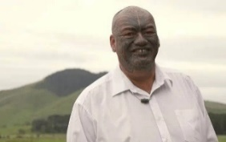 | Shane Te Ruki  Te Awamutu  Māori representative | 13 July 2023 | 30 June 2026
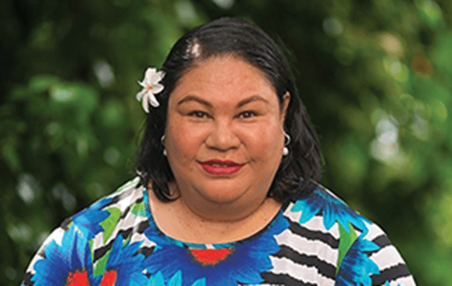 | Jannita Pilisi  Auckland  Pasifika representative | 29 April 2024 | 31 March 2027

Policies and processes
We undertake regular reviews of internal policies, covering areas like finance, human resources, conflicts of interest and delegations. In each review, we consider the appropriateness of existing policy, best practice examples from similar organisations and compliance with legislation.
We also have a strong focus on improving the services we deliver, particularly on investment decision-making and reporting processes.
The goal under the Creative New Zealand perspective of our long-term strategic direction is that: We have the strategies, services and the operational capacity to drive development of the arts in New Zealand.
To deliver to this, we are interested not just in the efficiency and effectiveness of our processes but the extent to which they are fair, equitable and accessible to all New Zealanders.
We regularly assess, with the arts sector, whether we are performing to the standards we have set for ourselves. Each year, we survey users of our services on their experience engaging with Creative New Zealand and we use this valuable feedback to inform service improvements.
We also have a formal complaints management system and we monitor informal feedback from applicants and clients through social media and interactions with staff, which also help provide ongoing feedback.
We regularly report on those who access or benefit from our services and the diversity of our organisation and those who contribute to decision-making. This reporting, in line with our Diversity in the Arts Policy, aims to increase our understanding of issues around equity and access in the arts.

Environmental impact
Creative New Zealand has agreed to sign up to the Government’s carbon emissions reduction programme and will, over 2024/25, develop an emissions management and reduction plan. This work was unable to be completed in 2023/24. We will also establish baseline data and reporting to obtain carbon emissions data for flights, rental cars and accommodation. Travel costs are expected to be Creative New Zealand’s most significant area of carbon emissions.

Our staff
We rely on having a skilled and engaged staff to achieve our strategic intentions. As of 30 June 2024, we have 80 staff (78.8 full-time equivalent staff), based in Auckland, Wellington, Christchurch, Dunedin and across other centres (as remote working has become increasingly feasible). We have dedicated office spaces in Auckland and Wellington.
Our staff work across five groups: Arts Development Services, Business Services, Māori Strategy and Partnerships, Pacific Arts, and Strategy and Engagement.
The Creative New Zealand whānau has professional experience across artforms, international market development and cultural exchange, audience development, project management, and corporate and business services.
All staff are offered training and development in a variety of areas aligned with their individual needs and those of the organisation (including under the Te Kaupapa o Toi Aotearoa). Creative New Zealand also has a Māori Language Plan in place.
We show commitment to our ‘good employer’ obligations by maintaining and reporting against a personnel policy that includes reference to the seven good employer elements, those being:
- leadership, accountability and culture
- recruitment, selection and induction
- employee development, promotion and exit
- flexibility and work design
- remuneration, recognition and conditions
- harassment and bullying prevention
- safe and healthy environment.
Our aim is to have a leadership team and workforce that reflect the communities we serve. Vacancies are advertised through various channels, to attract a diverse pool of applicants.
We also include, in our personnel policy and reporting, specific commitments to the aims, aspirations and employment requirements of Māori, ethnic or minority groups, women and people with disabilities. We also support, within Creative New Zealand, implementation of the Government’s action plan to reduce gender, Māori, Pacific and ethnic pay gaps and create a fairer workplace.

Toi is broadly understood as ‘art’ or ‘knowledge’ (source: Te Aka Māori Dictionary: www.maoridictionary.co.nz).
Te Waka Toi Pātaka is described in more detail in Te Hā o ngā Toi—Māori Arts Strategy 2019–2024. Available at: www.creativenz.govt.nz/about-creative-nz/corporate-documents/te-ha-o-nga-toi-maori-arts-strategy-2019-2024.
Manatū Taonga Ministry for Culture and Heritage Long-Term Insights Briefing (2022): www.mch.govt.nz/publications/long-term-insights-briefing-2022.
Creative New Zealand Briefing to the Incoming Minister 2023: www.creativenz.govt.nz/about-creative-nz/corporate-documents/briefing-to-the-incoming-minister-for-arts-culture-and-heritage-2023.
The reduction in this target is due to the reduced budget for Grants and Special Opportunities in 2024/25 meaning we will be supporting the development of fewer new works.
‘Arts activities’ capture a variety of works that Creative New Zealand funds (eg, plays, concerts, dance performances, exhibitions, workshops, masterclasses, publications). ‘Events’ capture the number of opportunities audiences have to experience arts activities (eg, each time a play, concert, dance performance, workshop, masterclass occurs; each day an exhibition is open to the public; each sale or publication).
This measure and the related historical performance reporting replaces the measure Number of participants in arts activities funded by Creative New Zealand. The change was made in June 2025 to improve performance reporting requirements under the Service Reporting Performance Standard (PBE FRS 48). In our Annual Report 2024/25, we’ll continue to track the number of people who participated in arts activities we supported, as reported by our funding recipients.
Through Grants and Special Opportunities Investment Category.
This figure replaces the forecast published on 1 July 2024. The figure was amended in June 2025 and is the actual result for 2023/24.
This measure and the related historical performance reporting replaces the measure Number of attendances at arts activities and events funded by Creative New Zealand (in person and online). The change was made to improve performance reporting requirements under the Service Reporting Performance Standard (PBE FRS 48). In our Annual Report 2024/25, we’ll continue to track the number of people who attended arts activities we supported, as reported by our funding recipients.
This figure replaces the forecast published on 1 July 2024. The figure was amended in June 2025 and is the actual result for 2023/24.
The three measures are: The arts should receive public funding; My community would be poorer without the arts; and The arts help improve New Zealand society.
The Arts Council sets the operating costs between 15 percent and 16 percent of total expenditure. In 2024/25, there is a temporary increase to the operating costs range to up to 18 percent. This change will be reviewed ahead of planning for 2025/26. This measure covers investment across all five Creative New Zealand deliverables.
A Samoan term that translates as ‘to adorn the space between people,’ or develop and support meaningful relationships through collaboration.

