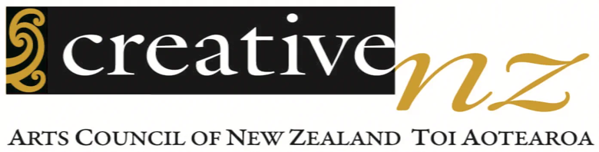
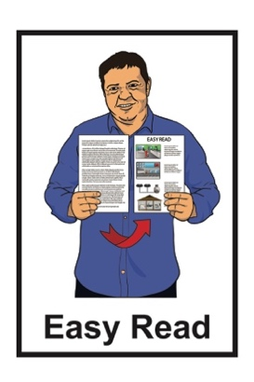

Tū Mai Rā, Toi Aotearoa

Our Long-Term Strategy to 2040

Published: July 2026

Before you start

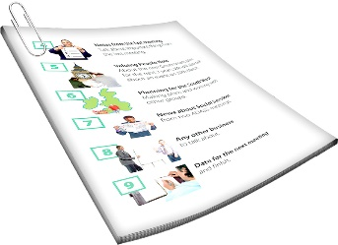
This is a long document.


It can be hard for some people to read a document this long.

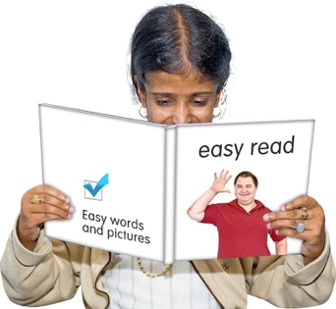
Some things you can do to make it easier are:
read it a few pages at a time
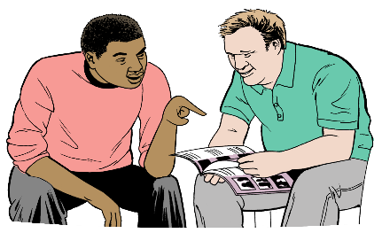
set aside some quiet time to look at it
have someone read it with you to support you to understand it.

What you will find in here

Page number:


About this Easy Read 3

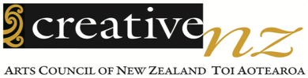
About Creative New Zealand 9


Our values 18


Our vision 22

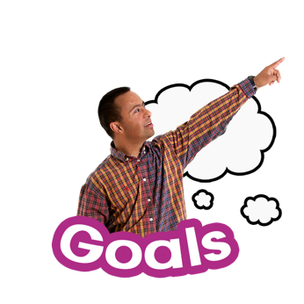
Our goals 24

Our waiata 36


Photo credits 40

About this Easy Read

This Easy Read is from
Creative New Zealand.

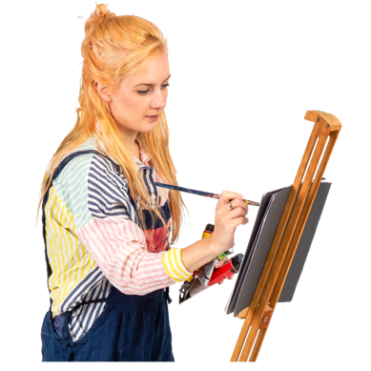
Creative New Zealand works to support:
the arts
ngā toi Māori / Māori arts.

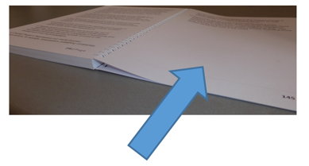
There is more information about Creative New Zealand on
pages 8 to 18 of this Easy Read.


When you see we / our / us in this Easy Read it means Creative
New Zealand.

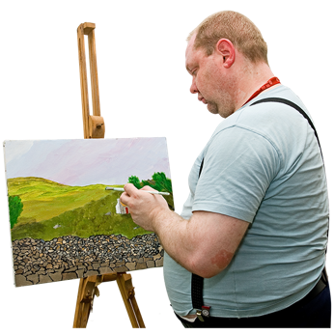
The arts means all kinds of creative things people do like:
painting
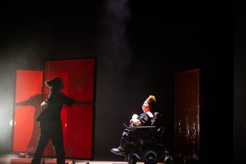
dancing
writing
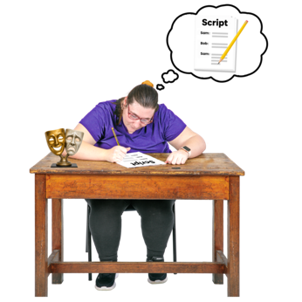
making jewellery
making tapa cloth.

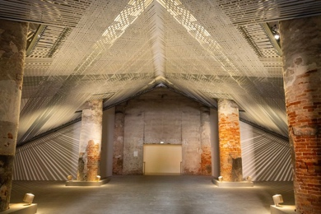
Ngā toi Māori / Māori arts are:
any art made by Māori artists
Māori arts like:
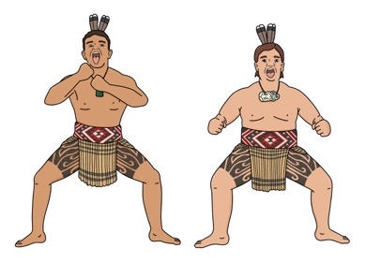
- raranga / weaving
- kapa haka
- whaikairo / carving.

This Easy Read is about our long-term strategy called Tū Mai Rā, Toi Aotearoa.

Here a strategy is a plan for:
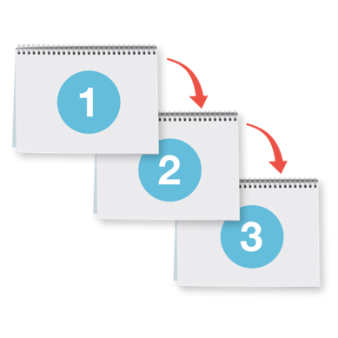
the things we want to make happen
what we need to do to make those things happen.



In this Easy Read Tū Mai Rā, Toi Aotearoa will be called the strategy.

The strategy talks about:
our vision
the goals we will work on from now until 2040.


Here our vision is an idea about what we think things should be like
in the future.

Here goals are the things we plan to do to make our vision real.

This Easy Read is a summary of the full strategy.

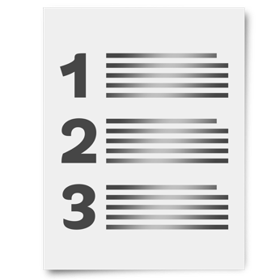
A summary:
is shorter than the full document
tells the main ideas.

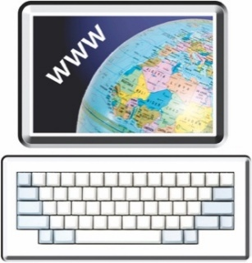
You can read the full strategy on our website at:

www.creativenz.govt.nz/tumaira
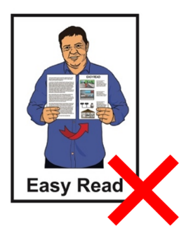

The full strategy is not in Easy Read.


We believe that a lot of good things could happen in the arts and ngā toi Māori in the coming years.

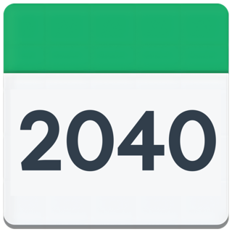
We also know that a lot of things could change before 2040.


We will also change to make the future we want.

About Creative New Zealand
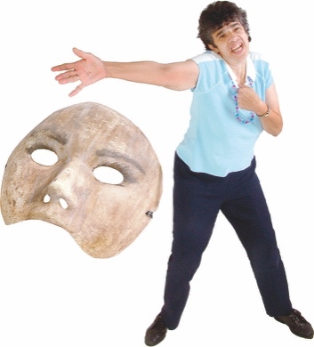

We have been supporting the arts in Aotearoa New Zealand since 1964.

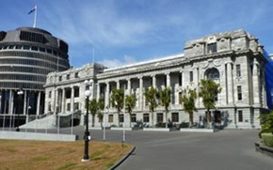
The Arts Council of New Zealand Toi Aotearoa Act 2014 says our purpose is to:

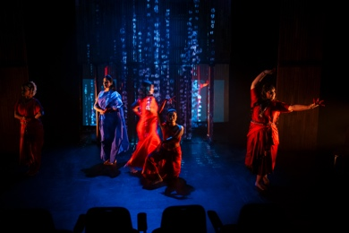
Encourage, promote and support the arts in New Zealand for the benefit of all New Zealanders.

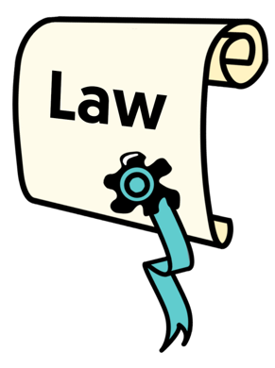
The Arts Council of New Zealand Toi Aotearoa Act 2014 is a law made by the Government about how our organisation should run.


Here encourage means to give people reasons to feel:
confident
hopeful.

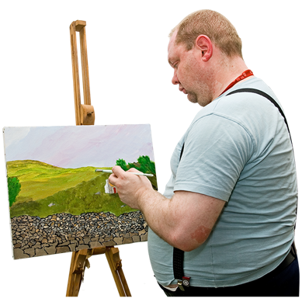
Here promote means to tell people how they can:
make art
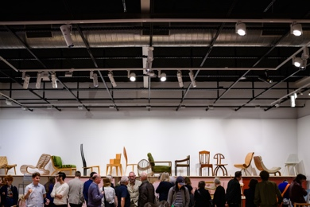
see art
support the arts.

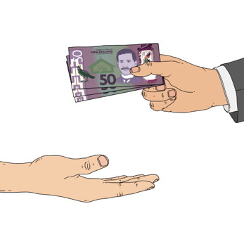
Some of the ways we support the arts and ngā toi Māori are:
giving artists money
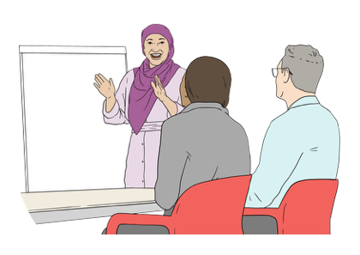
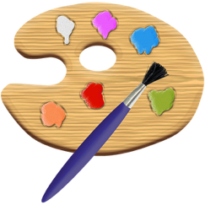

training artists to:
- take care of their money
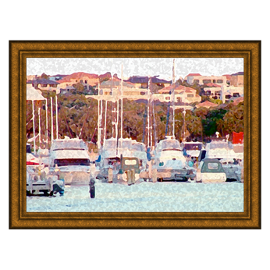
- get people to see their art
showing the work of Aotearoa New Zealand artists overseas
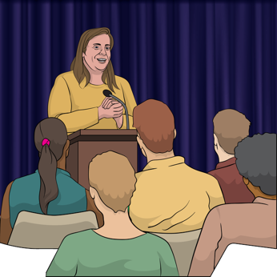
giving the Government advice about supporting the arts
speaking up about why the arts are important.

Artists are people who make art.

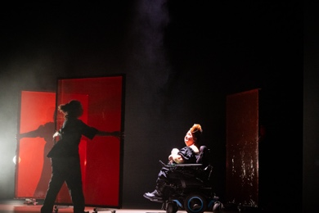
We support:
a lot of different kinds of art
arts from many cultures like:
- ngā toi Māori / Māori arts
- Pacific arts.

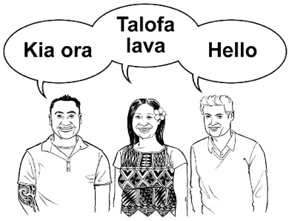
Culture is a way of:
thinking that a group shares
doing things as a group.
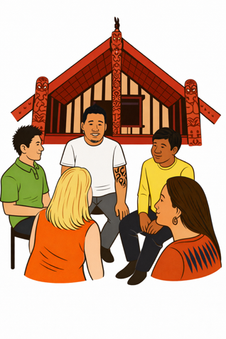

There are many different cultures in
Aotearoa New Zealand like:
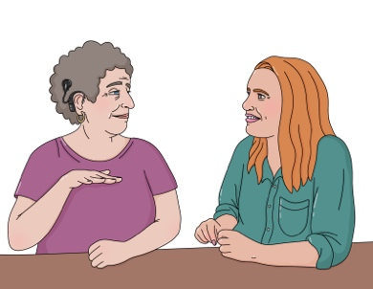
Māori culture
Pacific culture
Deaf culture.

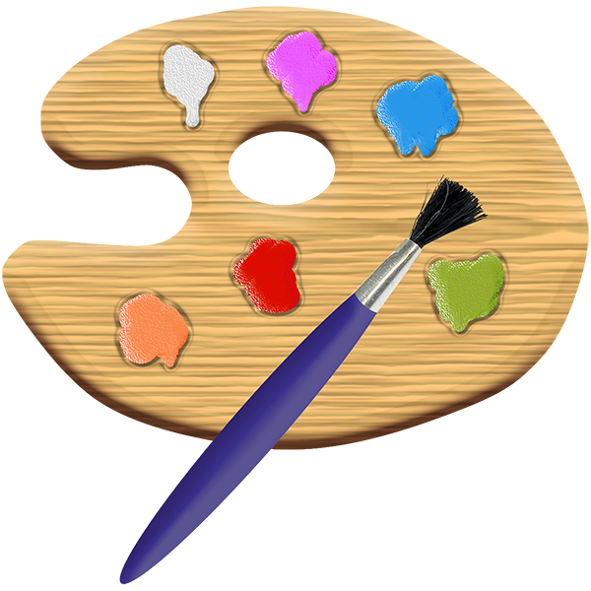
The arts and ngā toi Māori in Aotearoa New Zealand are always changing as:
people find new ways to make art
artists from different cutures come to Aotearoa New Zealand.

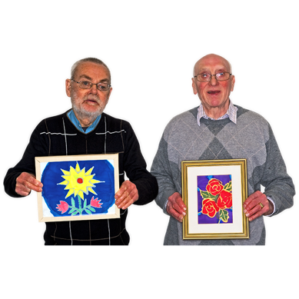
It is good for people to:
make art
see / experience art.


The arts and ngā toi Māori can:
make people feel good
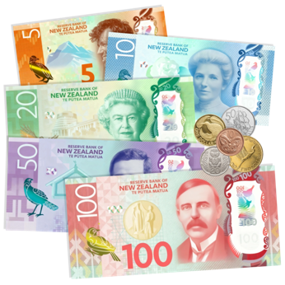
make money for:
- artists
- Aotearoa New Zealand.
The arts and ngā toi Māori can also:
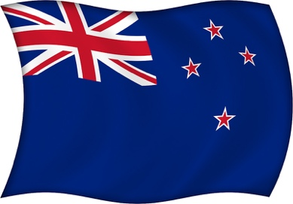
bring people / communities together
tell the world about Aotearoa New Zealand.

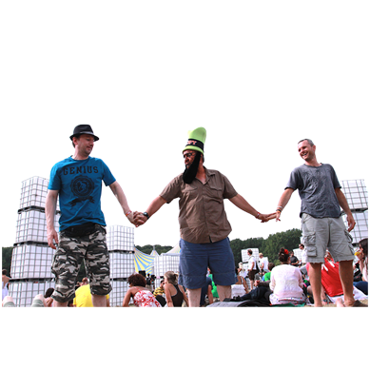
Here communities are groups of people who have something in common like:
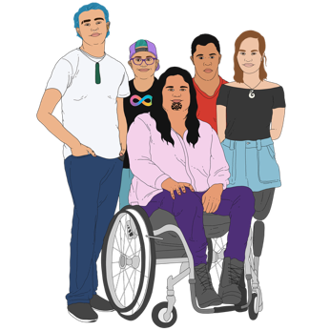
the way they make art
where they live
the culture they come from.

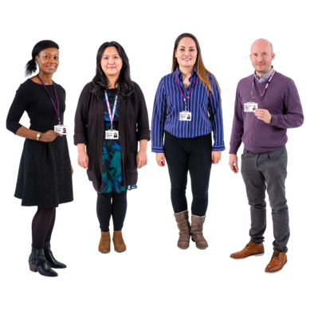
The people who work for us have a lot of different:
skills
experience.

We work with the arts community to make our:
plans
decisions.

Here the arts community is everyone who works to:
make art
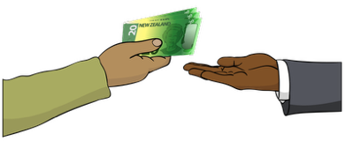
show art
sell art.

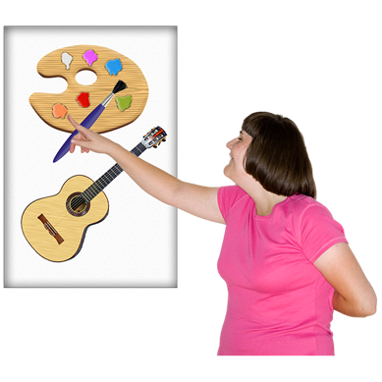
We want to make sure the artists we work with can choose how they:
make art
live their lives.

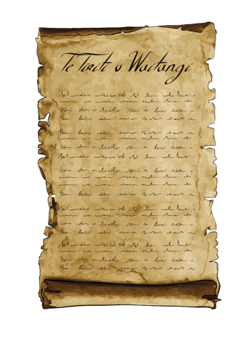
We believe Te Tiriti o Waitangi / the Treaty of Waitangi is very important for everyone who lives in Aotearoa
New Zealand including:
tangata whenua / Māori
tangata tiriti / everyone else.

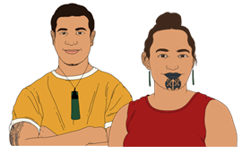
Te Tiriti o Waitangi / the Treaty of Waitangi is an important agreement between Māori and the Crown.

It is about Māori and the
New Zealand Government
making decisions together.

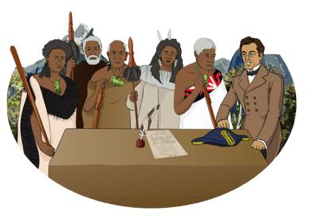
Te Tiriti o Waitangi guides how we:
work
make decisions.

Since 1994 we have spent over
1 and a half billion dollars on supporting the arts in Aotearoa New Zealand.

About 3 quarters of our money comes from the New Zealand Lottery Grants Board Te Puna Tahua.

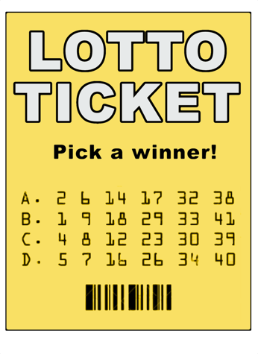
The New Zealand Lottery Grants Board Te Puna Tahua supports communities with money from things like:
Lotto
Instant Kiwi.

About 1 quarter of our money comes from the government.

Our values


Here values are ideas that:
we think are important

tell us:
- what is right / wrong
- how to behave.


Our values tell us how to work with:
each other
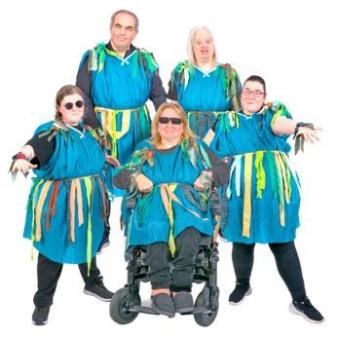
the arts community
everyone.


Āwhinatia – strengthen and support

We are:
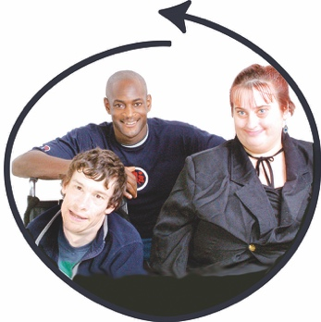
supportive
inclusive.

Inclusive means everyone can:
take part
feel like they belong.
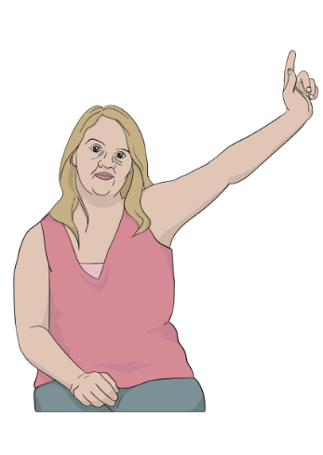

We are accountable for the things we do.


Being accountable means doing things in a responsible way like:

doing what we promise
fixing problems as soon as possible.
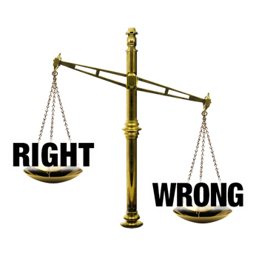

We will always try to do the right thing.

Honotia – connect and grow

We work together with:
each other
the arts community.


We treat everyone with respect.

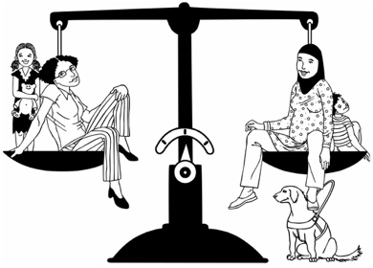
Here respect means treating people:
fairly
like they are important.



Māiatia – have courage and confidence


We are proud of the work we do.

We always work to do our best.

We believe good things will happen.

Our vision

Our vision is:
The arts and ngā toi Māori are flourishing: created by a thriving arts community, enriching lives here and around the world.

This means we want to make Aotearoa New Zealand a place where there is a lot of:
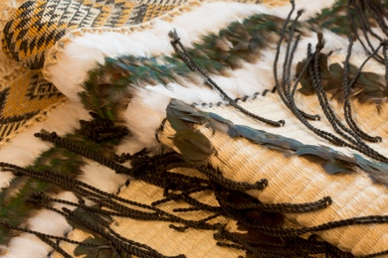
art
ngā toi Māori.

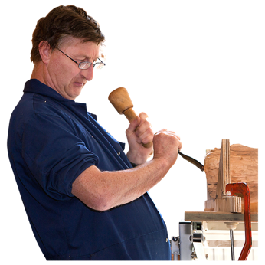
We want artists / everyone in the arts community to be able to:

make the best art they can
live good lives.

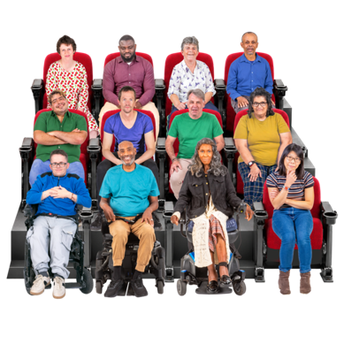
We want art to make life better for people:
in Aotearoa New Zealand
around the world.

Our goals

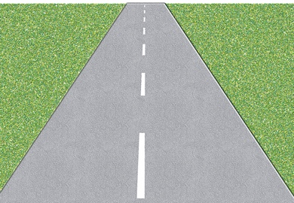
We sometimes call the things in the strategy te haerenga / our journey.

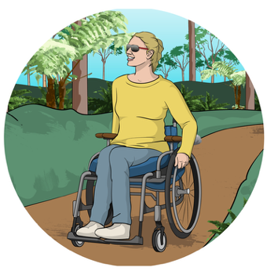
Journey means travelling from
1 place to another.

Our journey is how we move from:

the way things are now
to
how things could be in 2040.

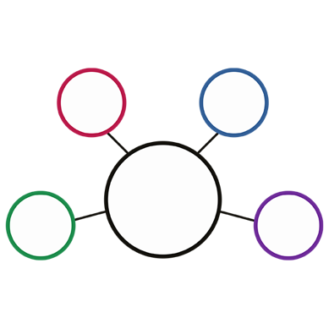
Our goals all link together.

Work on each goal will support work on the other goals.

Each goal has priorities.

Here priorities are the things we think:

are most important
need to be done first.


Goal 1

Communities can make their own decisions about the arts / ngā toi Māori.


A priority for this goal is to support communities to make their own decisions about the arts and ngā toi Māori.


Another priority for this goal is to make better ways for communities to be in charge of decisions about the arts / ngā toi Māori.

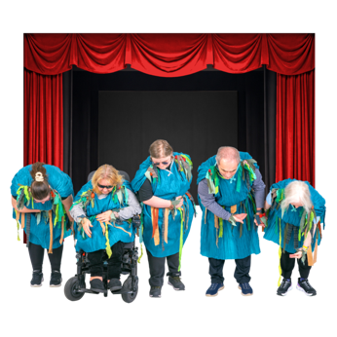
Goal 2

People are supported to have good careers in the arts.
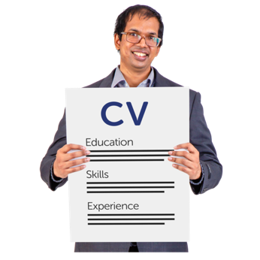

A career means all the jobs / work someone does in their lifetime.

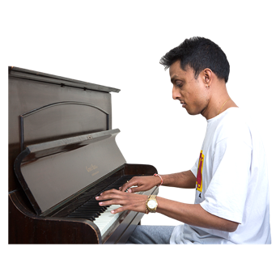
Careers in the arts include:
making art
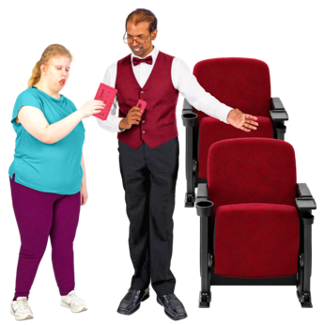
supporting artists
showing art to people like running a theatre.

The priorities for this goal are to:
work with the government to give more support to the arts
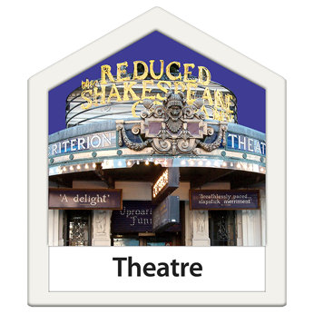
build relationships with iwi / hapū to better support Māori artists
support businesses that let people earn money from their art
find more organisations that will give money to support the arts
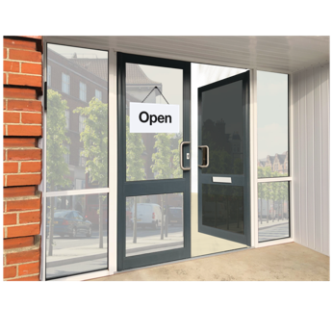
find new places for artists to sell their work:
- in Aotearoa New Zealand
- around the world.

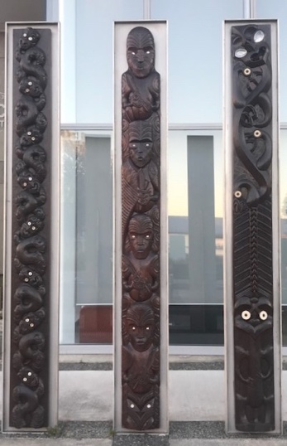
Goal 3

Ngā toi Māori / Māori arts will be:
in a lot of places
treated as something very important to Aotearoa
New Zealand
enjoyed by people all around the world.


A priority for this goal is to make sure Māori have fair support in the arts / ngā toi Māori.

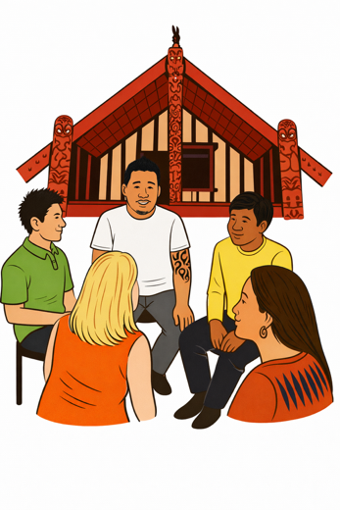
Other priorities for this goal are to:
build good relationships with Māori including:

- tangata whenua / Māori communities
- Māori-led arts organisations
- ringatoi / Māori artists
take care of ngā toi Māori so they can be taonga for a long time
make better ways for ngā toi Māori to do well:
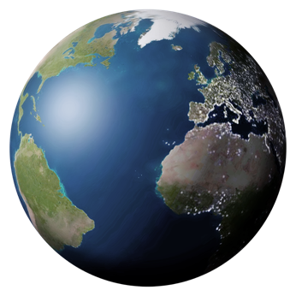
- in Aotearoa New Zealand
- around the world.

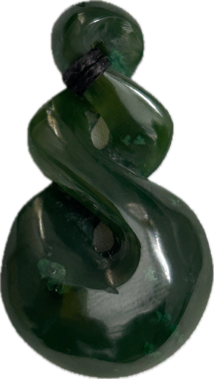
Here a taonga is:
a treasure
something that means a lot to people.

Goal 4
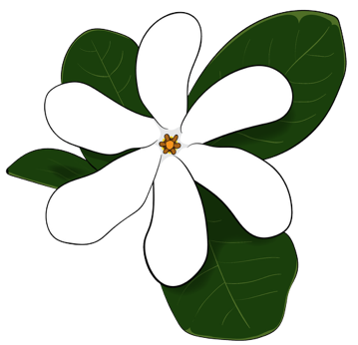
Pacific arts in Aotearoa New Zealand will be:
doing well
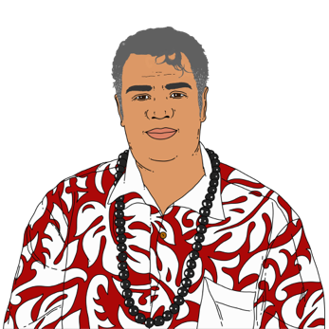
led by Pasifika people
seen in:
- Aotearoa New Zealand
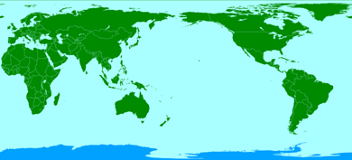
- Te Moana-nui-a-kiwa / the Pacific
- places around the world.

The priorities for this goal are to:
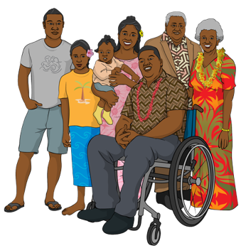
invest in Pacific arts so there can be exciting new art
support Pacific art communities to work together

find ways to make people everywhere excited about Pacific arts.

Invest means to spend:
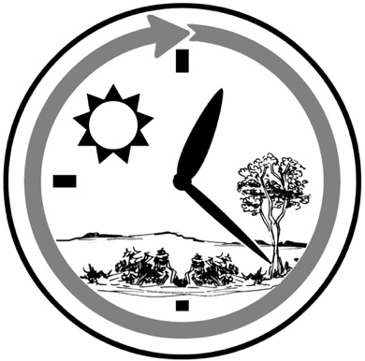
money
time
effort.

Goal 5

New Zealanders will enjoy the
arts and ngā toi Māori every day.

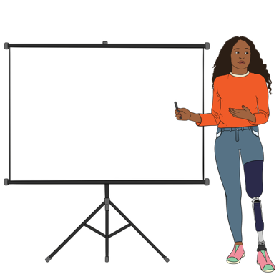
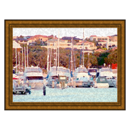
1 priority for this goal is to teach people about the arts and ngā toi Māori so they will:
understand the arts better
enjoy the arts more.


Another priority for this goal is to support arts communities to speak up for themselves

Another priority for this goal is to make it easier for people to take part in the arts by:
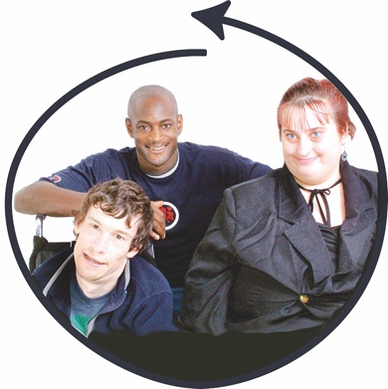
- getting rid of barriers
- making the arts more inclusive.

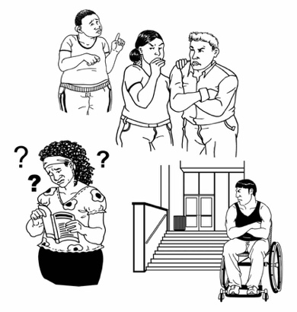
Barriers are things that make it harder for people to do the things they want / need to do.

Barriers to the arts are things like:

theatres that do not have space for wheelchairs
art classes that cost a lot of money.

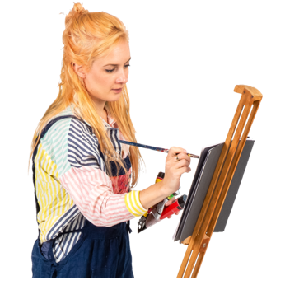
Goal 6

We are a trusted organisation that supports the arts / ngā toi Māori.
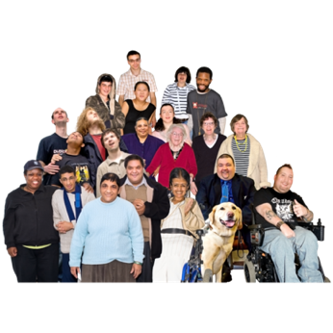

We make life better for people in Aotearoa New Zealand.

The priorities for this goal are to:
have everything we need to:
- meet our goals
- stick to our values
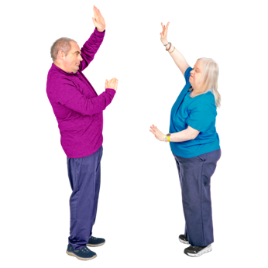
- change when we need to
work to support the arts in lots of ways.

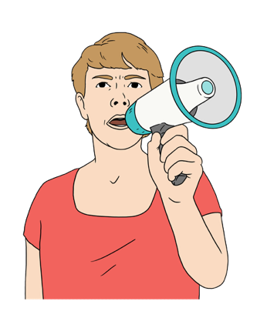
More priorities for this goal are to:
speak up to make sure:
- people understand why the arts are important
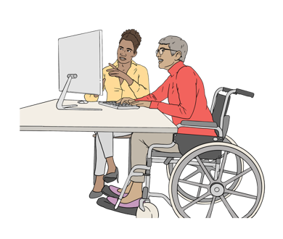
- the arts are treated well
make all the things we do accessible for people who:

- work for us
- need our support.

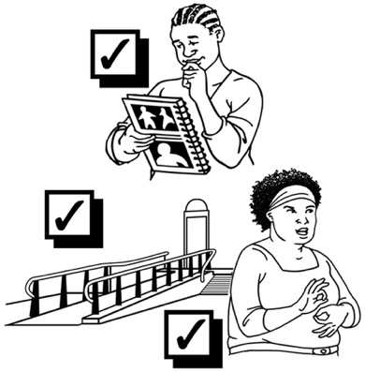
Accessible means that everyone can do the things they want / need
to do.

Our waiata

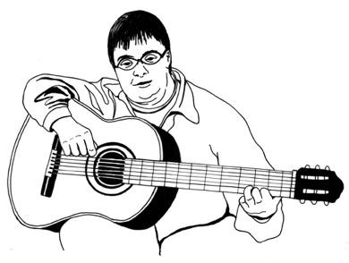
This waiata / song was written for us in 2019 by Kura Moeahu.

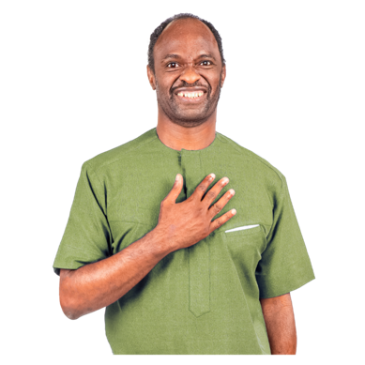
It is called Tū Mai Rā, Toi Aotearoa.

Tū Mai Rā, Toi Aotearoa means Stand Proudly, Creative New Zealand.

We have given the name of this waiata to the strategy.

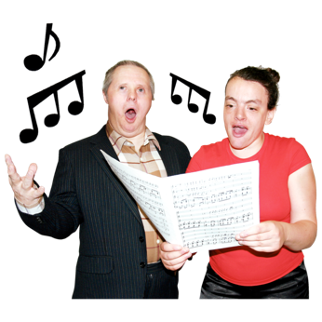
Our waiata says that as we move into the future we should:
stand strong
be proud.

It says we should:
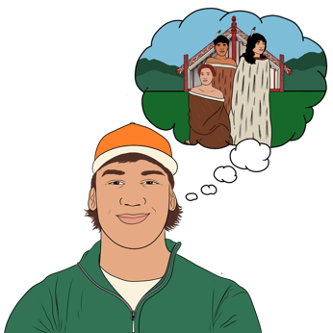
lead the way for the communities we work with
share our stories
support communities to grow.
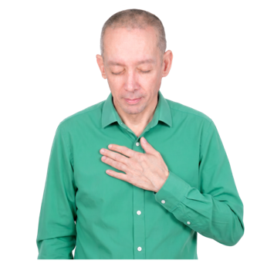

It also says we should stay:
balanced
connected to:
- people
- the land.

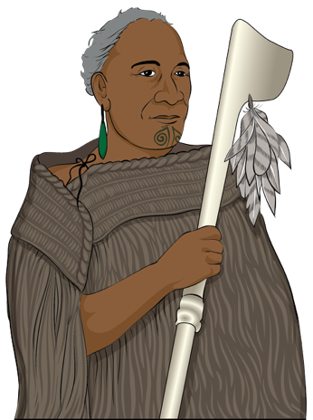
Tū Mai Rā, Toi Aotearoa

Tū mai rā, Toi Aotearoa

ki te ao hurihuri,

hahana atu,
whakaniko tōku whare kōrero.

Ko Tāne manahau

i te kete aronui,

whātoro te whanaketanga

ki te hononga tīpuna.

Uruuru ki te māiatanga

mō ngā hapori,
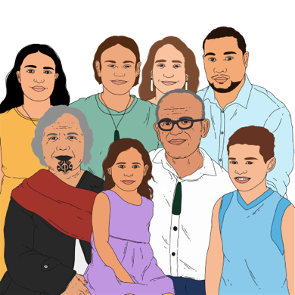
whakamaua, whakamaua kia tina

i ngā whakaritenga, te āwhina me te akina,

ki te hononga, hononga whenua.

Stand proudly, Toi Aotearoa

in this ever-changing world,

blaze the pathway,
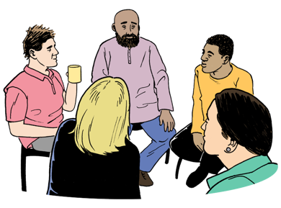
beautify my house of dialogue.

Tane the resilient
brought about responsibility,
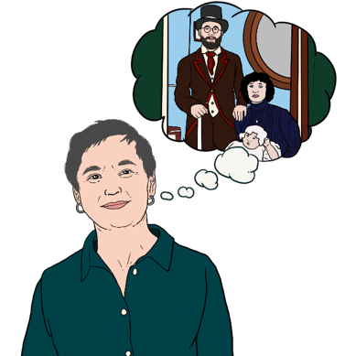
extended are the arms of development to the past.

Enter into the potential of the communities,

maintain the balance,

through support and advocacy,

keeping us anchored to Papatūānuku.

Photo credits

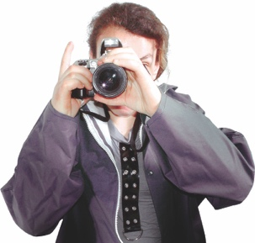
Some of the photos in this Easy Read came from Creative New Zealand.

Here is some information about those photos.

This photo is of a korowai / cloak that was woven by Diggeress Rangituatahi Te Kanawa in 1981.

This photo is of a dance called Aiga by Touch Compass.

The photo was taken at the Nelson Arts Festival in 2024 by Melissa Banks.
This photo is from an exhibition called The Chair: A story of design and making in Aotearoa held at Object Space in 2023.

The photo was taken by
Jinki Cambronero.

This photo is of an installation called Takapau, 2022 by the Mataaho Collective.

The photo was taken at the Venice Biennale exhibition by Ben Stewart.

This photo is from a dance called Yānum by the Artham Dance Company.

The photo was taken by
David St George.
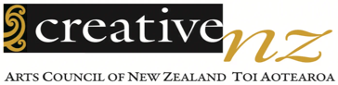
This information has been written by Creative New Zealand.

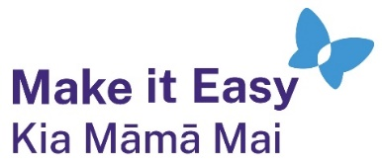
It has been translated into Easy Read by the Make it Easy Kia Māmā Mai service of People First New Zealand Ngā Tāngata Tuatahi.
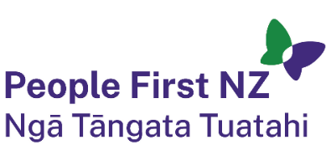
The ideas in this document are not the ideas of People First New Zealand Ngā Tāngata Tuatahi.

All images used in this Easy Read document are subject to copyright rules and cannot be used without permission.


Make it Easy uses images from:

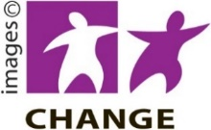
- Photosymbols

- Change Images

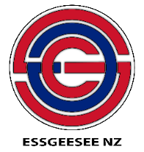
- Huriana Kopeke-Te Aho
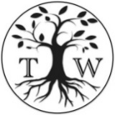
- SGC Image Works

- T Wood

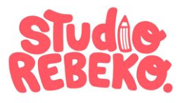
- Studio Rebeko

- Inga Kramer.

