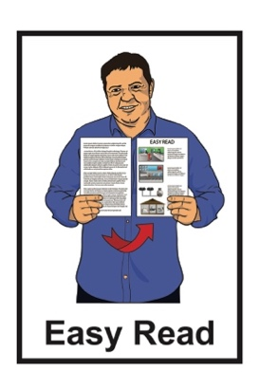
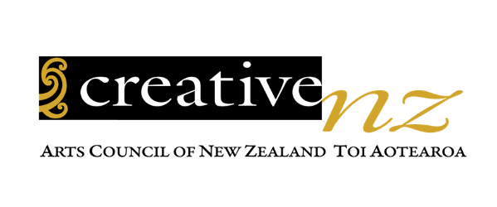

Accessibility Action Plan

2023 to 2028
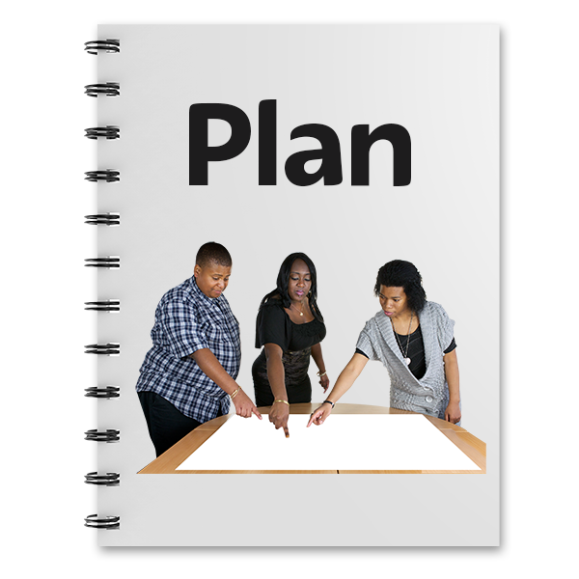

Published: March 2024

Before you start

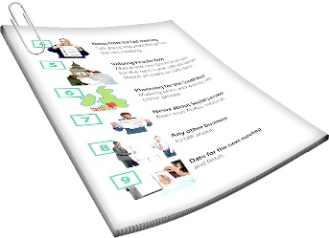
This is a long document.

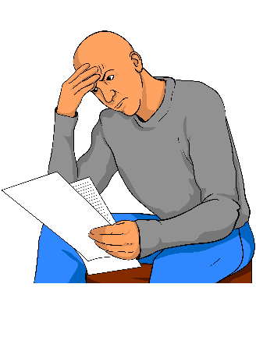
It can be hard for some people to read a document this long.

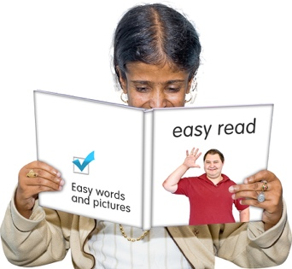
Some things you can do to make it easier are:
read it a few pages at a time
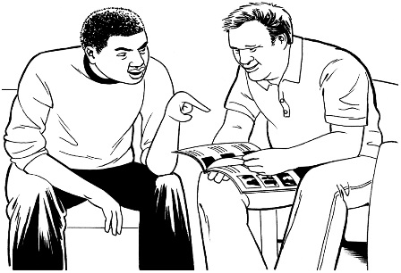
set aside some quiet time to look at it
have someone read it with you to support you to understand it.

What you will find in here

Page number:

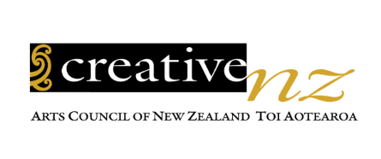
About Creative New Zealand 3
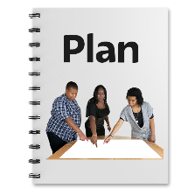

The Action Plan 6

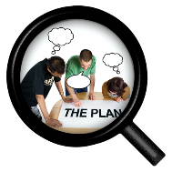
What does the
Action Plan say? 10

Where to find more information 30

About Creative New Zealand

This document was written by Creative New Zealand.

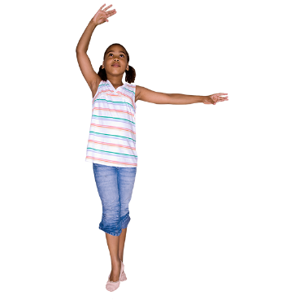
Creative New Zealand works to support the arts.

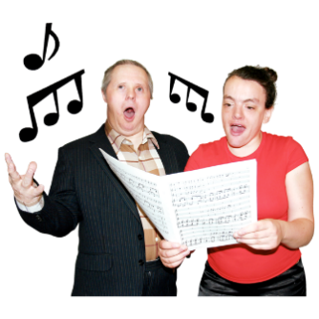
The arts means things like:
- dancing
- music / singing
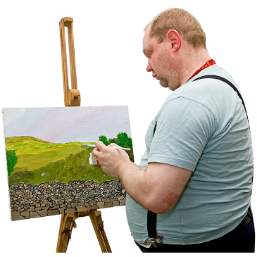
- acting

- things in museums / galleries

- painting.
The arts also means things like:
- writing
  - poems
  - stories
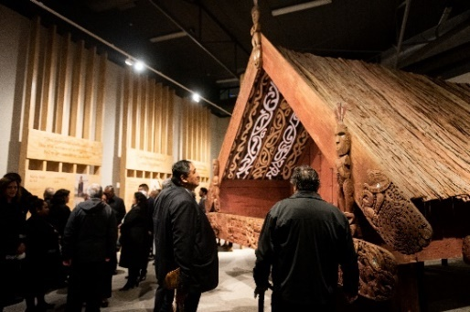
- Ngā toi Māori / Māori arts like:

  - carving

  - weaving
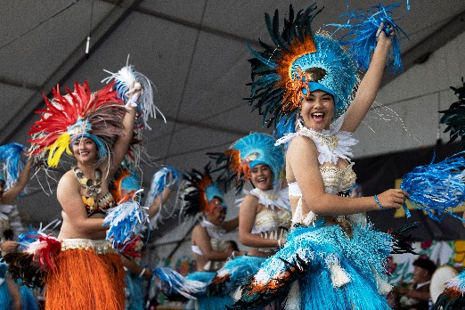
  - kapa haka

- Pacific arts like:

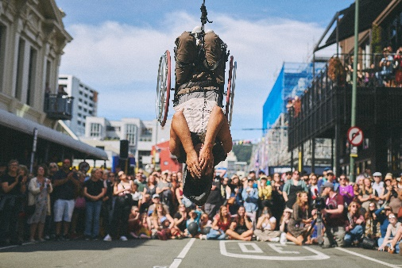
  - making tapa cloth

  - making tivaevae / quilts

- festivals.

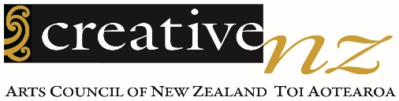
Creative New Zealand supports the arts in New Zealand with:

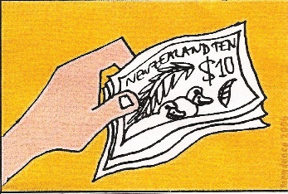
- money

- training
- research

- showing the work of New Zealand artists overseas

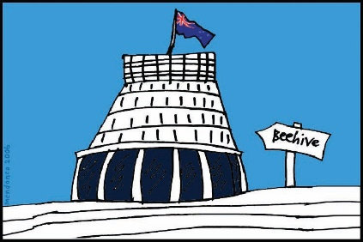
- telling the government what to do to support the arts.

In this Easy Read document when it says we / our this means Creative New Zealand.

The Action Plan

This is an Easy Read summary of the Creative New Zealand Accessibility Action Plan.

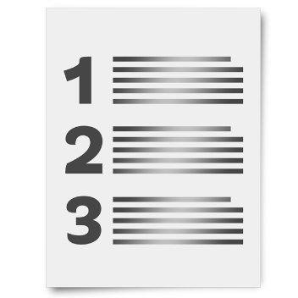
A summary:
is shorter than the full document
tells you the main ideas.

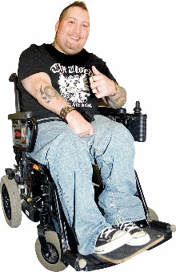
Accessibility means that disabled people can do the things they want to like:
go to meetings
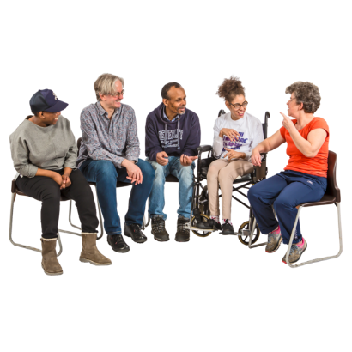
work
apply for money.
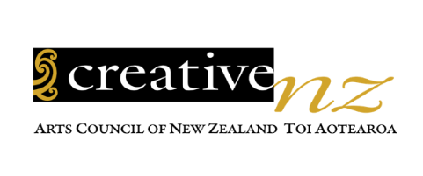
The Creative New Zealand Action Plan says what we will do to make the Accessibility Policy happen.
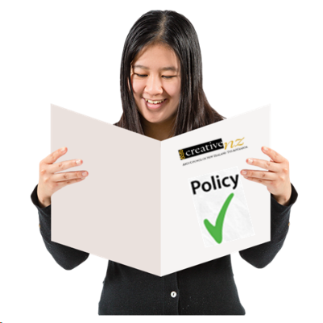

The Accessibility Policy says how we will work with disabled people.

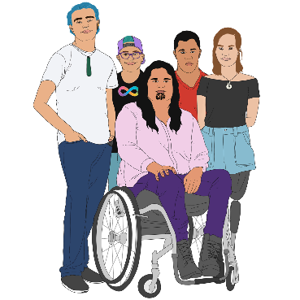
When we talk about disabled people in this document we mean everyone who is:
Turi Māori / Deaf Māori
tāngata whaikaha Māori / disabled Māori
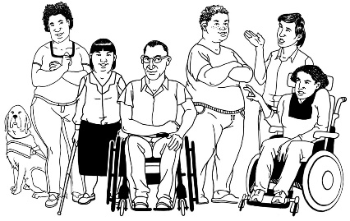
Deaf
tāngata whaikaha / disabled.

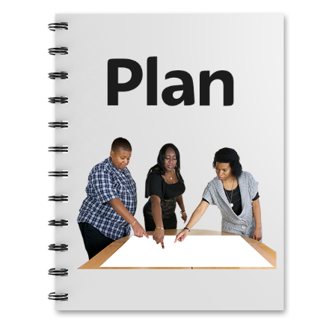
The Action Plan includes:
work we are already doing
new work we are planning to do.

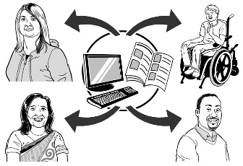
The Action Plan uses information from disabled people about:
things they want us to do
things they want us to change.

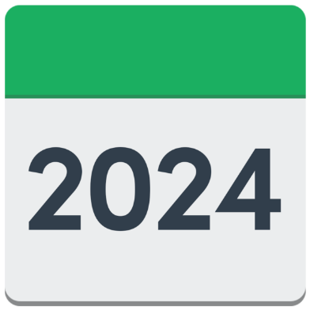
Our Action Plan says that some changes will happen:
this year
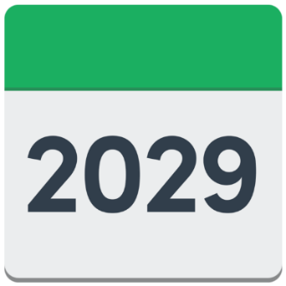
in the next 5 years
after 5 years.

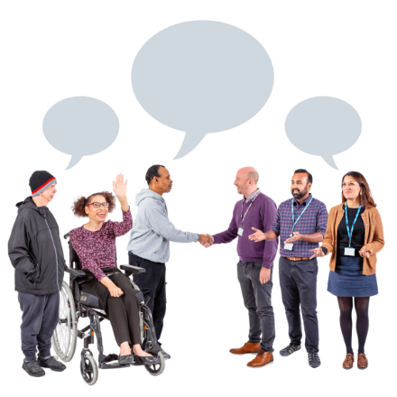
Our staff will make the changes together with:
Deaf people
disabled people
disability organisations.

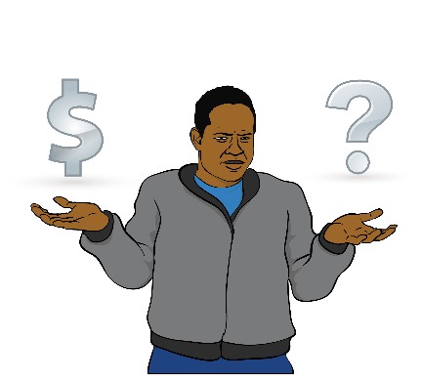
Some changes might cost more money so we will ask for funding if we need to.

What does the Action Plan say?

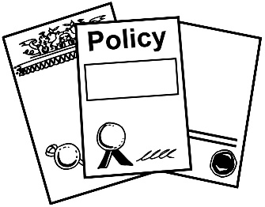
The Accessibility Policy has 4 policy principles.

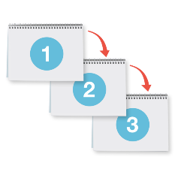
Policy principles are the ideas that guide our work.

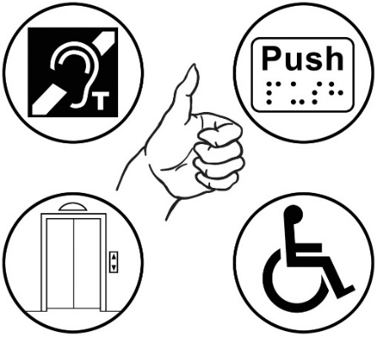
The Action Plan says how we will make the policy principles happen with:
7 main actions
23 smaller actions.

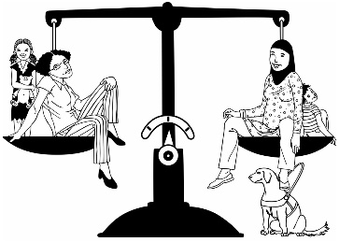
Policy principle 1:
Mana Tautika – Equity

Equity means treating everyone fairly.
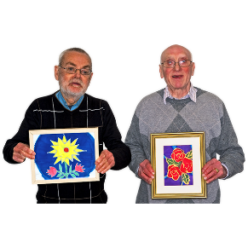

Action 1: Disabled artists can get the support they need

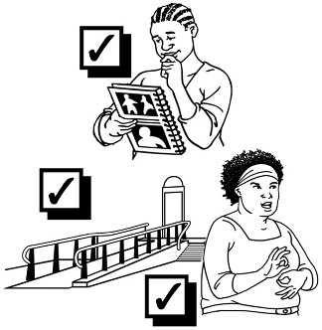
We will use our money to make sure all our services are accessible so that disabled people can use them.

When we fund / give money to disabled artists we will also pay for access costs like:
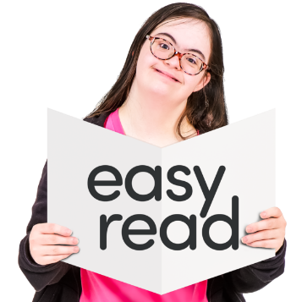
New Zealand Sign Language interpreters
alternate formats like:
  - Easy Read
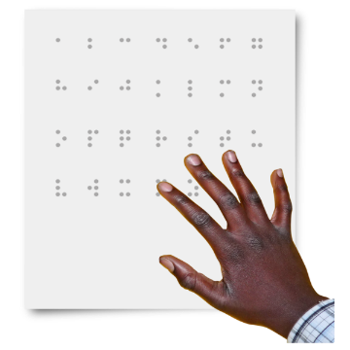
  - large print
  - Braille
  - audio
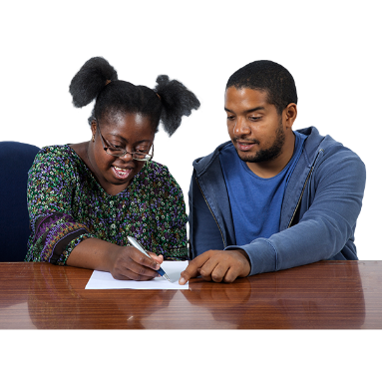
support people.

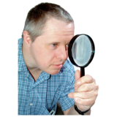
Disabled artists can ask for this support when they are:
finding out how to make their artwork
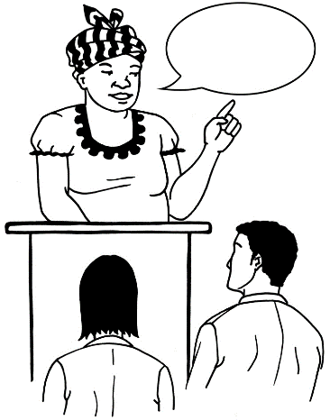
making their artwork
showing their artwork
talking to communities.

Action 2: Our services will be accessible to everyone

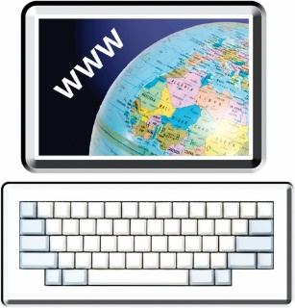
Disabled people can use our computer systems like:
our website
ways of applying for money to make arts
the places we keep information.

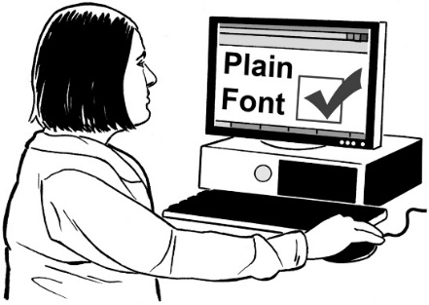
The systems must be able to be used by:
people who work for us
other people.
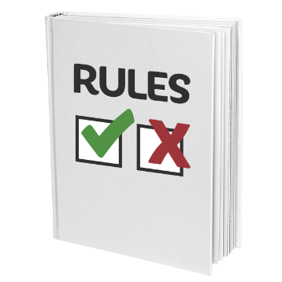
The systems must follow the rules so they can be used by people using assistive technology.

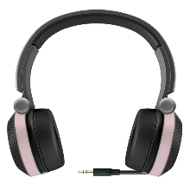
Assistive technology means things like:
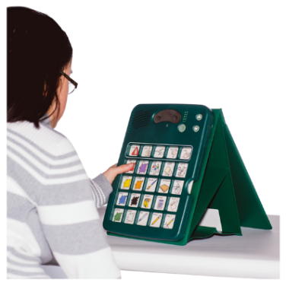
screen readers / talking computers
different kinds of keyboards
computers that you can use by talking instead of typing.
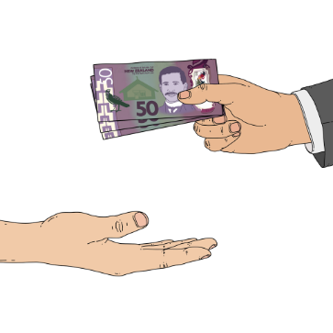

Our services must be accessible for disabled people to apply / ask for funding / money.
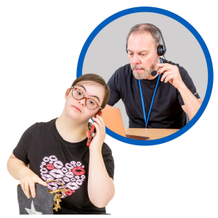

We will support disabled people who want to ask for funding / money.
We want everyone to feel included in our spaces like:
workplaces
events like meetings.

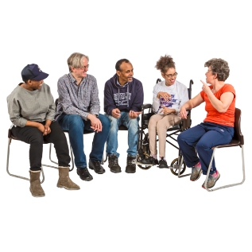
Action 3: Disabled people can talk to us in a way that is right for them

Creative New Zealand information is in:
plain language
other alternate formats.

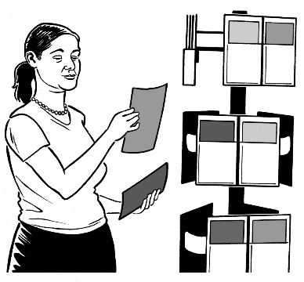
Our information includes:
who we are
what we can do
our plans
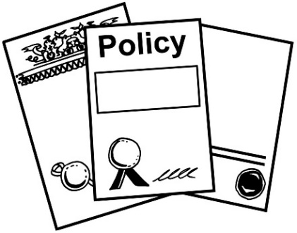
our policies / rules
research / studies that we do.

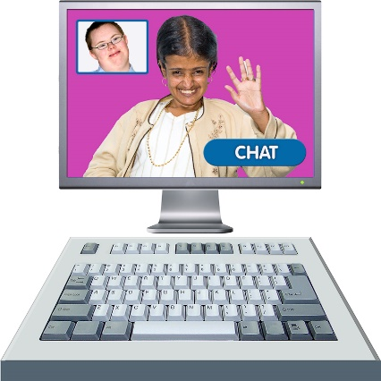
Creative New Zealand communication must work well for:
people who work for us
people who want to talk to us:
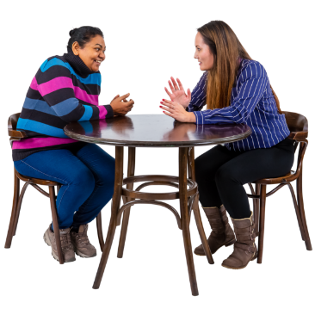
  - using the internet
  - in person.

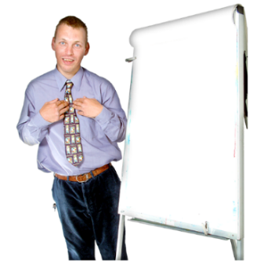
Policy principles 2 and 3

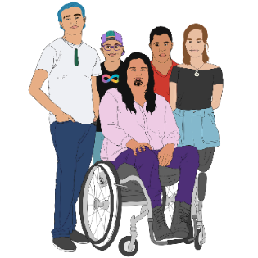
Policy principle 2: Te Mana Whaikaha Hei Kaihautū - Leadership by Deaf and disabled people
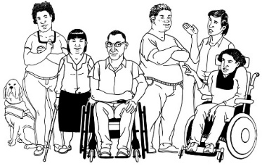
Policy principle 3: Iti Kahurangi – Value

Policy principles 2 and 3 work together using the same actions.

Action 4: Disabled artists feel part of Creative New Zealand

We make this happen by:
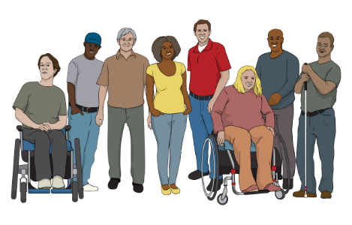
including everyone
using the right knowledge
having disabled staff.

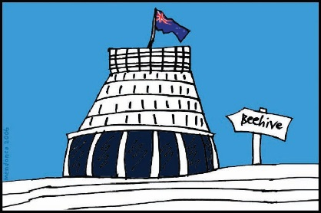
We ask that the Minister for Arts, Culture and Heritage chooses disabled arts leaders for the Arts Council.

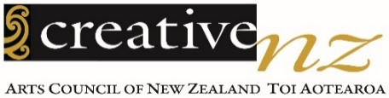
The Arts Council is the group that leads Creative New Zealand.

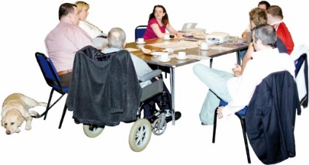
Creative New Zealand will keep working with the Manga Tipua Accessibility Advisory Group.

The Manga Tipua Accessibility Advisory Group is a group of disabled people who advise Creative New Zealand on how to do things better.

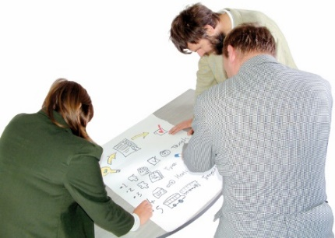
Creative New Zealand has opportunities for disabled people to:
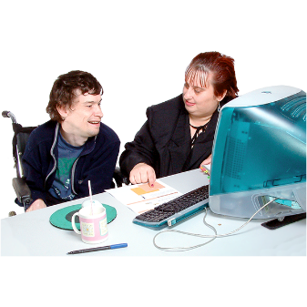
- lead our work in accessibility
- work with our staff.

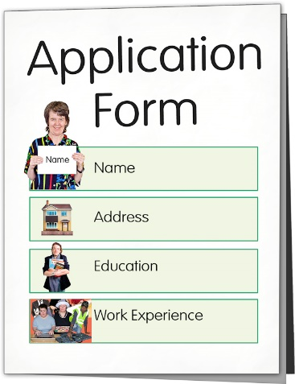
We make it easy for disabled people to work for Creative New Zealand by:
hiring disabled staff in a way that works for them
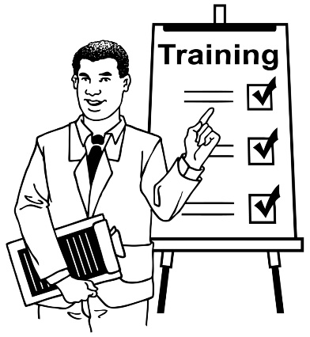
having jobs that include disabled people
welcoming disabled people in our workplaces
making sure disabled people can learn new skills with us.

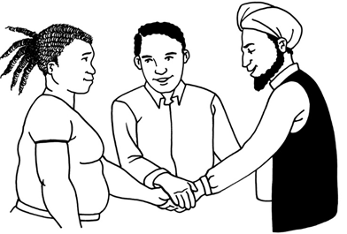
Action 5: We work together to make more opportunities for disabled artists

When we design our work we include disabled people who:
work for us as staff
are artists
are the people who make decisions about which arts to give money to.

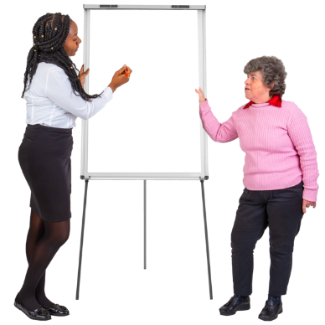
We give disabled artists:
work training
leadership training.

We work to make things fair for disabled people by working together with:
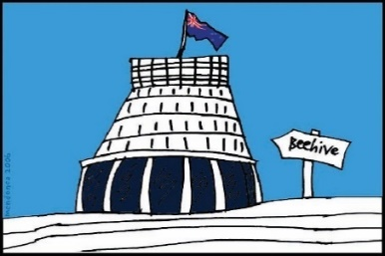
Government
other organisations.

We offer support for disabled people to:
work in arts jobs
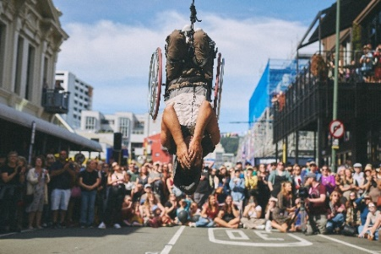
create art
learn more about how to work in arts jobs.

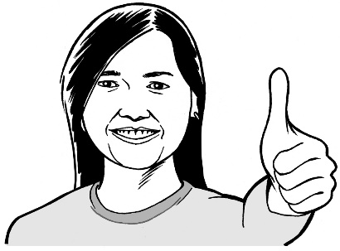
Policy principle 4:
Ngākau Pono – Integrity

Integrity means things like:
being honest
telling the truth.

Action 6: We answer to the communities we serve

We have the right skills to do the things we need to follow laws / rules like:
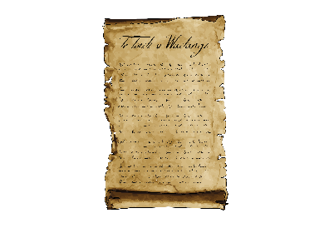
Te Tiriti o Waitangi / The Treaty of Waitangi
the Disability Convention.

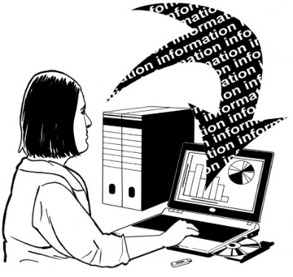
We work with disabled people to:
collect disability information
share information in a way that people can use it
look after disabled people in the way we collect information.

When we get services from other companies we let them know that the services must be accessible for disabled people.

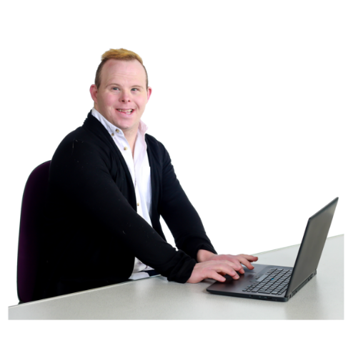
We try to buy from companies that:
have disabled staff members
have policies / plans to make things better for disabled people.

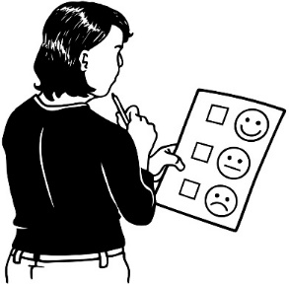
We make it easy for people to tell us what they think of our services.

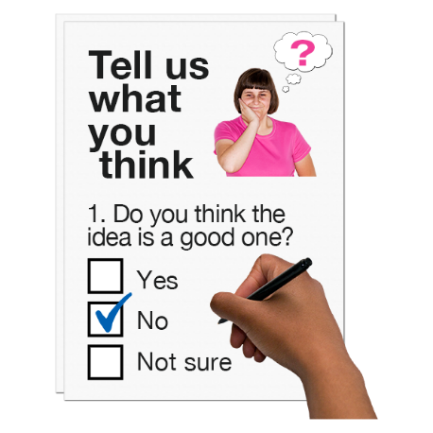
When people tell us about something they cannot access we answer in a good way to fix it.

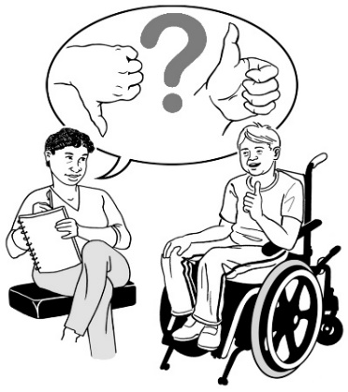
When we check if our services are working well we:
ask disabled people what they think
have questions about access.

We sign up to the Accessibility Charter so all New Zealanders can use our services.

The Accessibility Charter tells organisations that work for the Government how to make things better for disabled people.

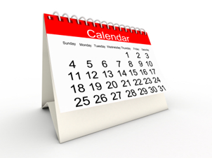
Every 3 years we will work with disabled people to check how well we are doing with the:

- Accessibility Policy

- Accessibility Action Plan.

We will write a report to say:
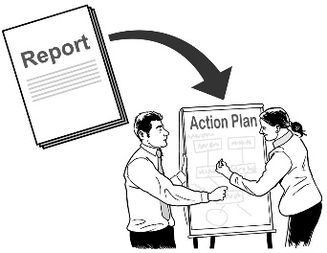
what we have done
what worked well
how we could do better.
Action 7: We make sure people can use our services

We train our staff to understand how to work with disabled people.

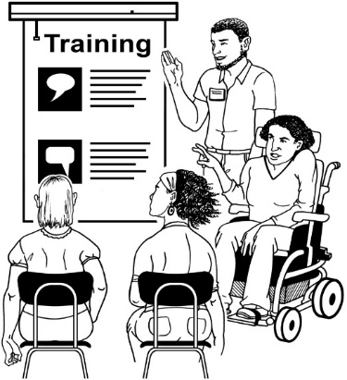
We use trainers that:

- are disabled people

- disabled people tell us are good.

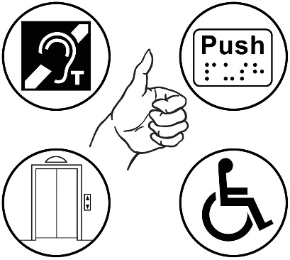
We make sure that accessibility is in everything that we do.

We want all New Zealanders to be able to use our services.

Where to find more information

You can find more information on the Creative New Zealand website at:

https://creativenz.govt.nz/

The website has both the full and Easy Read:
- Accessibility Action Plan 2023 to 2028
- Accessibility Policy 2023 to 2028.

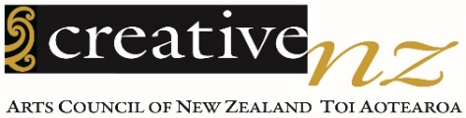
You can talk to someone at
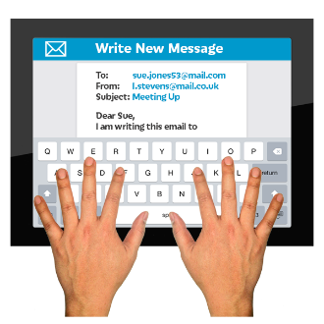
Creative New Zealand about the Accessibility Action Plan by:
- email:

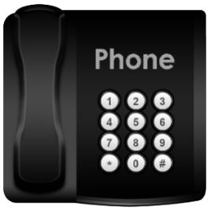
info@creativenz.govt.nz
- phone:
0800 273 284

This is a free number which means it does not cost you any money to call.

If you find it hard to use the phone the New Zealand Relay service is for people who are:

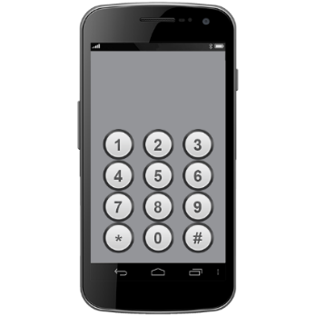
- Deaf / hard of hearing

- deafblind

- speech impaired / find it hard to talk.

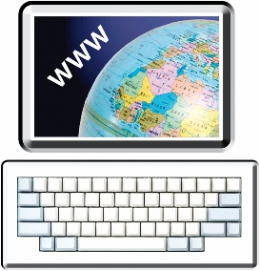
You can find out more about the New Zealand Relay service at:

www.nzrelay.co.nz

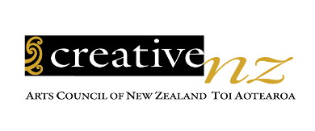
This information was written by Creative New Zealand.

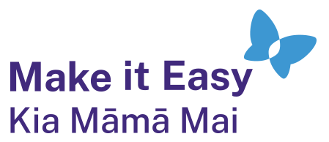
It has been translated into Easy Read by the Make it Easy Kia Māmā Mai service of People First New Zealand Ngā Tāngata Tuatahi.

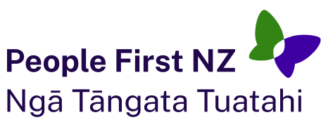
The ideas in this document are not the ideas of People First New Zealand Ngā Tāngata Tuatahi.

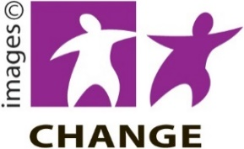
Make it Easy uses images from:

- Changepeople.org

            - Photosymbols.com

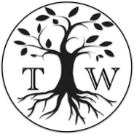
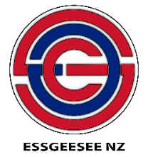
- SGC Image Works

- Huriana Kopeke-Te Aho

- T. Wood
Some images were also provided by Creative New Zealand.
All images used in this Easy Read document are subject to copyright rules and cannot be used without permission.

