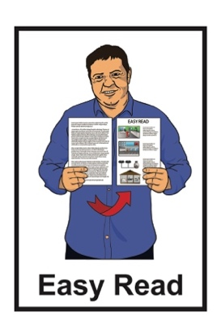
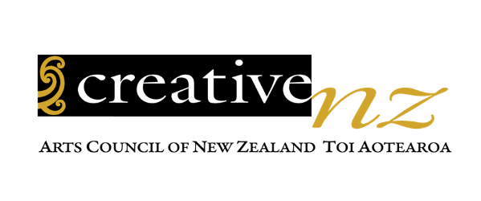

Tapatahi Accessibility Policy
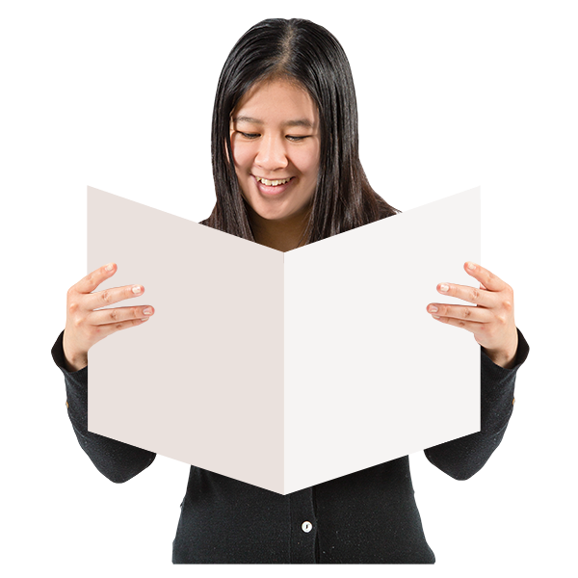
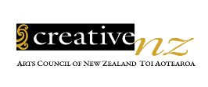

Published: March 2024

Before you start

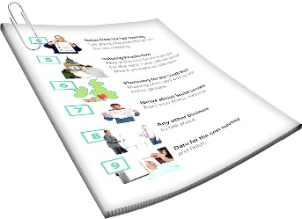
This is a long document.

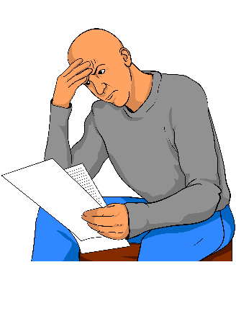
It can be hard for some people to read a document this long.

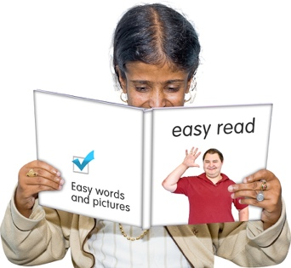
Some things you can do to make it easier are:
read it a few pages at a time
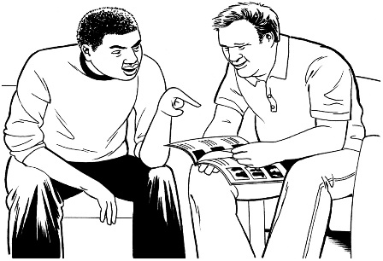
set aside some quiet time to look at it
have someone read it with you to support you to understand it.

What you will find in here

Page number:
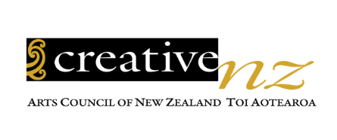

About Creative New Zealand 4
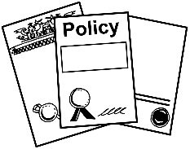

What this document is about 7

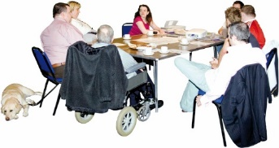
How we wrote the
Accessibility Policy 12
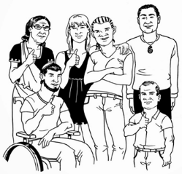

What do we mean by disability? 16

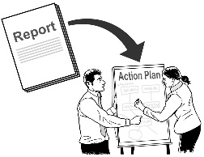
When the policy will be reviewed 19

Page number:
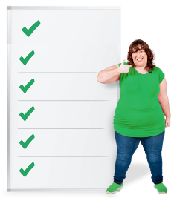

The policy principles 20

Where to find more information 33

About Creative New Zealand

This document was written by Creative New Zealand.

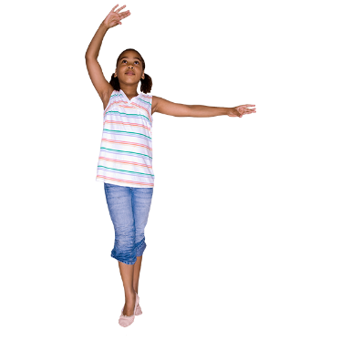
Creative New Zealand works to support the arts.

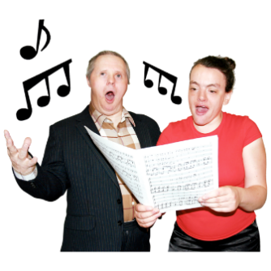
The arts means things like:
- dancing
- music / singing
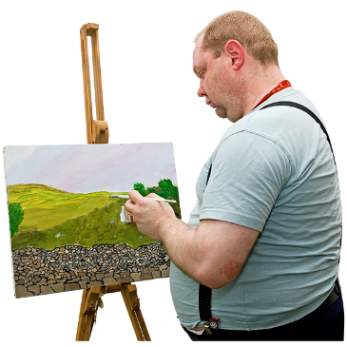
- acting

- things in museums / galleries

- painting.
The arts also means things like:
- writing
  - poems
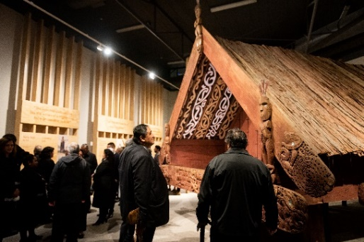
  - stories

- Ngā toi Māori / Māori arts like:

  - carving

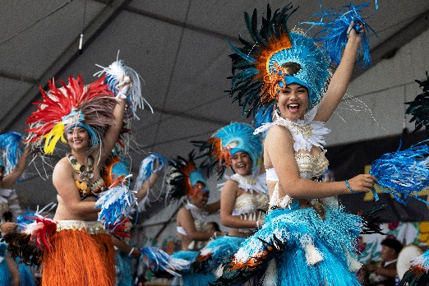
  - weaving

  - kapa haka

- Pacific arts like:

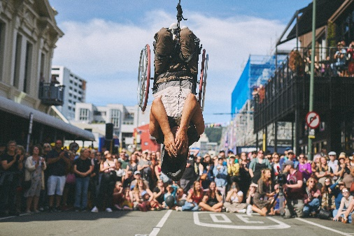
  - making tapa cloth

  - making tivaevae / quilts

- festivals.

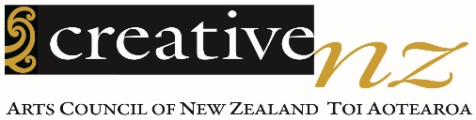
Creative New Zealand supports the arts in New Zealand with:

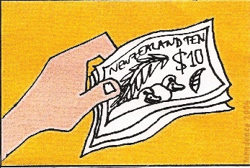
- money

- training
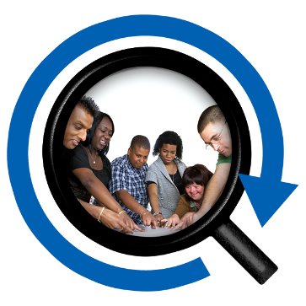
- research

- showing the work of New Zealand artists overseas
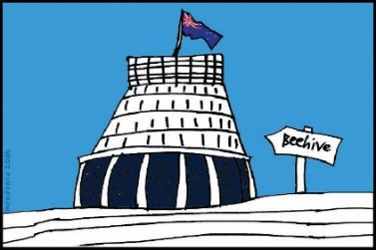
- telling the government what to do to support the arts.

In this Easy Read document when it says we / our this means Creative New Zealand.

What this document is about

This is an Easy Read summary of the Creative New Zealand Accessibility Policy 2023 to 2028.

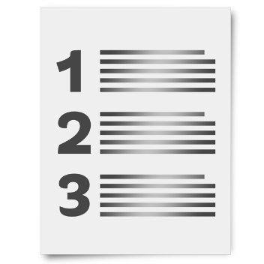
A summary:
is shorter than the full document
tells you the main ideas.

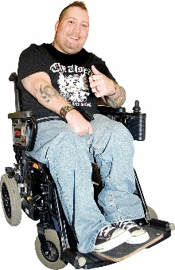
Accessibility means that disabled people can do the things they want to like:
go to meetings
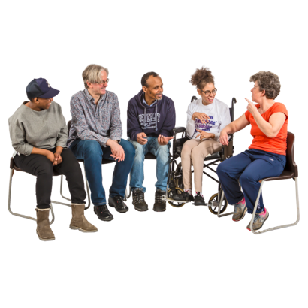
work
apply for money.
The Creative New Zealand Accessibility Policy says how we will work with all New Zealanders including disabled people.

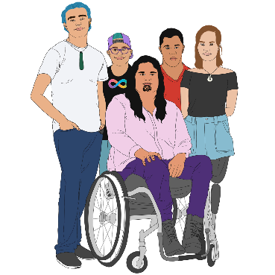
When we talk about disabled people in this document we mean everyone who is:
Turi Māori / Deaf Māori
tāngata whaikaha Māori / disabled Māori
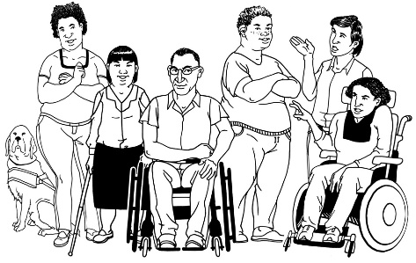
Deaf
tāngata whaikaha / disabled.

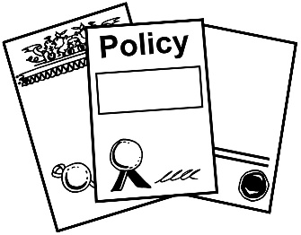
The Accessibility Policy covers 4 main areas.

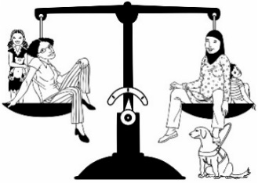
- Policy principle 1:
Mana Tautika – Equity

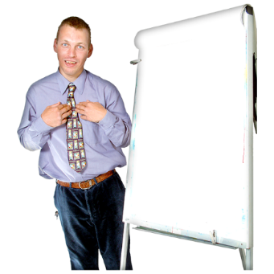
- Policy principle 2:
Te Mana Whaikaha Hei Kaihautū – Leadership by disabled people

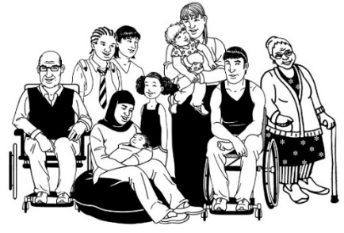
- Policy principle 3:
Iti Kahurangi – Value

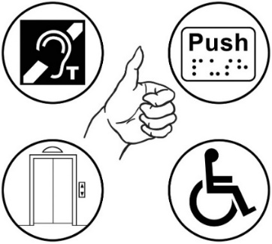
- Policy principle 4:
Ngākau Pono – Integrity

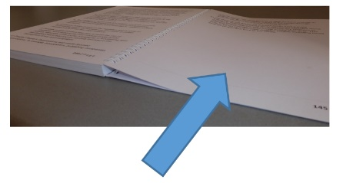
We will explain these policies on pages 20 to 32.

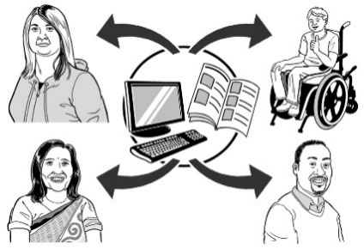
We want everyone to be able to use our:

- information
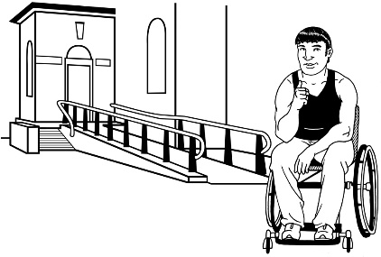
- services like funding

- spaces.

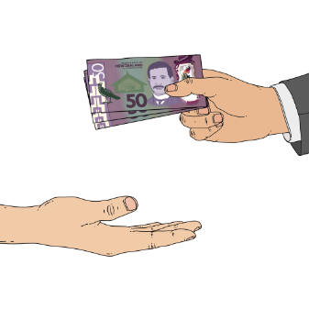

Our services should:
be fair to all people
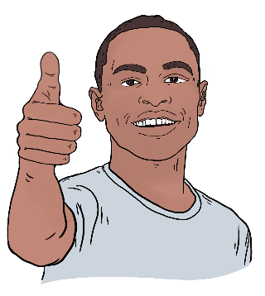
involve everyone
make everyone feel safe.

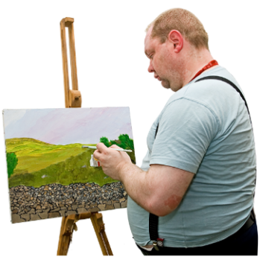
Disabled artists should be able to:
be seen
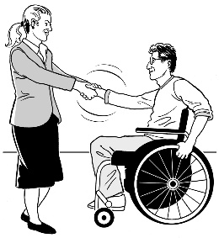
make art that people can enjoy
be treated as well as other artists.

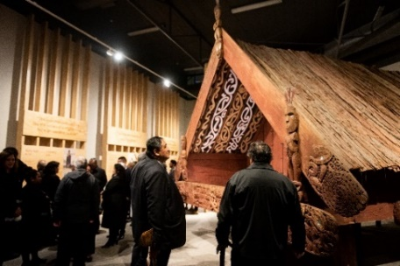
All New Zealanders should be able to enjoy the work we support in:
the arts
ngā toi Māori / Māori arts.

How we wrote the Accessibility Policy

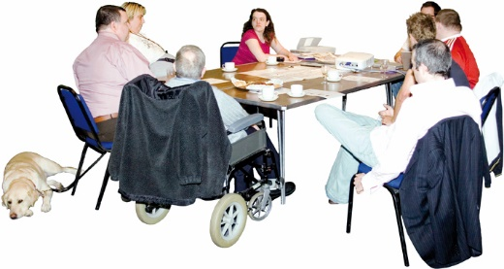
To write our accessibility policy we worked with the Creative New Zealand Manga Tipua Accessibility Reference Group.

The Creative New Zealand Manga Tipua Accessibility Reference Group was made up of people who are:
- Turi Māori / Deaf Māori
- tāngata whaikaha Māori / disabled Māori
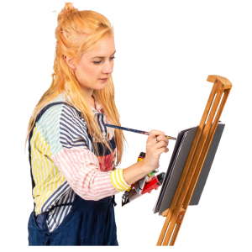
- disabled arts leaders
- disability rights leaders.

To write the policy we also talked to:
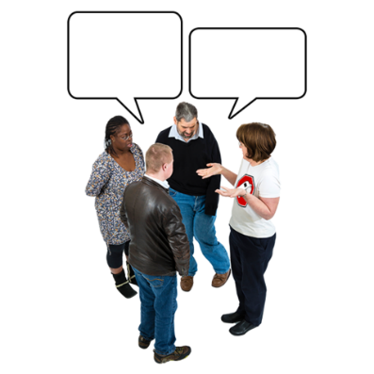
- Deaf artists
- disabled artists
- disability arts groups
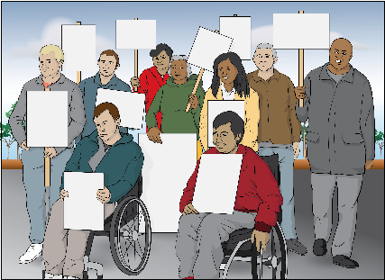
- disability rights groups
- disability advocacy organisations.

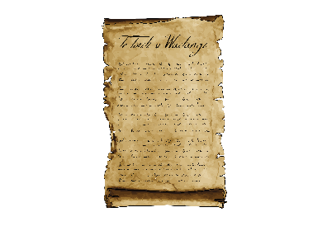
To write the policy we also followed the ideas in 4 main documents:
Te Tiriti o Waitangi / The Treaty of Waitangi
New Zealand Disability Strategy
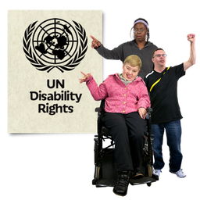
United Nations Convention on the Rights of Persons with Disabilities / UNCRPD
Arts Council of New Zealand Toi Aotearoa Act 2014.

Te Tiriti o Waitangi / The Treaty of Waitangi is an important agreement between:
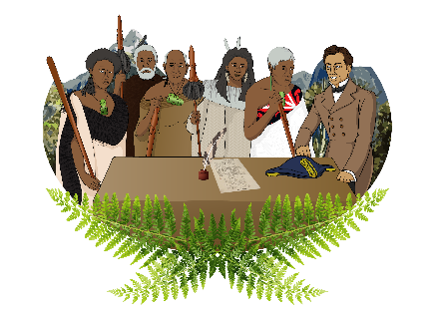
- Māori

- the British Crown.

The New Zealand Disability Strategy tells the Government how to make good decisions so that disabled people can:
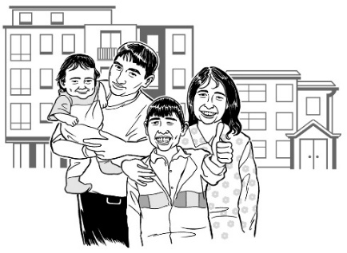
- have good lives
- get the same things as other people.
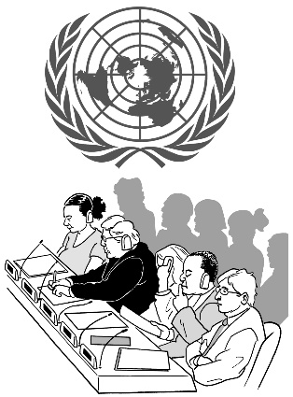

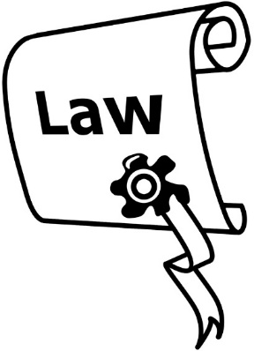
The UNCRPD is a law lots of countries have agreed to that says disabled people have the same rights as everybody else.

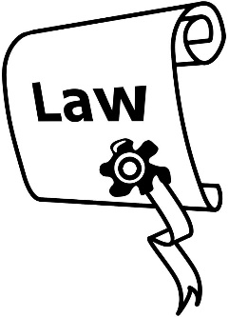
The Arts Council of New Zealand Toi Aotearoa Act 2014 is the law that says what things Creative New Zealand should do.

What do we mean by disability?

We use the meaning of disability from the United Nations Convention on the Rights of Persons with Disabilities / UNCRPD.

The UNCRPD says that disability is created by the barriers that people face like not being able to:

- get into buildings

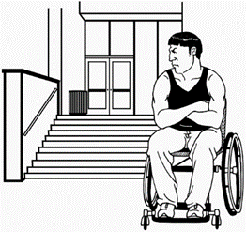
- get jobs

- have a good education.

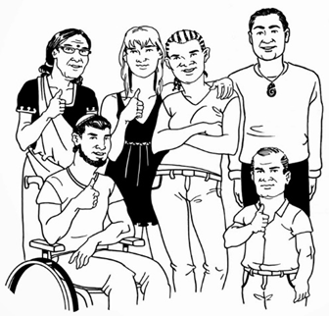
Disabled people can include people who:

- have mental health issues like depression

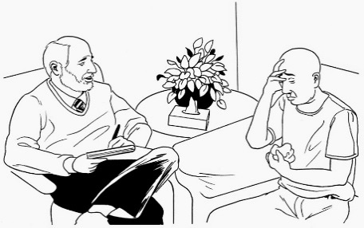
- are neurodivergent / see the world differently to other people

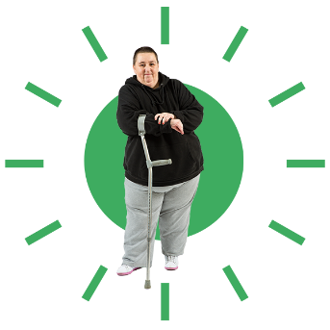
- are blind / have low vision
- have physical impairments
- are Deaf / deaf.

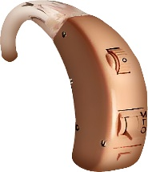
Deaf / deaf means both:
people who have hearing loss
Deaf people who use sign language.

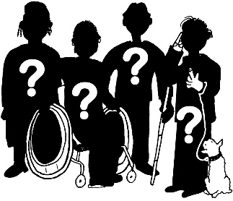
People do not need to say that they are disabled to be included.

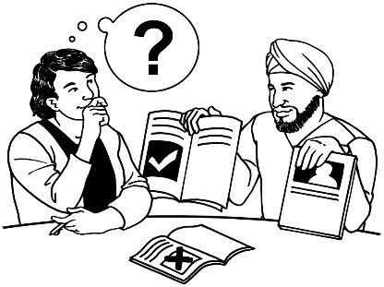
We try to use the words that disabled people choose to talk about themselves.

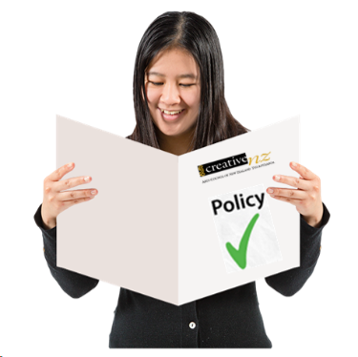
We will change our policy when ideas about disability change.

When the policy will be reviewed

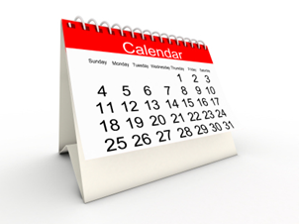
Every 3 years we will work with disabled people to check how well we are doing with the:

- Accessibility Policy 2023 to 2028
- Accessibility Action Plan 2023 to 2028.

On page 33 you can find information about where to find these 2 documents.

We will write a report to say:
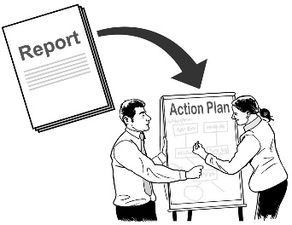
what we have done
what worked well
how we could do better.

The policy principles

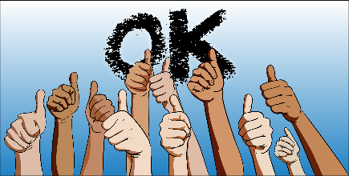
There are 4 principles / ideas to guide the way we will do our work.

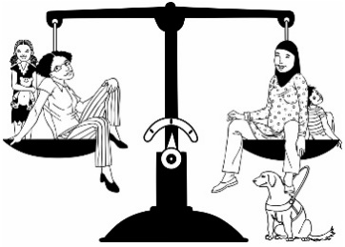
Policy principle 1:
Mana Tautika – Equity

Equity means treating everyone fairly.
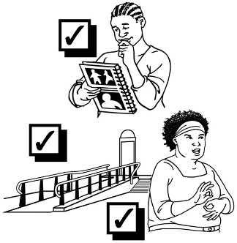

We will remove barriers so that disabled people have equal access to be involved in ngā toi / the arts.
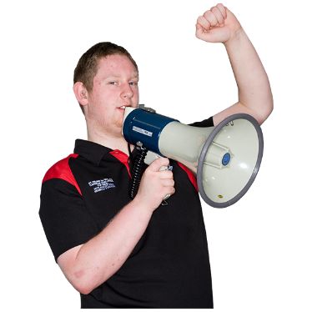

We want to stop discrimination where disabled people are treated unfairly.
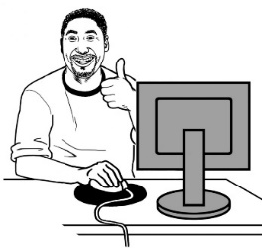
We want to make sure that all people can use our:

- services

- workplaces.

We support the idea in the New Zealand Disability Strategy of Aotearoa New Zealand being a non-disabling society.

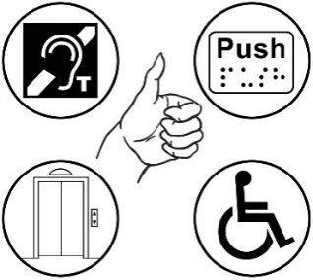
Non-disabling means that we take away barriers / the things that stop disabled people having the same chances as everyone else.

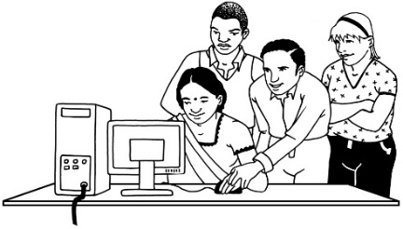
When we make choices we always listen to artists so we can:
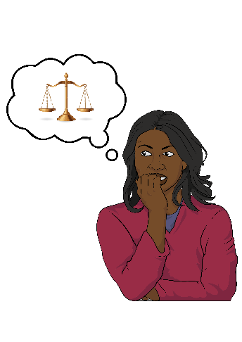
- take away barriers

- treat people fairly.

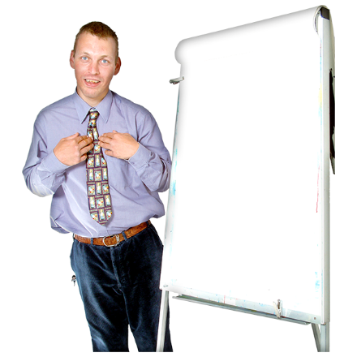
Policy principle 2:
Te Mana Whaikaha Hei Kaihautū – Leadership by disabled people

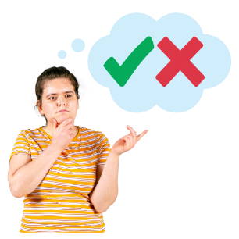
We ask disabled artists about choices that might change
things for them.

We tell people about the art of disabled people in Aotearoa New Zealand.

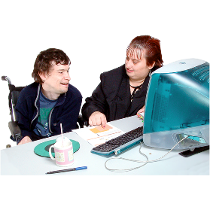
We have disabled leaders in our:
work
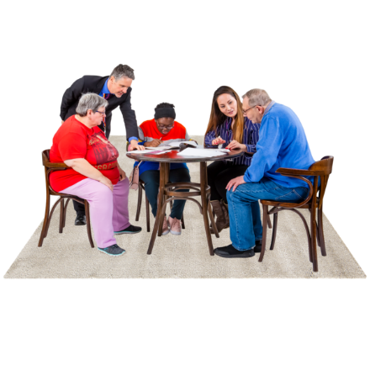
staff
governance / board.
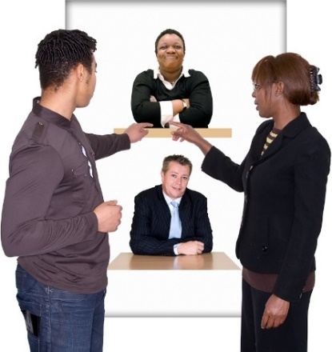
We ask disabled people what they think about how we do our work.

We support disabled artists to have rangatiratanga / make choices about their own futures.
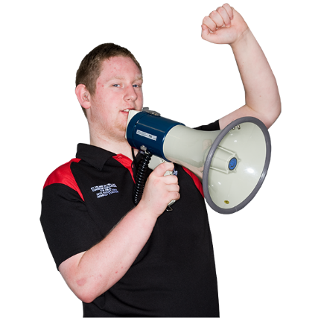

We tell people how important the work of disabled artists is to Aotearoa New Zealand.

Policy principle 3:
Iti Kahurangi – Value

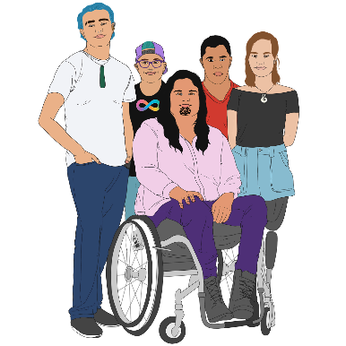
It is important to hear the lived experiences of:

- Turi Māori

- tāngata whaikaha Māori
- Deaf people

- disabled people.

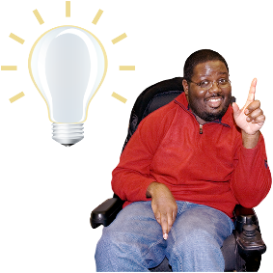
Disabled people bring different:
ideas
experiences.
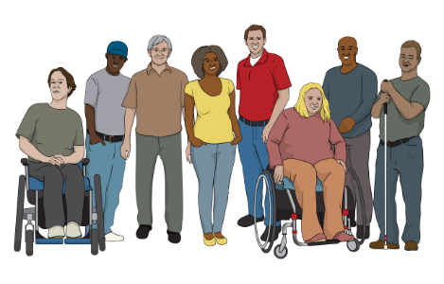

Disabled people come from all different:
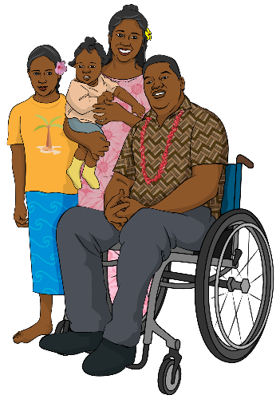
.
- countries

- whānau / families

- gender identities
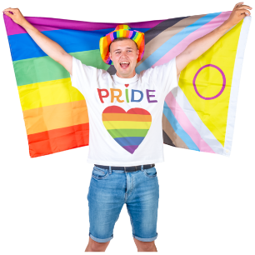
- sexual orientations

- beliefs.

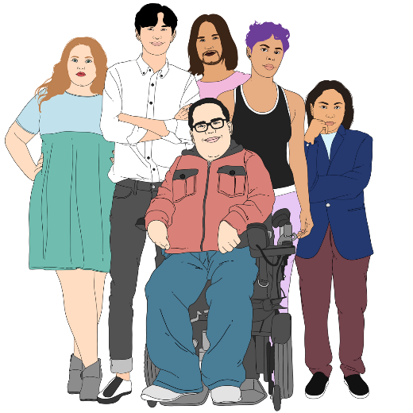
Gender identities is if you are:
- a man
- a woman
- another gender like non-binary.

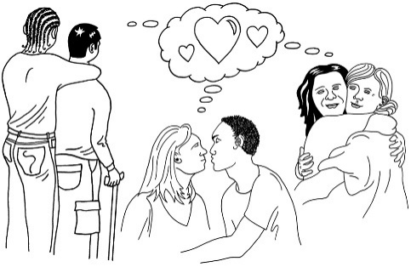
Sexual orientations can mean:
- if you are attracted to anyone
- which genders you are attracted to.

People might talk about sexual orientation with words like:
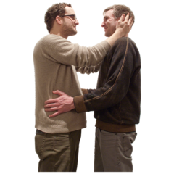
- straight / heterosexual
- gay / lesbian / homosexual
- bisexual / pansexual
- asexual.
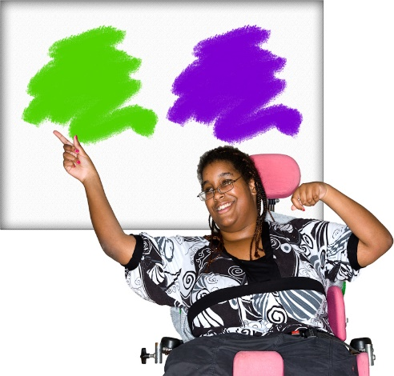
We support people being able to choose how they:
identify / talk about themselves
tell other people what is important to them.
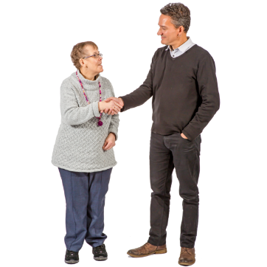

We treat all people with
manaaki / respect.

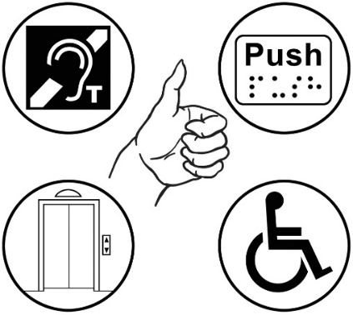
Policy principle 4:
Ngākau Pono – Integrity

We work in a way that everyone can access.

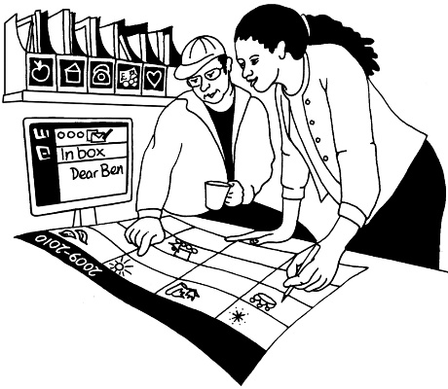
We have the right:

- skills

- ways of thinking about things.

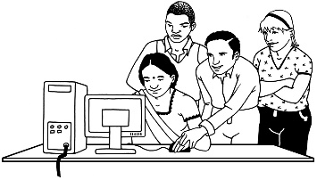
We design our services so that everyone can use them.

We will stand up against ableist:

- beliefs

- actions.
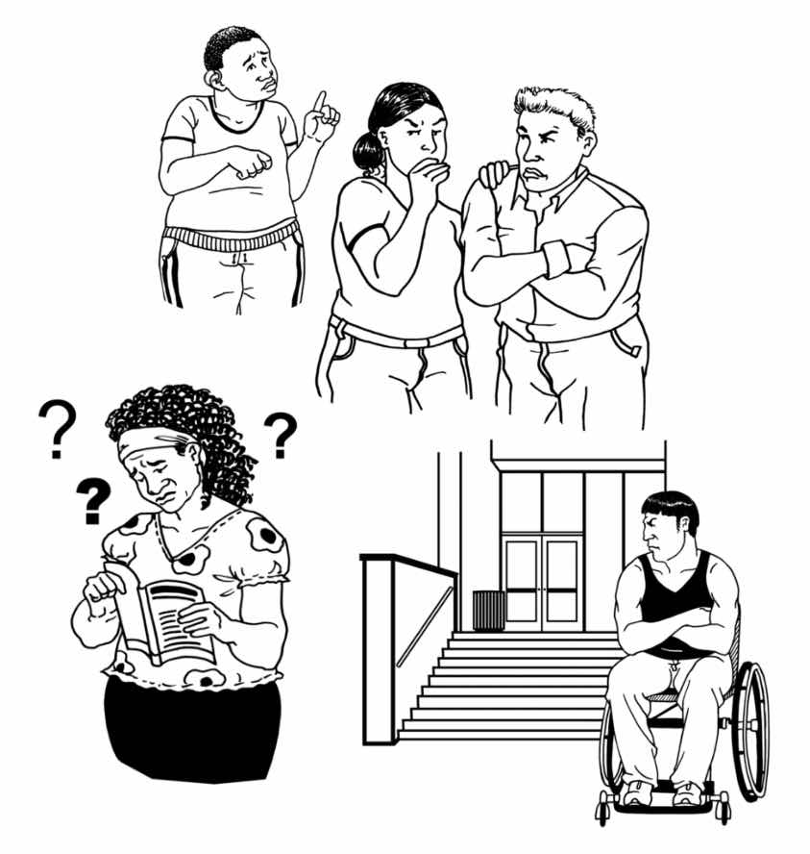
Ableist means discrimination against / being unfair to disabled people because they are disabled.

We work hard to make everyone in our workplace feel:
safe
supported.

We listen to what people tell us so that we can make things better.

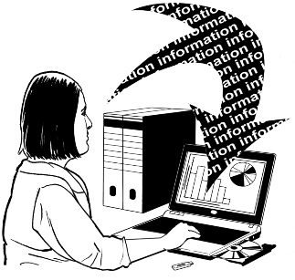
We use data / information to make decisions that:
include what disabled people think
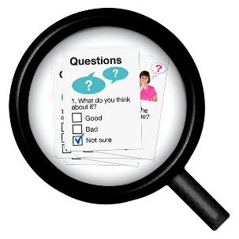
can be used by disabled people.

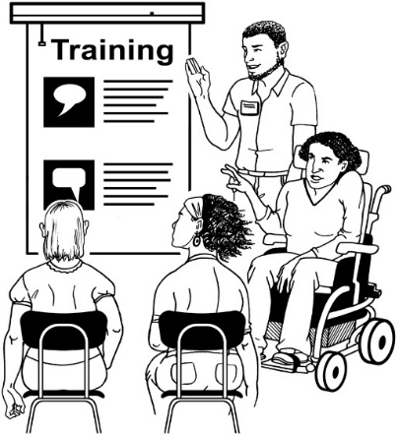
We train our staff to understand what they can do to work well with disabled people.

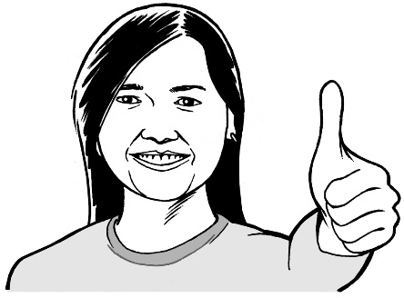
We use trainers that:
are led by disabled people
disabled people tell us are good.
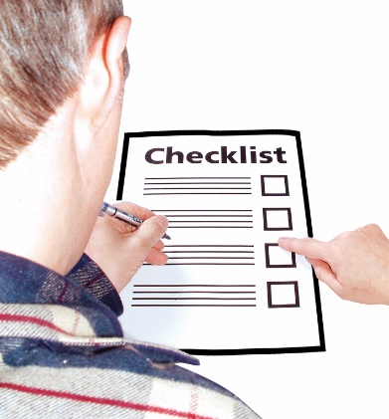

We check a lot that the services we provide meet the needs of disabled people.

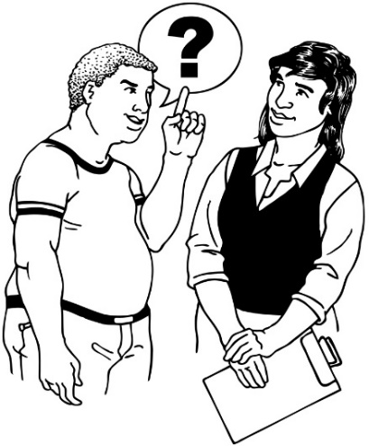
We do this by:
asking disabled people if our services meet their needs
checking that we are following the rules / laws.

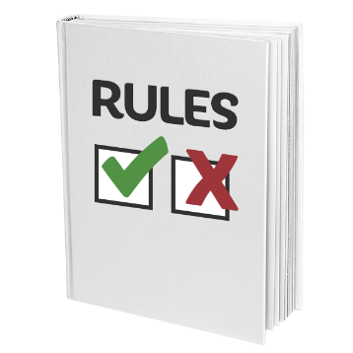
We follow rules / laws to make sure we are doing the right thing for disabled people.

You can find a list of these rules / laws in our Accessibility Action Plan 2023 to 2028.

Where to find more information

You can find more information on the Creative New Zealand website at:

https://creativenz.govt.nz/

The website has both the full and Easy Read:
Accessibility Policy 2023 to 2028
Accessibility Action Plan 2023 to 2028.

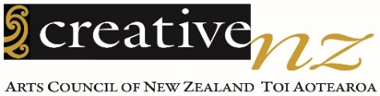
You can talk to someone at
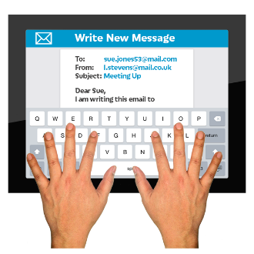
Creative New Zealand about the Accessibility Policy by:
- email:

info@creativenz.govt.nz
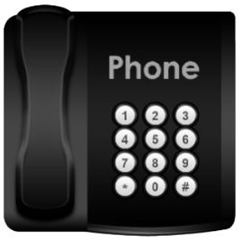
- phone:

0800 273 284

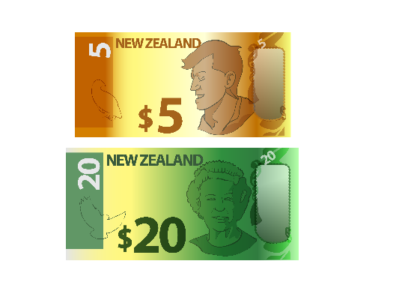
This is a free number which means it does not cost you any money to call.

If you find it hard to use the phone the New Zealand Relay service is for people who are:

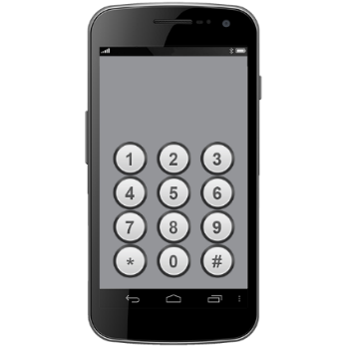
- Deaf / hard of hearing

- deafblind

- speech impaired / find it hard to talk.

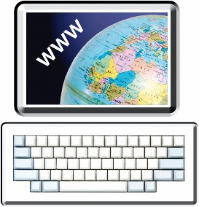
You can find out more about the New Zealand Relay service at:

www.nzrelay.co.nz

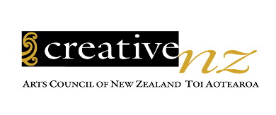
This information was written by Creative New Zealand.

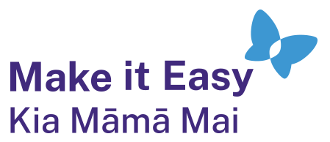
It has been translated into Easy Read by the Make it Easy Kia Māmā Mai service of People First New Zealand Ngā Tāngata Tuatahi.

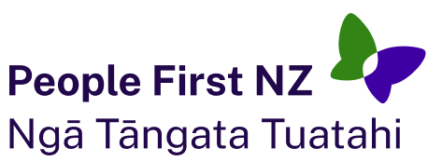
The ideas in this document are not the ideas of People First New Zealand Ngā Tāngata Tuatahi.

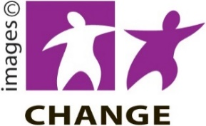
Make it Easy uses images from:

- Changepeople.org

            - Photosymbols.com

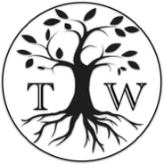
- SGC Image Works

- Huriana Kopeke-Te Aho

- T. Wood
Some images were also provided by Creative New Zealand.
All images used in this Easy Read document are subject to copyright rules and cannot be used without permission.

