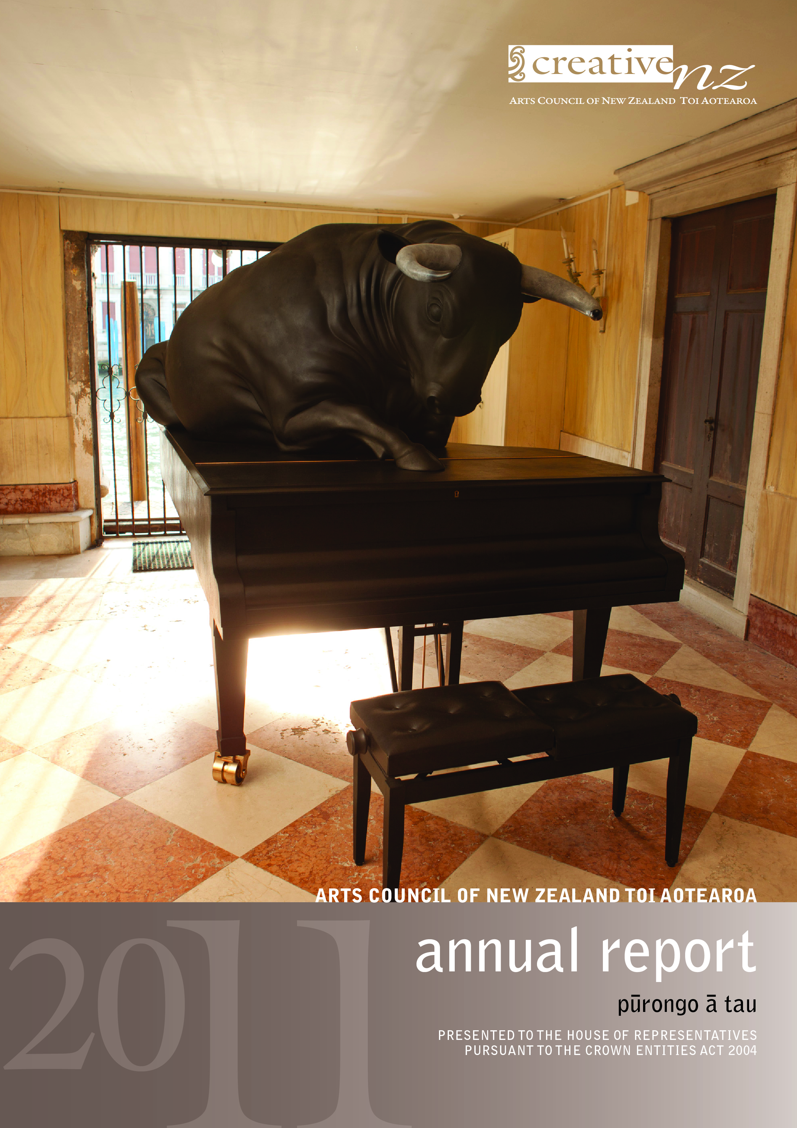

Contact us
Website: www.creativenz.govt.nz
Wellington Office
Old Public Trust Building
131–135 Lambton Quay
PO Box 3806
Wellington 6140
T: 04 473 0880
F: 04 471 2865
E: info@creativenz.govt.nz
Auckland Office
Third Floor
Southern Cross Building
Cnr High and Victoria Streets
PO Box 1425
Auckland 1140
T: 09 373 3066
F: 09 377 6795
E: northern@creativenz.govt.nz
Christchurch Office
c/- Christchurch Polytechnic Institute of Technology
City Campus
Madras Street
Christchurch
PO Box 3806
Wellington 6140
T: 03 366 2337
F: 03 366 9199
E: southern@creativenz.govt.nz

Front cover: Michael Parekowhai
A Peak in Darien (sitting bull) 2011
Bronze, stainless steel, two pieces: 2200 x 2850 x 1750mm, 520 x 1050 x 320mm
Photo credit: Michael Hall, courtesy of the artist and Michael Lett Gallery.

In accordance with section 150(3) of the Crown Entities Act 2004, this Annual Report for 2010/11 of the Arts Council of New Zealand Toi Aotearoa (trading as Creative New Zealand) is presented to the House of Representatives.

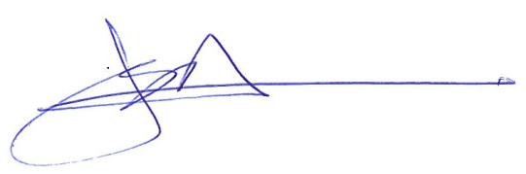
Erima Henare
Member, Arts Council
31 October 2011

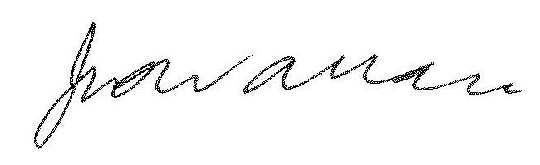

Jimmy Wallace
Member, Arts Council
31 October 2011

CONTENTS | NGĀ IHIRANGI
Our Chair and Chief Executive Review the Year | Ngā tirohanga mai tō mātou tiamana, me te tumuaki nō tenei tua 8
PART ONE: CREATIVE NEW ZEALAND’S ROLE AND OPERATING ENVIRONMENT | TE TAIAO WHAKAHAERE ME TE MAHI A TOI AOTEAROA 10
Creative New Zealand – Who We Are | Toi Aotearoa – Ko wai mātou 11
Our vision 11
Our purpose 11
What we are trying to achieve 11
What we do 12
PART TWO: THE YEAR IN REVIEW | TE TIROHANGA O TĒNEI TAU 14
Highlights and Achievements | Ngā Miramira me ngā whakatutukitanga 15
Introduction | Kupu whakataki 15
Overview 15
Financial performance 16
Where we invest 17
Funding trends 21
How those we fund perform 23
Response to the Canterbury earthquakes 24
Performance Against Strategic Outcomes | Ngā Tairitenga me ngā Whakaritenga hua o te Rautaki 26
Outcome 1: New Zealanders Participate in the Arts 27
Our stories from 2010/11 27
What we were seeking to achieve 28
What we did 28
How we performed 31
Outcome 2: High-quality New Zealand Art is Developed 35
Our stories from 2010/11 35
What we were seeking to achieve 36
What we did 36
How we performed 38
Outcome 3: New Zealanders Experience High-quality Arts 42
Our stories from 2010/11 42
What we were seeking to achieve 43
What we did 43
How we performed 45
Outcome 4: New Zealand Arts Gain International Success 50
Our stories from 2010/11 50
What we were seeking to achieve 51
What we did 51
Venice Biennale 53
How we performed 54
Managing Organisational Health | Te whakahaere i te ora o te tari 57
Best organisational culture 57
Best people 58
Best relationships 59
Best thinking and decisions 60
Best governance and management 61
Best structures and processes 62
Equal Employment Opportunities reporting 62
PART 3: ORGANISATIONAL PERFORMANCE | NGĀ WHAKATUTUKITANGA O TE TARI 65
Non-financial Performance: Statement of Service Performance | Ngā Kaupapa Utukore: Te Pūrongo Whakaritenga Ratonga 66
Revised Statement of Intent – March 2011 66
Reconciling non-financial performance to financial performance 66
Total Revenue, Income and Expenditure under Vote Arts, Culture and Heritage 67
Output 1: Funding for Artists, Arts Practitioners and Arts Organisations 69
Output 1.1: Recurrent Funding 69
Output 1.2: Contestable Funding 72
Output 1.3: Creative Communities Scheme 76
Output 1.4: International Programme Funding 79
Output 2: Capability Building for Artists, Arts Practitioners and Arts Organisations 82
Skill building 82
Audience and market development 82
Output 3: Advocacy for the Arts 85
Financial Performance | Ngā Whakaritenga Pūtea 87
Independent Auditor’s Report 87
Statement of Responsibility 90
Statement of Financial Performance 91
Statement of Comprehensive Income 92
Statement of Changes in Equity 92
Statement of Financial Position 93
Statement of Cash Flows 94
Reconciliation of the net surplus from operations with the net cash flows from operating activities 96
Statement of Commitments 97
Statement of Contingent Liabilities 99
Statement of Contingent Assets 100
Notes to the Financial Statements 101
1. Statement of accounting policies 101
2. Revenue from the Crown 110
3. Revenue from New Zealand Lottery Grants Board 111
4. Other revenue 111
5. Grant retirements and gains 111
6. Personnel expenses 112
7. Depreciation and amortisation 112
8. Council / Board / Committee fees 113
9. Other operating expenses 114
10. Funding, capability building and advocacy 114
11. Revaluation reserves 115
12. Cash and cash equivalents 116
13. Debtors and other receivables 116
14. Property, plant and equipment 116
15. Works of art 118
16. Investment property 118
17. Intangible assets 118
18. Creditors and other payables 119
19. Special purpose funds 119
20. Employee entitlements 120
21. Related parties 121
22. Financial instruments 123
23. Capital management 126
24. Significant budget variances 126
25. Events subsequent to balance date 128
PART FOUR: APPENDICES 129
Appendix 1: Creative New Zealand’s Governance Structure | Ngā tikanga whakahaere a Toi Aotearoa 130
Planned changes to our governance structure 130
Arts Council 131
Arts boards 132
Membership of the Arts Council / arts boards / Pacific Arts Committee 133
Directions from the Minister 134
Acts in breach of statute 134
Permission to act 135
Governance and management 135
Appendix 2: Changes made to the Statement of Intent 2010–13 137
Financial summary revisions 137
Output 1.1: Recurrent Funding revisions 139
Output 1.2: Contestable Funding revisions 141
Output 1.3: Creative Communities Scheme revisions 143
Output 1.4: International Funding revisions 145
Output 2: Capability building for artists, practitioners and arts organisations 147
Output 3: Advocacy for the arts 149

Our Chair and Chief Executive Review the Year | Ngā tirohanga mai tō mātou tiamana, me te tumuaki nō tenei tua
New and dynamic art has continued to stimulate New Zealanders throughout the last year. Artists have shown characteristic resilience amid difficult times.
Thanks to the ongoing support of the New Zealand Lottery Grants Board (NZLGB) and Government – through the Ministry for Culture and Heritage – we invested a record $35.7 million in grants and initiatives in 2010/11, an increase of $1 million on the previous year.
If a society is judged by the way it responds to the needs of vulnerable citizens, the Canterbury earthquakes tested us all. Those not directly affected were challenged to respond with efficiency and humanity.
As Christchurch people plan the rebuild of their shattered city, arts and culture are a central part of their discussions.
Creative New Zealand has focused on ways to keep artists in Christchurch. Thanks to Christchurch Polytechnic Institute of Technology we were able to find ‘homeless’ arts organisations a shared work space. Our Earthquake Emergency Response Fund awarded 33 grants totalling $667,532, so the sector could deliver creative experiences to the community amid heartbreak and chaos. In spite of destroyed venues, ruined materials and continuing aftershocks, the Christchurch Arts Festival went ahead, helped with an additional grant of $125,548 to ensure festival tickets cost no more than $20. Organisers were determined that a strong sense of family, community and creativity would prevail.
From the South Pacific, it can be challenging to ensure our unique perspective is seen and heard internationally. At the 54th Venice Biennale – the pre-eminent international contemporary visual arts event – Michael Parekowhai represented New Zealand with the breathtaking installation, On First Looking into Chapman’s Homer. It included an intricately carved red Steinway concert grand piano, and two bronze concert grand pianos, each supporting a bronze bull. Music from the carved Steinway entranced visitors and the exhibition adds not just to Michael Parekowhai’s career, but to New Zealand’s reputation for compelling visual arts.
The Creative Communities Scheme continues to deliver projects and activities which reflect the uniqueness and diversity of New Zealand communities. These critical projects are administered by 67 territorial authorities. The total expenditure was $2,818,742 – a similar figure to last year – but an important change saw a funding cap removed so higher grants could be allocated.
Recommendations from last year’s review of our Recurrent Funding programme led to two new multi-year funding programmes, Arts Leadership Investment (Toi Tōtara Haemata) and Arts Development Investment (Toi Uru Kahikatea). They will provide more clarity, flexibility and stability into our funding of arts organisations and artists. Toi Tōtara Haemata enabled three new organisations to receive longer term funding among 24 arts organisations confirmed into the programme. The complementary programme, Toi Uru Kahikatea, provides investment to a further 49 organisations.
We are grateful to the Ministers of the Crown, particularly Hon Christopher Finlayson and Hon Nathan Guy, and to the appointed board members, peer advisers, patrons and local authorities who invest so heavily in the arts.
In these difficult economic times some arts organisations are finding their audiences under financial pressure, and local authorities, community trusts, sponsors, and philanthropists have heavy demands on their revenues.
Some Government organisations with which Creative New Zealand has worked for many years (most recently the Ministry of Science and Innovation and the ‘Smash Palace’ project) have withdrawn their investment in the arts.
Future increases in revenue from the NZLGB are uncertain and Creative New Zealand’s overall revenue and record levels of investment may be near their peak in 2012/13.
To maintain our current high levels of investment for the next three years we are budgeting for modest operating losses and drawing on accumulated reserves and one off grants from NZLGB. Those we invest in will need to grow their revenue from philanthropy and the box office.
At Creative New Zealand we will continue to manage our costs, which have reduced as a proportion of revenue from 20.3% in 2001/02 to 17.6% in 2010/11. While insurance and depreciation costs are rising out of our control, we will improve the efficiency of the systems that drive our granting work, up-skill staff to work effectively in Māori contexts and improve our website and public access to services and information.
Legislation to streamline our structure into a single unitary board is currently before Parliament, and will deliver cost savings and greater flexibility.
Along with our core business of funding the arts, we will invest in substantial government-to-government initiatives such as the Venice Biennale, the Festival of Pacific Arts and the 2012 Frankfurt Book Fair where New Zealand will feature as Guest of Honour country.
Following a ministerial report on ways to increase philanthropy, we will advance initiatives that assist arts organisations to benefit from the positive philanthropic environment the government has established.
We also eagerly anticipate the third survey of New Zealanders in the Arts due in early 2012 and its insights into New Zealanders’ appreciation of the arts in their lives.

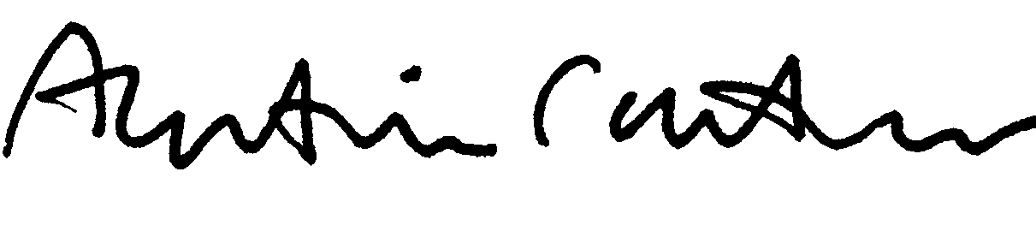
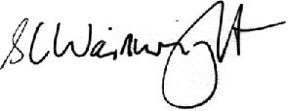

Alastair Carruthers Stephen Wainwright
Chair, Arts Council Chief Executive

PART ONE: CREATIVE NEW ZEALAND’S ROLE AND OPERATING ENVIRONMENT | TE TAIAO WHAKAHAERE ME TE MAHI A TOI AOTEAROA

Creative New Zealand – Who We Are |
Toi Aotearoa – Ko wai mātou
The Arts Council of New Zealand Toi Aotearoa (which operates under the trading name of Creative New Zealand) was established by the Arts Council of New Zealand Toi Aotearoa Act 1994. It is the national agency for the development of the arts.
The purpose of the Act is to encourage, promote and support the arts in New Zealand for the benefit of all New Zealanders.
In achieving this purpose, Creative New Zealand is required to do the following (section 5):
- recognise the cultural diversity of the people of New Zealand
- recognise in the arts the role of Māori as tāngata whenua
- recognise the arts of the Pacific Islands' peoples of New Zealand
- recognise and uphold the following principles:
- participation, by supporting initiatives that encourage participation in the arts
- access, by supporting the availability of projects of merit to communities or sections of the population that would otherwise not have access to them
- excellence and innovation, by supporting activities of artistic and cultural significance that develop the creative potential of artists and artforms
- professionalism, by maintaining and developing a professional arts infrastructure, both at national and community levels
- advocacy, by promoting New Zealand’s arts and artists locally, nationally and internationally.

Our vision
Strong and dynamic New Zealand arts, valued in Aotearoa and internationally.

Our purpose
Creative New Zealand is the national arts development agency developing, investing in and advocating for the arts.

What we are trying to achieve
We have four strategic outcomes we are seeking to achieve on behalf of all New Zealanders. These strategic outcomes and their associated performance measures are identified in our Statement of Intent 2010–13. These outcomes are listed below.
Outcome 1: New Zealanders participate in the arts
Outcome 2: High-quality New Zealand art is developed
Outcome 3: New Zealanders experience high-quality arts
Outcome 4: New Zealand arts gain international success
For each outcome, several ‘impacts’ have been identified. Impacts are descriptions of the differences Creative New Zealand is seeking to make for New Zealanders in the arts environment in New Zealand.

What we do
To achieve its purpose, Creative New Zealand provides three key services or outputs:
- funding for artists, practitioners and organisations
- capability building for artists, practitioners and organisations
- advocacy for the arts.
We monitor and compare what is achieved through each of these three services to understand where the greatest benefit is obtained. The measures of success for our outputs are detailed in the Statement of Intent 2010–13 and reported on in Part Four of this Annual Report.

FUNDING
Creative New Zealand funding supports individual professional development opportunities, as well as the creation, presentation and distribution of art, across community and professional arts.
In 2010/11, Creative New Zealand had four major funding programmes:
- Recurrent Funding
- Contestable Funding
- International Programme Funding
- Creative Communities Scheme.
Creative New Zealand’s budget for 2010/11 was just over $43 million, of which around 82 percent was distributed to the community through funding. Creative New Zealand is recognised as having expertise in running funding processes and using its knowledge and skills to make sound decisions.
In 2009/10, Creative New Zealand undertook a review of the Recurrent Funding programme. This is the last of three reviews covering the majority of our funding processes. The results of the review were released in July 2010 and were implemented over 2010/11. Two new complementary multi-year funding programmes will apply from 1 January 2012.
Further information about the review is included in Part Three of this Report (under Output 1.1 Recurrent Funding).

CAPABILITY BUILDING
In addition to funding, Creative New Zealand offers a range of services designed to help artists, arts practitioners and arts organisations to enhance their capabilities. Examples of capability building include leadership and governance workshops for the arts community and resources to help arts organisations to develop their audiences or to succeed internationally.
We are, at present, reviewing our capability-building programmes. The review is expected to be completed by the end of 2011. Any changes to the programmes offered are expected to be implemented from 1 July 2012.
The budget for capability building is nearly 3 percent of the total budget.

ADVOCACY FOR THE ARTS
Creative New Zealand’s role as an advocate for the arts and arts development is increasingly important.
Through the advocacy programme, we aim to raise awareness of the role and contribution of the arts to society, address key issues affecting the sector and change the environment for the benefit of the arts. Advocacy can also be a means to enable artists, arts practitioners and arts organisations to access resources and support from sources other than Creative New Zealand.
We advocate by carrying out research; fostering relationships and partnerships, both nationally and internationally; participating in cross-government initiatives and, where relevant, making submissions on issues facing the arts sector or Creative New Zealand.
All Creative New Zealand staff play a role in advocating for and promoting the arts; therefore, the costs of advocacy lie mostly within personnel costs. The costs for advocacy listed in this report are those of producing research and resources that are made publicly available.
Looking ahead, we seek to position ourselves as a leading voice for the arts.
PART TWO: THE YEAR IN REVIEW | TE TIROHANGA O TĒNEI TAU

Highlights and Achievements | Ngā Miramira me ngā whakatutukitanga

Introduction | Kupu whakataki
During 2010/11, Creative New Zealand invested time and resources in its four strategic outcomes. These contribute to our vision.
This report captures the key areas of focus and achievements for the year under each strategic outcome.

Overview
During 2010/11, there were:
8 contestable funding rounds completed
1,474 contestable funding applications processed
584 grants awarded through the Contestable Funding programme
493 projects satisfactorily completed
24 scholarships and residencies awarded
35 relationships with professional arts organisations (through the Recurrent Funding programme)
13 awards presented
67 partnerships with territorial authorities
1,725 grants made to support community arts activities through the Creative Communities Scheme
57 programmes designed to build skills and audience and market development capability delivered to the arts sector
20 projects funded through the International Funding programme, including a highly successful attendance at the 2011 Venice Biennale by Michael Parekowhai’s installation, On First Looking into Chapman’s Homer.

Financial performance
In 2010/11, Creative New Zealand invested $35.7 million in the arts sector through a range of grants and initiatives delivered to artists, arts practitioners and arts organisations. This compares with $34.8 million in 2009/10 and is nearly twice the level of expenditure ($18.7 million) in 2001/02.
Creative New Zealand’s direct investment in artists, arts practitioners and arts organisations in 2010/11 is around 82 percent of Creative New Zealand’s total expenditure.
The balance of our expenditure includes all personnel costs and organisational overheads. Since 2001/02, our expenditure on personnel costs and overheads has declined as a percentage of total expenditure; from 20.3 percent in 2001/02 to 18.2 percent in 2009/10 and 17.6 percent in 2010/11.
In addition, the increase in dollar figures of personnel costs and overheads over the past four years has been lower than inflation, as shown in the table below.

Comparison between years | Operating cost increase  ($) | Change in operating costs  (%) | Inflation  (%) | Net change  (%)
2010/11 : 2007/08 | 330,992 | 4.5 | 9.0 | -4.5
We are continuously seeking ways of ensuring that personnel costs are appropriate to the roles our staff play. Because we invest in individual artists and arts practitioners, our personnel costs are higher than if we invested only in organisations, as more staff time is spent processing larger numbers of smaller grants and in supporting individuals.
Overhead costs are reviewed regularly to ensure best value for money. For more information on this work, see Part Three of this report.
In 2010/11, personnel costs and overheads were less than budgeted and less than 2009/10 figures.
Figure 1 illustrates the dual trends of:
- steadily increasing expenditure on grants and initiatives
- comparatively flat expenditure on personnel costs and overheads while maintaining our levels of activity.
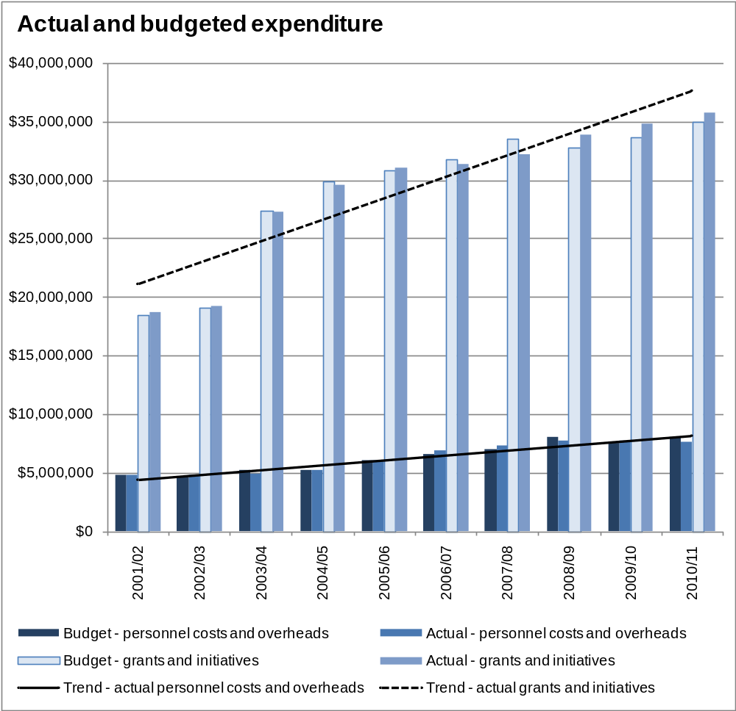
Figure 1: Comparison of total and budgeted grants and initiatives and personnel costs and overheads, 2001/02 to 2010/11

Where we invest
The 2010/11 year saw record levels of investment in grants and initiatives, spread across:
- our three outputs (the services we supply) – see figure 2 for details of the spread between our funding programmes
- our four strategic outcomes (the results we are seeking to achieve for New Zealanders) – see figure 3
- a range of artforms – see figure 4
- all regions of New Zealand – see figure 5.
Of our investment in artists, arts practitioners and arts organisations, 97 percent is by way of grants made through our funding programmes, with the balance being spent on capability building (around 3 percent and advocacy (less than 1 percent). The amount spent on advocacy is low as this generally occurs through staff time (for example, in preparing submissions and managing relationships) rather than direct expenditure.

Distribution between programmes
Figure 2 shows the distribution of funding between our four main funding programmes, each of which is designed to support the arts sector in a different way.
- Recurrent Funding supports the development of a sustainable arts infrastructure by funding, for a fixed term, key arts organisations that are delivering continuous programmes.
- Contestable Funding supports individual artists, arts practitioners and arts organisations to deliver projects.
- The Creative Communities Scheme is a small-grants scheme that is administered by the 67 territorial local authorities (councils) and designed to support community participation in the arts. Funding is allocated on a population basis.
- The International Programme Funding supports artists, arts practitioners and arts organisations to present their work overseas.
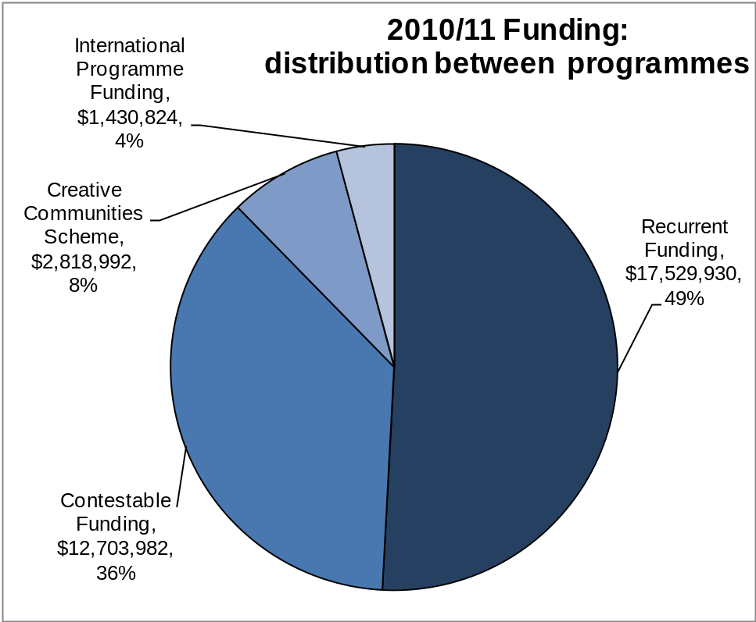
Figure 2: Distribution of funding between programmes, 2010/11

Distribution between outcomes
Creative New Zealand’s activities support four Outcomes.
We are one of many agencies contributing to Outcome 1: New Zealanders participate in the arts. Others include the gaming and community trusts, local government, iwi, local businesses, other parts of central government, and individual artists and arts organisations, including arts festivals.
For Outcome 2: High-quality New Zealand art is developed and Outcome 3: New Zealanders experience high-quality arts, Creative New Zealand is the only national arts development organisation working across all artforms. As a result, these two outcomes make up our largest areas of investment.
The investment in Outcome 4: New Zealand arts gain international success reflects the smaller number of artists, arts practitioners and arts organisations operating internationally and our main focus on developing high-quality art in New Zealand for New Zealand audiences.
Figure 3 shows how the investment in funding and capability building is distributed to our four strategic outcomes.
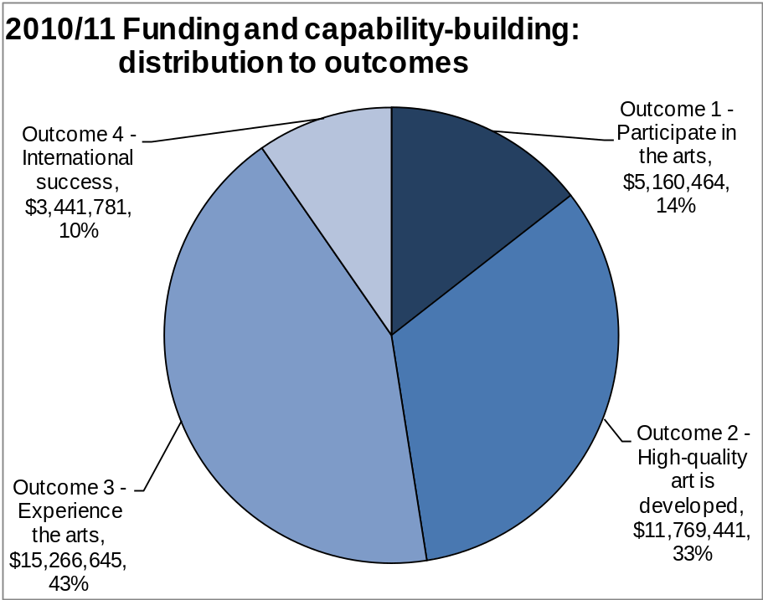
Figure 3: Distribution of funding and capability building investment to outcomes, 2010/11

Distribution to artforms
The distribution of our investment across artforms reflects several factors, including:
- the variable costs of delivering different artforms (for example, opera and orchestral music have high fixed costs) and
- whether other funders are involved (for example, local authorities play a significant role in funding visual arts infrastructure through the network of regional art galleries).
Figure 4 shows how most of our funding (Contestable Funding, Recurrent Funding and Creative Communities Scheme) is distributed to the artforms that we support.
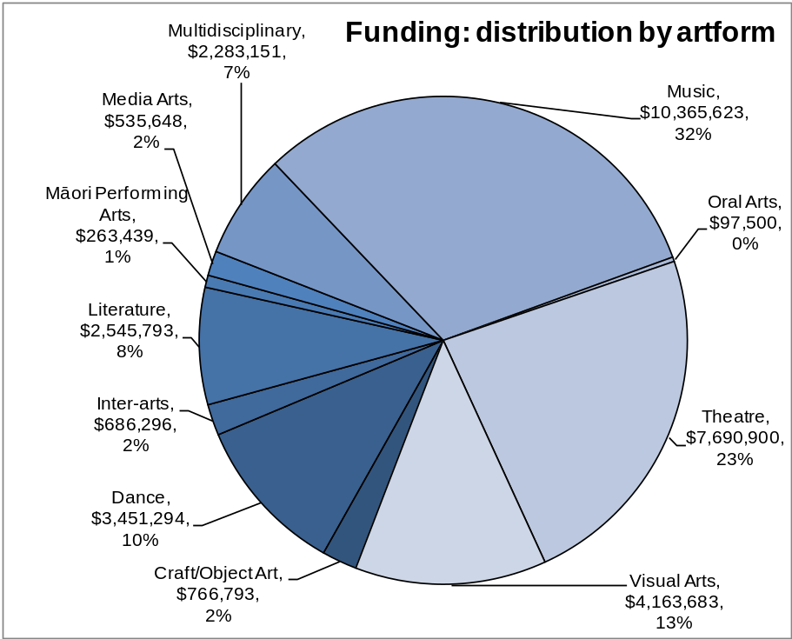
Figure 4: Distribution of funding (Contestable, Recurrent and Creative Communities) by artform, 2010/11

Distribution to location
With the exception of the Creative Communities Scheme, where funding is allocated to the territorial authorities on a population basis, Creative New Zealand does not allocate funding on a regional basis through its funding programmes.
However, we do fund several organisations that tour work throughout the country so that New Zealanders outside of the main centres can experience the arts.
Figure 5 shows how most of our funding (Contestable Funding, Recurrent Funding and Creative Communities Scheme) is distributed according to region. The allocation to regions is based on the location of the art delivery, rather than the home location for the artist or arts organisation. The organisations funded to tour work are recorded as ‘national’.
Region | 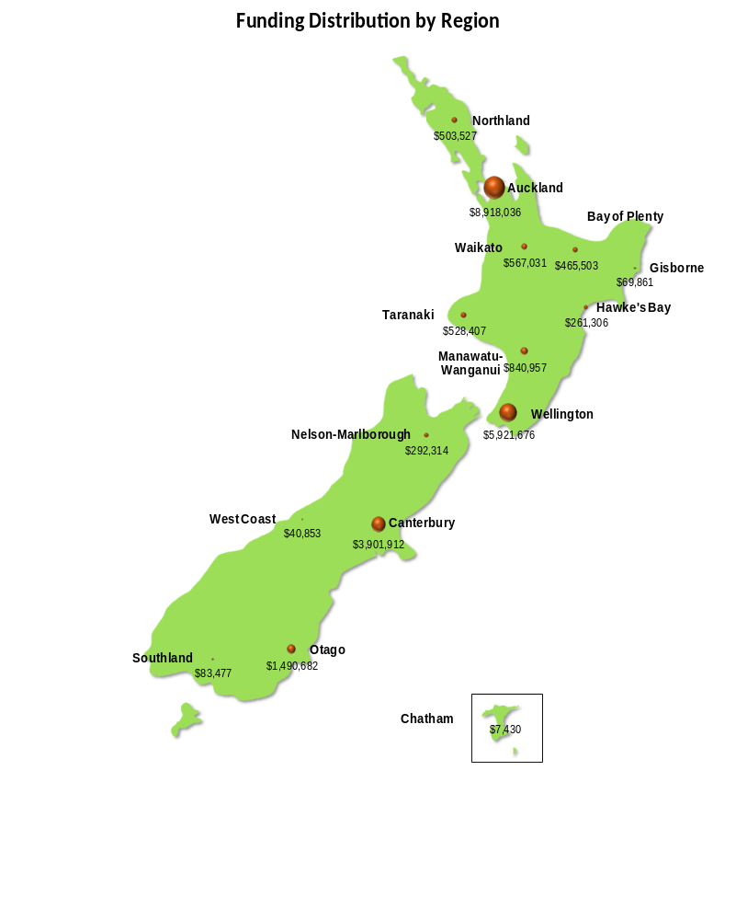  Funding | %
Auckland | $ 8,918,036 | 27.2%
Bay of Plenty | $ 465,503 | 1.4%
Waikato | $ 567,031 | 1.7%
Gisborne | $ 69,861 | 0.2%
Wellington | $ 5,921,676 | 18.0%
Hawke's Bay | $ 261,306 | 0.8%
Manawatu-Whanganui | $ 840,957 | 2.6%
Northland | $ 503,527 | 1.5%
Taranaki | $ 528,407 | 1.6%
Canterbury | $ 3,901,912 | 11.9%
Southland | $ 83,477 | 0.3%
Otago | $ 1,490,682 | 4.5%
West Coast | $ 40,853 | 0.1%
Nelson-Marlborough | $ 292,314 | 0.9%
Chatham Islands | $ 7,430 | 0.0%
National | $ 7,599,374 | 23.1%
Overseas | $ 1,339,726 | 4.1%

Figure 5: Funding distribution by region (Contestable, Recurrent and Creative Communities Scheme), 2010/11

Funding trends
Creative New Zealand has consistently increased its direct investment in artists, arts practitioners and arts organisations for the past decade.
However, it is unlikely this upward trend will continue beyond 2012/13. Constraints on central government have meant that funding from Vote: Arts, Culture and Heritage has been held at the same level since 2008/09. It is only because of the increased distributions from the New Zealand Lottery Grants Board that we have been able to increase our funding to the sector. However, the Board has now completed the distribution of its reserves and further significant increases in funding from this source are doubtful.
Figure 1 (page 17) shows the overall expenditure pattern for the past decade and figure 6 shows the trend for the past three years with the contributions made by each funding programme, plus the capability building and advocacy outputs.
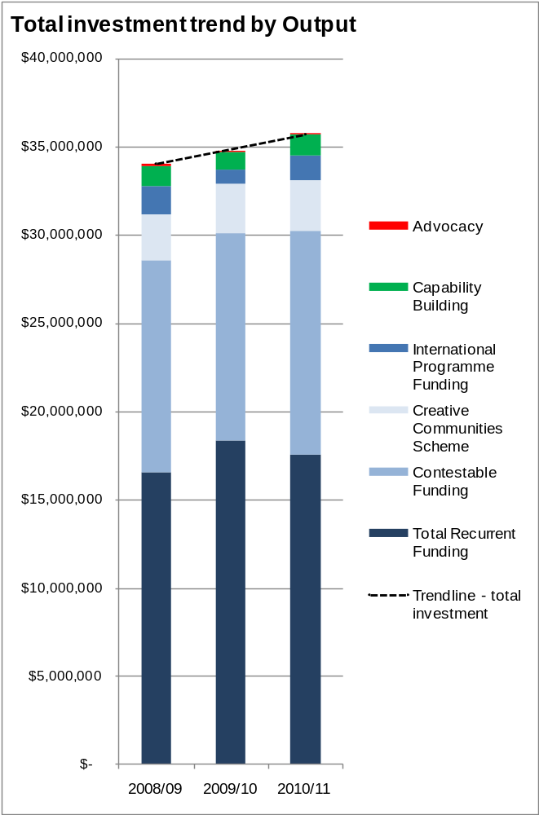
Figure 6: Total investment shown by output, 2008/09 to 2010/11
Demand for our funding has risen from $26.3 million in applications for Contestable Funding in 2008/09 to $33.4 million in 2010/11 as shown in figure 7.
Contestable funding supports a range of activities and is designed to respond to the most compelling applications from the sector. We are able to support nearly 40 percent of requests and provide about 36 percent of the funding requested.
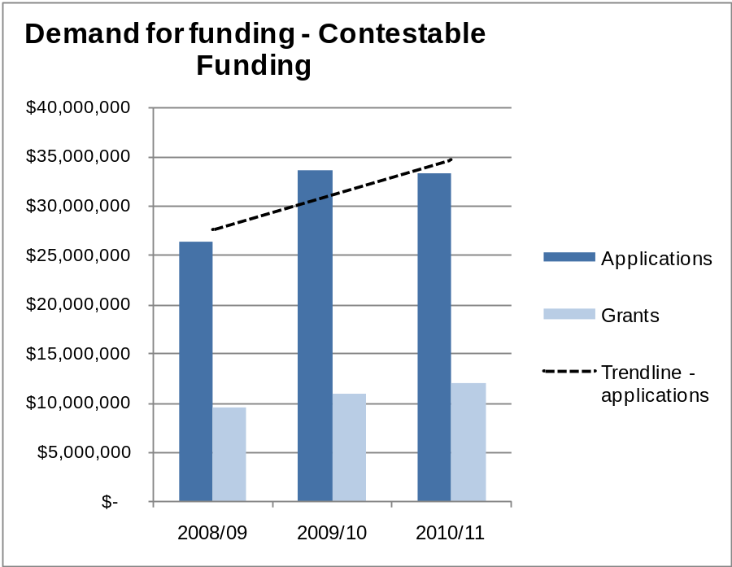
Figure 7: Demand for funding; dollar value of applications, Contestable Funding, 2008/09 to 2010/11
In contrast, the Creative Communities Scheme is designed to support participation in the arts at the community level. Grants in 2009/10 averaged at just over $1,200 and, following the removal of a funding cap, have risen to an average of $1,640 in 2010/11. Under this scheme we support 68 percent of applications but only 38 percent of the funding requested.
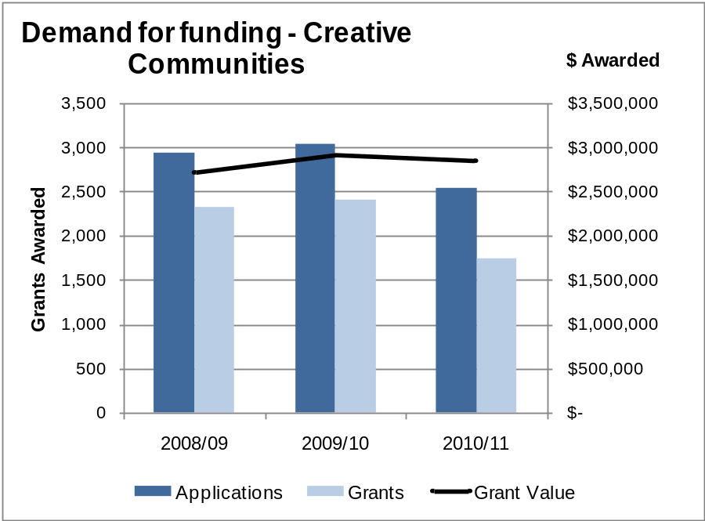
Figure 8: Demand for funding, Creative Communities Scheme, 2008/09 to 2010/11

How those we fund perform
We monitor what results are achieved by the artists, arts practitioners and arts organisations that receive funding from Creative New Zealand.
- Those who receive Contestable or International Funding have their project completion reports evaluated against the expectations of their initial application and funding agreement.
- The results of Creative Communities Scheme grants are assessed against the expectations of the original application by the local authority which administered the grant.
- Recurrently Funded Organisations (RFOs) are assessed by Creative New Zealand based on their reporting of their activities against the expectations of their funding agreements.
Figure 9 shows the combined results for 2010/11.
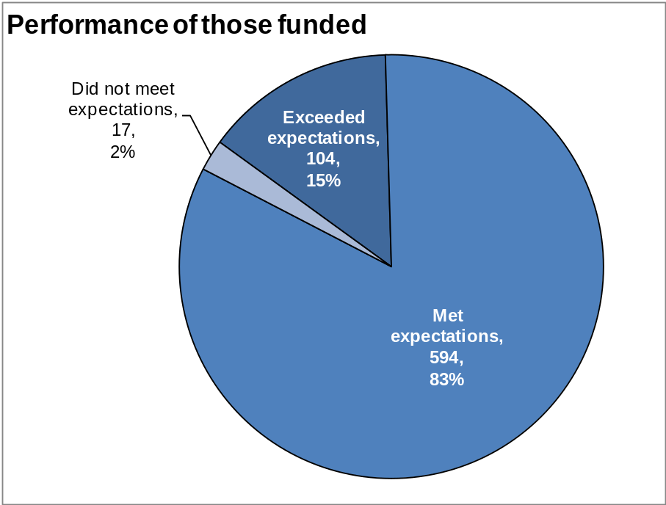
Figure 9: Evaluation of performance of funding recipients, all programmes, 2010/11

Response to the Canterbury earthquakes
Creative New Zealand has responded quickly to support artists, arts practitioners and arts organisations affected by the Canterbury earthquakes.
Our main interventions have been to:
- provide funding in advance to the four RFOs based in Christchurch to enable them to meet immediate expenses post the February 2011 earthquake
- establish the Christchurch Earthquake Emergency Response Fund from which 33 grants totalling $667,532 were awarded in 2010/11. (The budget for 2010/11 and 2011/12 is $2 million, with a further $0.5 million per annum budgeted for 2012/13 and 2013/14. Grant applications are considered monthly to ensure a timely response to need.)
- establish an organisational office hub, in partnership with the Christchurch Polytechnic Institute of Technology, for those organisations that were made ‘homeless’ by the earthquakes
- work with the local arts sector and the Ministry for Culture and Heritage to provide input into planning processes run by the Christchurch City Council and Canterbury Earthquake Recovery Authority
- create a specific position to support the local arts sector in its recovery
- create a specific page on the Creative New Zealand website to provide a resource on work being done to support the recovery, plus write and circulate a regular e-newsletter to help people stay in touch with developments.

Performance Against Strategic Outcomes | Ngā Tairitenga me ngā Whakaritenga hua o te Rautaki

Outcome 1: New Zealanders Participate in the Arts

Our stories from 2010/11
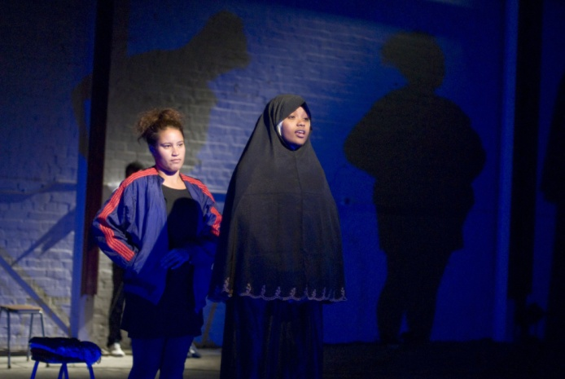
More than 400 people from the Māori, Somali and artistic communities of South Wellington worked together to find common threads and ways of examining the challenges they face. Crossing Lines – a professional theatre show presented by EKO Theatre and backed by an exhibition – emerged from the process by bringing these communities together in the show “Be-Longing”.
(Impact – Community arts participation; Artform – Theatre; Arts Grant)
Figure 10: Crossing Lines, EKO Theatre, (image by Helen Mitchell)
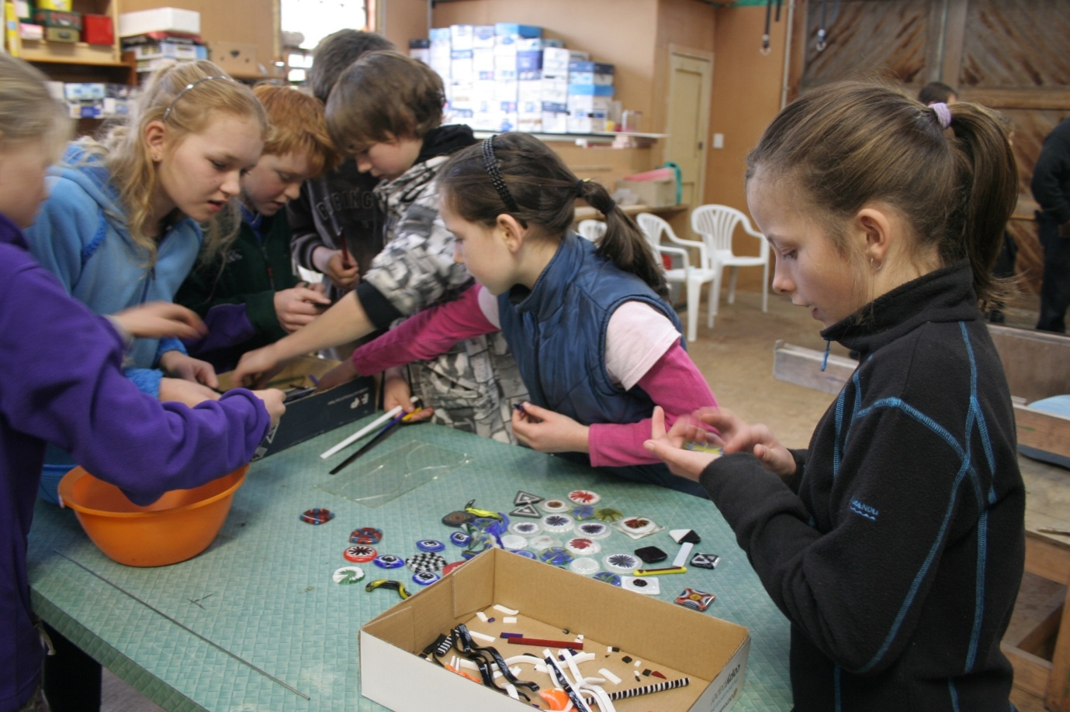
Manawatu glass artist Ben Sablerolle presented a series of workshops to emphasise to young people the accessibility of glass as an artform. The project was delivered in conjunction with three local schools in Kimbolton, Apiti and Kiwitea. Not only did Ben showcase methods of working with both fused and blown glass work he taught the children about the history of art glass, his approach to glass and its technology, equipment and safety, artistic identity, marketing and sales.
(Impact – Community arts participation; Artform – Craft/Object Art; Creative Communities Scheme)
Figure 11: Children at the workshops (image courtesy of Feilding Herald)
Pacific performance poet, writer, musician and youth worker, Daren Kamali received a grant towards compiling a collection of Pacific poetry into a book/CD package. Language is key to preserving the Pacific heritage arts and Daren’s project was realised with a launch at the end of June 2010. Of Fijian, Wallis and Futuna descent, he fused the spoken word with music, creating chants, melodies, rhymes and harmonies inspired by his upbringing in Fiji and New Zealand.
Daren’s compilation includes a CD with his recordings of spoken word pieces and songs translated into Fijian by Dr Apolonia Tamata (Fijian Heritage Specialist, University of South Pacific, Suva). The book features illustrations by Hawaiian artist Leahna Gill and animation storyboards by Munro Te Whata.
(Impact – Pacific heritage arts; Artform – Literature; Quick Response Grant)

What we were seeking to achieve
Creative New Zealand is one of several funders of community arts and aims to provide opportunities for all New Zealanders to have access to and participate in the arts for the benefit of their communities.
Providing opportunities for Māori, Pacific peoples and diverse ethnic groups to participate in their arts is a key element to this outcome. By providing a wide range of arts experiences, throughout the country, Creative New Zealand contributes to local communities’ engagement with the arts.
In particular, we seek to make a difference through the following three impacts:
- Māori heritage arts – Māori communities preserve, develop and transmit their cultural traditions and artistry
- Pacific heritage arts – Pacific communities preserve, develop and transmit their customary artistic practices
- Community arts participation – New Zealand’s diverse communities participate in and develop the arts.
We support a wide variety of community arts activities across the regions, reflecting New Zealand’s increasingly diverse population.

What we did
Through our Contestable Funding programme we invested $1,406,426 through 76 grants awarded over all three impacts during 2010/11. This is the largest number of grants awarded under Outcome 1 since the beginning of the new Contestable Funding programme in February 2009.
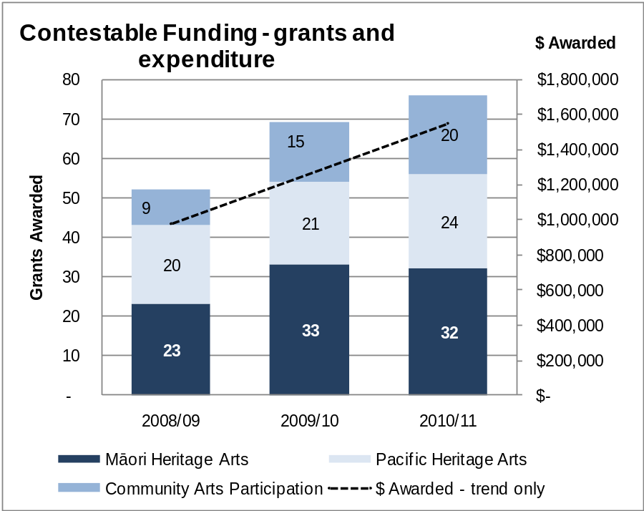
Figure 12: Grants and expenditure by impact, 2008/09 to 2010/11 (Contestable Funding only)
Contestable funding under Outcome 1 includes:
- Quick Response and Arts Grants, Arts and Sector Investments
- Toi Ake funding to hapū and iwi for the preservation of toi Māori (5 grants, $161,205)
- the Toi Atu Tohunga Tukunga programme under which senior Māori arts practitioners mentor less experienced artists and arts organisations (5 projects, $27,125)
- projects to support the implementation of the Health of Pacific Heritage Arts review undertaken in 2009 (7 projects, $17,779)
Through our Creative Communities Scheme, administered by the 67 territorial authorities throughout the country, we invested $2,818,742. Local artists and community arts organisations received 1,725 grants through the Scheme. These grants funded a range of arts activities and supported communities to preserve and develop their diverse arts.
The number of grants awarded has declined in 2010/11, following the removal of a funding cap on the Scheme. This has given the territorial authorities the opportunity to fund fewer projects but at a rate higher than in previous years.
The average Creative Communities Scheme grant in 2010/11 was $1,643 compared with $1,209 in 2009/10.
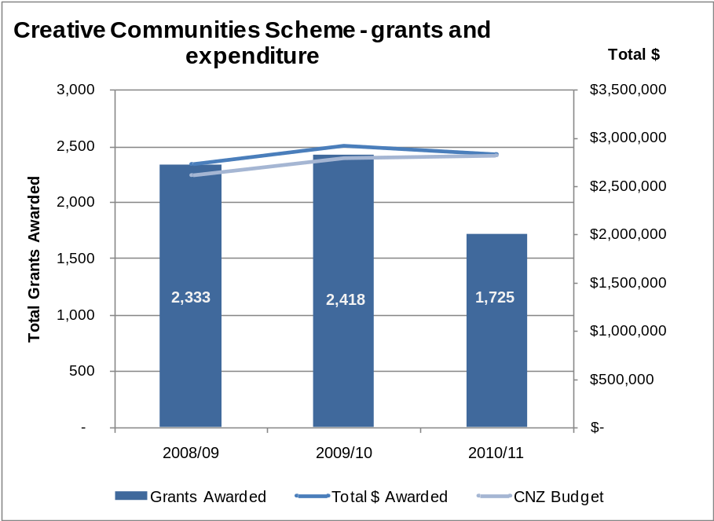
Figure 13: Creative Communities Scheme, grants, budget and expenditure, 2008/09 to 2010/11
In addition to grants under the Contestable Funding programme and the Creative Communities Scheme, nine RFOs contributed $929,537 to this Outcome through their work.
In total, we invested just over $5 million in supporting opportunities for all New Zealanders to participate in the arts.
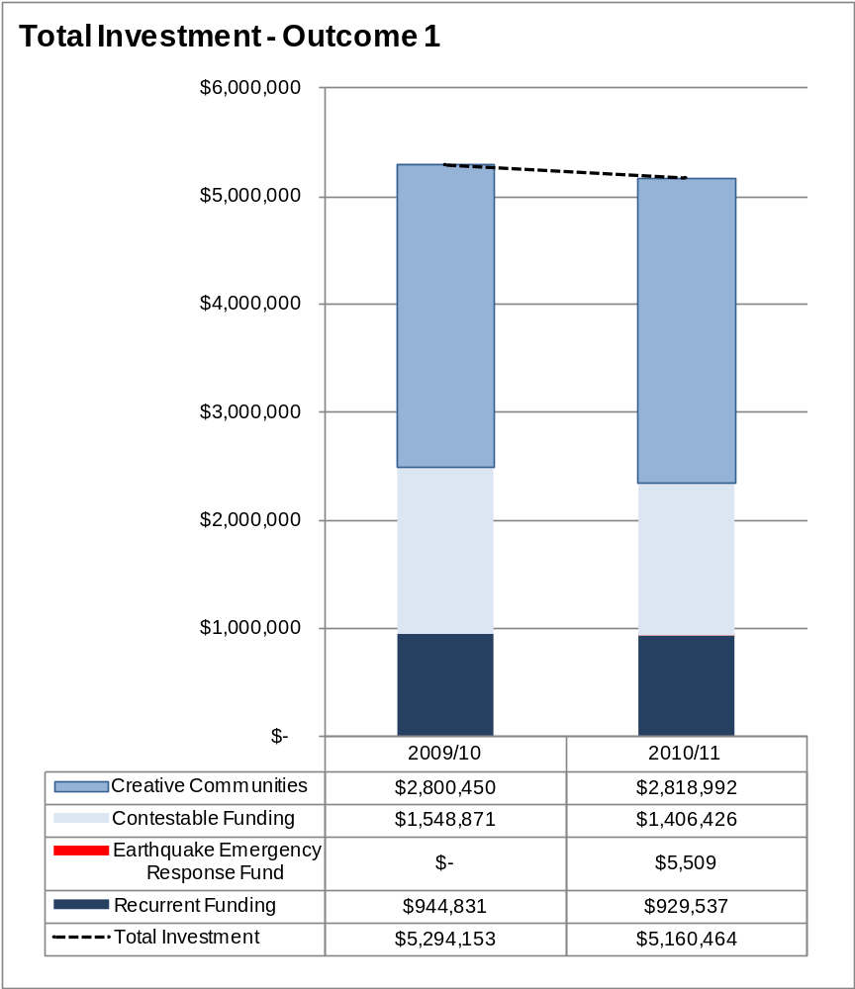
Figure 14: Total investment in Outcome 1, 2009/10 and 2010/11

How we performed
A total of 74 projects (worth $1,428,049) funded from the Contestable Fund in 2010/11 and previous years were successfully completed during the year (compared with 69 projects worth $1,440,327 in 2009/10).

SHORT TO MEDIUM TERM
Impact | Performance indicator and standard | Proof of performance
Māori communities preserve, develop and transmit their cultural traditions and artistry | Performance Indicator (all impacts)  Māori, Pacific and diverse works delivered by geographical region.  Standard (all impacts)  Maintain or increase the number of projects completed and the dollar value of funding | Figure 12 (page 28) shows the increase in funding and numbers of Māori, Pacific and Community Arts projects (diverse works) through the Contestable Funding programme.  Figure 13 (page 29) shows the increase in funding through the Creative Communities Scheme and a drop in grant numbers (which is attributed to removing the Scheme funding cap).  Figure 4 (page 20) shows the total investment by artform, across the Recurrent and Contestable Funding programmes and the Creative Communities Scheme.  Figure 27 (page 46) shows the cultural focus (cultural heritage) of the projects awarded grants in 2010/11.  Figure 15 (below) shows the comparison of funding awarded under Outcome 1 with the distribution of New Zealand’s population.
Pacific communities preserve, develop and transmit their customary artistic practices

New Zealand’s diverse communities participate in and develop the arts
Although Creative New Zealand does not fund on a population basis (with the exception of the Creative Communities Scheme), the focus of Outcome 1 is on increasing participation in the arts by all New Zealanders.
Figure 15 provides a comparison of the distribution of funding under Outcome 1 (from the Contestable Funding programme and the Creative Communities Scheme) with the estimated population of each region.
In contrast to figure 5 (page 21) it demonstrates that, under Outcome 1, funding is distributed more evenly across the country, with less of a focus on the main centres.
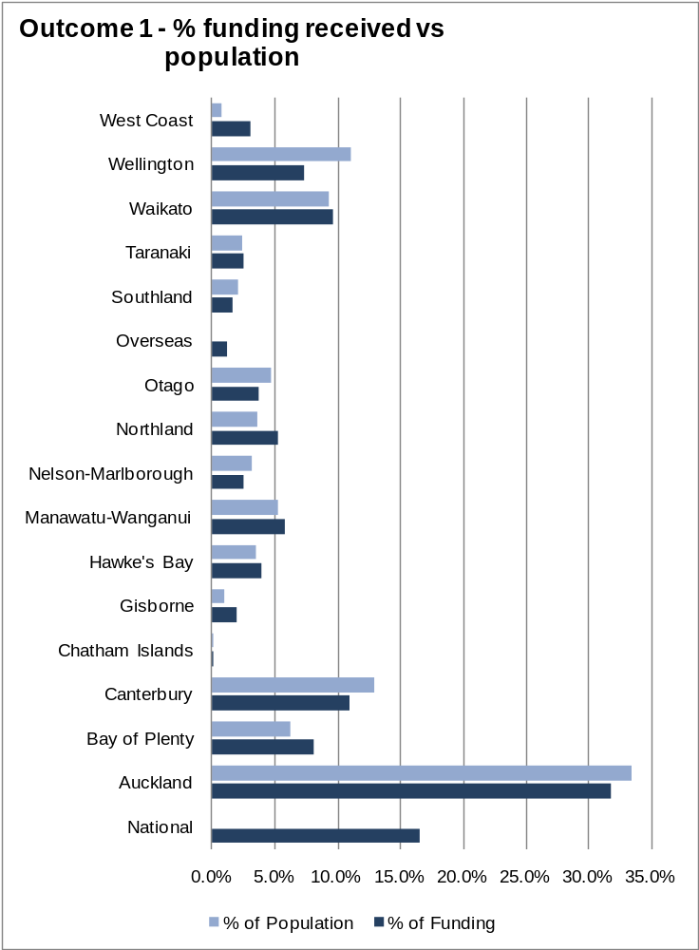
Figure 15: Percentage of funding received under Outcome 1, by region, compared with estimated population (Contestable and Recurrent Funding, Creative Communities Scheme)

LONG TERM
The long term performance indicator is to maintain or increase the level of New Zealanders’ participation in the arts.
The measure uses data from the triennial survey, New Zealanders and the arts: attitudes, attendance and participation, which has been run twice, in 2005 and 2008. The next survey is being undertaken in late 2011. Results will be reported in the 2011/12 Annual Report.
Overall participation rates from previous surveys are shown below in figure 16.
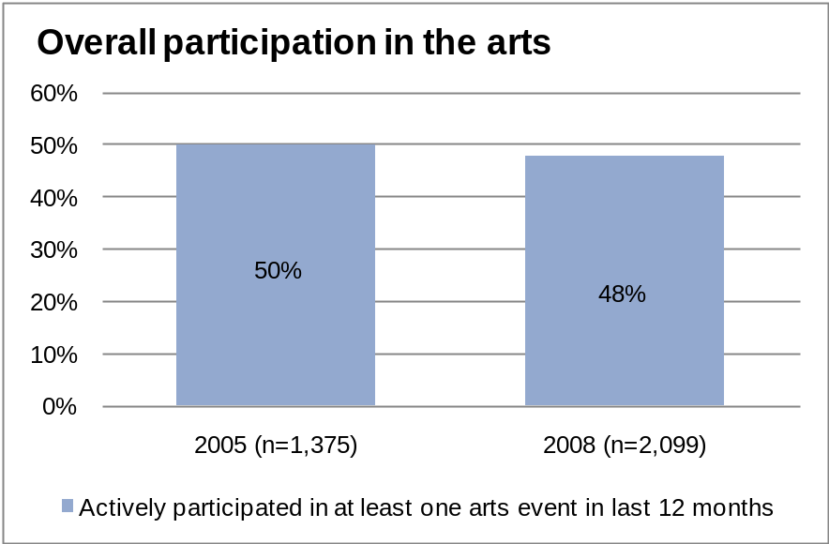
Figure 16: Participation in the arts (from New Zealanders and the arts survey)
Figure 16 shows that the overall trend is an incremental decrease.
However, the base rate can be compared with the 2010 survey by the Arts Council of Wales, which reported an increase in participation to 39 percent of respondents normally participating in an art form at least once a year (up from 20 percent recorded in 2005).

Outcome 2: High-quality New Zealand Art is Developed

Our stories from 2010/11
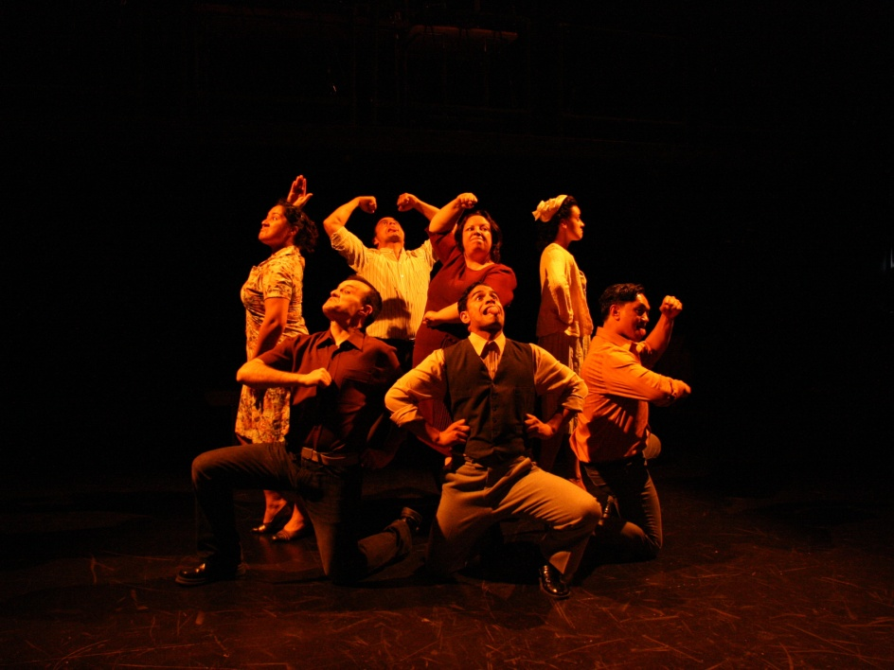
Tawata Productions was given funding towards a programme of Māori theatre works and development initiatives in 2011.
One result was a development season of Hone Kouka’s play Tu, a work inspired by the award-winning novel by Patricia Grace, (Ngāti Toa, Ngāti Raukawa, Te Ati Awa). A sweeping epic, weaving text and image, the play brings redemption to a man in exchange for his long-carried burden. Hone’s previous work includes Ngā Tangata Toa and the internationally renowned Waiora and The Prophet.
Figure 17: Tu, Tawata Productions (image by Aneta Ruth)
This arts investment supported Tawata Productions for a development season of Tu in November 2010 in Wellington. In 2011, Tu will be presented in Gisborne as part of a second development season before the final work is showcased in 2012.
(Impact – High-quality artists; Artform – Theatre; Arts Investment)
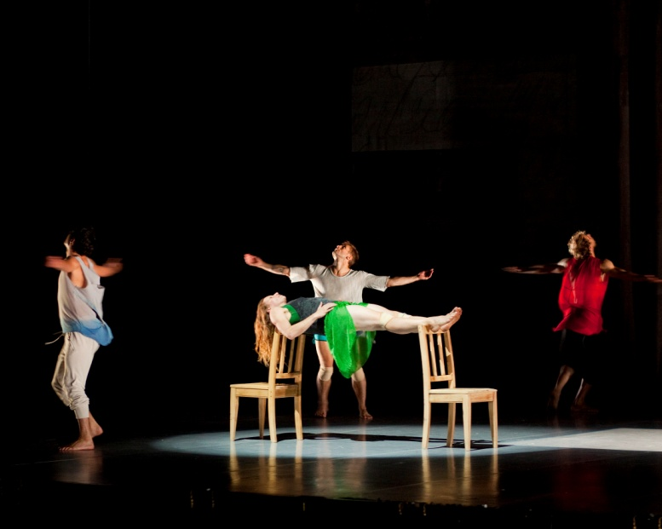
rapt, a new dance work from choreographer Douglas Wright, one of this country’s most important artists, was commissioned by Auckland Arts Festival. Creative New Zealand supported the workshop development and commissioning of the work. Wright describes rapt – his 11th full-length piece – as “celebrating the dark radiant energies of the body [with] haunting unforgettable dances of serenity and power”.
The opening season received rave reviews – the New Zealand Herald described the dancing as “explosive, lyrical and distinctively Wright's own via nine brilliant bodies...”
Figure 18: rapt, by Douglas Wright, Auckland Arts Festival (image by John Savage)
(Impact - Producing innovative work; Artform – Dance; Arts Investment)

What we were seeking to achieve
New Zealand arts depend on the creativity of artists. Creative New Zealand seeks to ensure that New Zealand artists have the opportunity to fulfil their potential by continually developing their artforms, the quality of their work, and their skills and capability.
Creative New Zealand is committed to developing and strengthening the body of New Zealand artistic work through the following impacts:
- Developing potential – Artists, practitioners and arts organisations with potential develop their skills and practice
- High-quality artists – Artists, practitioners and arts organisation that are acknowledged for the quality of their work are supported
- Producing innovative work – High-quality and innovative new work is developed, including Māori and Pacific work and the works of New Zealand’s diverse cultures.
As we are the only national arts development organisation allocating funding across all artforms, this is a key role.

What we did
Through our Contestable Funding programme we invested $7,252,048 through 322 grants awarded in 2010/11. This is the largest number of grants and the highest level of funding awarded under Outcome 2 in the past three years.
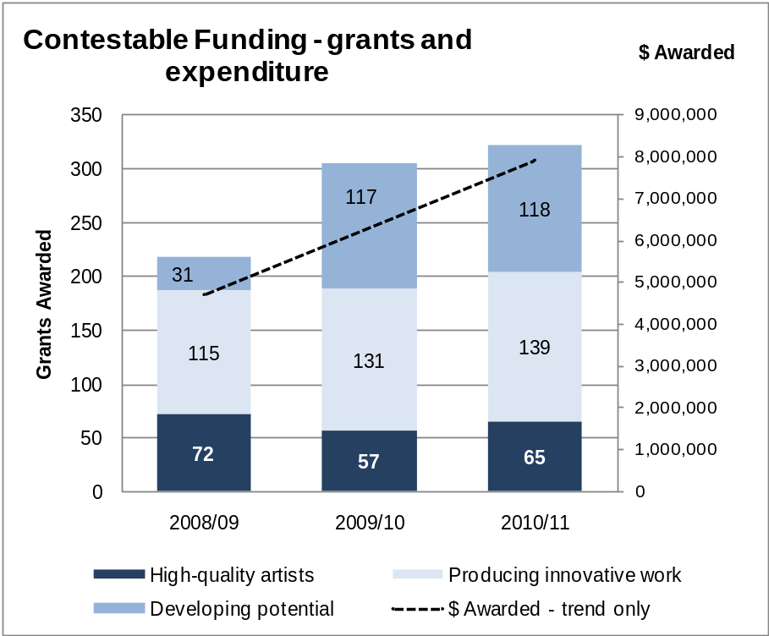
Figure 19: Grants and expenditure from Contestable Funding, by impact, 2008/09 to 2010/11
Contestable Funding shown in figure 19 includes:
- Arts Grants, Quick Response Grants, Arts and Sector Investments
- special opportunities such as:
- bursaries and scholarships
- residencies and awards, including prestigious awards as the Prime Minister’s awards for Literary Achievement and the Creative New Zealand Michael King Writers’ Fellowship
- the Te Waka Toi and Pacific Arts Awards, Creative New Zealand’s own awards recognising contributions to Māori and Pacific arts
- the Smash Palace Fund, which was a partnership between the Ministry of Research, Science and Technology and Creative New Zealand. (The 2010/11 year was the final year for the Fund following the merger of the Ministry with the Foundation for Research, Science and Technology to create the Ministry of Science and Innovation.)
- the Independent Filmmakers’ Fund (IFF). This was the last year that grants were awarded from this fund, following the decision by the New Zealand Film Commission to disinvest in the Fund. The 2010/11 grants round was supported by Creative New Zealand alone and will be replaced in 2011/12 with a new artform category of ‘media arts’ within the wider grants programme.
In addition, 32 of our Recurrently Funded Organisations contributed $4,421,304 to this outcome through their work. Outcome 3 has previously been where most of the RFOs have been reported. Amounts from 2009/10 shown in figure 20 have been reworked to give a result comparable with 2010/11.
In total, we invested $11,769,441 in a range of activities and projects designed to support the development of high-quality arts.
The decrease in the level of funding for Special Opportunities, Smash Palace and IFF shown in figure 20 is attributable to the cessation of both the IFF ($310,290 awarded in 2010/11 compared with $500,000 in 2009/10) and Smash Palace ($129,306 awarded in 2010/11 compared with $522,331 in 2009/10. The balance remaining in the fund was returned to the Ministry of Science and Innovation).
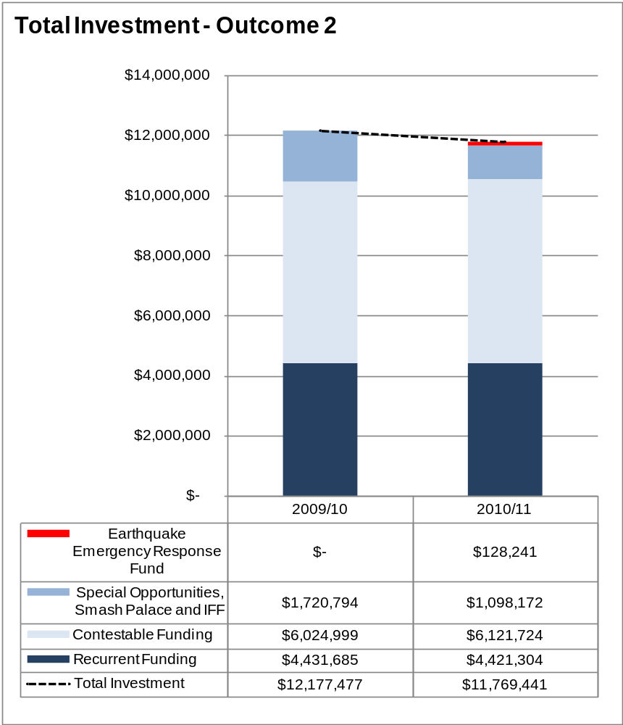
Figure 20: Total investment in Outcome 2, 2009/10 to 2010/11

How we performed
A total of 271 projects (worth $5,648,440) funded from Contestable Funding in 2010/11 and previous years were successfully completed during the year (compared with 285 projects, worth $4,632,999, in 2009/10).

SHORT TO MEDIUM TERM
Impact | Performance indicator and standard | Proof of performance
Artist, practitioners and arts organisations with potential develop their skills and practice | Indicator  Artists are satisfactorily completing creative and professional development opportunities  Standard  Maintain or increase | 77 ‘Developing potential’ projects from the Contestable Funding programme (worth $1,603,768) were completed in 2010/11 compared with 42 projects (worth $374,503) completed in 2009/10.
Artists, practitioners and arts organisations that are acknowledged for the quality of their work are supported | Indicator  Artists are satisfactorily completing creative and professional development opportunities  Standard  Maintain or increase | 64 ‘High quality artists’ projects from the Contestable Funding programme (worth $1,287,768) were completed in 2010/11 compared with 71 projects (worth $1,247,859) completed in 2009/10.  Refer to figure 20 for the variation over time in grants awarded under this impact. Since completed projects are directly attributable to the number of grants awarded in the current and previous years, a reduction in the number of completed projects is to be expected.
High-quality and innovative new work is developed, including Māori and Pacific work and the works of new Zealand’s diverse cultures | Indicator  Artists are producing high-quality and innovative new works, including Māori and Pacific works and the works of diverse cultures  Standard  Maintain or increase | At present, Creative New Zealand is unable to track ‘new work’ projects under Contestable Funding. New systems are being developed to enable reporting on new works in the future.  Figure 21 shows the range of performances and other activities offered by the RFOs in 2010/11 and figure 22 shows the number of these that were New Zealand works (both new works and revisions of existing works).
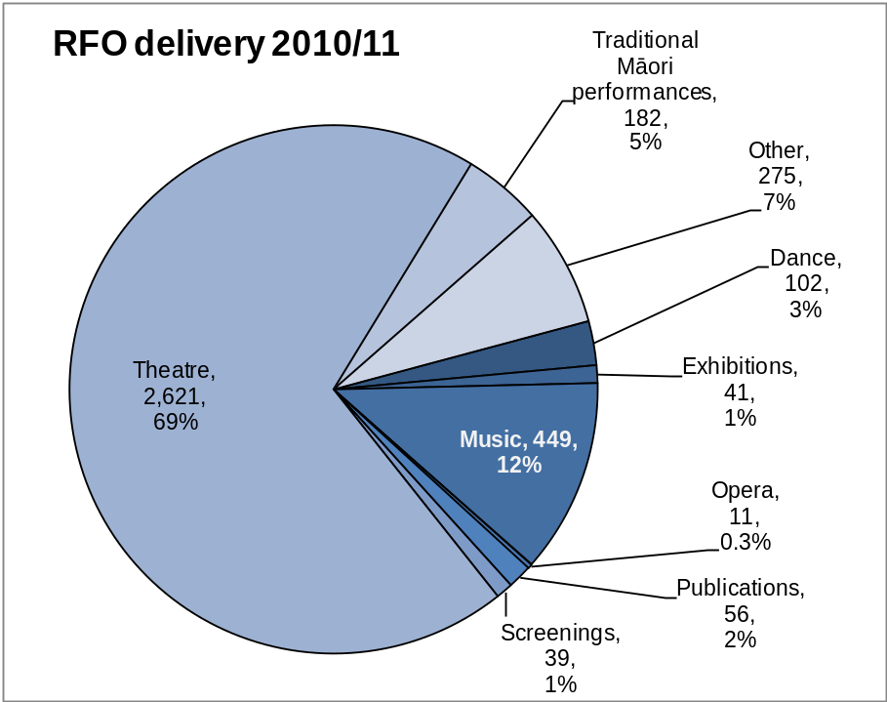
Figure 21: Number of activities delivered by the Recurrently Funded Organisations in 2010/11
Figure 22 shows the number of performances, presentations, readings and exhibitions delivered by RFOs in 2010/11, along with the number that were of New Zealand work (that is, work by a New Zealand citizen or resident, both new works and revisions of existing works).
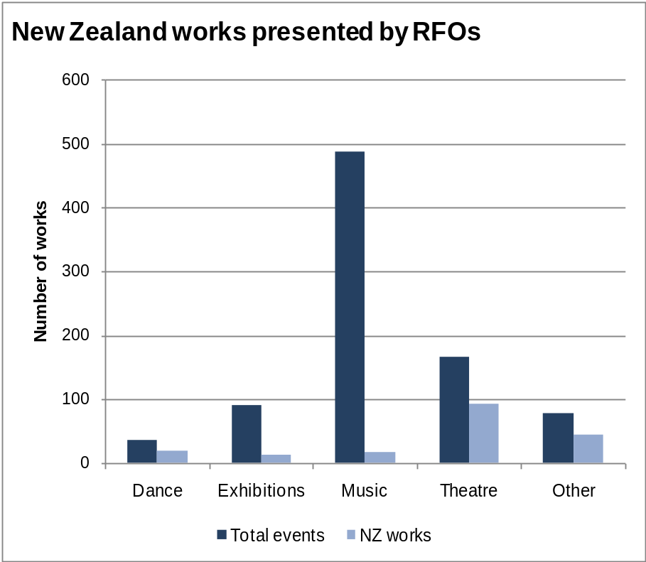
Figure 22: New Zealand works delivered by Recurrently Funded Organisations in 2010/11
Figure 22 shows that the level of New Zealand works delivered for the 2010/11 year were in excess of 50 percent for dance, theatre and other events. The level of New Zealand works delivered in music is low but generally is to be expected as most of the classical repertoire is European. The level of New Zealand content in exhibitions is lower that would be expected and may be attributable to galleries not necessarily reporting New Zealand content correctly.

LONG TERM
The long-term measure for Outcome 2 is that artists are producing “high-quality and innovative new works, including Māori and Pacific works and the works of diverse cultures”. At present, Creative New Zealand is unable to track ‘new work’ projects and systems are being developed to enable reporting on new works as well as New Zealand works in the future.
In the meantime, figure 22 provides an overview of the total presentations delivered by RFOs and the New Zealand works presented by them.

Outcome 3: New Zealanders Experience High-quality Arts

Our stories from 2010/11
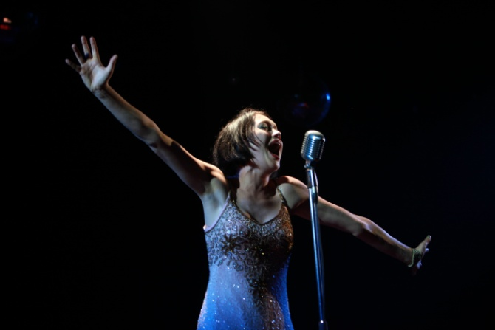
The rights to perform Cabaret, one of the world’s most popular musicals, with its raunchy beginning and heart-wrenching end, have only just become available again. The Court Theatre’s production, featuring Outrageous Fortune star, Antonia Prebble, hit the mark for Christchurch audiences in the wake of the 4 September 2010 earthquake. Described by one reviewer as “a stylish production with a highly talented cast; it speaks for itself that the audience, on the night I went, were in fits of laughter for the first 15 minutes and absolute silence for the last 15”.
Figure 23: Cabaret, The Court Theatre (image by Sabin Holloway)
(Impact – Delivery of the arts; Artform – Theatre; Recurrently Funded Organisation)
The fourth annual 21st Century Arts Conference, programmed and delivered by Creative New Zealand, was held in June 2011. The theme of the conference –This Time it’s Personal – focused on achieving success by engaging audiences and personalising their arts experience. The conference is the only one of its kind that:
- is integrated: 240 artistic leaders, chief executives, marketing managers and local and central government representatives attended in 2011
- is pan-artform and pan-organisation
- places New Zealand contributors at the centre of the conference as industry leaders
- places increased importance on discussion (conferring) and networking than on straight presentation.
(Impact – Developing audiences; Capability-building Programme. All contributor materials (videos, presentations) are available on Creative New Zealand’s website: www.creativenz.govt.nz/21stCentury)
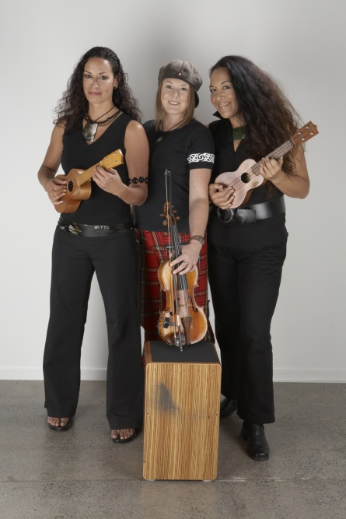
From Onekaka to Putaruru and Whangarei to Cromwell, Arts on Tour New Zealand toured acclaimed Pasifika group, Pacific Curls to 15 rural and smaller centres in February 2011. Combining the fiddle, ukulele, taonga puoro (traditional Māori instruments) and vocals with a range of other instruments including cajons, stomp pedals, kalimba, djembe and other percussion, the group’s special blend of Celtic, Māori, Pacific, South American and African influences provided these regional audiences with a diverse musical experience.
(Impact – Diversity of the arts; Artform – Music: Arts on Tour New Zealand – RFO)
Figure 24: Pacific Curls (image Pacific Curls website)

What we were seeking to achieve
Creative New Zealand aims to broaden the opportunities for New Zealanders to access the arts. We do this by supporting arts experiences across New Zealand and contributing to the organisations that provide them, including building organisations’ skills in engaging with their audiences.
The availability of Māori and Pacific art is a critical component of this outcome, as is increasing the geographic distribution of diverse arts experiences and increasing the capability of artists, arts practitioners and arts organisations.
In particular, we seek to make a difference through the following three impacts:
- Delivery of the arts – artists, practitioners and arts organisations deliver high-quality arts experiences to New Zealanders
- Diversity of the arts – New Zealand audiences have access to diverse arts experiences
- Developing potential – Artists, practitioners and arts organisations develop skills and capabilities to deliver work and increase and diversify their audiences.
As Creative New Zealand is the only national arts development organisation allocating funding across all artforms, this is a key role.

What we did
Through our Contestable Funding programme we invested $3,298,204 through 116 grants awarded during 2010/11. This reverses the decrease in funding and numbers of grants seen in 2009/10 to levels higher than those achieved in 2008/09.
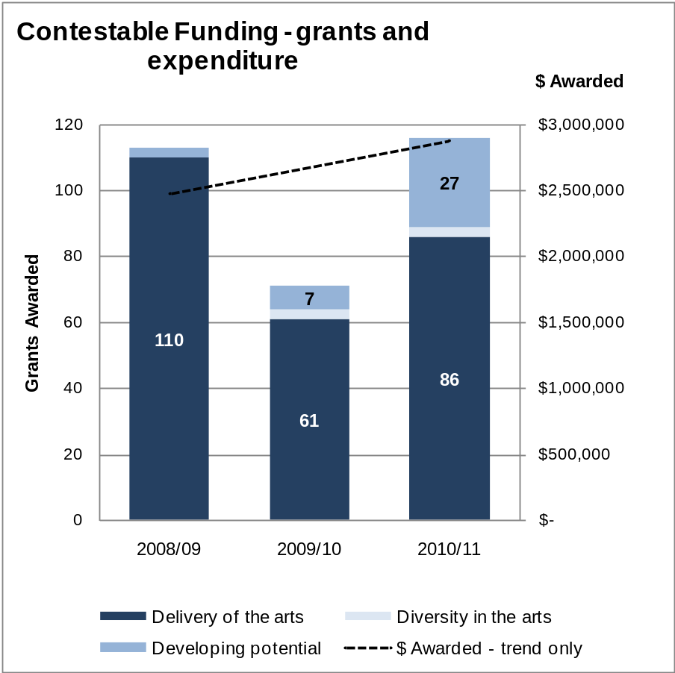
Figure 25: Grants and expenditure, by impact, 2008/09 to 2010/11 (Contestable Funding and Earthquake Emergency Response Fund)
In addition, 31 of our RFOs contributed $11,447,279 to this Outcome through their work.
Outcome 3 has previously been where most of the RFOs have been reported. Amounts from 2009/10 (shown in figure 26) have been reworked to give a result comparable with 2010/11.
The decrease in Recurrent Funding from $12,211,675 in 2009/10 to $11,447,279 in 2010/11 is attributable to the cessation of funding to MIC Toi Rerehiko, lesser amounts being spent on organisations at risk and a series of grants given to RFOs for strategic interventions in 2009/10 ($449,079) that were not repeated in 2010/11.
We also invested $521,162 through 33 activities from our capability-building programme.
In total, we invested $15,266,645 in this outcome in 2010/11.
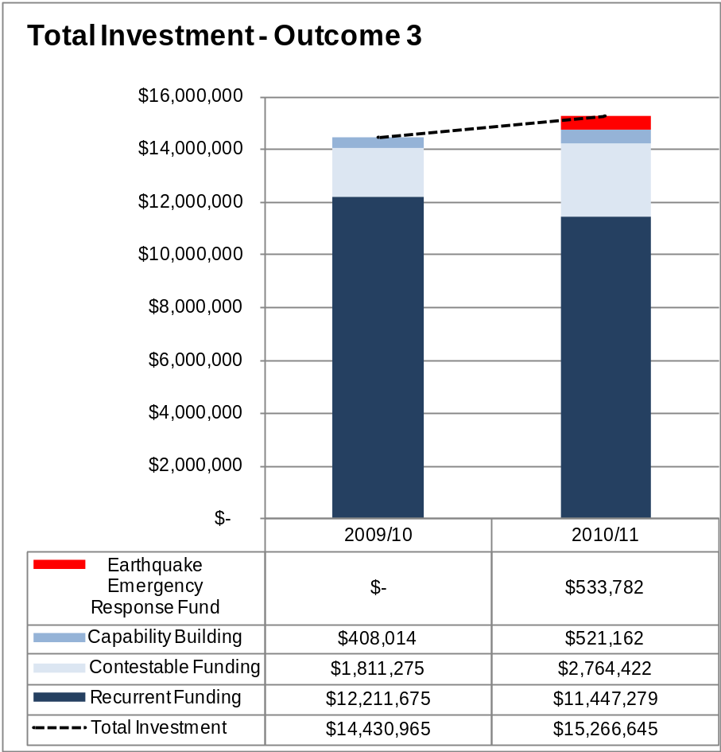
Figure 26: Total investment in Outcome 3, 2009/10 and 2010/11

How we performed
A total of 81 projects (worth $1,773,862) funded from the Contestable Fund in 2010/11 and previous years were successfully completed during the year (compared with 120 projects worth $3,204,887 in 2009/10).
The decrease in the number and value of completed projects under Outcome 3 is partly a consequence of the low numbers of grants from the Contestable Funding programme awarded under this outcome in 2009/10.
The decrease is also an effect of the implementation of Arts Investments and Sector Investments, as part of the new Contestable Funding programme from 1 February 2009. These grants are generally for longer time than other grants and many are only due to report in late 2011 or 2012. Under this Outcome, there are 12 Arts and Sector Investments, worth $829,880, that were awarded in 2009 and 2010 but have yet to be completed.

SHORT TO MEDIUM TERM
Impact | Performance indicator and standard | Proof of performance
Artists, practitioners and arts organisations deliver high-quality arts experiences to New Zealanders | Indicator  High-quality arts experiences are available across New Zealand  Standard  Maintain or increase | Figure 5: Funding distribution by region shows the geographical distribution of Creative New Zealand’s funding.  Creative New Zealand distributed 5.8 percent more funding to artists, arts practitioners and arts organisations under Outcome 3 in 2010/11 than in 2009/10.
New Zealand audiences have access to diverse arts experiences | Indicator  Diverse arts experiences are available across New Zealand  Standard  Maintain or increase | Figure 4: Distribution of funding by artform shows the range of artforms that we invest in under all outcomes.  Figure 27 shows the cultural focus (the cultural heritage of the projects) of the grants awarded in 2010/11 from the Contestable Funding programme and the Creative Communities Scheme. Because this is the first year this data has been available for the Creative Communities Scheme, no comparative year is shown.
Artists, practitioners and arts organisations develop skills and capabilities to deliver work and increase and diversify their audiences | Indicator  Levels of audience attendance at events funded by Creative New Zealand  Standard  Maintain or increase | Figure 28 shows the total attendances, by artform, at performances and events run by RFOs.
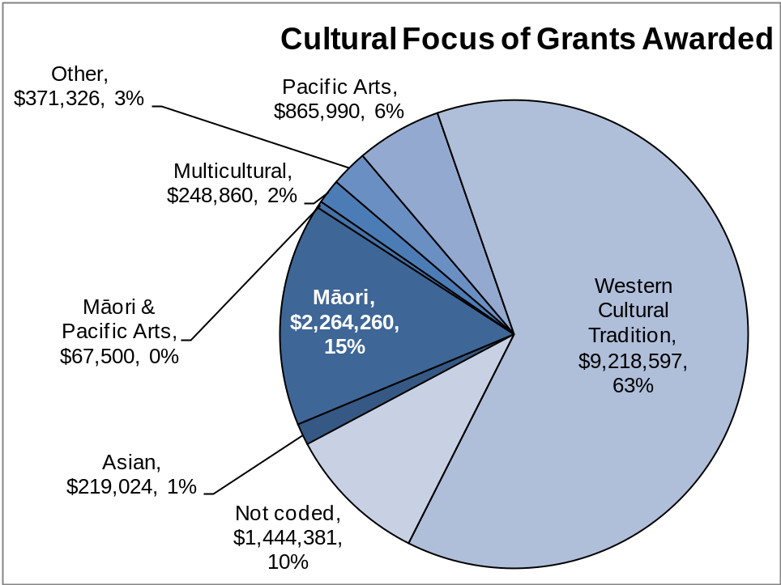
Figure 27: Cultural focus of grants awarded in 2010/11 (Contestable Funding and Creative Communities Scheme)
Figure 28 shows a small decline in attendances at performances and presentations undertaken by RFOs.
The decline in attendances reported by the RFOs is supported by analysis undertaken by Creative New Zealand into box office data collected through our Audience 360º capability-building programme.
The decline is attributed to the difficult economic climate. The effects of the February 2011 earthquake are excluded from figure 28 and the analysis undertaken by Creative New Zealand into box office data collected through our Audience 360º programme as both are based on calendar years.
Data from the Audience 360º report shows that, before the September earthquake, revenue in the group of organisations covered was up 5 percent on the same (January to August) period in 2009. However, revenue for the full year ended down 5.4 percent on 2009.
As would be expected, attendances in Christchurch are at a comparatively lower level than elsewhere. The Court Theatre’s attendance figures for the 2010 calendar year are at 92 percent of the 2009 rate and the Christchurch Symphony Orchestra suffered a 20 percent decline in attendance figures in 2010 compared with the previous year.
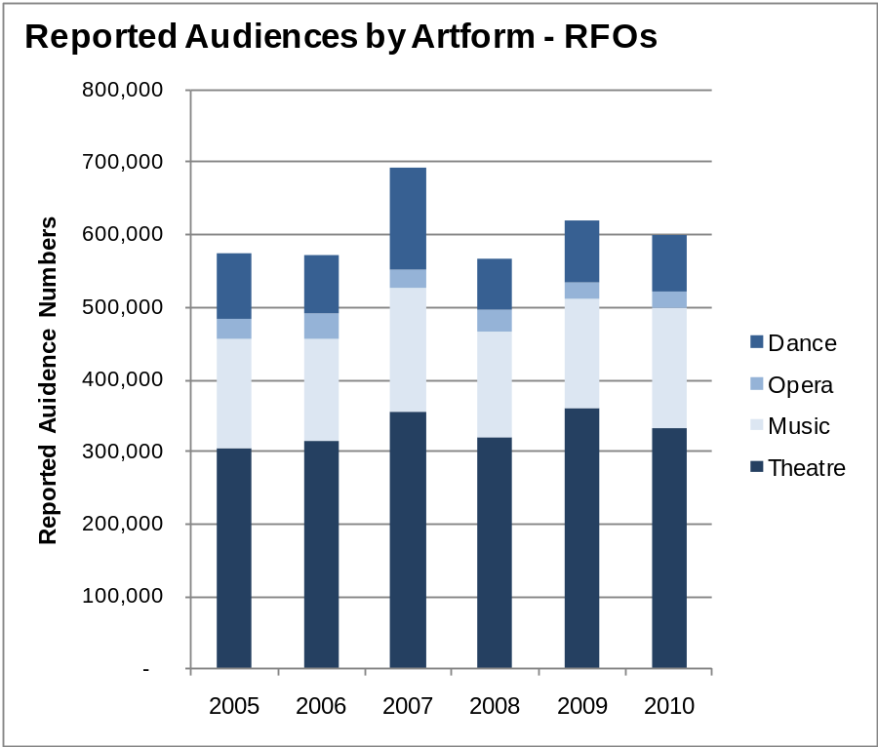
Figure 28: Reported Audiences at events and performances by RFOs, by artform, 2005 to 2010

LONG TERM
The long term performance indicator is to maintain or increase the level of New Zealanders’ attendance in the arts.
The measure uses data from the triennial survey, New Zealanders and the arts: attitudes, attendance and participation which was last run in 2008. The next survey is being undertaken in mid to late 2011. Results will be reported in the 2011/12 Annual Report.
Previous survey results are shown in figure 29.
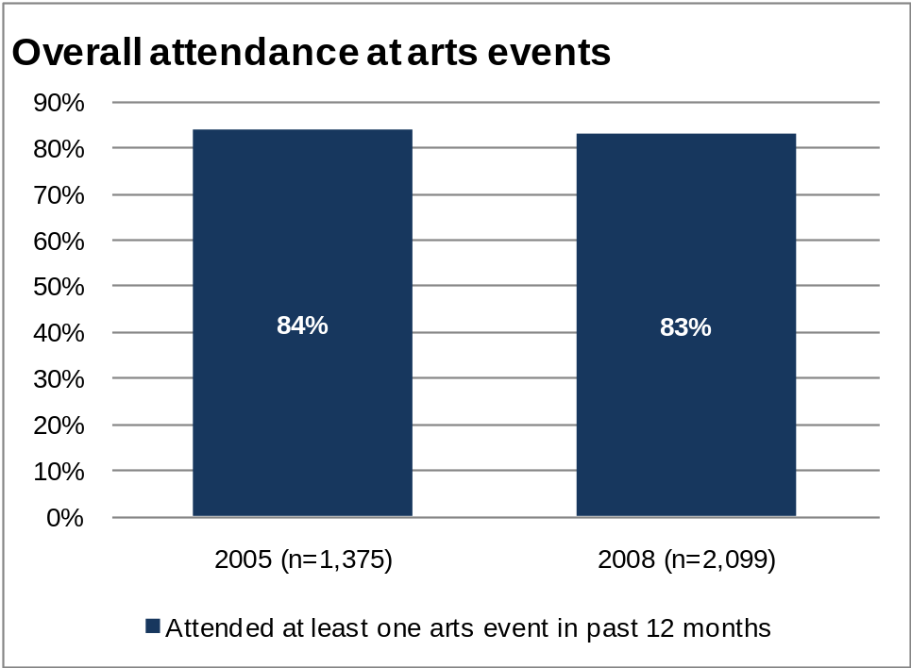
Figure 29: Overall attendance at arts events (New Zealanders and the arts survey)
The overall trend is one of maintenance.
However, the base rate can be compared with the 2010 survey by the Arts Council of Wales, which reported an increase in attendance to 86 percent of respondents normally participating in an art form at least once a year (up from 76 percent recorded in 2005). However, it must be noted that Arts Wales includes all cinema attendance in these figures (the New Zealand survey includes film festivals but not mainstream cinema) and the 2010 figure drops to 81 percent when cinema is excluded.

Outcome 4: New Zealand Arts Gain International Success

Our stories from 2010/11

Te Manu Ka Tau (Flying Friends International Visitors)
More than 100 international presenters, curators and directors have visited New Zealand since Te Manu Ka Tau’s beginning in 2009. The aim of the Creative New Zealand initiative is to encourage international exchange and collaboration, including facilitating exposure, sales of work, networking and capability building in publishing, performing and visual arts. The 2011 group contained 45 international directors, producers, literary scouts, publishers and curators from 15 countries who accessed more than 60 professional acts presented at Arts Pasifika, Auckland Arts Festival, WOMAD, SOUNDS Aotearoa and the Auckland Writers and Readers Festival plus many showcases of works in development.
New Zealand artists were able to gain advice and insight from the international guests who took part in several panel discussions touching on subjects like entrepreneurialism, literature rights, selling and the translation market, succeeding in a changing publishing market, music and programming, freelancing and the role of indigenous arts. The visitors reflect Creative New Zealand’s focus on existing and developing markets for New Zealand art in Australia, Asia, the Americas and Europe.
(Impact – International market development; Artforms – Literature, Craft/Object, Theatre, Music, Dance, Visual Arts; Capability-building Programme investment)
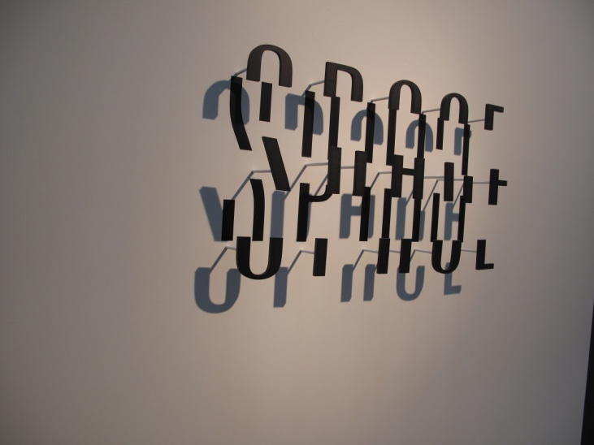
Five New Zealand craft/object artists were funded to exhibit at one of Europe’s most prestigious showcases for emerging talent in design, technology and craft/object art – Talente 2011. Creative New Zealand, in liaison with the craft/art community, identified the show as an important development opportunity. Over the past three years, Creative New Zealand has funded successful applicants to participate, accompanied by a mentor providing advice on how to make the most of the opportunity. For the young artists, the chance to meet gallery owners, dealers, collectors and gain insight into the way the European market works was invaluable.
Figure 30: Broken Sans, Anzac Tasker, (image by Anzac Tasker)
(Impact – New Zealand’s distinctive voice is heard overseas; Artform – craft/object; Attendance at market or fair)

What we were seeking to achieve
Creative New Zealand aims to position the best of New Zealand’s arts and artists internationally, working collaboratively with its partners to achieve lasting success in target markets. Target markets include Australia, Asia and the West Coast of North America, plus specific events in Europe such as Talente (a craft/object fair) and the Venice Biennale.
International exposure allows artists to develop their practice through observing and interacting with international colleagues. International success can also help develop New Zealand arts domestically by:
- increasing international awareness of New Zealand’s distinctive art
- providing role models to inspire other New Zealand artists to raise their sights
- increasing local artists’ understanding of international expectations and standards
- providing New Zealand artists with additional income.
We seek to make a difference through the following three impacts:
- New Zealand’s distinctive voice is heard overseas - Distinctive, high-quality, internationally viable art is presented overseas
- Market Development - International markets and audiences for New Zealand art are developed
- Developing potential - Artists, arts practitioners and arts organisations develop skills and capabilities for engaging internationally.
Creative New Zealand is one of several organisations involved in presenting New Zealand art internationally and in developing markets for New Zealand art.

What we did
Most of the activity under Outcome 4 is substantially different from that under the other outcomes. Support often involves targeted interventions by Creative New Zealand rather than contestable applications.
Our Touring Fund provides support for artists – including companies, bands and ensembles – to accept invitations to present their work internationally. These invitations come about following the artist’s appearance at a market or fair or through relationships that arise from overseas experts visiting New Zealand. In 2010/11, the Touring Fund supported 18 artists with grants worth $312,779.
A total of $897,895 was invested in attending the 2011 Venice Biennale, including contributions from the Museum of New Zealand Te Papa Tongarewa and money raised by the Venice patrons. Creative New Zealand’s budget for the Biennale is $700,000 spread over two years.
We also started preparing for the 2012 Festival of Pacific Arts, to be held in the Solomon Islands.
As part of our capability-building programme, we ran 10 workshops to help New Zealand artists to succeed on the world stage, supported 58 artists to attend 6 international fairs or markets and, through the Te Manu Ka Tau (Flying Friends International Visitors) programme, brought groups of overseas curators, presenters and director to New Zealand to see local art and artists.
Through our Contestable Funding we invested $642,108 through 65 grants awarded in 2010/11.
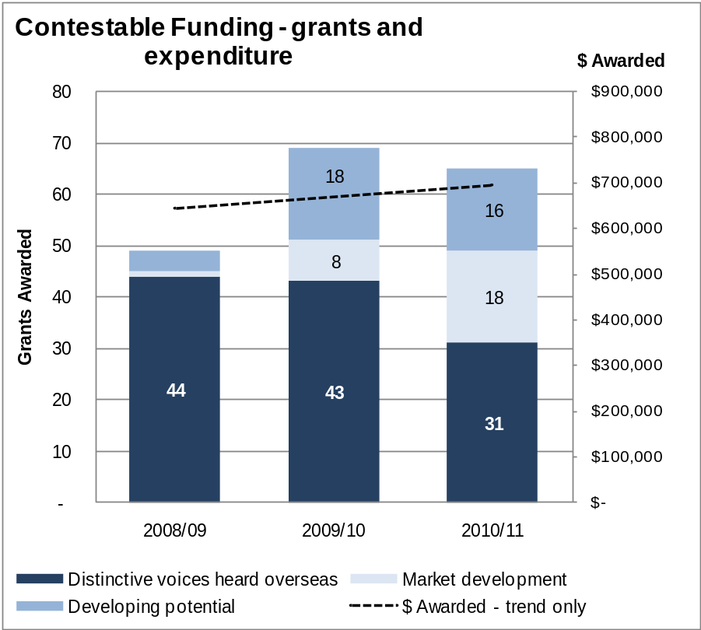
Figure 31: Grants and expenditure, by impact, 2008/09 to 2010/11 (Contestable Funding only)
Through 14 of our RFOs, we invested $731,810 in this Outcome and, in total, we invested $3,441,781.
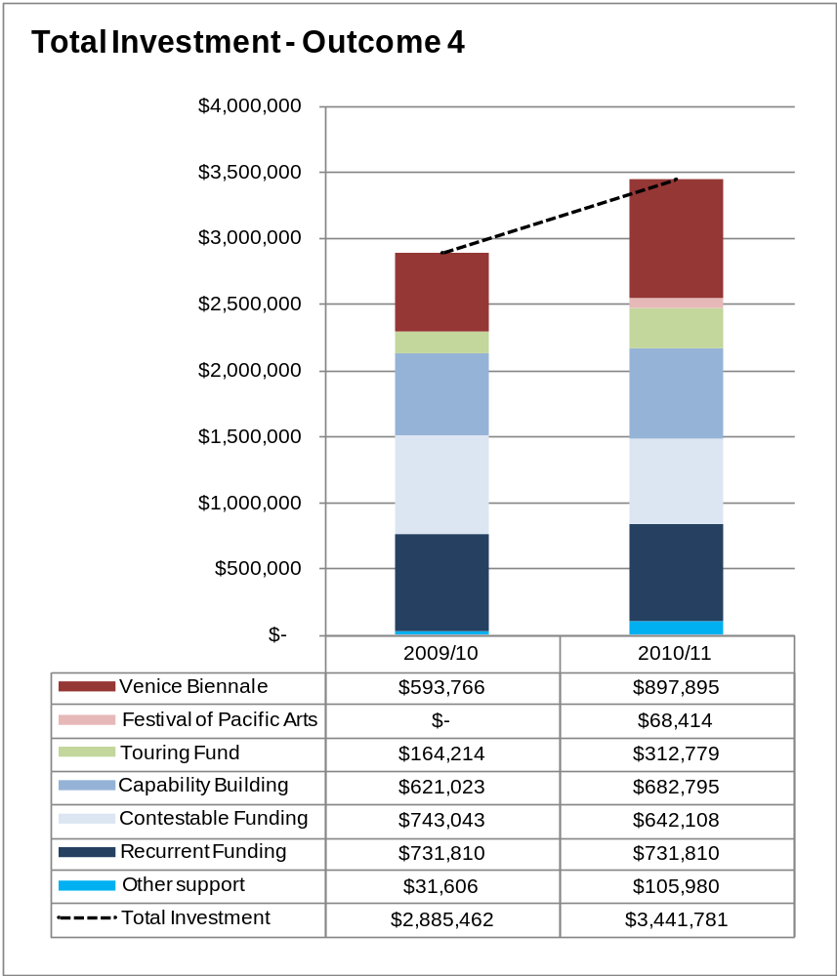
Figure 32: Total investment, by funding source, in Outcome 4, 2009/10 to 2010/11

Venice Biennale
The 54th Venice Biennale opened in June 2011 and New Zealand’s exhibition continues until 23 October 2011. New Zealand’s project for the 2011 Biennale is On First Looking into Chapman’s Homer, a sculptural installation by Michael Parekowhai. The work includes one intricately carved red Steinway concert grand piano (He Kōrero Pūrākau mo Te Awanui o Te Motu: Story of a New Zealand River) and two concert grand pianos fabricated in bronze supporting two cast bronze bulls (A Peak in Darien and Chapman’s Homer).
Music is central to the exhibition with continual performances of New Zealand and European music on the Steinway throughout the exhibition period.
As at the end of August 2011, over 26,000 people had visited the New Zealand project. Creative New Zealand is running an online survey about the exhibition. Initial feedback from the first two months (June and July) indicates that around 86 percent of respondents rated the exhibition as above average or excellent. Media stories, both from overseas and within New Zealand, have been overwhelmingly positive.
After the Biennale finishes, the exhibition will travel to Paris to be shown at the renowned Musée du Quai Branly. A series of recitals on the carved Steinway, which will be positioned in the museum foyer, is planned. The exhibition will then feature at the Christchurch Art Gallery in mid 2012. Several of the works in the exhibition have been sold.
Creative New Zealand manages New Zealand’s participation in the Biennale, which occurs through a government-to-government invitation.

How we performed
A total of 67 projects (worth $833,314) funded through Contestable Funding in 2010/11 and previous years were successfully completed during the year (compared with 53 projects worth $486,744 in 2009/10).

SHORT TO MEDIUM TERM
Impact | Performance indicator and standard | Proof of performance
Distinctive, high-quality, internationally viable art is presented overseas | Indicator  New Zealand artists and artworks are presented at key international events and markets  Standard  Increase numbers | In 2010/11, Creative New Zealand funded 58 artists to attend 6 international fairs or markets at a cost of $259,030. This compares with 56 participants at 7 fairs or markets and a cost of $400,725 in 2009/10.  In addition, through the Te Manu Ka Tau (Flying Friends International Visitors) programme, we brought 45 international directors, producers, literary scouts, publishers and curators from 15 countries to New Zealand to view the best of our art in its local context. This compares with 49 visitors in 2009/10.
International markets and audiences for New Zealand art are developed | Indicator  New Zealand artists are selected for or invited to events in key international markets  Standard  Increase numbers | Our key international markets have been identified as Asia, Australia, West Coast of North America (United States of America and Canada), plus specific events in Europe.  Figure 33 shows the number of projects in each location for 2009/10 and 2010/11.  Figure 34 shows the investment made in the projects in figure 33.  For both figures, the ‘Incoming Visitors’ category includes the Te Manu Ka Tau programme, plus the creation, rehearsal, translation, freight or travel costs for an international project from Contestable Funding.
Artists, arts practitioners and arts organisations develop skills and capabilities for engaging internationally | Indicator  New Zealand artists are selected for or invited to events in key international markets  Standard  Increase numbers | In 2010/11, Creative New Zealand initiated 10 international workshops, involving 67 attendees, at a cost of $84,545. This compared with 2 workshops, involving 37 people in 2009/10.  See above for information on invitations to key events in selected markets.
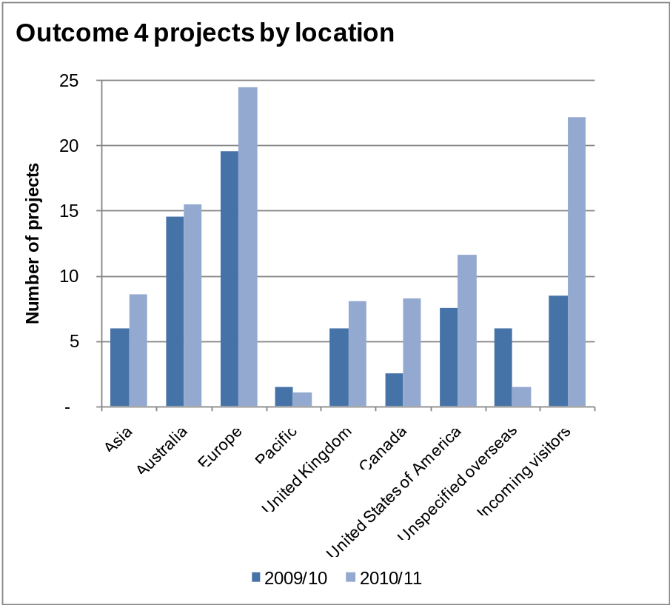
Figure 33: Location of Outcome 4 projects, 2009/10 and 2010/11 (Contestable Funding, Touring Fund and Markets and Fairs)
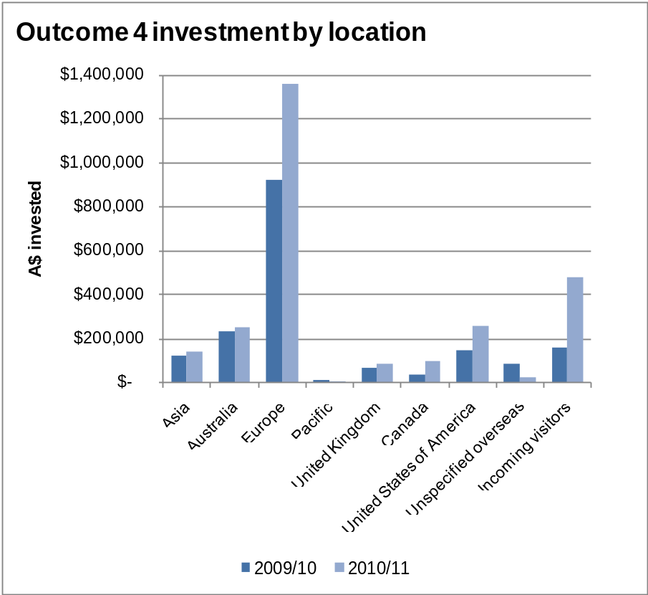
Figure 34: Location of investment in Outcome 4 projects, 2009/10 and 2010/11 (Contestable Funding, Touring Fund and Markets and Fairs)

LONG TERM
The long term performance indicator is to increase the number of artists and artworks presented at key international events and markets that receive positive critical acclaim and invitations for further international engagement.
Creative New Zealand is working on ways in which information on repeat invitations can be captured on an on-going basis.

Managing Organisational Health | Te whakahaere i te ora o te tari
At Creative New Zealand we recognise that our organisational culture and our people, systems, processes, decision making and relationships are critical in enabling us to achieve our outcomes.
To help us focus on each aspect of our organisational health we have defined six headings under which activity can be grouped and performance measured.

Best organisational culture

What we did
- Creative New Zealand has in place a strategy for partnering with Māori and an annual plan for Māori language initiatives.
- Since 2008 we have participated in the annual Best Workplaces Survey and used the results to help us identify ways in which we can improve. The key results are shown on figure 35.
- Across the organisation, various initiatives were developed to lift performance further, including regular organisational communications (weekly panui from the Chief Executive and monthly all-staff meetings), performance appraisals linked to remuneration, and targeted training and development.
- During 2010/11, the Senior Leadership Team has been working with a leadership development specialist to build their performance, both as a team and individually.
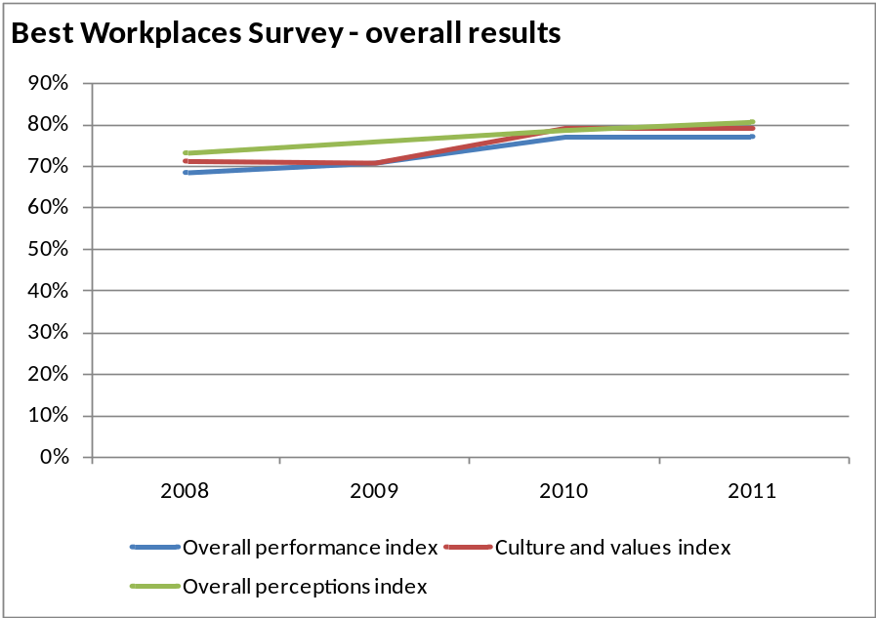
Figure 35: Key results from Best Workplaces Survey, 2008 to 2011

Best people

What we did
- The training budget for the 2010/11 year was $155,000 (nearly $2,970 per full-time equivalent staff member or 3.5 percent of personnel costs), of which $151,844 was spent. Training ranged from software user training, plain English writing training, presentation skills development, coaching and mentoring to leadership and management development.
- All staff received at least one development opportunity of some sort and most accessed a variety of training initiatives.
- Weekly classes in Te reo Māori continue to be offered and 10 staff attended in 2010/11.
- The staff turnover rate for the year to 30 June 2011 was 13 percent, a slight increase following a pattern of decline since the peak in 2007/08 (see figure 36).
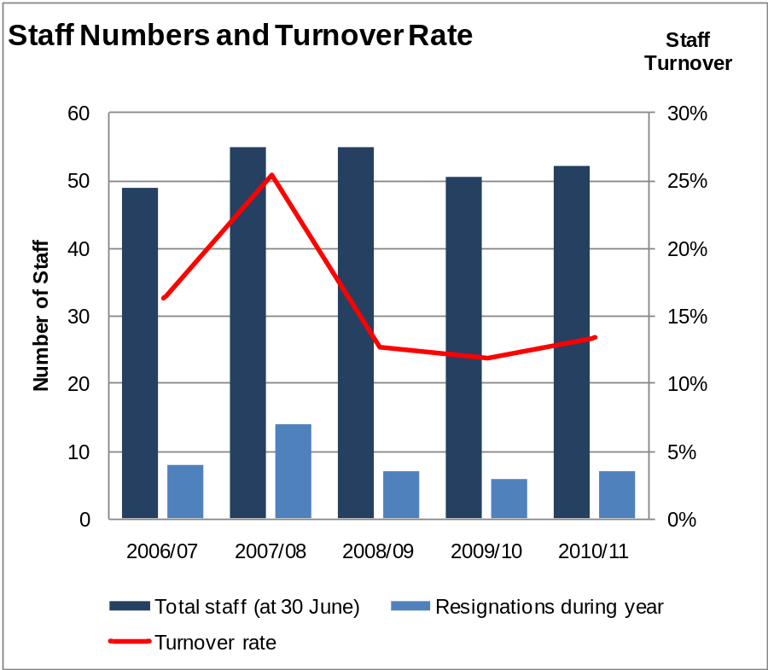
Figure 36: Staff numbers and turnover rate, 2006/07 to 2010/11

Best relationships

What we did
- In 2010/11, as part of its advocacy strategy, Creative New Zealand:
- completed and published research into ways to strengthen private sector support for the arts
- undertook analysis of the data collected from venues and arts organisations participating in the Audience 360º programme, which gathers ticketing and population data about arts attendances (the report was published in August 2011).
- We have continued to maintain and develop relationships with key stakeholders, including local authority partners.
- We began work on a stakeholder management strategy and an advocacy strategy.
- We designed an initial customer satisfaction survey that was implemented in July 2011. Initial key results from the survey are shown in figure 37.
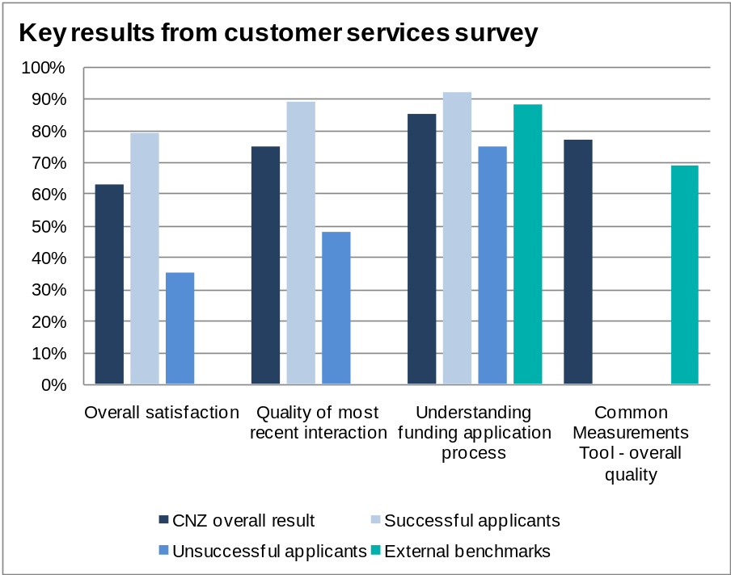
Figure 37: Key results from the initial customer services survey, 2011

Best thinking and decisions

What we did
- Following the review of the Recurrent Funding programme undertaken in 2009/10, the results of which were published in July 2010, we:
- created two new complementary funding programmes to replace the Recurrent Funding programme, and the Arts and Sector Investments under the Contestable Funding programme. The new programmes – Arts Leadership Investment (Toi Tōtara Haemata) and Arts Development Investment (Toi Uru Kahikatea) – start on 1 January 2012.
- called for expressions of interest and applications for the new programmes, assessed the responses, using internal and external expertise, and made decisions on which organisations would be funded, from which programme, for what initiatives and for how long.
- developed contracts and tools to monitor and evaluate the performance of all organisations in the new programmes.
- To develop an organisation-wide monitoring and evaluation strategy and embed it in all our review and decision-making processes, we:
- appointed a monitoring and evaluation manager
- developed monitoring and evaluation strategies and systems for the new Arts Leadership Investment (Toi Tōtara Haemata) and Arts Development Investment (Toi Uru Kahikatea) programmes and built the associated data collection requirements into the contracts for the new programmes.
- To support best decision-making through our funding programmes we:
- implemented measures in response to research into the health of Māori Heritage Arts and Pacific Heritage Arts
- developed a community arts policy
- completed initial research projects into young people and the arts and young emerging arts practitioners, with further work to be done in 2011/12
- developed a plan for public consultation on digital and media arts (to occur in 2011/12)
- completed a review of our International programme and supporting systems and structures.
- We also commenced reviews of our:
- capability-building programmes
- Toi Ake funding programme, which provides funding to hapū and iwi for the preservation of toi Māori
- Tohunga Tukunga programme under which senior Māori arts practitioners mentor less experienced artists and arts organisations.
- We progressed the development of our Balanced Scorecard – a tool to provide management with improved decision-making tools. Implementation is occurring in 2011/12.
- We also progressed work on developing improved output, outcome and impact measures for the Statement of Intent and the systems for data capture and analysis to support the improved measures. This work is reflected in the 2011–14 Statement of Intent and further development is being done for the 2012–15 Statement of Intent.

Best governance and management

What we did
- Creative New Zealand has in place a comprehensive Governance Manual and Delegation Schedule assigning responsibility to the Arts Council, arts boards and management. Delegations are reviewed at least annually.
- An annual meeting calendar is established for the Arts Council, arts boards and committees and a work plan is in place for each.
- Members of the Arts Council, arts boards and committees are aware of the duty to manage existing and potential conflicts of interest. A conflict of interest register is maintained, and meeting processes support individual members to manage all existing and potential conflicts of interest.
- New Arts Council, arts board and committee members receive a comprehensive induction to Creative New Zealand and their specific roles.
- The Arts Council of New Zealand Toi Aotearoa Bill was introduced to Parliament in June 2010. As at publication of this report, the bill is awaiting its second reading.
- Creative New Zealand has developed a governance transition project to ensure, subject to the new legislation being passed:
- the new Arts Council, once appointed, is able to assume its responsibilities and fulfil its functions from day one
- there is minimal or no disruption to external clients who use Creative New Zealand’s services
- stakeholders, customers and clients are informed of the changes in a timely manner.
- The annual survey of satisfaction of members of the Arts Council, Arts Board, Te Waka Toi and the Pacific Arts Committee gave an overall satisfaction rating of 90 percent in 2010/11 (compared with a range of 80 to 85 percent achieved in 2009/10).

Best structures and processes

What we did
- Creative New Zealand has developed an overarching information and communications technology strategy of making better use of 21st century tools. In 2010/11 we:
- progressed investigations into options for new integrated grants management and financial systems. One option includes a partnership with other government agencies to develop a system in common. Work is continuing in 2011/12.
- improved the functionality and reporting of existing legacy information systems as an interim measure while options for replacement systems are being considered
- introduced improved video conferencing facilities at all Creative New Zealand offices, thereby improving the ability for staff to contribute to meetings held in another location and reducing travel costs
- extended the capacity for communications via Skype
- provided additional equipment and licenses to permit remote working
- The Finance, Risk and Audit Committee maintains an overview of Creative New Zealand’s financial position and risk management (every two months) and legislative compliance (twice yearly).

Equal Employment Opportunities reporting
The Crown Entities Act, 2004 requires us to:
- operate a personnel policy that complies with the principle of being a good employer
- make that policy available to employees
- ensure that we comply with the policy and report in the Annual Report on the extent of our compliance.

EEO policy and practice
Creative New Zealand’s EEO policy is an integral part of the organisation’s policy and procedures manual. A copy is supplied to every employee with their employment contract and is also readily available from our intranet.
In the August 2011 Best Workplaces Survey, we achieved an 84 percent satisfaction rate from staff to the statement, ‘This organisation is an equal opportunity employer’ – an 8 percent increase from four years ago.

Staff profile as at 30 June 2011
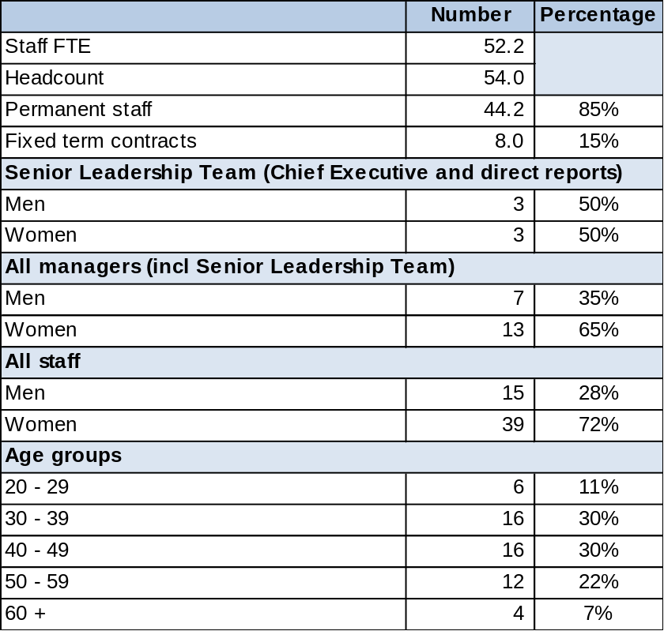
Ten percent of our managers are Māori, 15 percent of our total staff are Māori and 5 percent identify with other ethnic groups.

Leadership Development
- All members of the Senior Leadership Team and third tier managers received extensive training and development opportunities in the 2010/11 year.

Recruitment
- Creative New Zealand continues to attract an excellent calibre of applicants for its vacancies and has not experienced difficulty in filling any positions. Applicants are routinely invited to bring whānau or other support, and pōwhiri are reasonably commonplace. Selection panels typically include a gender mix, Māori and Pākehā. As far as possible we recruit internally so that staff are given career development opportunities.
- Full induction programmes are tailored to suit the needs of each new employee and encompass Good Employer principles, including health and safety, harassment and bullying prevention, stress prevention and so on.

Training and development
- Details of the development opportunities provided to staff and management are given above under ‘Best people’.
- We actively encourage staff to learn Te reo Māori and to attend weekly waiata practice.
- Monthly staff meetings routinely include sessions on building staff understanding of tikanga Māori.

Flexible work arrangements
- Flexible working arrangements are offered to recognise the needs of staff with families and with disabilities. Of our staff, 12 percent work part time, and staff have remote access to our information technology systems when they need to work from home.

Remuneration and recognition
- Creative New Zealand uses an external remuneration specialist to benchmark its positions against the private and public sector. Remuneration reviews are conducted annually based on performance, external benchmarks and within a predefined budget.
- The organisation uses additional methods to celebrate individual staff successes throughout the year.

Health and safety
- All new staff receive workplace assessments.
- All staff were offered flu vaccinations.
- A health and safety team meets monthly to develop new initiatives to promote staff wellbeing.
- Hazard identification is undertaken regularly.
- All staff have access to a confidential employee assistance programme at no charge.
- In the latest culture survey there was an 80 percent satisfaction rate from staff to the statement, “This organisation cares about the wellbeing of its people”.
- The organisation has received no allegations of bullying or harassment in the past 12 months.
PART 3: ORGANISATIONAL PERFORMANCE | NGĀ WHAKATUTUKITANGA O TE TARI

Non-financial Performance: Statement of Service Performance | Ngā Kaupapa Utukore: Te Pūrongo Whakaritenga Ratonga

The Statement of Intent 2010–13 set out the forecast for Creative New Zealand’s outputs for 2010/11.

Revised Statement of Intent – March 2011
A number of the measures and forecasts established in the Statement of Intent 2010–13 required the implementation of new collection and reporting systems to support them. However, implementation of those new systems was delayed.
In early 2011, following discussions with the Ministry for Culture and Heritage, the Office of the Auditor General and Audit New Zealand, it was decided to amend the Statement of Intent to reflect the measures that could be reported on. A revised Statement of Intent 2010–13 was tabled in Parliament in March 2011.
The original set of forecasts and measures are shown compared with the current measures in Appendix 2 of this report.

Reporting against the revised Statement of Intent
The following section presents Creative New Zealand’s achievements in 2010/11 through its three main output areas as measured against the revised Statement of Intent.
An overview of the achievements throughout the year is also presented on pages 8 to 63.

Comparative figures for 2008/09 and 2009/10
The structure of the outputs and performance measures in this Non-financial Performance: Statement of Service Performance changed between 2008/09 and 2009/10 and again between 2009/10 and 2010/11.
Consequently, some of the comparative performance information and figures for 2008/09 and 2009/10 have not been audited in this format and therefore are presented for trend analysis only.

Reconciling non-financial performance to financial performance
The financial data provided in this Non-Financial Statement of Service Performance cannot be fully reconciled to the Financial Performance section of the report because of different ways in which the data is aggregated and recognised.

Total Revenue, Income and Expenditure under Vote Arts, Culture and Heritage
Creative New Zealand operates under one central government output class: Promotion and Support of Arts and Film.
Funding is received from the Government through Vote: Arts, Culture and Heritage and the New Zealand Lottery Grants Board.
The following table shows the original forecast, the revised forecast from the March 2011 Revised Statement of Intent, the actual expenditure and the variance between the actuals and revised forecast.

 | Notes | 2010/11 Forecast Revised | 2010/11 Forecast Original | 2010/11 Actual | Variance
Revenue
Promotion and support of the arts and film |  | $ 15,689,000 | $ 15,689,000 | $ 15,689,000 | $ -
New Zealand Lottery Grants Board |  | $ 25,475,150 | $ 23,070,913 | $ 27,796,169 | $ 2,321,019
Other |  | $ 1,157,472 | $ 1,394,076 | $ 1,704,947 | $ 547,475
Total Revenue |  | $ 42,321,622 | $ 40,153,989 | $ 45,190,116 | $ 2,868,494
Expenses
Funding, Capability Building and Advocacy
Recurrent Funding Programme | 1 | $ 17,321,780 | $ 17,321,780 | $ 17,529,930 | $ 208,150
Contestable Funding Programme | 2 | $ 11,651,006 | $ 10,650,767 | $ 12,703,982 | $ 1,052,976
Creative Communities Scheme | 3 | $ 2,789,500 | $ 2,789,500 | $ 2,818,992 | $ 29,492
International Programme Funding | 4 | $ 248,000 | $ 340,000 | $ 1,430,824 | $ 1,182,824
Other Funding | 5 | $ 998,500 | $ 78,500 | N/A | ($ 998,500)
Capability-building Programmes | 6 | $ 1,859,000 | $ 1,557,000 | $ 1,158,201 | ($ 700,799)
Advocacy - Research and Strategy | 7 | $ 150,000 | $ 610,000 | $ 60,526 | ($ 89,474)
Other |  | $ – | $ - | $ 17,770 | $ 17,770
Total Funding, Capability Building and Advocacy |  | $ 35,017,786 | $ 33,347,547 | $ 35,720,225 | $ 702,439
Personnel and Other Operating Expenses |  | $ 8,038,204 | $ 7,742,292 | $ 7,673,370 | ($ 364,834)
TOTAL EXPENDITURE |  | $ 43,055,990 | $ 41,089,839 | $ 43,393,595 | $ 337,605
NET SURPLUS/(DEFICIT) |  | ($ 734,368) | ($ 935,850) | $ 1,796,521 | $ 2,530,889
Less:
Revaluation of Land and Buildings | 8 | $ - | $ - | $ 1,163,092 | $ 1,163,092
Revaluation of Works of Art | 8 | $ - | $ - | $ 200,981 | $ 200,981
Total other comprehensive income |  | $ - | $ - | $ 1,364,073 | $ 1,364,073
TOTAL PER STATEMENT OF COMPREHENSIVE INCOME |  | ($ 734,368) | ($ 935,850) | $ 432,448 | $ 1,166,816

Notes to the table above:
For an explanation of the revised revenue and forecast figures please refer to note 24 in the Financial Performance section of this report.
1. | Refer to Output 1.1 for further information.
2. | Refer to Output 1.2 for further information.
3. | Refer to Output 1.3 for further information.
4. | Refer to Output 1.4 for further information.
5. | The Other Funding forecast includes the Flexible Funding Portfolio and the Christchurch Earthquake Emergency Response Fund. However, expenditure against these budgets has been reclassified to Contestable to better reflect their nature. Actual costs include $25,000 from the Flexible Funding Portfolio and $667,532 for grants from the Christchurch Earthquake Emergency Response Fund.
6. | The original forecast included Venice Biennale $375,000; Festival of Pacific Arts (FOPA) $70,000 and Māori Arts Development Initiative $320,000 classified under capability building.  The revised forecast included Venice Biennale $375,000; FOPA $70,000.  The Venice Biennale and FOPA are disclosed under International Programme Funding in actuals, as their substance is funding; and the Māori Arts Development Initiative is disclosed under Contestable.  Refer to Output 2 for further information.
7. | The original forecast included ‘Develop International Markets and Audiences’ $510,000 under Advocacy; while it is in fact Capability Building and is disclosed there.  Refer to Output 3 for further information.
8. | No attempt was made to estimate in the Statement of Intent the impact of the revaluation of the Old Public Trust Building and the works of art. Refer to Note 24 to the Financial Statements for more information.

Output 1: Funding for Artists, Arts Practitioners and Arts Organisations
Creative New Zealand provides funding to artists, arts practitioners and arts organisations and their projects. It provides this funding in the following ways:
- multi-year funding for organisations
- as grants in response to applications that meet published criteria
- through initiatives established by the Arts Council, arts boards and Pacific Arts Committee in response to specific needs
- through devolving funds to partners for them to distribute.
The four key funding programmes are:
- Recurrent Funding
- Contestable Funding
- Creative Communities Scheme
- International Programme Funding.

Output 1.1: Recurrent Funding
Creative New Zealand’s investment in this programme supports the development of a sustainable infrastructure in the arts sector by funding key arts organisations (RFOs) for a fixed term. With such support, organisations are able to plan one, two or three-year programmes of activity.
Funding is provided to organisations in two ways:
- core funding, which is the amount specified in the funding agreement with each organisation and provided for a defined period.
- other funding – targeted support as required.
Creative New Zealand monitors the performance of the organisations regularly throughout the year, and works with them to improve their performance, as demonstrated under Output 2: Capability-building for artists, practitioners and organisations.
This output supports all four Outcomes. For further information on the distribution of Recurrent Funding to Outcomes, please see Part Two of this report.

Recurrent Funding review
During 2009/10, Creative New Zealand undertook an extensive review of the Recurrent Funding programme. The main reasons for reviewing the programme were that:
- the existing portfolio of RFOs (34 in 2010/11) had remained largely unchanged for over 20 years and was closed to new entrants
- major demographic changes have occurred in New Zealand over the past 20–30 years, including:
- increasing Māori and Pacific populations
- increasing ethnic diversity
- significant shifts in where and how people live and how they access art
- the rationale for investment decisions and investment levels under the Recurrent Funding programme was no longer clear, being based mainly on historic precedent.
The results of the review were implemented in 2010/11, with the creation of two new, complementary programmes that, from 1 January 2012, will replace the Recurrent Funding programme, plus the Arts Investment and Sector Investment grants in the Contestable Funding programme.
The new programmes are the Arts Leadership Investment (Toi Tōtara Haemata) and the Arts Development Investment (Toi Uru Kahikatea) programmes (referred to as the Tōtara and Kahikatea programmes).
The new programmes will provide increased clarity, stability and flexibility in the way we support New Zealand’s arts infrastructure. Tōtara organisations will fulfil specific key roles that Creative New Zealand has identified as important to the health of the arts sector. They will provide leadership and play an active role in promoting collaboration, developing talent, fostering new work, supporting innovation and taking artistic risks. Kahikatea organisations have more flexibility in what they are funded to deliver.
Further information on the review and new investment programmes is available on Creative New Zealand’s website www.creativenz.govt.nz.

Performance against forecasts
 | Notes | 2010/11 Forecast Revised | 2010/11 Actual |  | Variance to Target (+/-%)
 | Notes | 2010/11 Forecast Revised | Organisations | $ | Variance to Target (+/-%)
Quantity
Number of organisations contracted to deliver programmes of activity | 1 | 35 | 34 | $17,151,690 | (3%)
Quality
Organisations’ performances or services are assessed against quality criteria | 2 | 100% of organisations | 91% |  | (9%)
Organisations meet or exceed requirements of funding agreements | 3 | ≥ 90% | 91% |  | 1%
Timeliness
Payments to organisations are delivered within agreed timeframes | 4 | 100% | 100% | $17,529,930 | –

Notes to the table above:
1. | One RFO, MIC Toi Rerehiko, ceased being funded by Creative New Zealand effective from 28 February 2011. The funding received by MIC Toi Rerehiko up until this date is included in this table.  Dollar value includes core funding only. The total funding provided to RFOs is reported under note 4 to this table.
2. | Each RFO is allocated two external assessors, who attend a performance or event run by the organisation and provide confidential reports back to Creative New Zealand. Assessors are all professional peers within the New Zealand arts sector.  Three RFOs – Booksellers New Zealand, the New Zealand International Arts Festival and MIC Toi Rerehiko – were not assessed within the period. MIC Toi Rerehiko left the Recurrent Funding programme at the end of February 2011; Booksellers was also known to be leaving. The New Zealand International Arts Festival is biennial and last occurred in March 2010.
3. | This performance measure has been introduced in 2010/11. Organisations are assessed by Creative New Zealand based on their reporting of their activities against the expectations of their funding agreements.  Three RFOs – The Physics Room, The Court Theatre and the Christchurch Symphony Orchestra have been affected by the Christchurch earthquakes and therefore are not meeting expectations as agreed in their funding agreements. Funding is being continued to support them to recover from the earthquakes.
4. | This measure reflects the importance Creative New Zealand places on timely payment to the organisations. Payments of core funding are normally monthly; payments of other funding occur on an as required basis.  The actual dollar value includes the total funding received by RFOs (that is, core funding plus any other funding) but excludes grants from the Christchurch Earthquakes Emergency Response Fund Grants (reported under Output 1.2 Contestable Funding) and capability building (reported under Output 2).  The Physics Room, The Court Theatre, the Christchurch Symphony Orchestra and Arts on Tour New Zealand – the four RFOs based in Christchurch – received their funding for March to June 2011 inclusive paid out in advance to enable them to meet immediate expenses following the February 2011 earthquake.

Performance trends
 | Notes | 2008/09 Actual |  | 2009/10 Actual |  | 2010/11 Actual
 | Notes | Orgs | $ | Orgs | $ | Orgs | $
Quantity
Number of organisations contracted to deliver programmes of activity |  | 36 | $15,161,780 | 35 | $16,666,780 | 34 | $17,151,690
Quality
Organisations’ performances or services are assessed against quality criteria | 1 | New measure |  | 51% |  | 91%
Organisations meet or exceed requirements of funding agreements |  | New measure |  | New measure |  | 91%
Timeliness
Payments to organisations are delivered within agreed timeframes | 2 | 100% | $16,566,591 | 100% | $18,320,001 | 100% | $17,529,930

Notes to the table above:
1. | The target for both 2009/10 and 2010/11 was to assess 100 percent of RFOs. This was not achieved in 2009/10 and additional resources were provided in 2010/11.
2. | Total payments are down on the 2009/10 year following the cessation of funding to MIC Toi Rerehiko, lesser amounts being spent on organisations at risk, and a series of grants given to RFOs for strategic interventions in 2009/10 ($449,079) not being repeated in 2010/11.
Figure 38 shows the declining trend in numbers of organisations in the programme compared with increasing funding to the portfolio.
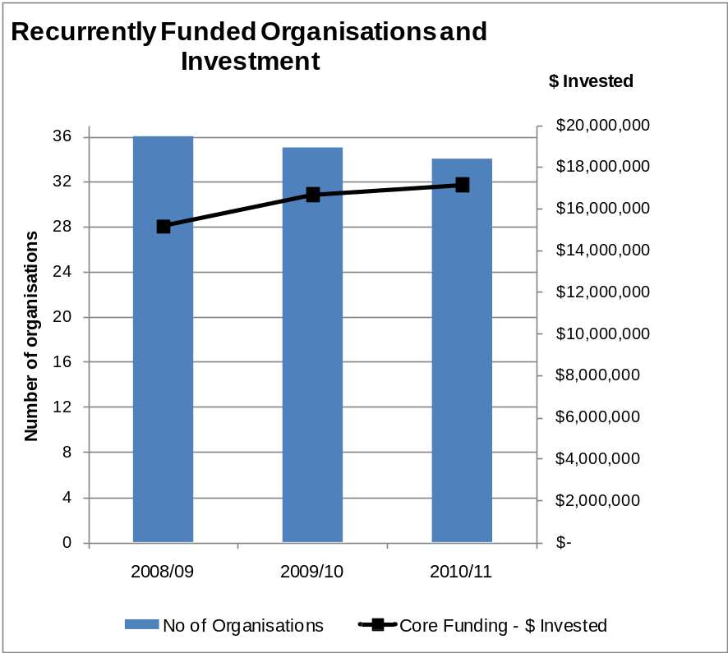
Figure 38: Number and Total Investment in Recurrently Funded Organisations, 2008/09 to 2010/11

Output 1.2: Contestable Funding
Creative New Zealand provides contestable funding through a range of programmes, selecting the best artists, arts practitioners and arts organisations and their projects. Around 500 projects are supported each year through the Contestable Funding programme.
A key aspect considered by the Contestable Funding assessment process is how effectively a project will achieve one, or more, of the results (‘impacts’) that Creative New Zealand is seeking.
In 2010/11, there were four main types of grants or investments available through Contestable Funding: Quick Response Grants, Arts Grants, Arts Investments and Sector Investments.
The quality of all projects is assessed by Creative New Zealand staff. Arts Grants, Arts Investments and Sector Investments projects are also assessed by external peer assessors. Projects are assessed for artistic quality on a seven-point scale across four areas.
- The idea: What is it that you want to do?
- The process: How will you carry out the project and where and when will it occur, and how will you evaluate the completed project?
- The people: Who is involved?
- The budget: How much will it cost?
Where relevant, projects are assessed for their contribution to cultural diversity, innovation and community arts participation. Projects are also assessed against how they meet one or more of Creative New Zealand’s impacts.
The Contestable Funding programme also includes Special Opportunities (awards, residencies, bursaries, scholarships), the Toi Ake and Toi Atu Tohunga Tukunga programmes which focus on specific outcomes for Māori and the Smash Palace Collaboration Fund. Applicants are assessed against additional criteria that are specific to these particular programmes.
Information about Creative New Zealand's Contestable Funding is available at www.creativenz.govt.nz.
Following the devastating Christchurch earthquakes, Creative New Zealand used some of its reserves to establish an Earthquake Emergency Response Fund. Emergency assistance grants have been made (and continue to be made) from the Fund which has been budgeted for until 2013/14.
Applications for these grants are considered on a monthly basis to provide rapid responses to changing needs in Christchurch. The emergency assistance grants are reported under Contestable Funding for 2010/11.
This output supports all four Outcomes. For further information on the distribution of Contestable Funding to Outcomes, please see Part Two of this report.

Performance against forecasts
 | Notes | 2010/11 Forecast | 2010/11 Actual |  | Variance to Target (+/-%)
 | Notes | Grants Approved | Grants Approved | $ Approved | Grants Approved
Quantity
Total Contestable projects | 1 | 450-500 | 584 | $12,703,982 | 17%
Quality
Project completion rate | 2 | 99% | 99% |  | –
Projects meet or exceed requirements of the approved application and the funding agreement | 3 | ≥ 95% | 97% (of the 84% of projects that were evaluated) |  | 2%
Timeliness
Grants are processed within published timeframes | 4 | 100% | 100% |  | –

Notes to the table above:
1. | This is an activity measure and is demand driven. However, it provides context for the Contestable Funding programme. Grants are project based and applicants may receive more than one grant in a year.
2. | A project is satisfactorily completed when a project completion report has been received by Creative New Zealand. Because a project may not be completed in the same year as it is funded, the project completion rate presented here includes all contestable projects funded across previous financial years.
3. | In 2010/11, a new process was introduced for evaluating the project completion reports against the objectives for the project as recorded in the original application and the funding agreement. Only those projects that were approved under the new Contestable Funding programme (that is, awarded after 1 February 2009) have been evaluated. Projects are evaluated as ‘Met expectations’, ‘Exceeded expectations’ or ‘Did not meet expectations’.  Of the reports received in 2010/11, 87 percent have been evaluated. The balance will be evaluated in 2011/12. Of those which have been evaluated, 97 percent were evaluated as ‘Met expectations’ or ‘Exceeded expectations’.
4. | This performance measure reflects the importance that Creative New Zealand places on timely application and assessment processes. Funding timeframes are published in the Contestable Funding Guide, Ngā Pūtea, published each year and available at www.creativenz.govt.nz.

Performance trends
 | 2008/09 Actual |  | 2009/10 Actual |  |  | 2010/11 Actual
 | Grants Approved | $ Approved | Grants Approved | $ Approved |  | Grants Approved | $ Approved
Quantity
Total Contestable projects | 527 | $11,972,682 | 504 |  | $11,739,438 | 584 |  | $12,703,982
Quality
Project acquittal rate | 99% |  | 99% |  |  | 99%
Projects meet or exceed requirements of the approved application and the funding agreement | 100% |  | 98% (of the 98% of projects that were evaluated |  |  | 97% (of the 84% of projects that were evaluated)
Timeliness
Grants are processed within published timeframes | 100% |  | 100% |  |  | 100%

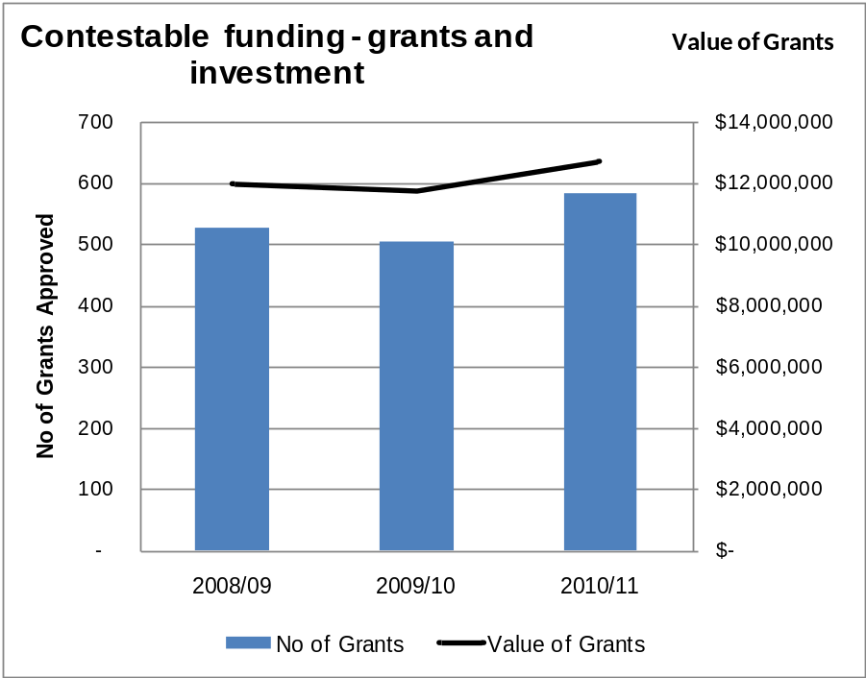
Figure 39: Number and value of grants, Contestable Funding programme, 2008/09 to 2010/11
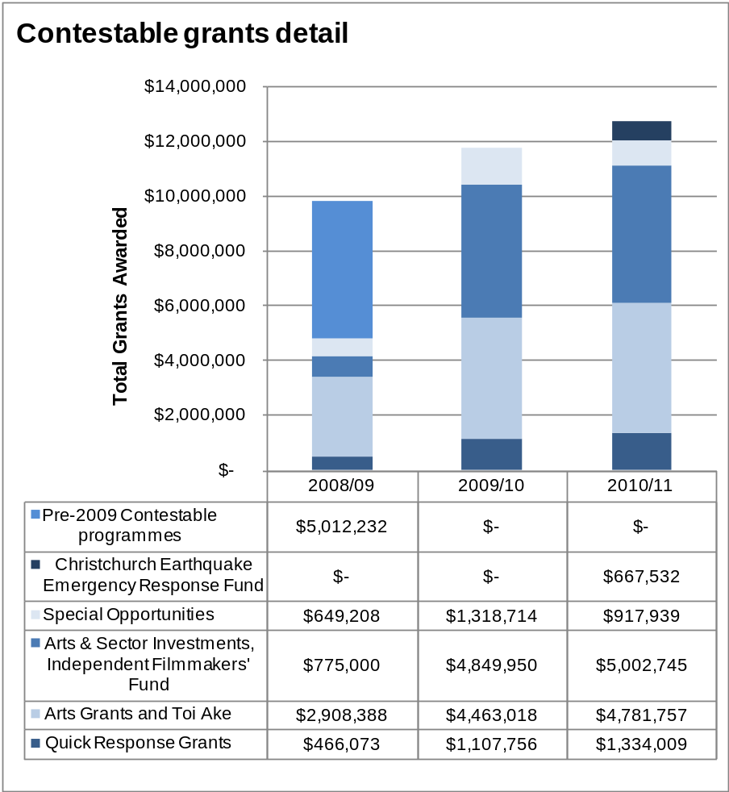
Figure 40: Numbers of Contestable grants, by grant type, 2008/09 to 2010/11

Output 1.3: Creative Communities Scheme
Established in 1995, the Creative Communities Scheme is a small-grants scheme that supports community arts projects and activities that take place within the local area of a territorial authority or local council. In contrast with the Recurrent Funding and Contestable Funding programmes, funding under the Creative Communities Scheme is devolved by Creative New Zealand to the 67 territorial authorities, which administer the scheme themselves or through suitable third parties.
Local assessment committees consider applications for funding under the scheme. Funding decisions are made on the basis of criteria set by Creative New Zealand:
- Broad community involvement – The project creates opportunities for local communities to engage with and participate in arts activities
- Diversity – The project supports the diverse arts and cultural traditions of local communities, enriching and promoting their uniqueness and cultural diversity
- Young people – The project enables and encourages young people (under 18 years) to engage with and actively participate in the arts.
This output directly supports Outcome 1: New Zealanders participate in the arts.

Performance against forecast
 | Notes | 2010/11 Forecast | 2010/11 Actual |  | Variance to Target (+/-%)
 | Notes | 2010/11 Forecast | Number | $ | Variance to Target (+/-%)
Quantity
Number of territorial authorities that will distribute Creative Communities Scheme funding |  | 67 | 67 |  | 0%
Triennial contracts with territorial authorities are signed in accordance with the Creative Communities Scheme policy |  | 100% | 100% |  | 0%
Number of grants awarded | 1 | 2,400 | 1,725 | $ 2,838,818 | (28%)
Quality
Projects are successfully completed in accordance with contracts | 2 | New measure | 99%
Timeliness
All Creative Communities Scheme funds are distributed within the required timeframe | 3 | 98% of funds distributed | 93% |  | (5%)

Notes to the table above:
1. | This is an activity measure and is demand driven. However, it provides context for the Scheme.  Grants are project-based and applicants may receive more than one grant in a year.  Changes to the Creative Communities Scheme which were effective from 1 July 2010 removed a previous funding cap. This has resulted in a higher average grant value compared with previous years (that is, $1,643 in 2010/11 versus $1,209 in 2009/10).  The actual dollar value shown is the value of approved grants, including rollovers from previous years, refunded grants and some funding from other sources.  Creative New Zealand’s total expenditure for this Scheme in 2010/11 was $2,818,742.
2. | This is a new measure, introduced in 2010/11. Projects are completed when grant recipients submit a project completion report to the territorial authority that made the grant. Because a project may not be completed in the same year it is funded, completed project numbers are currently low, but are expected to rise over the next one to two years. There have been 303 projects completed, of which only 3 have been assessed as ‘Did not meet expectations’.
3. | Percentage of funds distributed is calculated based on the total amount of funding allocated (including expenditure on promoting the Scheme) divided by the total funding sourced from Creative New Zealand (that is, 2010/11 allocation, rollovers from previous years and any grant funding returned to the territorial authority).  Changes to the Scheme which came into effect from 1 July 2010 required amendments to funding rounds for some territorial authorities (to a minimum of two rounds and a maximum of four). Because this is the first year of implementing these changes, some lag between target and achievement is to be expected, as applicants and authorities adjust to the new patterns.  As a rule, subject to agreement with Creative New Zealand, authorities may rollover up to 15 percent of a year’s unspent allocation to the following year. If that 15 percent roll over was factored in to this calculation, only 2.46 percent of funds ($68,435) remain unspent.

Performance trends
 | Notes | 2008/09 Actual |  | 2009/10 Actual |  | 2010/11 Actual
 | Notes | Number | $ | Number | $ | Number | $
Quantity
Number of territorial authorities that will distribute Creative Communities Scheme funding | 1 | 73 |  | 73 |  | 67
Triennial contracts with territorial authorities are signed in accordance with the Creative Communities Scheme policy |  | 100% |  | 100% |  | 100%
Number of grants awarded |  | 2,333 | $2,728,045 | 2,418 | $2,924,322 | 1,725 | $2,838,818
Quality
Projects are successfully completed in accordance with contracts |  | New measure |  | New measure |  | 99%
Timeliness
All Creative Communities Scheme funds are distributed within the required timeframe |  | 91% of funds distributed |  | 93% |  | 93%

Note to the table above:
1. | The decrease in the number of territorial authorities is attributable to amalgamation of Rodney District, Waitakere City, North Shore City, Auckland City, Manukau City, Papakura District and Franklin District councils into the new Auckland Council in November 2010.
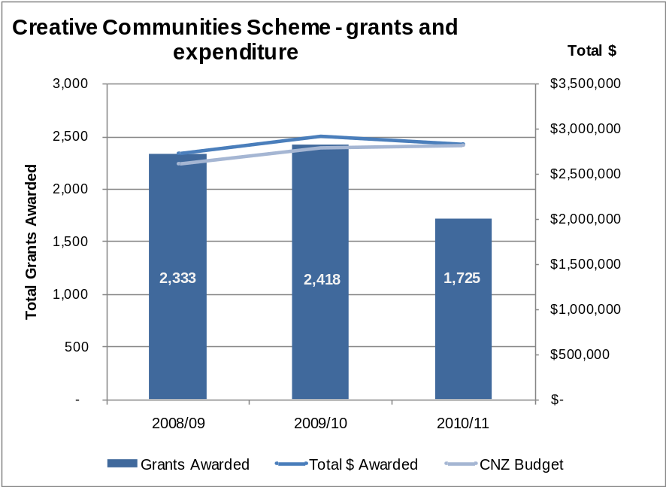
Figure 41: Number and value of grants, Creative Communities Scheme, 2008/09 to 2010/11

Output 1.4: International Programme Funding
Through International Programme Funding, Creative New Zealand identifies opportunities to support individual artists, practitioners, organisations or clusters of artists to tour, exhibit or perform internationally. International Funding also provides support for a New Zealand work to be performed by an overseas artist or company.
International Funding support might happen after a New Zealand artist or work has appeared at a trade fair overseas or after a particular market-development initiative.
Other activities include providing advice and resources to New Zealand artists seeking to work, or who are working, internationally.
The delivery of this programme is specific and targeted. International projects are generally longer term and outcomes take a minimum of six months and potentially up to 18 months to be fully recognised.
This output directly supports Outcome 4: New Zealand arts gain international success.

Performance against forecast
 | Notes | 2010/11 Forecast | 2010/11 Actual |  | Variance to Target  (+/-%)
 | Notes | 2010/11 Forecast | Number | $ | Variance to Target  (+/-%)
Quantity
Touring Fund projects |  |  | 18 | $ 312,779
Venice Biennale | 1 |  | 1 | $ 897,895
Festival of Pacific Arts | 2 |  | 1 | $ 68,414
Subtotal |  | ≥ 20 | 20 | $ 1,279,088 | -
Other Activities |  |  |  | $ 151,736
Total |  |  |  | $ 1,430,824
Quality
Projects are delivered in accordance with funding agreements | 3 | ≥ 80% | 100% (of the 53% of projects that were evaluated) |  | 25%

Notes to the table above:
1. | The total project investment for Creative New Zealand is $700,000 across two financial years – 2010/11 and 2011/12.  Expenditure for the Venice Biennale in 2010/11 is covered by the Creative New Zealand budget, plus $312,000 raised by the Venice patrons and $80,000 contributed by the Museum of New Zealand Te Papa Tongarewa.
2. | Festival of Pacific Arts costs are for project planning; the Festival will be held in 2012.
3. | In 2010/11, a new process was introduced of formally evaluating the project completion reports against the objectives for the project as recorded in the original application and the funding agreement. Projects are evaluated as ‘Met expectations’, ‘Exceeded expectations’ or ‘Did not meet expectations’.  Not all projects have been assessed. New systems and processes have been implemented to ensure that this is achieved.  Of the reports received in 2010/11, 53 percent have been evaluated. Of those evaluated, 100 percent met or exceeded expectations.

Performance trends
 | Notes | 2008/09 Actual |  | 2009/10 Actual |  | 2010/11 Actual
 | Notes | Number | $ | Number | $ | Number | $
Quantity
Number of projects funded | 1 | 20 | $1,612,481 | 25 | $804,761 | 20 | $1,430,824
Quality
Projects are delivered in accordance with funding agreements | 2 | 100% (of the 69% of projects that were evaluated) |  | 98% (of the 87% of projects that were evaluated) |  | 100% (of the 53% of projects that were evaluated)

Note to the table above:
1. | In 2010/11, expenditure on the Venice Biennale was $897,895 (compared with $593,766 in $2009/10) and on touring projects was $312,779 (compared with $164,214 in 2009/10). Expenditure on other services also increased.
2. | In 2008/09, 69 percent of projects were evaluated and 100 percent of those evaluated met or exceeded expectations. In 2009/10, 87 percent of projects were evaluated and 98 percent of those evaluated met or exceeded expectations.

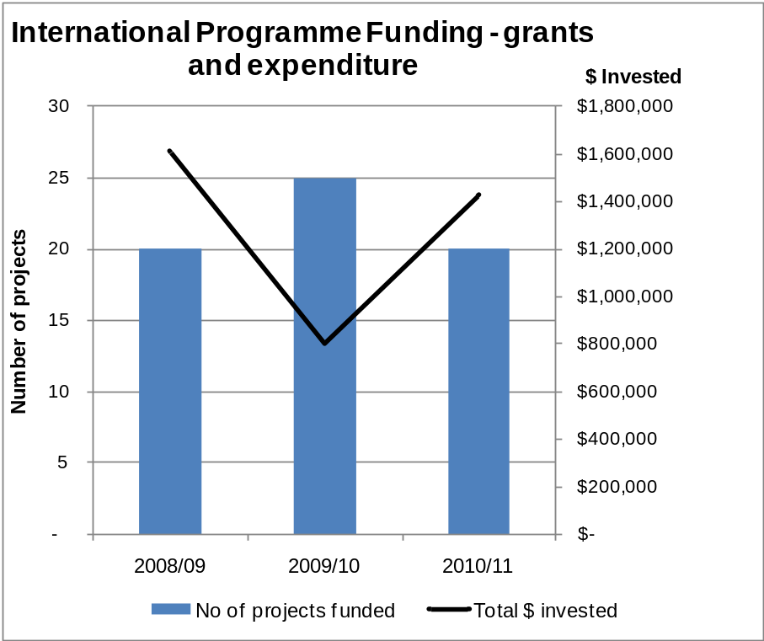
Figure 42: Number and value of projects, International Programme Funding, 2008/09 to 2010/11

Output 2: Capability Building for Artists, Arts Practitioners and Arts Organisations
Creative New Zealand delivers advice and capability-building initiatives to artists, arts practitioners and arts organisations. Capability building is provided in several areas, including leadership, governance, internal organisational systems and processes, audience development, market development and to support international engagement.
This output is supported by two main categories of activity.

Skill building
The national aspect of skill building was previously the Arts Organisations Development programme – delivering capability-building initiatives aimed at increasing the skills of arts organisations and arts practitioners, including arts leadership, governance, finance, human resources and specific targeted interventions.
The international aspect delivers strategic initiatives that aim to build the skills of artists, practitioners and organisations to produce and/or curate, plan, promote, negotiate, market, sell and manage international engagements.

Audience and market development
The national aspect of audience and market development delivers strategic initiatives that aim to encourage arts organisations and individuals to build dynamic and sustainable audience relationships. Key initiatives for 2010/11 are:
- 21st Century Arts Conference
- Audience 360º (vital statistics audience data programme)
- Move On Up coaching programme
- Optimise (was Getting On-line)
- Spotlight on Diversity programme
The initiatives offer advice, insight and audience intelligence through research, capability-building initiatives and coaching consultancies. Experts work alongside practitioners to develop strategies for attracting new and retaining existing audiences, and to gather data to help organisations benchmark their performance.
The international aspect of audience and market development aims to build strong relationships between local artists, arts practitioners and arts organisations with key players in international arts management and resourcing. This is done through attendance at international markets and fairs and bringing overseas experts and agents to New Zealand to experience New Zealand arts.
In addition to the formal categories of activity, Creative New Zealand staff working with individual artists, arts practitioners and arts organisations provide coaching and advice on a daily basis, using their own experience and expertise.
The delivery of all capability building is specific and targeted and supports all four Outcomes.

Performance against targets
 | Notes | 2010/11 Forecast | 2010/11 Actual |  | Variance to Target (+/-%)
 | Notes | 2010/11 Forecast | Number | $ | Variance to Target (+/-%)
Quantity
Total number of capability-building initiatives delivered to the sector | 1 | ≥ 25 | 57 | $1,158,201 | 128%
Number of person-days of workshop-based capability-building initiatives delivered | 2 | ≥ 500 | 500 |  | 0%
Number of participants in experiential capability-building initiatives | 3 | ≥ 50 | 101 |  | 102%
Quality
Proportion of participants who find the workshop-based capability-building initiatives to be relevant and effective | 4 | ≥ 90% | 88% |  | (2%)
Proportion of participants in international markets and fairs and overseas experts to view programmes who find the initiatives to be relevant and effective | 5 | ≥ 75% | 92% |  | 23%

-

Notes to the table above:
1. | Aggregated total number of activities, including those where participation is difficult to measure (for example on-line discussions in Optimise).  The forecast for 2010/11 was set on a conservative basis. Additional initiatives were offered to meet demand (for example governance training was provided to the entire board of 21 organisations, as opposed to previous years where a small number of larger courses were run offering training to selected individual board members).
2. | This is a new measure designed to provide direct comparisons of multi-day initiatives with part-day workshop events. The workshops are counted as part of note 1 above.
3. | Includes attendances at markets and fairs and the number of international visitors brought in to view New Zealand art locally (for example Te Manu Ka Tau – incoming visitors – programme).
4. | Based on immediate feedback from attendees at 30 workshops, using a five-point rating scale. The top two scales (relevant/very relevant and effective/very effective) are included in these results.
5. | Based on completion reports from six markets and fairs – the seventh fair was attended by Creative New Zealand only (for research purposes).

Performance trends
 | Notes | 2008/09 Actual |  | 2009/10 Actual |  | 2010/11 Actual
 | Notes | Number | $ | Number | $ | Number | $
Quantity
Number of capability-building initiatives delivered to the sector |  | 22 | $1,094,258 | 31 | $1,013,862 | 57 | $1,158,201
Total number of participants in capability-building initiatives | 1 | N/A |  | 564 |  | 886
Quality
Proportion of participants who find the workshop-based capability-building initiatives to be relevant and effective |  | 90% |  | 90% |  | 88%

Note to the table above:
1. | Aggregated total number of participants in all activities. Included for trend purposes. Includes all market and fair attendances as well as the 21st Century Arts Conference and all workshops, plus additional activities, for example workshops on Optimise, Spotlight on diversity and international workshop series. Several events showed a significant increase in attendance compared with 2009/10.  Comparative 2008/09 data is not available.
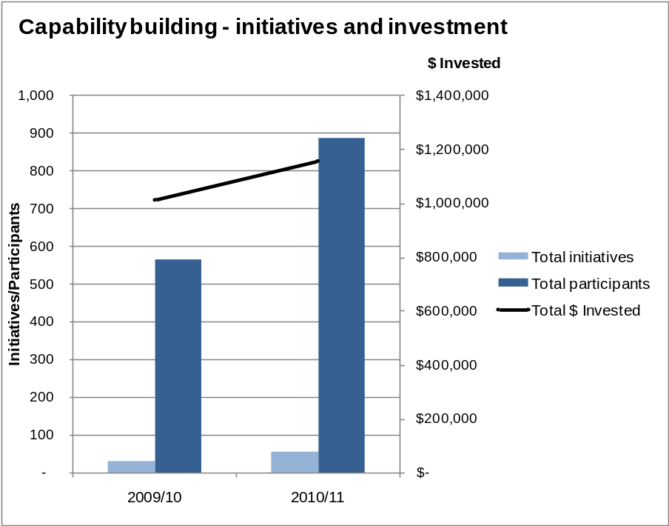
Figure 43: Capability building – initiatives, participation and investment, 2009/10 to 2010/11

Output 3: Advocacy for the Arts
The main aims of the advocacy programme are to raise awareness of the role and contribution of the arts and of key issues affecting the sector, and to change the environment for the benefit of the arts.
The advocacy programme includes the following activities:
- carrying out research for the arts sector
- developing strategic partnerships to increase support for the arts
- participating in cross-government initiatives
- where relevant, making submissions on issues affecting the arts sector or Creative New Zealand. In 2010/11, Creative New Zealand made submissions on:
- Auckland Regional Amenities Funding Board, Draft Funding Plan 2011/12
- Auckland Council’s 2011/12 Draft Annual Plan
- Wellington City Council’s 2010/11 Draft Annual Plan
- Palmerston North City Council’s Draft Arts Strategy.

Performance against targets
 | Notes | 2010/11 Forecast | 2010/11 Actual |  | Variance to Target (+/-%)
 | Notes | 2010/11 Forecast | Number | $ | Variance to Target (+/-%)
Quantity
Research
Total number of research projects and other resources delivered to the sector | 1 | 3 | 2 | $60,526 | (33%)
Strategic partnerships
Total number of meetings per key partner | 2 | 3 | 3 | N/A | 0%
Quality
The arts sector is using available resources as indicated by the website usage |  | ≥ 400,000 unique page views | 446,344 |  | 12%

Notes to the table above:
1. | Includes Health of Māori Heritage Arts (published November 2010) and Art of the possible: strengthening private sector support for the arts in New Zealand (published October 2010).  Publication of the results of the Audience 360º programme (part of Output 2) was postponed to 2011/12 for further analysis.
2. | Key partners are Auckland Council/ASB Community Trust and Wellington City Council. Meetings have also been held with Christchurch, Dunedin and Palmerston North City Councils.

Performance trends
 | Notes | 2008/09 Actual |  | 2009/10 Actual |  | 2010/11 Actual
 | Notes | Number | $ | Number | $ | Number | $
Quantity
Research
Total number of research projects and other resources delivered to the sector | 1 | 1 | $179,825 | 2 | $54,737 | 2 | $60,526
Strategic partnerships
Total number of meetings per key partner |  | 2 |  | 2 |  | 3
Quality
The arts sector is using available resources as indicated by the website usage |  |  |  |  |  | 446,344 unique page views

Note to the table above:
1. | The 2008/09 expenditure includes the cost of the 2008 New Zealanders and the arts survey, which will be re-run in 2011.

Financial Performance | Ngā Whakaritenga Pūtea

Independent Auditor’s Report

To the readers of the Arts Council of New Zealand Toi Aotearoa’s
financial statements and statement of service performance
for the year ended 30 June 2011
The Auditor-General is the auditor of the Arts Council of New Zealand Toi Aotearoa (Creative New Zealand). The Auditor-General has appointed me, J.R. Smaill, using the staff and resources of Audit New Zealand, to carry out the audit of the financial statements and statement of service performance of Creative New Zealand on her behalf.
We have audited:
- the financial statements of Creative New Zealand on pages 89 to 125 that comprise the statement of financial position, statement of commitments, statement of contingent liabilities and statement of contingent assets as at 30 June 2011, the statement of financial performance, statement of comprehensive income, statement of changes in equity, statement of cash flows and reconciliation of the net surplus from operations with the net cash flows from operating activities for the year ended on that date and notes to the financial statements that include accounting policies and other explanatory information; and
- the statement of service performance of Creative New Zealand on pages 65 to 84.

Opinion
In our opinion:
- the financial statements of Creative New Zealand on pages 89 to 125:
- comply with generally accepted accounting practice in New Zealand; and
- fairly reflect Creative New Zealand’s:
- financial position as at 30 June 2011; and
- financial performance and cash flows for the year ended on that date.
- the statement of service performance of Creative New Zealand on pages 65 to 84:
- complies with generally accepted accounting practice in New Zealand; and
- fairly reflects, for each class of outputs for the year ended 30 June 2011, Creative New Zealand’s:
- service performance compared with the forecasts in the statement of forecast service performance for the financial year; and
- actual revenue and output expenses compared with the forecasts in the statement of forecast service performance at the start of the financial year.
Our audit was completed on 31 October 2011. This is the date at which our opinion is expressed.
The basis of our opinion is explained below. In addition, we outline the responsibilities of the Arts Council and our responsibilities, and we explain our independence.

Basis of opinion
We carried out our audit in accordance with the Auditor-General’s Auditing Standards, which incorporate the International Standards on Auditing (New Zealand). Those standards require that we comply with ethical requirements and plan and carry out our audit to obtain reasonable assurance about whether the financial statements and statement of service performance are free from material misstatement.
Material misstatements are differences or omissions of amounts and disclosures that would affect a reader’s overall understanding of the financial statements and statement of service performance. If we had found material misstatements that were not corrected, we would have referred to them in our opinion.
An audit involves carrying out procedures to obtain audit evidence about the amounts and disclosures in the financial statements and statement of service performance. The procedures selected depend on our judgement, including our assessment of risks of material misstatement of the financial statements and statement of service performance, whether due to fraud or error. In making those risk assessments, we consider internal control relevant to Creative New Zealand’s preparation of the financial statements and statement of service performance that fairly reflect the matters to which they relate. We consider internal control in order to design audit procedures that are appropriate in the circumstances but not for the purpose of expressing an opinion on the effectiveness of Creative New Zealand’s internal control.
An audit also involves evaluating:
- the appropriateness of accounting policies used and whether they have been consistently applied;
- the reasonableness of the significant accounting estimates and judgements made by the Arts Council;
- the adequacy of all disclosures in the financial statements and statement of service performance; and
- the overall presentation of the financial statements and statement of service performance.
We did not examine every transaction, nor do we guarantee complete accuracy of the financial statements and statement of service performance. We have obtained all the information and explanations we have required and we believe we have obtained sufficient and appropriate audit evidence to provide a basis for our audit opinion.

Responsibilities of the Arts Council
The Arts Council is responsible for preparing financial statements and a statement of service performance that:
- comply with generally accepted accounting practice in New Zealand;
- fairly reflect Creative New Zealand’s financial position, financial performance and cash flows; and
- fairly reflect its service performance.
The Arts Council is also responsible for such internal control as is determined necessary to enable the preparation of financial statements and a statement of service performance that are free from material misstatement, whether due to fraud or error.
The Arts Council’s responsibilities arise from the Crown Entities Act 2004.

Responsibilities of the Auditor
We are responsible for expressing an independent opinion on the financial statements and statement of service performance and reporting that opinion to you based on our audit. Our responsibility arises from section 15 of the Public Audit Act 2001 and the Crown Entities Act 2004.

Independence
When carrying out the audit, we followed the independence requirements of the Auditor-General, which incorporate the independence requirements of the New Zealand Institute of Chartered Accountants.
Other than the audit, we have no relationship with or interests in Creative New Zealand.
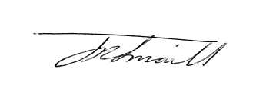
J.R. Smaill
Audit New Zealand
On behalf of the Auditor-General
Wellington, New Zealand
Matters relating to the electronic presentation of the audited financial statements and statement of service performance
This audit report relates to the financial statements and statement of service performance of the Arts Council of New Zealand Toi Aotearoa (Creative New Zealand) for the year ended 30 June 2011 included on Creative New Zealand’s website. Creative New Zealand’s Council is responsible for the maintenance and integrity of Creative New Zealand’s website. We have not been engaged to report on the integrity of Creative New Zealand’s website. We accept no responsibility for any changes that may have occurred to the financial statements and statement of service performance since they were initially presented on the website.
The audit report refers only to the financial statements and statement of performance named above. It does not provide an opinion on any other information which may have been hyperlinked to or from the financial statements and statement of service performance. If readers of this report are concerned with the inherent risks arising from electronic data communication they should refer to the published hard copy of the audited financial statements and statement of service performance as well as the related audit report dated 31 October 2011 to confirm the information included in the audited financial statements and statement of service performance presented on this website.
Legislation in New Zealand governing the preparation and dissemination of financial information may differ from legislation in other jurisdictions.

Statement of Responsibility
For the year ended 30 June 2011

The Council of Creative New Zealand accepts responsibility for the preparation of Creative New Zealand’s financial statements and statement of service performance, and the judgements made in them.
The Arts Council of Creative New Zealand accepts responsibility for establishing and maintaining a system of internal control designed to provide reasonable assurance as to the integrity and reliability of financial and non-financial reporting.
In the opinion of the Arts Council of Creative New Zealand, the annual financial statements and the statement of service performance for the year ended 30 June 2011 fairly reflect the financial position and operations of Creative New Zealand.
Signed on behalf of the Arts Council:

Erima Henare
Member, Arts Council
31 October 2011

Jimmy Wallace
Member, Arts Council
31 October 2011

Statement of Financial Performance
For the year ended 30 June 2011

BUDGET |  |  | ACTUAL | ACTUAL
2011 |  | NOTE | 2011 | 2010
$000 |  |  | $000 | $000
 | INCOME
15,689 | Revenue from Crown | 2 | 15,689 | 10,189
23,071 | Revenue from New Zealand Lottery Grants Board | 3 | 27,796 | 32,344
932 | Interest income |  | 609 | 564
262 | Other revenue | 4 | 702 | 870
200 | Grant retirements and gains | 5 | 394 | 507
40,154 | TOTAL INCOME |  | 45,190 | 44,474
 | EXPENDITURE
33,348 | Funding, capability building and advocacy | 10 | 35,722 | 34,799
4,454 | Personnel | 6 | 4,433 | 4,402
300 | Depreciation and amortisation | 7 | 489 | 426
282 | Council, board and committee fees | 8 | 266 | 277
– | Net Foreign exchange loss |  | – | 25
2,756 | Other operating expenses | 9 | 2,485 | 2,626
41,140 | TOTAL EXPENDITURE | 10 | 43,395 | 42,555
(986) | NET OPERATING SURPLUS / (DEFICIT) |  | 1,795 | 1,919

The accompanying accounting policies and notes form an integral part of these financial statements.

Statement of Comprehensive Income
For the year ended 30 June 2011

BUDGET |  |  | ACTUAL | ACTUAL
2011 |  | NOTE | 2011 | 2010
$000 |  |  | $000 | $000
(986) | Net operating surplus / (deficit) for the year |  | 1,795 | 1,919
 | Other comprehensive income
- | Revaluation of land and buildings | 14 | (1,163) | (252)
- | Revaluation of works of art | 15 | (201) | (102)
 | Total other comprehensive income |  | (1,364) | (354)
(986) | Total comprehensive income |  | 431 | 1,565

Statement of Changes in Equity
For the year ended 30 June 2011

BUDGET |  |  | ACTUAL | ACTUAL
2011 |  | NOTE | 2011 | 2010
$000 |  |  | $000 | $000
13,620 | Total public equity as at 1 July |  | 13,372 | 11,807
(986) | Net operating surplus/(deficit) for the year |  | 1,795 | 1,919
– | Other comprehensive income |  | (1,364) | (354)
(986) | Total comprehensive income |  | 431 | 1,565
12,634 | TOTAL PUBLIC EQUITY AS AT 30 JUNE |  | 13,803 | 13,372
8,858 | Accumulated funds as at 1 July |  | 8,964 | 7,045
(986) | Net operating surplus/(deficit) for the year |  | 1,795 | 1,919
7,872 | Accumulated funds as at 30 June |  | 10,759 | 8,964
4,762 | Revaluation reserve as at 1 July |  | 4,408 | 4,762
– | Revaluation of land and buildings | 14 | (1,163) | (252)
– | Revaluation of works of art | 15 | (201) | (102)
4,762 | Revaluation reserve as at 30 June |  | 3,044 | 4,408
12,634 | TOTAL PUBLIC EQUITY AS AT 30 JUNE |  | 13,803 | 13,372

The accompanying accounting policies and notes form an integral part of these financial statements.

Statement of Financial Position
As at 30 June 2011

BUDGET |  |  | ACTUAL | ACTUAL
2011 |  | NOTE | 2011 | 2010
$000 |  |  | $000 | $000
 | PUBLIC EQUITY
4,762 | Revaluation reserves | 11 | 3,044 | 4,408
7,872 | Accumulated funds |  | 10,759 | 8,964
12,634 | TOTAL PUBLIC EQUITY |  | 13,803 | 13,372
 | Represented by:
 | ASSETS
 | Current assets
15,112 | Cash and cash equivalents | 12 | 21,483 | 17,696
78 | Debtors and other receivables | 13 | 203 | 374
116 | Prepayments |  | 171 | 114
15,306 | Total current assets |  | 21,857 | 18,184
 | Non-current assets
4,678 | Property, plant and equipment | 14 | 3,275 | 4,579
2,339 | Works of art | 15 | 2,046 | 2,237
491 | Investment property | 16 | 540 | 550
549 | Intangible assets | 17 | 492 | 539
8,057 | Total non-current assets |  | 6,353 | 7,905
23,363 | TOTAL ASSETS |  | 28,210 | 26,089
 | LIABILITIES
 | Current liabilities
2,214 | Creditors and other payables | 18 | 2,495 | 1,729
235 | Employee entitlements | 20 | 321 | 329
8,280 | Grants payable |  | 11,550 | 10,623
10,729 | Total current liabilities |  | 14,366 | 12,681
 | Non-current liabilities
– | Employee entitlements | 20 | 41 | 36
– | Total non-current liabilities |  | 41 | 36
10,729 | TOTAL LIABILITIES |  | 14,407 | 12,717
12,634 | NET ASSETS |  | 13,803 | 13,372
The accompanying accounting policies and notes form an integral part of these financial statements.
Stephen Wainwright Erima Henare
Chief Executive Member, Arts Council
31 October 2011 31 October 2011

Statement of Cash Flows
For the year ended 30 June 2011

BUDGET |  |  | ACTUAL | ACTUAL
2011 |  |  | 2011 | 2010
$000 |  |  | $000 | $000
 | CASH FLOWS FROM OPERATING ACTIVITIES
 | Cash was provided from:
15,689 |  | Crown revenue | 15,689 | 10,189
23,071 |  | New Zealand Lottery Grants Board | 27,796 | 32,344
262 |  | Other revenue | 663 | 833
43 |  | Net goods and services tax | 1,206 | –
– |  | Retirement of grants | 103 | 163
932 |  | Interest received | 600 | 590
39,997 |  |  | 46,057 | 44,119
 | Cash was applied to:
33,182 |  | Payments of grants | 34,499 | 33,031
4,472 |  | Payments to employees | 4,436 | 4,361
2,608 |  | Payments of operating expenses | 3,088 | 3,887
– |  | Net goods and services tax | – | 705
40,262 |  |  | 42,023 | 41,984
(265) | NET CASH FLOWS FROM OPERATING ACTIVITIES |  | 4,034 | 2,135
 | CASH FLOWS FROM INVESTING ACTIVITIES
 | Cash was provided from:
– |  | Sale of property, plant and equipment | 1 | 2
 | Cash was applied to:
211 |  | Purchase of property, plant, equipment  and intangible assets | 248 | 192
(211) | NET CASH FLOWS FROM INVESTING ACTIVITIES |  | (247) | (190)
(476) | NET INCREASE (DECREASE) IN CASH HELD |  | 3,787 | 1,945
 | Add opening cash brought forward:
81 |  | Cash on hand and at bank | 142 | 522
15,507 |  | Short-term deposits | 17,554 | 15,229
– | Add effect of unrealised foreign currency gain |  | – | –
15,112 | BALANCE AT END OF YEAR |  | 21,483 | 17,696
 | Represented by:
 | Closing cash carried forward:
80 |  | Cash on hand and at bank | 29 | 142
15,032 |  | Short-term deposits | 21,454 | 17,554
15,112 |  |  | 21,483 | 17,696
The goods and services tax (GST) (net) component of operating activities reflects the net GST paid and received with the Inland Revenue Department. The GST (net) component has been presented on a net basis, as the gross amounts do not provide meaningful information for financial statement purposes.
The accompanying accounting policies and notes form an integral part of these financial statements.
Reconciliation of the net surplus from operations with the net cash flows from operating activities
For the year ended 30 June 2011

 |  | ACTUAL | ACTUAL
 |  | 2011 | 2010
 |  | $000 | $000
Net surplus (deficit) from operations |  | 1,795 | 1,919
Add (less) non-cash items:
 | Depreciation and amortisation | 489 | 426
 | (Gain) loss on foreign exchange | (3) | –
 | Loss on disposal of property, plant and equipment | 2 | 7
 | Loss (gain) on revaluation of investment property | 10 | (59)
 | Retirement of grants | (291) | (285)
 |  | 207 | 89
Add (less) movements in working capital items:
 | Decrease (increase) in prepayments | (57) | 25
 | Decrease (increase) in accounts receivable | (35) | (35)
 | Decrease (increase) in interest receivable | (9) | 26
 | Increase (decrease) in GST payable / receivable | 1,206 | (705)
 | Increase (decrease) in accounts payable | (287) | 120
 | Increase (decrease) in provision for employee entitlements | (3) | 41
 | Increase (decrease) in current grants committed | 1,218 | 657
 |  | 2,033 | 129
Add (Less) items classified as an investing activity
 | Net loss (gain) on the sale of property, plant and equipment | (1) | (2)
NET CASH FLOW FROM OPERATING ACTIVITIES |  | 4,034 | 2,135

The accompanying accounting policies and notes form an integral part of these financial statements.
Statement of Commitments
As at 30 June 2011

 | 2011 | 2010
 | $000 | $000
Capital commitments approved and contracted | – | –
Non-cancellable operating lease commitments (as lessor) receivable:
Creative New Zealand leases out part of the Old Public Trust Building under an operating lease.
The future minimum lease payments under the terms of the non-cancellable lease are as follows:
Not later than one year | 3 | 46
Later than one year and not later than two years | 3 | –
Later than two years and not later than five years | 9 | –
Later than five years | 2 | –
 | 17 | 46
Non-cancellable operating lease commitments (as lessee) payable:
Not later than one year | 116 | 151
Later than one year and not later than two years | 101 | 145
Later than two years and not later than five years | 125 | 217
Later than five years | – | 10
 | 342 | 523
Grant commitments, payable:
Not later than one year | 614 | 10,301
Later than one year and not later than two years | 400 | 214
 | 1,014 | 10,515
TOTAL COMMITMENTS | 1,356 | 11,038
Operating lease commitments
Creative New Zealand leases office premises in Auckland and Christchurch, photocopiers, facsimile machines and printers. The non-cancellable leasing period for these leases range from two to six years. There are no contingent rents payable and no sublease income is receivable on these operating leases.
Grant commitments
Contracts are entered into with organisations, which Creative New Zealand funds on a two- or three-year basis. Amounts granted under these contracts are disclosed in the Statement of Financial Performance to the extent that they relate to the financial year.
The major variation in grant commitments is caused by the timing of funding contracts under the Recurrent Funding programme. The current contracts end on 31 December 2011. The new funding contracts for the Arts Leadership Investment (Toi Tōtara Haemata) and Arts Development Investment (Toi Uru Kahikatea) programmes, which begin on 1 January 2012, were ratified in August 2011.

Statement of Contingent Liabilities
As at 30 June 2011

The Old Public Trust Building strengthening
In April 2010, Creative New Zealand was notified by the Wellington City Council that, subject to section 124 of the Building Act 2004, the Old Public Trust Building had been classified as earthquake prone.
The Building Act 2004 and the associated Wellington City Council Earthquake Prone Buildings policy would suggest that significant upgrade of the Old Public Trust Building is required within a 10–15 year period; however, some discretion is permitted for heritage buildings. The Old Public Trust Building is a Category 1 Heritage Place.
Creative New Zealand has noted that doing nothing to the building is not seen as appropriate given the building’s importance or for the safety of its occupants.
Creative New Zealand’s share of the estimated cost of $1.267 million for the strengthening of the Old Public Trust Building (not including refurbishment) would be $0.836 million, with the other members of the Body Corporate paying the balance.

Bank Guarantees
 | ACTUAL | ACTUAL
 | 2011 | 2010
 | $000 | $000
Bank of New Zealand - Datacom Employer Services Limited | 150 | 150
Bank of New Zealand - Wellington Regional Chamber of Commerce | 974 | –
 | 1,124 | 150
The two bank guarantees to Wellington Regional Chamber of Commerce of $0.974 million relate to the ATA Carnet bank indemnity. The Carnet relates to the sea and air freight of exhibition items shipped to the Venice Biennale 2011 that runs from 4 June to 27 November 2011.

Statement of Contingent Assets
As at 30 June 2011
As a result of a review of policy relating to grant defaults, Creative New Zealand has started to invoice grantees who are in default of their grant terms and conditions.
The issuance of these invoices could result in either the grantee producing a satisfactory acquittal report or the repayment of the grant. If a satisfactory acquittal report is provided then the repayment of the grant will not be pursued.
It is not possible to reliably estimate the amount recoverable on these invoices; therefore, amounts invoiced during the financial year and not paid as at 30 June 2011 have not been recognised in the Statement of Financial Position. Instead the invoiced amounts are disclosed below as a contingent asset in accordance with NZ IAS 37.
At 30 June 2011, the total invoiced to grantees in a default position was as follows.
 | 2011 | 2010
Granting board or committee | $000 | $000
Arts Board | 16 | 16
Te Waka Toi | 32 | 75
Pacific Arts Committee | 42 | 48
Screen Innovation Fund | – | 36
 | 90 | 175

Notes to the Financial Statements

1. Statement of accounting policies
for the year ended 30 June 2011.

1.1 Reporting entity
The Arts Council of New Zealand Toi Aotearoa was established on 1 July 1994 by the Arts Council of New Zealand Toi Aotearoa Act 1994. The Council has chosen to operate under the name Creative New Zealand.
Creative New Zealand is a Crown entity as defined by the Crown Entities Act 2004 and is domiciled in New Zealand. As such, Creative New Zealand’s ultimate parent is the New Zealand Crown.
Its purpose, as defined under the Arts Council of New Zealand Toi Aotearoa Act 1994, is to encourage, promote and support the arts in New Zealand for the benefit of all New Zealanders.
Accordingly, Creative New Zealand has designated itself as a public benefit entity for the purposes of New Zealand Equivalents to International Financial Reporting Standards (NZ IFRS).
The financial statements of Creative New Zealand are for the year ended 30 June 2011 and were authorised for issue by Creative New Zealand on 18 October 2011.

1.2 Basis of preparation

1.2.1 Statement of compliance
The financial statements have been prepared in accordance with the Arts Council of New Zealand Toi Aotearoa Act 1994 and the Crown Entities Act 2004, which includes the requirement to comply with generally accepted accounting practice in New Zealand (NZ GAAP).
These financial statements comply with NZ IFRS, and other applicable financial reporting standards, as appropriate for public benefit entities.

1.2.2 Measurement base
The financial statements have been prepared on a historical cost basis, except where modified by the revaluation of land and building, works of art and investment property.
The accrual basis of accounting has been used unless otherwise stated.

1.2.3 Functional and presentation currency
The financial statements are presented in New Zealand dollars (NZ$), and are rounded to the nearest thousand dollars ($000), unless otherwise stated. The functional currency of Creative New Zealand is New Zealand dollars.

1.2.4 Changes in accounting policies and estimates
There have been no changes in accounting policies since the date of the last audited financial statements, other than the impact of changes in NZ IFRS. These policies have been applied on a basis consistent with previous years. If errors are detected that have a material impact on prior periods, then these are applied retrospectively, and comparatives are restated.
Creative New Zealand has early adopted the following revisions to accounting standards during the financial year, which have had only a presentational or disclosure effect:
NZ IAS 24 Related Party Disclosures (Revised 2009) – the effect of early adopting the revised NZ IAS 24 is:
- further information required to be disclosed about transactions between Creative New Zealand and entities controlled, jointly controlled, or significantly influenced by the Crown
- commitments with related parties require disclosure
- information is required to be disclosed about any related party transactions with Ministers of the Crown.

1.3 Standards, amendments and interpretations issued but not yet effective and have not been early adopted
The following new standards, amendments or interpretations that have been issued but are not yet effective may be relevant for Creative New Zealand's financial statements in the future. These standards, amendments or interpretations have not been applied in these financial statements but could have a material effect on these prospective financial statements if they had been applied.
NZ IFRS 9 Financial Instruments, effective from 1 January 2013, replaces NZ IAS 39 Financial Instruments: Recognition and Measurement. NZ IAS 39 is being replaced in the following three main phases:
- Phase 1 Classification and Measurement
- Phase 2 Impairment Methodology
- Phase 3 Hedge Accounting.
Phase 1 on the classification and measurement of financial assets has been completed and has been published in the new financial instrument standard NZ IFRS 9. NZ IFRS 9 uses a single approach to determine whether a financial asset is measured at amortised cost or fair value, replacing the many different rules in NZ IAS 39. The approach in NZ IFRS 9 is based on how an entity manages its financial instruments (its business model) and the contractual cash flow characteristics of the financial assets. The financial liability requirements are the same as those of NZ IAS 39, except for when an entity elects to designate a financial liability at fair value through the surplus/deficit. The new standard is required to be adopted for the year ended 30 June 2014. Creative New Zealand does not have complex financial and/or long-term financial assets and, therefore, does not expect material changes to current disclosures.

1.4 Accounting policies
The accounting policies set out below have been applied consistently to all periods presented in these financial statements.

1.4.1 Recognition of revenue and expenditure
Revenue is recognised and measured at the fair value of consideration received or receivable to the extent it is probable that the economic benefits will flow to Creative New Zealand and the revenue can be measured reliably.
Crown revenue
Creative New Zealand receives a significant amount of its funding from the Crown, which is restricted in its use for the purpose of meeting its objectives as specified in the Statement of Intent.
Revenue from the Crown is recognised as revenue when earned and is reported in the financial period to which it relates.
Other grants
Creative New Zealand receives the majority of its funding from the New Zealand Lottery Grants Board. This is recognised as revenue when it becomes receivable unless there is an obligation to return the funds if conditions of the grant are not met. If there is such an obligation, the grants are initially recorded as grants received in advance and recognised as revenue when conditions of the grant are satisfied.
Revenue received from third parties on the condition that it is used for a particular purpose is recognised in the Statement of Financial Performance only when the funds are spent for the designated purpose. Any unspent funds at the reporting date are included within current liabilities in the Statement of Financial Position and carried forward to the next financial year.
Interest
Interest income is recognised as it accrues on bank account balances, on-call and short-term deposits, using the effective interest method.
Rental income
Rental income is recognised in the Statement of Financial Performance on a straight line basis over the term of the lease.

1.4.2 Recognition of grants and initiatives expenditure
Non-discretionary grants are those grants awarded if the grant application meets the specified criteria and are recognised as expenditure when an application that meets the specified criteria for the grant has been received.
Discretionary grants are those grants where Creative New Zealand has no obligations to award on receipt of the grant application and are recognised as expenditure when approved by Creative New Zealand and the approval has been communicated to the applicant.
The liability disclosed in the Statement of Financial Position represents financial grants to New Zealand artists and arts organisations committed by Creative New Zealand but not uplifted at balance date.
When grants that were committed by Creative New Zealand in previous years are no longer required for the purpose for which they were committed, they are retired and recognised as a gain in the Statement of Financial Performance.
During the year, funds may be set aside for Council- or board-led projects, known as initiatives. If these funds are not fully expensed at the end of the financial year they are carried forward to the next financial year within current liabilities in the Statement of Financial Position.

1.4.3 Foreign currency transactions
Foreign currency transactions are translated into New Zealand dollars using the exchange rates prevailing at the dates of transactions. Foreign exchange gains and losses resulting from the settlement of such transactions and from the translation at year-end exchange rates of monetary assets and liabilities denominated in foreign currencies are recognised in the Statement of Financial Performance.

1.4.4 Income tax
Creative New Zealand is a public authority and, consequently, is exempt from the payment of income tax in accordance with the Income Tax Act 2007. Accordingly, no charge for income tax has been provided.

1.4.5 Leases
Creative New Zealand leases office premises in Christchurch and Auckland, photocopiers, facsimile machines and printers.
These leases, where the lessor effectively retains substantially all the risks and benefits of ownership of the leased items, are classified as operating leases. Lease payments under an operating lease are recognised as an expense on a straight line basis over the term of the lease in the Statement of Financial Performance.
Creative New Zealand does not have any finance lease arrangements.

1.4.6 Property, plant and equipment
Property, plant and equipment is shown at cost or valuation, less accumulated depreciation and impairment losses.
Revaluation
Land and buildings are revalued with sufficient regularity to ensure that the carrying amount does not differ materially from fair value and at least every three years. Fair value is determined from market-based evidence by an independent registered valuer. All other asset classes are carried at depreciated historical cost.
The carrying values of revalued assets are assessed annually to ensure that they do not differ materially from the assets’ fair values.
The net revaluation results are credited or debited to other comprehensive income and are accumulated to an asset revaluation reserve in equity for that class of assets. Where this would result in a debit balance in the asset revaluation reserve, this balance is not recognised in other comprehensive income but is recognised in the Statement of Financial Performance. Any subsequent increase on revaluation that reverses a previous decrease in value recognised in the Statement of Financial Performance will be recognised first in the Statement of Financial Performance, up to the amount previously expensed, and then recognised in other comprehensive income.
Additions
The cost of an item of property, plant and equipment is recognised as an asset only when it is probable that future economic benefits or service potential associated with the item will flow to Creative New Zealand and the cost of the item can be measured reliably.
Where an asset is acquired at no cost, or for a nominal cost, it is recognised at fair value when control over the asset is obtained.
Disposals
Gains and losses on disposals are determined by comparing the disposal proceeds with the carrying amount of the asset. Gains and losses on disposals are included in the Statement of Financial Performance.
When revalued assets are sold, the amounts included in asset revaluation reserves in respect of those assets are transferred to accumulated funds.
Subsequent costs
Costs incurred subsequent to initial acquisition are capitalised only when it is probable that future economic benefits or service potential associated with the item will flow to Creative New Zealand and the cost of the item can be measured reliably.
The costs of day-to-day servicing of property, plant and equipment are recognised in the Statement of Financial Performance as they are incurred.
Depreciation
Depreciation is provided on a straight line basis on all property, plant and equipment, other than freehold land, at rates that will write-off the cost (or valuation) of the assets to their estimated residual value over their useful lives.
The useful lives and associated depreciation rates of major classes of assets have been estimated as follows.

Land | Not depreciated
Building | 35 years | 2.9%
Building improvements | 10 or 35 years | 10% or 2.9%
Furniture, equipment and fittings | 5 years | 20%
Computer equipment | 4 years | 25%

1.4.7 Works of art
Works of art are revalued with sufficient regularity to ensure that the carrying amount does not differ materially from fair value and at least every three years. Fair value is determined from market-based evidence by an independent valuer. The results of revaluing works of art are credited or debited to an asset revaluation reserve for that class of asset, in the same way as land and buildings.
Works of art are not depreciated as they have an indeterminate useful life and are expected to appreciate in value over time. The carrying values of revalued works of art are assessed annually to ensure that they do not differ materially from the assets’ fair values.

1.4.8 Investment property
Investment property consists of part of the Old Public Trust Building on which rental income is earned.
The fair value of Creative New Zealand’s ownership of the premises is determined by an independent registered valuer using market-based evidence. To determine the fair value of the investment property, this valuation has been apportioned between the areas occupied by Creative New Zealand and the areas leased out on the basis of potential net rental income-earning capacity of each area.
Any change in the fair value of investment property is recognised in the Statement of Financial Performance in the year of valuation.

1.4.9 Intangible assets
Software acquisition and development
Acquired computer software licenses are capitalised on the basis of the costs incurred to acquire and bring to use the specific software.
Costs that are directly associated with the development of software for internal use are recognised as an intangible asset. Direct costs include the software development, employee costs and an appropriate portion of relevant overheads.
Staff training costs are recognised as an expense when incurred. Costs associated with maintaining computer software are recognised as an expense when incurred.
Amortisation
The carrying value of an intangible asset with a finite life is amortised on a straight line basis over its useful life. Amortisation begins when the asset is available for use and ceases at the date the asset is derecognised. The amortisation charge for each period is recognised in the Statement of Financial Performance.
The useful lives and associated amortisation rates of major classes of intangible assets have been estimated as follows.
Web portal 4 years 25% straight line
Acquired computer software 1 – 4 years 25% straight line

1.4.10 Impairment of non-financial assets
Property, plant and equipment and intangible assets that have a finite useful life are reviewed for indicators of impairment whenever events or changes in circumstances indicate that the carrying amount may not be recoverable. An impairment loss is recognised for the amount by which the asset’s carrying amount exceeds its recoverable amount. The recoverable amount is the higher of an asset’s fair value less costs to sell and value in use.
Value in use is depreciated replacement cost for an asset where the future economic benefits or service potential of the asset are not primarily dependent on the asset’s ability to generate net cash inflows and where Creative New Zealand would, if deprived of the asset, replace its remaining future economic benefits or service potential.
If an asset’s carrying amount exceeds its recoverable amount, the asset is impaired and the carrying amount is written down to the recoverable amount. For revalued assets, the impairment loss is recognised against the revaluation reserve for that class of asset. Where that results in a debit balance in the revaluation reserve, the balance is recognised in the Statement of Financial Performance.
For assets not carried at a revalued amount, the total impairment loss is recognised in the Statement of Financial Performance.
The reversal of an impairment loss on a revalued asset is credited to the revaluation reserve. However, to the extent that an impairment loss for that class of asset was previously recognised in the Statement of Financial Performance, a reversal of the impairment loss is also recognised in the Statement of Financial Performance.

1.4.11 Financial instruments
Creative New Zealand is party to non-derivative financial instruments as part of its normal operations. These financial instruments include bank accounts, on-call deposits, short-term deposits, trade and other receivables, and trade and other payables.
Except for those items covered by a separate accounting policy, all financial instruments are initially recognised in the Statement of Financial Position at fair value and all revenues and expenses in relation to financial instruments are recognised in the Statement of Financial Performance.
Creative New Zealand does not use derivative financial instruments.

1.4.12 Cash and cash equivalents
Cash and cash equivalents held by Creative New Zealand include bank balances, on-call bank deposits and short-term deposits with original maturities of three months or less that are readily convertible to known amounts of cash and that are subject to an insignificant risk of changes in value.
Investments in bank deposits are initially measured at fair value plus transaction costs. After initial recognition, investments in bank deposits are measured at amortised cost using the effective interest method, less any provision for impairment.

1.4.13 Debtors and other receivables
Debtors and other receivables are recognised initially at fair value and subsequently measured at amortised cost using the effective interest method, less any allowance for impairment.
Collectability of receivables is reviewed on an ongoing basis. An impairment provision is recognised when there is objective evidence that Creative New Zealand will not be able to collect amounts due according to the original terms of the receivable. Significant financial difficulties of the debtor, probability that the debtor will enter into a bankruptcy, receivership or liquidation, and default in payments are considered indicators that the debt is impaired. The amount of the impairment is the difference between the asset’s carrying amount and the present value of estimated future cash flows, discounted using the original effective interest rate. The carrying amount of the asset is reduced through the use of an allowance account, and the amount of the loss is recognised in the surplus or deficit. When the receivable is uncollectible, it is written-off against the allowance account for receivables.

1.4.14 Creditors and other payables
Creditors and other payables are initially measured at fair value and subsequently carried at amortised cost and due to their short-term nature they are not discounted. They represent liabilities for goods and services provided to Creative New Zealand before the end of the financial year that are unpaid and arise when Creative New Zealand becomes obliged to make future payments in respect of the purchase of these goods and services. The amounts are unsecured and are usually paid within 30 days of recognition.

1.4.15 Employee entitlements
Short-term employee entitlements
Employee entitlements expected to be settled within 12 months of balance date are measured at undiscounted nominal values based on accrued entitlements at current rates of pay. These include salaries and wages accrued up to balance date, annual leave earned, but not yet taken at balance date, retirement and long service leave entitlements expected to be settled within 12 months, time in lieu accrued up to balance date and sick leave.
Creative New Zealand recognises a liability for sick leave to the extent that compensated absences in the coming year are expected to be greater than the sick leave entitlements earned in the coming year. The amount is calculated based on the unused sick leave entitlement that can be carried forward at balance date, to the extent Creative New Zealand anticipates it will be used by staff to cover those future absences.
Creative New Zealand recognises a liability and an expense for bonuses where it is contractually obliged to pay them, or where there is a past practice that has created a constructive obligation.
Long-term employee entitlements
Employee entitlements that are due to be settled beyond 12 months, such as long service leave and retirement leave, have been calculated on an actuarial basis.
The calculations are based on:
- likely future entitlements accruing to staff, based on years of service, years to entitlement, the likelihood that staff will reach the point of entitlement and contractual entitlements information; and
- the present value of the estimated future cash flows.
Expected future payments are discounted using the weighted average of interest rates for government stock with terms to maturity similar to those of the relevant liabilities. The inflation factor is based on the expected long-term increase in remuneration for employees.

1.4.16 Superannuation scheme
Defined contribution scheme
Obligations for contributions to KiwiSaver and the State Sector Retirement Savings Scheme are accounted for as defined contribution superannuation schemes and are recognised as an expense in the Statement of Financial Performance as incurred.

1.4.17 Goods and services tax
All items in the financial statements are exclusive of GST, with the exception of accounts receivable and accounts payable, which are stated inclusive of GST. GST not recoverable as input tax is recognised as part of the related asset or expense.
The net amount of GST recoverable from, or payable to, the Inland Revenue Department is included as part of receivables or payables in the Statement of Financial Position.
The net GST paid to, or received from the Inland Revenue Department, including the GST relating to investing and financing activities, is classified as an operating cash flow in the statement of cash flows.
Commitments and contingencies are disclosed exclusive of GST.

1.4.18 Equity
Equity is measured as the difference between total assets and total liabilities. Equity is disaggregated and classified into the following components:
- accumulated funds and
- revaluation reserve.
Revaluation reserve
This reserve relates to the revaluation of land and buildings and works of art.

1.5 Budgeted figures
The budget figures are derived from the Statement of Intent as approved by Creative New Zealand at the beginning of the financial year. The budget figures have been prepared in accordance with NZ IFRS, using accounting policies that are consistent with those adopted by Creative New Zealand for the preparation of these financial statements.

1.6 Use of judgements, estimates and assumptions
The preparation of the financial statements requires management to make judgements, estimates and assumptions that affect the reported amounts in the financial statements. Creative New Zealand continually evaluates its judgements and estimates in relation to assets, liabilities, contingent liabilities, revenue and expenses. Creative New Zealand bases its judgements and estimates on historical experience and on other various factors it believes to be reasonable under the circumstances, the result of which form the basis of the carrying values of assets and liabilities that are not readily apparent from other sources.
Creative New Zealand has identified the following critical accounting policies for which significant judgements, estimates and assumptions are made. Actual results may differ from these estimates under different assumptions and conditions and may materially affect financial results or the financial position reported in future periods.

1.6.1 Significant accounting judgements
Impairment of non-financial assets
Creative New Zealand assesses impairment of all assets at each reporting date by evaluating conditions specific to Creative New Zealand and to the particular asset that may lead to impairment. These include property, plant and equipment, works of art and intangible assets. If an impairment trigger exists, the recoverable amount of the asset is determined. Given the current uncertain economic environment management considered that the indicators of impairment were significant enough and, as such, these assets have been tested for impairment or revalued in this financial period.
Operating lease commitments – Creative New Zealand as lessor
Creative New Zealand has entered into commercial property leases on its investment property. Creative New Zealand has determined that it retains substantially all the significant risks and rewards of ownership of the property primarily as the lease does not transfer ownership of the asset to the lessee at the end of the lease term. Thus Creative New Zealand has classified the leases as operating leases.

1.6.2 Significant accounting estimates and assumptions
Estimation of useful lives of assets
The estimation of the useful lives of assets has been based on historical experience and the economic life of the assets. In addition, the condition of the assets is assessed at least once a year and considered against the remaining useful life. Adjustments to useful lives are made when considered necessary. The useful life of the Old Public Trust Building was reassessed at 30 June 2009 to be 35 years.
Revaluation of land and buildings
The revaluation of land and buildings is performed by an independent valuer, using the capitalisation of the potential net income and discounted cash flow analysis. These methods are based upon assumptions including future rental income, anticipated maintenance costs, and appropriate discount rate.

2. Revenue from the Crown
Creative New Zealand has been provided with funding from the Crown, through the Ministry for Culture and Heritage, for the specific purposes of Creative New Zealand as set out in its founding legislation and the scope of the relevant government appropriations. Apart from these general restrictions, there are no unfulfilled conditions or contingencies attached to government funding (2010: nil).
The funding provided from the Crown amounted to $15.689 million (2010: $10.189 million).
A major variation in the level of Crown revenue between 2010 and 2011 is due to a one off transfer in 2010 of $5.5 million to the Crown for redistribution in Vote: Arts, Culture and Heritage portfolio.

3. Revenue from New Zealand Lottery Grants Board

 | 2011 | 2010
 | $000 | $000
Base funding | 23,250 | 23,071
One-off additional profit allocations | 975 | 2,130
One-off funding allocations from reserves | 3,571 | 7,143
 | 27,796 | 32,344

A major variation in the level of New Zealand Lottery Grants Board revenue between 2010 and 2011 is due to the change in the approach to calculating statutory body allocations by the Board, which resulted in Creative New Zealand receiving a one-off additional profit allocations.
To manage the risk of fluctuations in the New Zealand Lottery Grants Board future years' profits, Creative New Zealand received further one-off payments from the Board's reserves of $3.571 million (2010: $7.143 million).

4. Other revenue

 | 2011 | 2010
 | $000 | $000
Revenue from Ministry of Science and Innovation | 178 | 178
Revenue from New Zealand Film Commission | – | 250
Revenue from Ministry of Economic Development | – | 50
Venice Biennale Patrons | 312 | 299
Venice Biennale Te Papa contribution | 80 | –
Rental income | 69 | 71
The Todd Trust | 10 | 10
Other | 53 | 12
 | 702 | 870

5. Grant retirements and gains

 | 2011 | 2010
 | $000 | $000
Retirement of grants | 391 | 448
Net foreign exchange gain | 3 | –
Increase in fair value of investment property | – | 59
 | 394 | 507

6. Personnel expenses

 | 2011 | 2010
 | $000 | $000
Salaries and wages | 4,106 | 3,919
Other staff related costs | 315 | 425
Employer contributions to defined contribution plans | 33 | 32
Increase / (decrease) in employee entitlements | (21) | 26
Termination benefits | – | –
 | 4,433 | 4,402
Employer contributions to defined contribution plans include contributions to KiwiSaver and personal schemes of certain employees.
During the year ended 30 June 2011, no employees received compensation relating to the cessation of their employment with Creative New Zealand (2010: one employee received $10,730).
The number of employees whose remuneration for the financial year exceeded $100,000 is as follows:

Total remuneration and benefits | Number of employees
 | 2011 | 2010
$100,000 – 109,999 | 2 | 2
$110,000 – 119,999 | 1 | 2
$120,000 – 129,999 | 3 | 2
$130,000 – 139,999 | 1 | 1
$140,000 – 149,999 | Nil | Nil
$150,000 – 159,999 | Nil | Nil
$160,000 – 169,999 | Nil | Nil
$170,000 – 179,999 | Nil | Nil
$180,000 – 189,999 | Nil | Nil
$190,000 – 199,999 | Nil | Nil
$200,000 – 209,999 | Nil | Nil
$210,000 – 219,999 | Nil | Nil
$220,000 – 229,999 | Nil | Nil
$230,000 – 239,999 | 1 | Nil
$240,000 – 249,999 | Nil | 1
The Chief Executive's remuneration and benefits is in the $230,000 to $239,999 band. In 2010, the Chief Executive's remuneration included a one-off payment of accumulated annual leave of $13,335.

7. Depreciation and amortisation

 | 2011 | 2010
 | $000 | $000
Depreciation
Building | 77 | 84
Building improvements | 69 | 45
Furniture, equipment & fittings | 28 | 21
Computer equipment | 102 | 98
Amortisation
Computer software | 77 | 44
Web portal | 136 | 134
 | 489 | 426

8. Council / Board / Committee fees
Arts Council, Arts Board, Te Waka Toi and Pacific Arts Committee members earned the following fees/honoraria during the year for attendance at Council, Board and/or assessment committee meetings.

 | Fees 2011 | Fees 2010
Member | $ | $
A Carruthers (Chair, Arts Council) | 32,000 | 31,690
A Sorrell (Chair, Arts Board) | 21,000 | 21,000
D Haimona (Chair, Te Waka Toi) | 21,000 | 21,000
P Walker (Chair, Pacific Arts Committee, and Arts Board member) | 14,300 | 11,625
E Henare | 9,500 | 9,500
A Rush | 11,040 | 9,500
J Wallace | 9,500 | 9,025
H Kedgley | 9,500 | 6,333
J Davidson | 9,500 | –
J Binney | 332 | 2,375
O Kightley | – | 8,550
J Ng | – | 3,167
A Shaw | – | 3,167
M Prentice | 11,500 | 11,500
T Snow | 11,500 | 11,500
N Tanczos | 11,500 | 10,925
J Afford | 11,500 | –
S Ashton | – | 11,500
P Eames | – | 11,500
K Te Waru-Rewiri | 11,500 | 11,500
J Huria | 11,500 | 11,500
T Maxwell | 11,500 | 11,500
M Mahuika | 11,500 | 11,500
N Gray | 11,500 | 11,500
M Sciascia | 11,500 | 11,500
S Iosefa | 2,140 | 1,800
T Vao | 2,140 | 2,500
E Tavola | 2,140 | 2,500
F Hartnell | 2,140 | 2,150
M Smith | 1,790 | 2,500
F Endemann | 1,790 | 1,800
J Puka | 740 | 1,100
A Refiti | – | –
 | 265,552 | 277,207

9. Other operating expenses

 | 2011 | 2010
 | $000 | $000
Auditors’ remuneration – Audit New Zealand
For financial statement audit | 52 | 50
Operating lease payments | 168 | 153
Net loss on disposal of property, plant and equipment | 2 | 8
Decrease in fair value of investment property | 10 | –
Other operating expenses | 2,253 | 2,415
 | 2,485 | 2,626
Other operating expenditure comparative figures have been restated to align the presentation in the financial statements with the true nature of expenditure incurred. As a result, $1,111,000 of expenses was reclassified from 'other operating expenses' to 'funding, capability building and advocacy' (note 10) in the comparative figures, as follows.

To Funding: Presentation of Art – International | 164
To Capability Building:
Audience Development Programme | 284
Develop Markets and Building Skills and Capability – International | 659
To Advocacy | 4
Total reclassified to Funding, Capability Building and Advocacy | 1,111

10. Funding, capability building and advocacy

 | ACTUAL | ACTUAL
 | 2011 | 2010
 | $000 | $000
Arts Board
Recurrently Funded Organisations | 15,922 | 16,301
Arts Grants | 3,344 | 3,034
Creative Communities Scheme | 2,862 | 2,800
Sector Investments Grants | 2,783 | 2,501
Quick Response Grants | 1,002 | 864
Christchurch Earthquake Emergency Response Fund | 668 | –
Arts Investments Grants | 662 | 805
Distribution Strategy | 400 | 50
Fellowships and Residencies | 362 | 309
Independent Filmmakers’ Fund | 250 | 500
Recurrently Funded Organisations Initiatives | 220 | 108
Reserves Assistance Grants | 79 | 223
 | 28,554 | 27,495
Te Waka Toi
Recurrently Funded Organisations | 1,230 | 1,239
Arts Grants | 820 | 1,011
Sector Investments Grants | 402 | 398
Arts Investments Grants | 310 | 298
Quick Response Grants | 232 | 141
Toi Ake | 161 | 152
Māori Arts Development Initiative | 137 | –
Experiencing Māori Art | 68 | 80
Heritage Arts | 58 | 104
Toi Atu Tohunga Tukunga | 27 | 44
Toi Tuarangi | 25 | 1
Distribution Strategy | – | 200
 | 3,470 | 3,668
Pacific Arts Committee
Arts Grants | 310 | 266
Sector Investments Grants | 135 | 85
Quick Response Grants | 95 | 104
Heritage Arts Grants | 28 | 65
Health of Pacific Heritage Arts | 18 | 6
Pacific Arts Summit | 5 | 40
Distribution Strategy | – | 12
 | 591 | 578
Council and Other Funding
Venice Biennale | 898 | 594
Presentation of Art – International | 316 | 164
Smash Palace Fund | 195 | 522
Prime Minister's Awards for Literary Achievement | 180 | 180
toi ihoTM – Māori Made Mark | 1 | 63
11th Festival of Pacific Arts | 68 | –
 | 1,658 | 1,523
Funding | 34,273 | 33,264
Capability Building
Arts Organisations Development Programme | 241 | 588
Audience Development Programme | 361 | 284
Develop Markets and Building Skills and Capability – International | 786 | 659
 | 1,388 | 1,531
Advocacy | 61 | 4
Total Funding, Capability Building and Advocacy | 35,722 | 34,799
Expenditure comparative figures have been restated to better reflect the true nature and comparison of the expenditure incurred (note 9).

11. Revaluation reserves

 | 2011 | 2010
 | $000 | $000
Revaluation reserves at 30 June consist of:
Land and building revaluation reserve | 1,010 | 2,173
Works of art revaluation reserve | 2,034 | 2,235
 | 3,044 | 4,408

12. Cash and cash equivalents

 | 2011 | 2010
 | $000 | $000
Cash on hand and at bank | 29 | 142
Cash equivalents – short term deposits | 21,454 | 17,554
Total cash and cash equivalents | 21,483 | 17,696
The carrying value of short-term deposits with maturity dates of three months or less approximates their fair value.
The weighted average effective interest rate for short term deposits is 3.94% (2010: 3.72%).

13. Debtors and other receivables

 | 2011 | 2010
 | $000 | $000
GST receivable | – | 215
Interest receivable | 31 | 22
Sundry receivables | 172 | 137
 | 203 | 374
Debtors and other receivables are non-interest bearing and are normally settled on 30-day terms. The carrying value of debtors and receivables approximates to their fair value.
The ageing profile of receivables at year end is detailed below:

 | 2011 |  |  | 2010
 | Gross | Impairment | Net | Gross | Impairment | Net
 | $000 | $000 | $000 | $000 | $000 | $000
Not past due | 196 | – | 196 | 366 | – | 366
Past due 1 – 30 days | 6 | – | 6 | 1 | – | 1
Past due 31 – 60 days | 1 | – | 1 | 6 | – | 6
Past due 61 – 90 days | – | – | – | 1 | – | 1
Past due over 90 days | – | – | – | – | – | –
 | 203 | – | 203 | 374 | – | 374

14. Property, plant and equipment

 | Land | Building | Building improvements | Furniture, equipment and fittings | Computer equipment | Work in progress | Total
 | $000 | $000 | $000 | $000 | $000 | $000 | $000
Cost or valuation
Balance at 1 July 2010 | 1,248 | 2,652 | 1,058 | 574 | 818 | – | 6,350
Additions | – | – | 3 | 42 | 31 | 61 | 137
Reclassification | – | – | – | – | – | – | –
Revaluation increase/ (decrease) | (84) | (1,156) | – | – | – | – | (1,240)
Disposals | – | – | – | (20) | (4) | – | (24)
Balance at 30 June 2011 | 1,164 | 1,496 | 1,061 | 596 | 845 | 61 | 5,223
Accumulated depreciation
Balance at 1 July 2010 | – | – | 694 | 516 | 561 | – | 1,771
Depreciation expense | – | 77 | 69 | 28 | 102 | – | 276
Eliminated on disposal/ reclassification | – | – | – | (20) | (2) | – | (22)
Eliminated on revaluation | – | (77) | – | – | – | – | (77)
Balance at 30 June 2011 | – | – | 763 | 524 | 661 | – | 1,948
Carrying amount at 30 June 2011 | 1,164 | 1,496 | 298 | 72 | 184 | 61 | 3,275
Cost or valuation
Balance at 1 July 2009 | 1,344 | 2,892 | 941 | 668 | 764 | – | 6,609
Additions | – | – | 124 | 25 | 116 | – | 265
Reclassification | – | – | – | – | – | – | –
Revaluation increase/ (decrease) | (96) | (240) | – | – | – | – | (336)
Disposals | – | – | (7) | (119) | (62) | – | (188)
Balance at 30 June 2010 | 1,248 | 2,652 | 1,058 | 574 | 818 | – | 6,350
Accumulated depreciation
Balance at 1 July 2009 | – | – | 651 | 614 | 523 | – | 1,788
Depreciation expense | – | 84 | 45 | 21 | 98 | – | 248
Eliminated on disposal/ reclassification | – | – | (2) | (119) | (60) | – | (181)
Eliminated on revaluation | – | (84) | – | – | – | – | (84)
Balance at 30 June 2010 | – | – | 694 | 516 | 561 | – | 1,771
Carrying amount at 30 June 2010 | 1,248 | 2,652 | 364 | 58 | 257 | – | 4,579
The land and building assets represent the ownership of three floors of the Old Public Trust Building excluding the portion classified as Investment Property (note 16). The revalued land and building is stated at fair value as determined by Wayne Nyberg, the registered valuer with Darroch Limited, as at 30 June 2011.
The fair value has been determined using the capitalisation of the potential net income and discounted cash flow analysis.
These methods are based upon assumptions including future rental income, anticipated maintenance costs and an appropriate discount rate.

 | $000
Fair value of the Old Public Trust Building and associated land at 30 June 2011 per valuation | 3,200
Apportioned as follows:
Land | 1,164
Building | 1,496
Investment Property (note 16) | 540
 | 3,200

15. Works of art

 | 2011 | 2010
 | $000 | $000
Valuation
Balance at 1 July | 2,237 | 2,339
Additions | 10 | –
Revaluation increase/(decrease) | (201) | (102)
Disposals | – | –
Impairment losses | – | –
Carrying Amount at 30 June | 2,046 | 2,237
The works of art are stated at fair value as determined by Chris Moore of Chris Moore Gallery as at 30 June 2011. Mr Moore is an art dealer and an experienced valuer of artworks. There is no formal qualification for valuing artworks in New Zealand.

16. Investment property

 | 2011 | 2010
 | $000 | $000
Balance at 1 July | 550 | 491
Acquisitions | – | –
Transfer from property, plant and equipment | – | –
Change in fair value | (10) | 59
Balance at 30 June | 540 | 550
Investment property consists of part of the Old Public Trust Building, which is leased to third parties.
The property was revalued at 30 June 2011, see note 14 for further details.

17. Intangible assets

 | 2011 | 2010
 | $000 | $000
Cost
Balance at 1 July | 1,411 | 1,299
Additions | 166 | 112
Reclassification | – | –
Revaluation increase | – | –
Disposals | – | –
Balance at 30 June | 1,577 | 1,411
Amortisation
Balance at 1 July | 872 | 694
Amortisation expense | 213 | 178
Reclassification | – | –
Eliminated on disposal | – | –
Eliminated on revaluation | – | –
Balance at 30 June | 1,085 | 872
Carrying amount at 30 June | 492 | 539
Intangible assets consist of a web portal and computer software.

18. Creditors and other payables

 |  | 2011 | 2010
 |  | $000 | $000
Trade payables |  | 697 | 915
Accrued expenses |  | 188 | 149
GST payable | 13 | 991 | –
Special purpose funds | 19 | 619 | 665
 |  | 2,495 | 1,729
Creditors and other payables are non-interest bearing and are normally settled on 30-day terms, therefore, the carrying value of creditors and other payables approximates their fair value.

19. Special purpose funds
Included within Creditors and other payables are the following amounts which have been designated for special purposes:

 | Opening | Third |  | Closing
 | balance | party |  | balance
 | $000 | income | Expenditure | $000
2011
Screen Innovation Production Fund / Independent Filmmakers’ Fund | 59 | 1 | 60 | –
Tup Lang bequest | 79 | 2 | 5 | 76
Butland Music Foundation | 40 | 1 | 2 | 39
Louis Johnson bequest | 53 | 2 | 1 | 54
The Todd Trust | – | 10 | 10 | –
Old Public Trust Body Corporate | 13 | 147 | 138 | 22
Edwin Carr Foundation | 417 | 16 | 9 | 424
Mataora royalties | 4 | – | – | 4
 | 665 | 179 | 225 | 619
2010
Screen Innovation Production Fund / Independent Filmmakers’ Fund | 49 | 11 | 1 | 59
Tup Lang bequest | 77 | 2 | – | 79
Butland Music Foundation | 39 | 1 | – | 40
Louis Johnson bequest | 53 | 1 | 1 | 53
The Todd Trust | – | 10 | 10 | –
Old Public Trust Body Corporate | 12 | 128 | 127 | 13
Edwin Carr Foundation | 411 | 13 | 7 | 417
Mataora royalties | 3 | 1 | – | 4
 | 644 | 167 | 146 | 665

The Screen Innovation Production Fund / Independent Filmmakers’ Fund is a joint venture with the New Zealand Film Commission.
The Tup Lang bequest is held in trust and the income is given towards a grant for research and choreographic development of a new work.
The Butland Music Foundation appointed the Arts Council as their trustees in 1994. Income from trust funds is given towards a grant to a music student to help and encourage their studies within or beyond New Zealand.
The Louis Johnson bequest is held in trust and the income is given towards financing the Louis Johnson Writers' Bursary.
The Todd Trust contribution goes towards the Todd Writers' Bursary.
The Old Public Trust Body Corporate owns the Wellington premises occupied by Creative New Zealand.
The Edwin Carr Foundation was set up during 2004/05. Creative New Zealand administers the Foundation and its associated scholarships.
The Mataora royalties are received for a book funded by Te Waka Toi. These royalties will go back to Te Waka Toi via its funding/granting decisions.

20. Employee entitlements

 | 2011 | 2010
 | $000 | $000
Current employee entitlements are represented by:
Accrued salaries and wages | 66 | 48
Annual leave | 220 | 243
Time in lieu | 11 | 18
Long service leave | 24 | 20
Total current portion | 321 | 329
Non-current employee entitlements are represented by:
Long service leave | 41 | 36
Total non-current portion | 41 | 36
Total employee entitlements | 362 | 365

21. Related parties
All related party transactions have been entered into on an arms’ length basis.
Creative New Zealand is a wholly-owned entity of the Crown.

21.1 Significant transactions with government-related entities
Creative New Zealand has been provided with funding from the Crown through the Ministry for Culture and Heritage (note 2) of $15.689 million (2010: $10.189 million) for specific purposes as set out in its founding legislation and the scope of the relevant government appropriations.
Creative New Zealand has been provided with funding from the New Zealand Lotteries Grants Board (note 3) of $27.796 million (2010: $32.344 million). The Board was set up by Parliament to benefit the community by distributing the profits from the games run by the New Zealand Lotteries Commission. Lottery grants are administered by the Department of Internal Affairs.
The Ministry of Science and Innovation provided funding of $177,778 (2010: $177,778) for the Smash Palace Collaboration Fund (note 4). The fund is a partnership between Creative New Zealand and the Ministry of Science and Innovation to foster collaborations between New Zealand scientists and artists.
The Museum of New Zealand Te Papa Tongarewa contributed $80,000 towards the Venice Biennale 2011 (2010: $nil) (note 4).

21.2 Collectively, but not individually, significant, transactions with government-related entities
In conducting its activities, Creative New Zealand is required to pay various taxes and levies (such as GST, fringe benefit tax, pay as you earn (income) tax and Accident Compensation Corporation levies) to the Crown and entities related to the Crown. The payment of these taxes and levies, other than income tax, is based on the standard terms and conditions that apply to all tax and levy payers. Creative New Zealand is exempt from paying income tax.
Creative New Zealand also purchases goods and services from entities controlled, significantly influenced, or jointly controlled by the Crown. Purchases from these government-related entities for the year ended 30 June 2011 totalled $0.504 million (2010: $0.468 million). These purchases include the purchase of electricity from Genesis, air travel from Air New Zealand and postal services from New Zealand Post.

21.3 Other related party transactions
Creative New Zealand maintains interest registers for the Arts Council, the funding bodies (Arts Board, Te Waka Toi and the Pacific Arts Committee) and staff to record any interests they may have in an entity or person that is funded by, or is contracted to, Creative New Zealand for services.
Interests are declared and managed in line with Creative New Zealand's conflict of interest policy and the Crown Entities Act 2004.
The aggregate value of transactions and outstanding balances relating to key management personnel and entities or persons over which they have control or significant influence were as follows,

 |  |  | Transaction value |  | Balance outstanding
 |  |  | Year ended 30 June |  | Year ended 30 June
 |  |  | 2011 | 2010 | 2011 | 2010
Alick Shaw (Arts Council – term ended 31 October 2009) | Wellington Museums Trust | Trustee (from July 2009) | – | 412,393 | – | 239,960
Alick Shaw (Arts Council – term ended 31 October 2009) | New Zealand School of Music | Chair | – | 25,000 | – | 25,000
Decisions to fund the Wellington Museums Trust and the New Zealand School of Music were made by the Arts Board. The Arts Council itself does not make funding decisions for these entities.
Transactions with the above parties in the 2010/11 financial year are not related party transactions and, therefore, are not disclosed.

Te Kāhautu Maxwell (Te Waka Toi) | Te Matatini Society Incorporated | Trustee | 30,000 | – | – | –
The decision to contribute towards Te Matatini O Te Ra 2011 was made by Te Waka Toi. Te Kāhautu Maxwell declared his conflict of interest and therefore did not take part in any stage of the grant decision making process.

Pele Walker (Pacific Arts Committee) | St James Theatre Limited | Director | 5,330 | – | – | –
The transactions with St James Theatre Limited relate to venue hire and were carried out on a normal arms’ length basis.

Cath Cardiff (Senior Leadership Team) | Jessica Smith (Producer) | Family Member | – | 96,820 | – | –
Cath Cardiff (Senior Leadership Team) | Silo Theatre (Jessica Smith, Executive Director) | Family Member | 335,293 | – | 162,265 | –
Jessica Smith was appointed Executive Director of the Silo Theatre Trust in July 2010. Transactions with Silo Theatre Trust in the 2009/10 financial year are not related party transactions and, therefore, are not disclosed.
Jessica Smith was awarded two Arts Grants in 2009/10: one in partnership with Douglas Wright and the other in partnership with Shigeyuki Kihara. Both were administered by The Auckland Festival Trust.
The decisions to fund these projects and Silo Theatre Trust were made by the Arts Board. Cath Cardiff declared her conflict of interest and therefore did not take part in any stage of the grant decision making process.

21.4 Key management personnel compensation
 | 2011 | 2010
 | $000 | $000
Salaries and other short-term employee benefits | 1,156 | 1,220
Post-employment benefits | 41 | 39
Other long-term benefits (long service leave) | 4 | 4
 | 1,201 | 1,263
Key management personnel includes the Chief Executive and six members of the Senior Leadership Team as well as members of the Arts Council, Arts Board, Te Waka Toi and the Pacific Arts Committee.

22. Financial instruments

22.1 Financial instrument categories
The carrying amounts of financial assets and liabilities in each of the NZ IAS 39 categories are as follows.

 | 2011 | 2010
 | $000 | $000
Financial Assets
Loans and receivables
Cash and cash equivalents | 21,483 | 17,696
Debtors and other receivables | 203 | 374
Total Financial Assets | 21,686 | 18,070
Financial Liabilities
Financial liabilities at amortised cost
Creditors and other payables | 2,495 | 1,729
Grants payable | 11,550 | 10,623
Total Financial Liabilities | 14,045 | 12,352
The carrying value of financial assets and liabilities equates to their fair value at 30 June.

22.2 Financial instrument risks
Creative New Zealand's activities expose it to a variety of financial instrument risks, including market risk, credit risk and liquidity risk. Creative New Zealand has policies in place to manage the risks associated with financial instruments and seeks to minimise exposure. These policies do not allow any transactions that are speculative in nature to be entered into.

22.2.1 Market risk
Price risk
Price risk is the risk that the value of a financial instrument will fluctuate as a result of changes in market prices. Creative New Zealand does not invest in publicly traded financial instruments, therefore, the price risk is considered to be minimal.
Currency risk
Currency risk is the risk that the fair value or future cash flows of a financial instrument will fluctuate due to changes in foreign exchange rates.
Creative New Zealand is exposed to foreign currency risk on payments and liabilities that are denominated in a currency other than Creative New Zealand's functional and presentational currency, New Zealand dollars.
The level of payments in foreign currencies is small and the time between commitment and payment of the liability is generally less than one month, therefore Creative New Zealand considers foreign exchange risk to be minimal. No forward contracts are entered into to hedge foreign currency risk exposure.
Fair value interest rate risk
Fair value interest rate risk is the risk that the fair value of a financial instrument will fluctuate due to changes in market interest rates.
Creative New Zealand's exposure to fair value interest rate risk is limited to its bank deposits, which are held at fixed rates of interest. Creative New Zealand does not actively manage its exposure to fair value interest rate risk.
Cash flow interest rate risk
Cash flow interest rate risk is the risk that the cash flows from a financial instrument will fluctuate due to changes in market interest rates.
Creative New Zealand has no borrowings and has adopted a policy of holding short-term investments until maturity at a fixed rate. Therefore the cash flow interest rate risk is considered to be minimal.
The interest rates for fixed term deposits at 30 June 2011 were 3.6 percent and 3.8 percent (2010: 4.09 percent, 4.18 percent and 4.20 percent). Call deposits are invested at the interest rate of 3.1 percent at 30 June 2011 (2010: 2.75 percent).

22.3 Credit risk
Credit risk is the risk that a third party will default on its obligations to Creative New Zealand, causing Creative New Zealand to incur a loss.
Financial instruments, which potentially subject Creative New Zealand to risk, consist principally of cash, bank deposits and trade debtors.
Creative New Zealand is only permitted to deposit funds with the major banks that have a high credit rating, as defined by the Crown Entities Act 2004. For its other financial instruments, Creative New Zealand does not have significant concentrations of credit risk.
Creative New Zealand’s maximum credit exposure for each class of financial instrument is represented by the total carrying amount of cash and cash equivalents and debtors and other receivables. There is no collateral held as security against these financial instruments.
Credit quality of financial assets
The credit quality of financial assets that are neither past due nor impaired can be assessed by reference to Standard and Poor's credit ratings (if available) or to historical information about counterparty default rates.

 | 2011 | 2010
 | $000 | $000
Counterparties with credit ratings
Cash and cash equivalents
AA | 21,483 | 17,696
Total cash and cash equivalents | 21,483 | 17,696
Counterparties without credit ratings
Debtors and other receivables
Existing counterparty with no defaults in the past | 203 | 374
Existing counterparty with defaults in the past | – | –
Total debtors and other receivables | 203 | 374

22.4 Liquidity risk
Liquidity risk is the risk that Creative New Zealand will encounter difficulty raising liquid funds to meet commitments as they fall due.
Creative New Zealand monitors its forecast cash requirements closely and maintains a target level of cash to meet liquidity requirements.
Contractual maturity analysis
The table below analyses the contractual cash flows for all financial liabilities that will be settled based on the remaining period at the balance sheet date to the contractual maturity date.

2011 | Carrying amount | Contractual cash flows | Less than 1 year | Between 1 and 2 years | Between 2 and 5 years | Over 5 years
Creditors and other payables | 2,495 | 2,495 | 2,495 | – | – | –
Grants committed | 11,550 | 11,550 | 11,550 | – | – | –
2010
Creditors and other payables | 1,729 | 1,729 | 1,729 | – | – | –
Grants committed | 10,623 | 10,623 | 10,623 | – | – | –

23. Capital management
Creative New Zealand's capital is its equity, which comprises accumulated funds and revaluation reserves. Equity is represented by net assets.
Creative New Zealand is independent in deciding how to best use its capital for achieving its goals. However, Creative New Zealand is subject to the financial management and accountability provisions of the Crown Entities Act 2004, which impose restrictions in relation to borrowings, acquisition of securities, issuing guarantees and indemnities, and the use of derivatives.
Creative New Zealand manages its equity as a by-product of prudently managing revenues, expenses, assets, liabilities, investments, and general financial dealings to ensure Creative New Zealand effectively achieves its objectives and purpose, while remaining a going concern.
As a Crown entity, Creative New Zealand uses its capital to achieve its strategic and other goals. Creative New Zealand's statutory purpose is to encourage, promote and support the arts in New Zealand for the benefit of all New Zealanders, including both community and professional arts (Arts Council of New Zealand Toi Aotearoa Act 1994). Details of this can be found in the Statement of Service Performance.
The focus of capital management therefore includes the following aspects:
- ensuring that Creative New Zealand's activities are for the statutory purpose only.
- ensuring Creative New Zealand's financial viability, in terms of maintaining sufficient cash reserves and meeting minimum surplus and cash flow requirements.

24. Significant budget variances
Creative New Zealand's budget figures are derived from the Statement of Intent 2010–13 published in May 2010.
These forecast figures were based on a number of assumptions that are causing significant variances between budget and actual figures.
- The level of funding received from the New Zealand Lottery Grants Board had been estimated based on projected income for the 2009 financial year, because the actual funding was not confirmed until July 2010.
- The level of funding provided to the sector was based on historical data, existing business practices or actual business plan projections, and is dependent on the level of funding received.
- No attempt was made to estimate the impact of the Old Public Trust Building and the works of art annual revaluations.
Creative New Zealand's budgets were updated in the revised Statement of Intent 2010–13 published in March 2011 to reflect more accurately the actual performance and position of the organisation.
Explanations for major variances from the original Council's budgeted figures published in May 2010 are as follows.

24.1 Statement of financial performance
Total income was greater than budgeted by $5.036 million due to the factors outlined below.
- The actual total funding received from the New Zealand Lotteries Grants Board was greater than budget by $4.725 million. This variance was caused by the factors outlined below.
- The base funding increased from the 2009 level by $0.179 million.
- Because of the change in approach to calculating statutory body allocations by the New Zealand Lottery Grants Board, Creative New Zealand received a one-off additional allocation of $0.975 million from the 2009/10 profit.
- To manage the risk of fluctuations in the New Zealand Lottery Grants Board future years' profits, Creative New Zealand received two one-off payments from the New Zealand Lotteries Grants Board's reserves totalling $3.571 million ($1.250 million received in October 2010 and a further $2.321 million received in June 2011).
- Other income was greater than budgeted mainly due to the receipt of $0.312 million from the Venice Biennale 2011 patrons.
Total expenditure was greater than budgeted by $2.255 million due to the factors outlined below.
- Since September 2010, Creative New Zealand established the Earthquake Emergency Response Fund to help artists, arts practitioners and arts organisations directly affected by the Christchurch earthquakes. Through this channel Creative New Zealand distributed $0.668 million by the end of June 2011.
- The additional funding received from the New Zealand Lotteries Grants Board was partially allocated to the existing 2010/11 funding programmes, resulting in the total increase in funding, capability building and advocacy of $1.706 million. This figure excludes the Earthquake Emergency Response Fund.
- The depreciation and amortisation expense budget was based on the 2009 level. The increase in the actual expense is a result of the capitalisation of grants systems development that was work in progress in 2009 and a change in the useful life of the Old Public Trust Building.

24.2 Statement of financial position
- The revaluation reserve has decreased by $1.391 million due to the land and building and the works of art valuations at 30 June 2011 reflecting market conditions.
- The cash and cash equivalents balance has increased due to the increased funding received as explained above; in particular, the additional funding from the New Zealand Lotteries Grants Board received in June 2011.
- The movement in non-current assets reflects the market valuations of the land and building and the works of art.
- The movement in grants payable is due to the increased spending on funding attributable to the receipt of the higher than expected funding.

24.3 Statement of cash flows
- The statement of cash flows reflects the movements in the statement of financial performance. The cash inflow and cash outflow were higher than budgeted mainly due to the higher income received as explained above.

25. Events subsequent to balance date
On 26 August 2011, the Arts Council approved the Deed of Gift gifting Colin McCahon’s, Landscape Theme and Variation, Series B, 1963 to the Museum of New Zealand Te Papa Tongarewa, Wellington.
The artwork is made up of eight canvas panels each being around 1706 x 930mm. It was purchased by the Arts Advisory Council in December 1964 for $450. Its current valuation is $834,783 (excluding GST).
By gifting the art work to Te Papa, Creative New Zealand will be honouring the original intention of the purchase, being:
- acquiring the work for the nation and preventing the panels from going to overseas buyers, and
- making the panels available to members of the public by presenting them to the National Art Gallery provided, “the gallery undertakes to make proper display use of the panels”.
The artwork is currently on long term loan at Te Papa because Creative New Zealand does not have the wall space, appropriate security or humidity-controlled conditions required to hang or store this artwork in any of its current sites.
There have been no other events subsequent to 30 June 2011 that materially affect these financial statements.
PART FOUR: APPENDICES

Appendix 1: Creative New Zealand’s Governance Structure | Ngā tikanga whakahaere a Toi Aotearoa
Creative New Zealand’s structure is determined by the Arts Council of New Zealand Toi Aotearoa Act 1994 (the Act). A present, the structure consists of:
- the Arts Council
- two arts boards: the Arts Board and Te Waka Toi (the Māori arts board)
- the Pacific Arts Committee, which is a committee of the Arts Board
- management and staff.
Arts Council

Arts Board
Management and staff

Te Waka Toi
Pacific Arts Committee
Figure 44: Creative New Zealand governance structure

Planned changes to our governance structure
A government bill that would streamline Creative New Zealand’s governance structure is currently before Parliament. The changes are designed to improve our effectiveness and free up resources that would be better directed to artists.
The bill – the Arts Council of New Zealand Toi Aotearoa Bill – proposes to replace the Arts Council, Arts Board, Te Waka Toi and Pacific Arts Committee with a single governing board, which would be responsible for policy, strategy and allocating funding.
The new 13-member board would include at least four members representing Māori arts and at least two members representing Pacific Island arts. These members would each have knowledge of the artforms and cultural traditions of their respective communities.
These changes are not expected to significantly affect those in the arts sector who receive funding from us or who use our services.

Arts Council
The Arts Council of New Zealand Toi Aotearoa is the governing board of Creative New Zealand.
Members of the Arts Council are appointed by the Minister for Arts, Culture and Heritage. The Minister must consult with the Minister of Māori Affairs before appointing Māori members.
The Arts Council is responsible for:
- setting Creative New Zealand’s policy and strategic direction
- allocating funding to the arts boards for them to invest
- delivering funding in accordance with the allocation decisions of the arts boards
- undertaking specific initiatives aimed at achieving its goals.
The Arts Council is also responsible for, and monitors, the overall performance of Creative New Zealand and the arts boards.

Functions of the Arts Council
The Act sets out the Arts Council’s main functions in section 7. They are to:
- encourage, promote and support the arts in New Zealand for the benefit of all New Zealanders
- recognise in the arts the role of Māori as tāngata whenua
- promote the development of a New Zealand identity in the arts
- encourage, promote and support the arts of the Pacific Islands’ peoples of New Zealand and the arts of New Zealand’s diverse cultures
- determine the level of funding that should be available for each arts board to allocate
- deliver funding in accordance with the allocation decisions of the arts boards
- formulate policies for the direction of the arts boards
- ensure that the arts boards encourage, promote and support professional and community arts
- uphold and promote the rights of artists and the right to freedom in the practice of the arts
- maintain relationships with other agencies and organisations
- give advice to the Minister for Arts, Culture and Heritage on any matter relating to, or affecting, the Arts Council’s functions.
- The Council carries out its statutory functions with funds provided by the Government through Vote: Arts, Culture and Heritage and the New Zealand Lottery Grants Board, and it is accountable to the responsible Minister.

Committees of the Arts Council
There are three committees of the Arts Council that undertake work on its behalf: the Finance, Risk and Audit Committee, Chief Executive Performance Review Committee and Chairs’ Committee. Their roles are outlined below.
- The Finance, Risk and Audit Committee meets bi-monthly to ensure Creative New Zealand meets accounting and financial reporting standards, monitors risk, receives advice from auditors and makes recommendations to the Arts Council on financial policy.
- The Chief Executive Performance Review Committee meets as required to monitor the performance of the Chief Executive.
- The Chairs’ Committee is advisory only and meets as required to advise the Arts Council Chair on the implementation of Council policy and delivery of organisational processes as they apply to the arts boards and to ensure communication between the Arts Council and arts boards. In addition, the Chairs of the arts boards and the Pacific Arts Committee attend meetings of the Arts Council.

Arts boards
The Act establishes two funding boards, the Arts Board and Te Waka Toi. The Act also establishes the Pacific Arts Committee as a committee of the Arts Board.
The members of the two arts boards are appointed by the Minister for Arts, Culture and Heritage. The Minister consults with the Minister of Māori Affairs before appointing members to Te Waka Toi. Members of the Pacific Arts Committee are appointed by the Arts Board and the committee is chaired by an Arts Board member.
Creative New Zealand’s Strategic Plan 2010–13 provides direction for the arts boards.

Functions of the arts boards
The general functions of the arts boards reflect those of the Arts Council. The boards are required to:
- encourage, promote and support the arts in New Zealand for the benefit of all New Zealanders
- recognise in the arts the role of Māori as tāngata whenua
- promote the development of a New Zealand identity in the arts.
In carrying out those general functions, the arts boards have these specific functions:
- to allocate available funding to arts projects for professional and community arts
(The Arts Board allocates funding for the arts in New Zealand generally, but also specifically for the arts of the Pacific peoples (through the Pacific Arts Committee) and for the diverse cultures of New Zealand. Te Waka Toi allocates funding for Māori arts.)
- to establish mechanisms for peer assessment and guidelines for allocating funding
- to set guidelines for designated community arts providers
- to ratify and monitor funding decisions.
The arts boards also:
- make such inquiries, and provide the Arts Council with such reports, in connection with any matter referred by the Arts Council, as the Arts Council directs
- perform such functions as may be delegated under section 73 of the Crown Entities Act 2004
- keep the Arts Council fully informed of all activities in their area of responsibility
- co-operate fully with and help the Arts Council and each other in the carrying out of their functions.

Membership of the Arts Council / arts boards / Pacific Arts Committee
Membership of the Arts Council, arts boards and Pacific Arts Committee as of 30 June 2011 is outlined below.
All of the members whose names are marked with an asterisk have had their appointments rolled over pending the passage of the Arts Council of New Zealand Toi Aotearoa Bill, which is, at the time of writing, before Parliament.
ARTS COUNCIL | Appointed | Current term expires
Alastair Carruthers (Chair)* | 1 July 2007 | 30 June 2011
Erima Henare* | 1 July 2008 | 30 June 2011
Jimmy Wallace | 1 July 2009 | 30 June 2012
Anne Rush | 1 July 2009 | 30 June 2012
Helen Kedgley | 1 November 2009 | 31 October 2012
John Davidson | 1 July 2010 | 30 June 2013
Vacancy

ARTS BOARD | Appointed | Current term expires
Alan Sorrell (Chair)* | 1 July 2007 | 30 June 2011
Terry Snow* | 1 June 2005 | 30 June 2011
Michael Prentice | 1 July 2006 | 30 June 2012
Pele Walker | 1 July 2006 | 30 June 2012
Nandor Tanczos | 1 July 2009 | 30 June 2012
Jocelyn Afford* | 1 July 2010 | 30 June 2011
Anne Rush* | 1 July 2010 | 30 June 2011

TE WAKA TOI | Appointed | Current term expires
Darrin Haimona (Chair) | 1 July 2006 | 30 June 2012
Marina Sciascia* | 1 June 2005 | 30 June 2011
Te Kāhautu Maxwell* | 1 July 2008 | 30 June 2011
John Huria* | 1 July 2008 | 30 June 2011
Kura Te Waru Rewiri* | 1 July 2008 | 30 June 2011
Matanuku Mahuika | 1 July 2009 | 30 June 2012
Nathan Gray | 1 July 2009 | 30 June 2012

PACIFIC ARTS COMMITTEE | Island representative | Appointed | Current term expires
Pele Walker (Chair) |  | July 2006 | July 2012
Rev Suamalie Iosefa | Tuvalu | October 2003 | September 2011
Taniela Vao | Tonga | August 2007 | September 2011
Ema Tavola | Fiji | August 2007 | September 2011
Matafetu Smith | Niue | June 2008 | June 2011
Frances Hartnell | Cook Islands | June 2008 | June 2011
John Puka | Tokelau | December 2008 | December 2011
Fuimaona Karl Pulotu-Endemann | Samoa | August 2009 | August 2012
* Appointment rolled over pending the passage of the Arts Council of New Zealand Toi Aotearoa Bill.

Directions from the Minister
Creative New Zealand did not receive any directions from the Minister for Arts, Culture and Heritage in 2010/11.

Acts in breach of statute
Creative New Zealand cannot act in a way that is contrary to, or outside the authority of, an Act of Parliament. Creative New Zealand has not performed any ultra vires transactions (section 19 of the Crown Entities Act 2004).

Permission to act
Under the Crown Entities Act 2004, a member who is interested in a matter relating to a Crown entity must not vote or take part in any discussion or decision of the board or any committee relating to that matter. However, the Chair of a Crown entity may exempt one or more board members from this requirement if it is in the public interest to do so (section 68(6) of the Crown Entities Act 2004). No exemptions were granted in 2010/11.

Governance and management
The Arts Council delegates to the Chief Executive authority to manage the operational performance of Creative New Zealand. These delegations are detailed in Creative New Zealand’s Delegations Schedule, which is approved by the Arts Council.
The roles of governance and management are well defined and there is a successful working relationship between the governors and senior leadership team at Creative New Zealand.
Creative New Zealand’s senior leadership team comprises the following people:

Chief Executive: Stephen Wainwright
Arts Funding | Senior Manager:  Jane Clarke | The Arts Funding team manages the development and delivery of Creative New Zealand’s suite of funding programmes, including Toi Ake, Arts Grants, Arts Investments, the Creative Communities Scheme and other special opportunities for artists.  Creative New Zealand’s funding programmes are designed to support the development of a strong and dynamic arts sector in New Zealand and to provide New Zealanders with the opportunity to engage with the arts as participants and audience members.  Advisers work directly with artists, arts practitioners and arts organisations and combine their knowledge with the advice of external assessors to advise Creative New Zealand’s Arts Council and funding bodies.
Arts Policy, Capability and International | Senior Manager:  Cath Cardiff | The Arts Policy, Capability and International team lead the development of Creative New Zealand’s arts policy in line with the strategic plan and ensure that staff are aware of developments in the arts and are able to respond to these.  The team also provides skills development opportunities for individuals and organisations to improve their performance in finance, governance, and audience and market development, through targeted initiatives.  The team also promotes New Zealand art internationally by helping artists and arts organisations to access international audiences and markets by showcasing in key international arts markets and introducing international presenters to the work of New Zealand artists in New Zealand.
Business Services | Senior Manager:  Angus Evison | Business Services provides administration, grants processing, accounting, information technology, records management and human resource services to the organisation.
Planning Performance and Stakeholder Relations | Senior Manager:  Elizabeth Beale | The Planning, Performance and Stakeholder Relations team manages communications with the media and other stakeholders, initiates and implements advocacy initiatives, produces publications, and provides information to the arts sector and members of the public.  The team also manages government relations, including accountability documents, public and government requests for information, business planning and governance policy.
Māori Engagement | Senior Manager:  Muriwai Ihakara | The Senior Manager, Māori Engagement provides strategic and cultural leadership for the organisation in delivering effectively to Māori, including building relationships with iwi and other stakeholders and contributing to key projects.

Appendix 2: Changes made to the Statement of Intent 2010–13
Creative New Zealand’s Statement of Intent 2010–13 was revised in March 2011.
The revision was undertaken because a number of the measures originally included in the Statement of Intent required the implementation of new collection and reporting systems to support them. However, implementation of these new systems was delayed.
Replacement measures were developed using data that was already available and a revised Statement of Intent 2010–13 was tabled in Parliament in March 2011. Only Part 3: Annual Outlook – Forecast Performance for the Period 1 July 2010 – 30 June 2011 of the Statement of Intent was amended. None of the Outcome or Impact performance measures were changed.
As part of this revision, the opportunity to revise 2010/11 budget figures was taken, reflecting the additional income from the New Zealand Lottery Grants Board which had been confirmed in August 2010.
In the following pages, the original measures for the financials and for each non-financial output are shown together with their replacements.

Financial summary revisions

Original table
 | 2010/11 Forecast | 2011/12 Forecast | 2012/13 Forecast
Revenue
Government Grant | $15,689,000 | $15,689,000 | $15,689,000
New Zealand Lottery Grants Board | $23,070,913 | $23,070,913 | $23,070,913
Other | $1,394,076 | $1,503,660 | $1,503,660
Total revenue | $40,153,989 | $40,263,573 | $40,263,573
Expenses
Funding
Recurrent Funding Programme | $17,321,788 | $17,321,788 | $17,051,788
Contestable Funding Programmes | $10,045,767 | $10,430,767 | $10,045,767
Creative Communities Scheme | $2,789,500 | $2,789,500 | $2,789,500
International Programme Funding | $340,000 | $340,000 | $340,000
Capability-building programmes | $1,402,000 | $1,402,000 | $1,402,000
Advocacy
Research and Strategy | $350,000 | $300,000 | $400,000
Total expenses | $32,249,055 | $32,584,055 | $32,029,055

March 2011 revised table
 | 2010/11 Forecast | 2011/12 Forecast | 2012/13 Forecast
Revenue
Government Grant | $15,689,000 | $15,689,000 | $15,689,000
New Zealand Lottery Grants Board | $25,475,150 | $24,225,000 | $25,500,000
Other | $1,157,472 | $1,312,799 | $1,380,902
Total revenue | $42,321,622 | $41,226,799 | $42,569,902
Expenses
Funding
Recurrent Funding Programme | $17,321,780 | $17,871,780 | $17,871,780
Contestable Funding Programmes | $11,199,506 | $11,213,496 | $11,213,496
Creative Communities Scheme | $2,789,500 | $2,789,500 | $2,789,500
International Programme Funding | $248,000 | $248,000 | $248,000
Other Funding | $1,450,000 | $700,000 | $700,000
Capability-building programmes | $1,859,000 | $1,919,000 | $1,989,000
Advocacy – Research and Strategy | $150,000 | $100,000 | $200,000
Total expenses | $35,017,786 | $34,841,776 | $35,011,776

Output 1.1: Recurrent Funding revisions

Original table
 | Notes | 2008/09 Actual | 2009/10 Estimated Actual | 2010/11 Forecast | 2011/12 Forecast | 2012/13 Forecast
Quantity
Number of organisations that are managed to deliver programmes of activity | Note 1 | 36 | 35 | 35 | 35 | 35
Total performances, exhibitions and publications presented by organisations | Note 2 | 3916 | 4000 | 4000 | 4000 | 4000
Quality
Organisations’ performances or services are assessed against quality criteria | Note 3 | 100% of organisations have performances or services assessed against quality criteria
Programmes of activity are delivered in accordance with funding agreements | Note 4 | New measure | New measure | New measure | New measure | New measure
Timeliness
Payments are delivered within agreed timeframes | Note 5 | 100% | 100% | 100% | 100% | 100%
Organisations meet contractual obligations on time | Note 6 | New measure | New measure | New measure | New measure | New measure

Notes:
1. | This is an activity measure. However, it provides context for the Recurrent Funding programme.
2. | This is an activity measure. However, it provides context for the Recurrent Funding Programme. While Creative New Zealand does not have full control over the total number of performances, this measure is an indicator of good management of the organisations.
3. | A new process for assessing organisations was implemented in early 2010. All organisations self-assess the quality of their work against quality criteria set by Creative New Zealand.
4. | This performance measure has been introduced in 2009/10. Creative New Zealand manages and monitors the organisations to ensure that their forecast programmes of activity can be achieved. Baseline data will be developed in 2010.
5. | This measure is included to reflect the importance that Creative New Zealand places on timely payments to the organisations.
6. | This performance measure has been introduced in 2009/10. Creative New Zealand manages and monitors the organisations to ensure that their forecast programmes of activity can be achieved within reasonable timeframes. Baseline data will be developed in 2010.

March 2011 revised table
 | Notes | 2008/09 Actual | 2009/10 Actual | 2010/11 Forecast | 2011/12 Forecast | 2012/13 Forecast
Quantity
Number of organisations contracted to deliver programmes of activity | 1 | 36 | 35 | 35 | 34 | 34
Quality
Organisations’ performances or services are assessed against quality criteria | 2 | New measure | 51% | 100% of organisations | 100% of organisations | 100% of organisations
Organisations meet or exceed requirements of funding agreements | 3 | New measure | New measure | ≥ 90% | ≥ 92% | ≥ 94%
Timeliness
Payments to organisations are delivered within agreed timeframes | 4 | 100% | 100% | 100% | 100% | 100%

Notes:
1. | This is an activity measure. However, it provides context for the Recurrent Funding programme.
2. | A new process for assessing organisations was implemented in early 2010. All organisations are allocated two external assessors. Each assessor attends a performance or event run by the organisation and provides a confidential report back to Creative New Zealand. Assessors are all professional peers within the New Zealand arts sector.
3. | This performance measure has been introduced in 2010/11. Creative New Zealand manages and monitors contracts with the organisations to ensure that their forecast programmes of activity can be achieved. Baseline data will be developed in 2010/11.
4. | This measure is included to reflect the importance that Creative New Zealand places on timely payments to the organisations.

Output 1.2: Contestable Funding revisions

Original table
 | Notes | 2008/09 Actual | 2009/10 Estimated Actual | 2010/11 Forecast | 2011/12 Forecast | 2012/13 Forecast
Quantity
Number of projects funded | Note 1 | 436 | 450 | 450–500 | 450–500 | 450–500
Total performances, exhibitions and publications presented through the Contestable Funding programme | Note 2 | New measure | New measure | New measure | New measure | New measure
Quality
Project acquittal rate | Note 3 | 99% | 99% | 99% | 99% | 99%
Projects meet or exceed expectations as outlined in the Contestable Funding guide | Note 4 | New measure | New measure | New measure | New measure | New measure
Timeliness
Grants are processed within published timeframes | Note 5 | 100% | 100% | 100% | 100% | 100%
Projects are delivered on time in accordance with funding agreements | Note 6 | New measure | New measure | New measure | New measure | New measure

Notes:
1. | This is an activity measure and is demand driven. However, it provides context for the Contestable Funding programme.
2. | This performance measure has been introduced in 2009/10. It aims to measure the final results of the Contestable Funding programme. Baseline data will be developed in 2010.
3. | A project is ‘acquitted’ when a project completion report has been received. As a project may not be completed in the same year as it is funded, the project acquittal rate presented here includes all contestable projects funded across previous financial years. Creative New Zealand has improved acquittal rates since 2007/08 and, as the targets reflect, we will continue to focus on this area.
4. | This performance measure has been introduced in 2009/10. Creative New Zealand aims to improve monitoring of the results of projects and better evaluate the quality of the works that have been delivered. Baseline data will be developed in 2010.
5. | This performance measure has been included to reflect the importance that Creative New Zealand places on timely application and assessment processes. Funding timeframes are published in the Contestable Funding Guide, which is published each year and available at www.creativenz.govt.nz.
6. | This performance measure has been introduced in 2009/10. Creative New Zealand aims to improve our monitoring of the outcomes of projects including when they are delivered. Baseline data will be developed in 2010.

March 2011 revised table
 | Notes | 2008/09 Actual | 2009/10 Estimated Actual | 2010/11 Forecast | 2011/12 Forecast | 2012/13 Forecast
Quantity
Number of projects funded | 1 | 436 | 450 | 450–500 | 450–500 | 450–500
Quality
Project acquittal rate | 2 | 99% | 99% | 99% | 99% | 99%
Projects meet or exceed requirements of the approved application and the funding agreement | 3 | New measure | ≥ 95% | ≥ 95% | ≥ 95% | ≥ 95%
Timeliness
Grants are processed within published timeframes | 4 | 100% | 100% | 100% | 100% | 100%

Notes:
1. | This is an activity measure and is demand driven. However, it provides context for the Contestable Funding programme.
2. | A project is ‘acquitted’ when a project completion report has been received. As a project may not be completed in the same year as it is funded, the project acquittal rate presented here includes all contestable projects funded across previous financial years. Creative New Zealand has improved acquittal rates since 2007/08 and, as the targets reflect, we will continue to focus on this area.
3. | This performance measure was introduced in a slightly different format in 2009/10. Creative New Zealand aims to improve monitoring of the results of projects and better evaluate the quality of the works that have been delivered. Baseline data will be developed in 2010/11.
4. | This performance measure has been included to reflect the importance that Creative New Zealand places on timely application and assessment processes. Funding timeframes are published in the Contestable Funding Guide, which is published each year and available at www.creativenz.govt.nz.

Output 1.3: Creative Communities Scheme revisions

Original table
 | Notes | 2008/09 Actual | 2009/10 Estimated Actual | 2010/11 Forecast | 2011/12 Forecast | 2012/13 Forecast
Quantity
Number of territorial authorities that will distribute Creative Communities Scheme funding | Note 1 | 73 | 73 | 67 | 67 | 67
Total performances, exhibitions and publications presented through the Creative Communities Scheme | Note 2 | New measure | New measure | New measure | New measure | New measure
Quality
Projects are successfully completed in accordance with contracts | Note 3 | New measure | New measure | New measure | New measure | New measure
Timeliness
All Creative Communities Scheme funds are distributed within the required timeframe | Note 4 | 96% of all Creative Communities Scheme funds were distributed by in the 2008/09 period. | An estimated 97% of all Creative Communities Scheme funds will be distributed in the 2009/10 period. | 98% of all Creative Communities Scheme funds will be distributed in the 2010/11 period. | 99% of all Creative Communities Scheme funds will be distributed in the 2011/12 period. | 100% of all Creative Communities Scheme funds will be distributed in the 2012/13 period.
Notes:
1. | This is an activity measure. However, it provides context for the Creative Communities Scheme.
2. | This performance measure has been introduced in 2009/10. It aims to measure the final results of the Creative Communities Scheme. Baseline data will be developed in 2010.
3. | This performance measure has been introduced in 2009/10. Creative New Zealand aims to improve our monitoring of the distribution of funding under the Creative Communities Scheme to ensure that the programme is achieving maximum results. Baseline data will be developed in 2010.
4. | This timeliness performance measure has been introduced in 2009/10. With this measure, as with the performance measure “Projects are successfully completed in accordance with contracts”, Creative New Zealand aims to monitor the distribution of funding under the Creative Communities Scheme to ensure that the programme is achieving maximum results. Baseline data will be developed in 2010.

March 2011 revised table
 | Notes | 2008/09 Actual | 2009/10 Actual | 2010/11 Forecast | 2011/12 Forecast | 2012/13 Forecast
Quantity
Number of territorial authorities that will distribute Creative Communities Scheme funding | 1 | 73 | 73 | 67 | 67 | 67
Triennial contracts (with TAs) are signed in accordance with the Creative Communities Scheme policy | 2 | 100% | 100% | 100% | 100% | 100%
Quality
Projects are successfully completed in accordance with contracts | 3 | New measure | New measure | New measure | New measure | New measure
Timeliness
All Creative Communities Scheme funds are distributed within the required timeframe | 4 | 91% of funds distributed | 94% of funds distributed | 98% of funds distributed | 99% of funds distributed | 100% of funds distributed
Notes:
1. | This is an activity measure. However, it provides context for the Creative Communities Scheme.
2. | This performance measure is a variation on a measure used in the past. It is designed to ensure that all distribution of Creative Communities Scheme funds is done under a formal contractual arrangement.
3. | This performance measure has been introduced in 2010/11. Contracts are between grantees and the territorial authority which has awarded them a grant. Creative New Zealand aims to improve our monitoring of the distribution of funding under the Creative Communities Scheme to ensure that the programme is achieving maximum results. Baseline data will be developed in 2010/11.
4. | This timeliness performance measure has been introduced in 2009/10. With this measure, as with the performance measure “Projects are successfully completed in accordance with contracts”, Creative New Zealand aims to monitor the distribution of funding under the Creative Communities Scheme to ensure that the programme is achieving maximum results.

Output 1.4: International Funding revisions

Original Table
 | Notes | 2008/09 Actual | 2009/10 Estimated Actual | 2010/11 Forecast | 2011/12 Forecast | 2012/13 Forecast
Quantity
Number of projects funded | Note 1 | 23 | 20 | At least 20 | At least 20 | At least 20
Total performances, exhibitions and publications presented through the International Funding Programme | Note 2 | 23 | 20 | At least 20 | At least 20 | At least 20
Quality
Projects are delivered in accordance with funding agreements | Note 3 | New measure | New measure | New measure | New measure | New measure
Projects meet quality-assessment criteria | Note 4 | New measure | New measure | New measure | New measure | New measure
Timeliness
Projects are delivered on time in accordance with funding agreement | Note 5 | New measure | New measure | New measure | New measure | New measure
Notes:
1. | This is an activity measure and is demand-driven. However, it provides context for the International Funding Programme.
2. | This performance measure has been introduced in 2009/10. It aims to measure the final results of the International Funding Programme. Baseline data will be developed in 2010.
3. | This performance measure has been introduced in 2009/10. Creative New Zealand aims to improve our monitoring of the outcomes of projects and to better evaluate whether projects have been delivered in accordance with funding agreements. Baseline data will be developed in 2010.
4. | This performance measure has been introduced in 2009/10. Creative New Zealand aims to improve our monitoring of the results of projects and to better evaluate the quality of the works that have been delivered. Baseline data will be developed in 2010.
5. | This timeliness performance measure has been introduced in 2009/10. Creative New Zealand aims to improve our monitoring of the outcomes of projects, including when they are delivered. Baseline data will be developed in 2010.

March 2011 revised table
 | Notes | 2008/09 Actual | 2009/10 Actual | 2010/11 Forecast | 2011/12 Forecast | 2012/13 Forecast
Quantity
Number of projects funded | 1 | 20 | 25 | ≥ 20 | ≥ 20 | ≥ 20
Quality
Projects are delivered in accordance with funding agreements | 2 | New measure | New measure | ≥ 80% | ≥ 80% | ≥ 80%
Notes:
1. | This is an activity measure and is demand-driven. However, it provides context for the International Funding Programme.
2. | This performance measure involves the implementation of a new project evaluation process to analyse the completion reports submitted by all grant recipients and compare the results with the objectives. International projects have a higher risk because of additional variables outside the control of the grantee or Creative New Zealand. Accordingly, the forecasts are set at a level that recognises this higher risk.

Output 2: Capability building for artists, practitioners and arts organisations

Original table
 | Notes | 2008/09 Actual | 2009/10 Estimated Actual | 2010/11 Forecast | 2011/12 Forecast | 2012/13 Forecast
Quantity
Number of capability-building initiatives delivered to the sector | 1 | 15 | 15 | 15 | 15 | 15
Number of participants in capability-building programmes | 2 | 232 | 250 | 250 | 250 | 250
Quality
Proportion of participants who find the capability-building initiatives to be relevant and effective | 3 | 90% | 90% | At least 90% | At least 90% | At least 90%
Notes:
1. | This is an activity measure. However, it provides context for Creative New Zealand’s capability-building programmes. A review of capability-building initiatives is being carried out in 2010. This may affect all the forecast targets in this section.
2. | This performance measure has been introduced in 2009/10. While Creative New Zealand does not have total control over the number of participants in the programmes, increased participation over time may be an indicator of how effective the initiatives are for the sector. Baseline data will be developed in 2010.
3. | Not all capability-building programmes were evaluated in 2008/09. The actual figure is for the six audience- and market-development programmes only.

March 2011 revised table
 | Notes | 2008/09 Actual | 2009/10 Actual | 2010/11 Forecast | 2011/12 Forecast | 2012/13 Forecast
Quantity
Number of capability-building initiatives delivered to the sector | 1 | 15 | 31 | ≥ 25 | ≥ 25 | ≥ 25
Number of person-days of workshop-based capability-building initiatives delivered | 2 | New measure | 595 | ≥ 500 | ≥ 500 | ≥ 500
Number of participants in experiential capability-building initiatives | 3 | New measure | 56 | ≥ 50 | ≥ 50 | ≥ 50
Quality
Proportion of participants who find the workshop-based capability-building initiatives to be relevant and effective | 4 | 90% | 90% | ≥ 90% | ≥ 90% | ≥ 90%
Proportion of participants in international markets and fairs and overseas experts to view programmes who find the initiatives to be relevant and effective | 5 | New measure | New measure | ≥ 75% | ≥ 75% | ≥ 75%
Notes:
A review of capability-building initiatives is being carried out in 2010/11. This may affect all the forecast targets in this section.
1. | This is an activity measure. However, it provides context for Creative New Zealand’s capability-building programmes and includes several that are not able to be quantified or measured for quality in any other way (eg on-line fora).
2. | This is a new measure designed to provide direct comparisons of multi-day initiatives with part-day events. A person day is one person for one full day (so 4 person-days could be 2 people for a two-day course; 8 people for a half-day course or 1 person for a four-day course).
3. | This is a new measure designed to separate the classroom-based initiatives from those that are experiential (eg attendance at international markets and fairs).
4. | This measure is designed to capture the feedback from participants on the effectiveness and relevance of workshop initiatives.
5. | Experiential capability building is generally higher risk (more likely to be challenging to the participants) than workshop-based initiatives. Accordingly, the forecasts are set at a level that recognises this higher risk.

Output 3: Advocacy for the arts

Original table
 | Notes | 2008/09 Actual | 2009/10 Estimated Actual | 2010/11 Forecast | 2011/12 Forecast | 2012/13 Forecast
Quantity
Research
Total number of research projects and other resources delivered to the sector | Note 1 | 8 | 5 | 5 | 5 | 5
Strategic partnerships
Total number of meetings per key partner | Note 2 | 2 | 3 | 3 | 3 | 3
Quality
The arts sector is using available resources as indicated by the website usage | Note 3 | New measure | New measure | New measure | New measure | New measure

Notes:
1. | This is an activity measure. However, it provides context for the quality measure in this section. Note that International Market Development activities are now captured under Output 2: Capability building for artists, practitioners and arts organisations.
2. | This is an activity measure. However, it reflects the importance that Creative New Zealand places on developing strategic partnerships to increase support for the arts. Identified key partners for 2010/11 are Auckland City Council, Wellington City Council and Christchurch City Council.
3. | This performance measure has been introduced in 2009/10. Creative New Zealand aims to improve our monitoring and analysis of website usage to better understand which resources are most valuable. Baseline data will be developed in 2010.

March 2011 revised table
 | Notes | 2008/09 Actual | 2009/10 Actual | 2010/11 Forecast | 2011/12 Forecast | 2012/13 Forecast
Quantity
Research
Total number of research projects and other resources delivered to the sector | 1 | 8 | 3 | 3 | 5 | 5
Strategic partnerships
Total number of meetings per key partner | 2 | 2 | 3 | 3 | 3 | 3
Quality
The arts sector is using available resources as indicated by the website usage | 3 | New measure | New measure | ≥ 400,000  unique page views | ≥ 400,000  unique page views | ≥ 400,000  unique page views

Notes:
1. | This is an activity measure. However, it provides context for the quality measure in this section.  Note that International Market Development activities are now captured under Output 2: Capability building for artists, practitioners and arts organisations.
2. | This is an activity measure. However, it reflects the importance that Creative New Zealand places on developing strategic partnerships to increase support for the arts. Identified key partners for 2010/11 are Auckland City Council, Wellington City Council and Christchurch City Council.
3. | This performance measure has been introduced in 2009/10. Creative New Zealand aims to improve our monitoring and analysis of website usage to better understand which resources are most valuable. Baseline data will be developed in 2010/11.

Arts Council of New Zealand Toi Aotearoa Statement of Intent 2010–13, available at www.creativenz.govt.nz
The Creative Communities Scheme was reviewed in 2008/09 with the results of the review being implemented in 2010/11. A new Contestable Funding programme was introduced from February 2009.
A project is satisfactorily completed when a project completion report has been received. A project may not be completed in the same year it is funded.
Figures for grants and initiatives do not include any personnel costs or overheads.
Investment in our third output, Advocacy, is excluded from this graph as it cannot be attributed to individual outcomes.
Note that the 2008/09 and 2009/10 figures presented in this graph (and in subsequent graphs throughout this report) do not contain the same figures as reported in the annual report for those years. Creative New Zealand has reviewed how it reports some items of expenditure that were previously excluded from ‘grants and initiatives’ and has amended its expenditure reporting for those years to match the pattern used for 2010/11.
Not all International and Contestable projects have been evaluated in 2010/11 and the evaluation of Creative Communities Scheme projects occurred for the first time in 2010/11. The numbers of projects evaluated each year will increase over time.
Arts on Tour New Zealand, Christchurch Symphony Orchestra, The Court Theatre, The Physics Room
Arts Access Aotearoa, Auckland Philharmonia Orchestra, Black Grace, Choirs Aotearoa New Zealand, Chamber Music New Zealand, Christchurch Symphony Orchestra, Dance Aotearoa New Zealand, Kahurangi Māori Dance Trust, Toi Māori Aotearoa.
Comparisons are provided for only two years because only two years’ financial data has been audited in this format.
Population estimates as at 30 June 2010, from Statistics New Zealand.
Arts in Wales 2010, Attitudes, attendance and participation, available from www.artswales.org.uk
Includes publications, screenings, workshops and readings.
Audience 360º Report, available from www.creativenz.govt.nz. Note that not all RFOs belong to this programme, which is venue based.
Arts in Wales 2010, Attitudes, attendance and participation, available from www.artswales.org.uk
Artspace, Black Grace, Choirs Aotearoa New Zealand, Chamber Music New Zealand, Kahurangi Māori Dance Trust, National Theatre for Children, New Zealand Book Council, New Zealand String Quartet, Objectspace, Playmarket, SOUNZ, Taki Rua Productions, Tautai Contemporary Pacific Arts Trust, Toi Māori Aotearoa
Announcement or newsletter
In 2007/08, Creative New Zealand undertook an organisational restructure following the appointment of a new Chair of the Arts Council and Chief Executive.
The art of the possible: strengthening private sector support for the arts in New Zealand, available from www.creativenz.govt.nz
For ‘Understanding funding application process’ the external benchmark is the Australia Council for the Arts. For ‘Common Measurements Tool - overall quality’ the external benchmark is the 2009 KiwisCount survey.
Including budgets for Reserves Assistance Grants, Reserves Incentives Scheme, At Risk Organisation support, Strategic Interventions.
Venice Biennale expenditure is partly off-set by income of $392,000 (note 4). The project runs over two years with the larger part of expenditure being incurred in the first year.
AA refers to the counterparties’ Standard and Poor’s credit rating.
The Contestable Funding programme includes Distribution Strategy activities, the Toi Ake Programme, the Independent Film Makers Fund, the Smash Palace Collaboration Fund and residencies, bursaries and scholarships.
Capability-building programmes include International Market Development and Distribution Strategy activities.
Not all activities are detailed in this section.
The Contestable funding programme includes Distribution Strategy activities, the Toi Ake Programme, the Independent Filmmakers’ Fund, the Smash Palace Collaboration Fund and residencies, bursaries and scholarships
Other funding includes Flexible Funding Portfolio, Christchurch Earthquake Emergency Response Fund, Māori Arts Development Initiative and the Prime Minister’s Awards for Literary Achievement
Capability building includes international market development
Not all activities are detailed in this section

