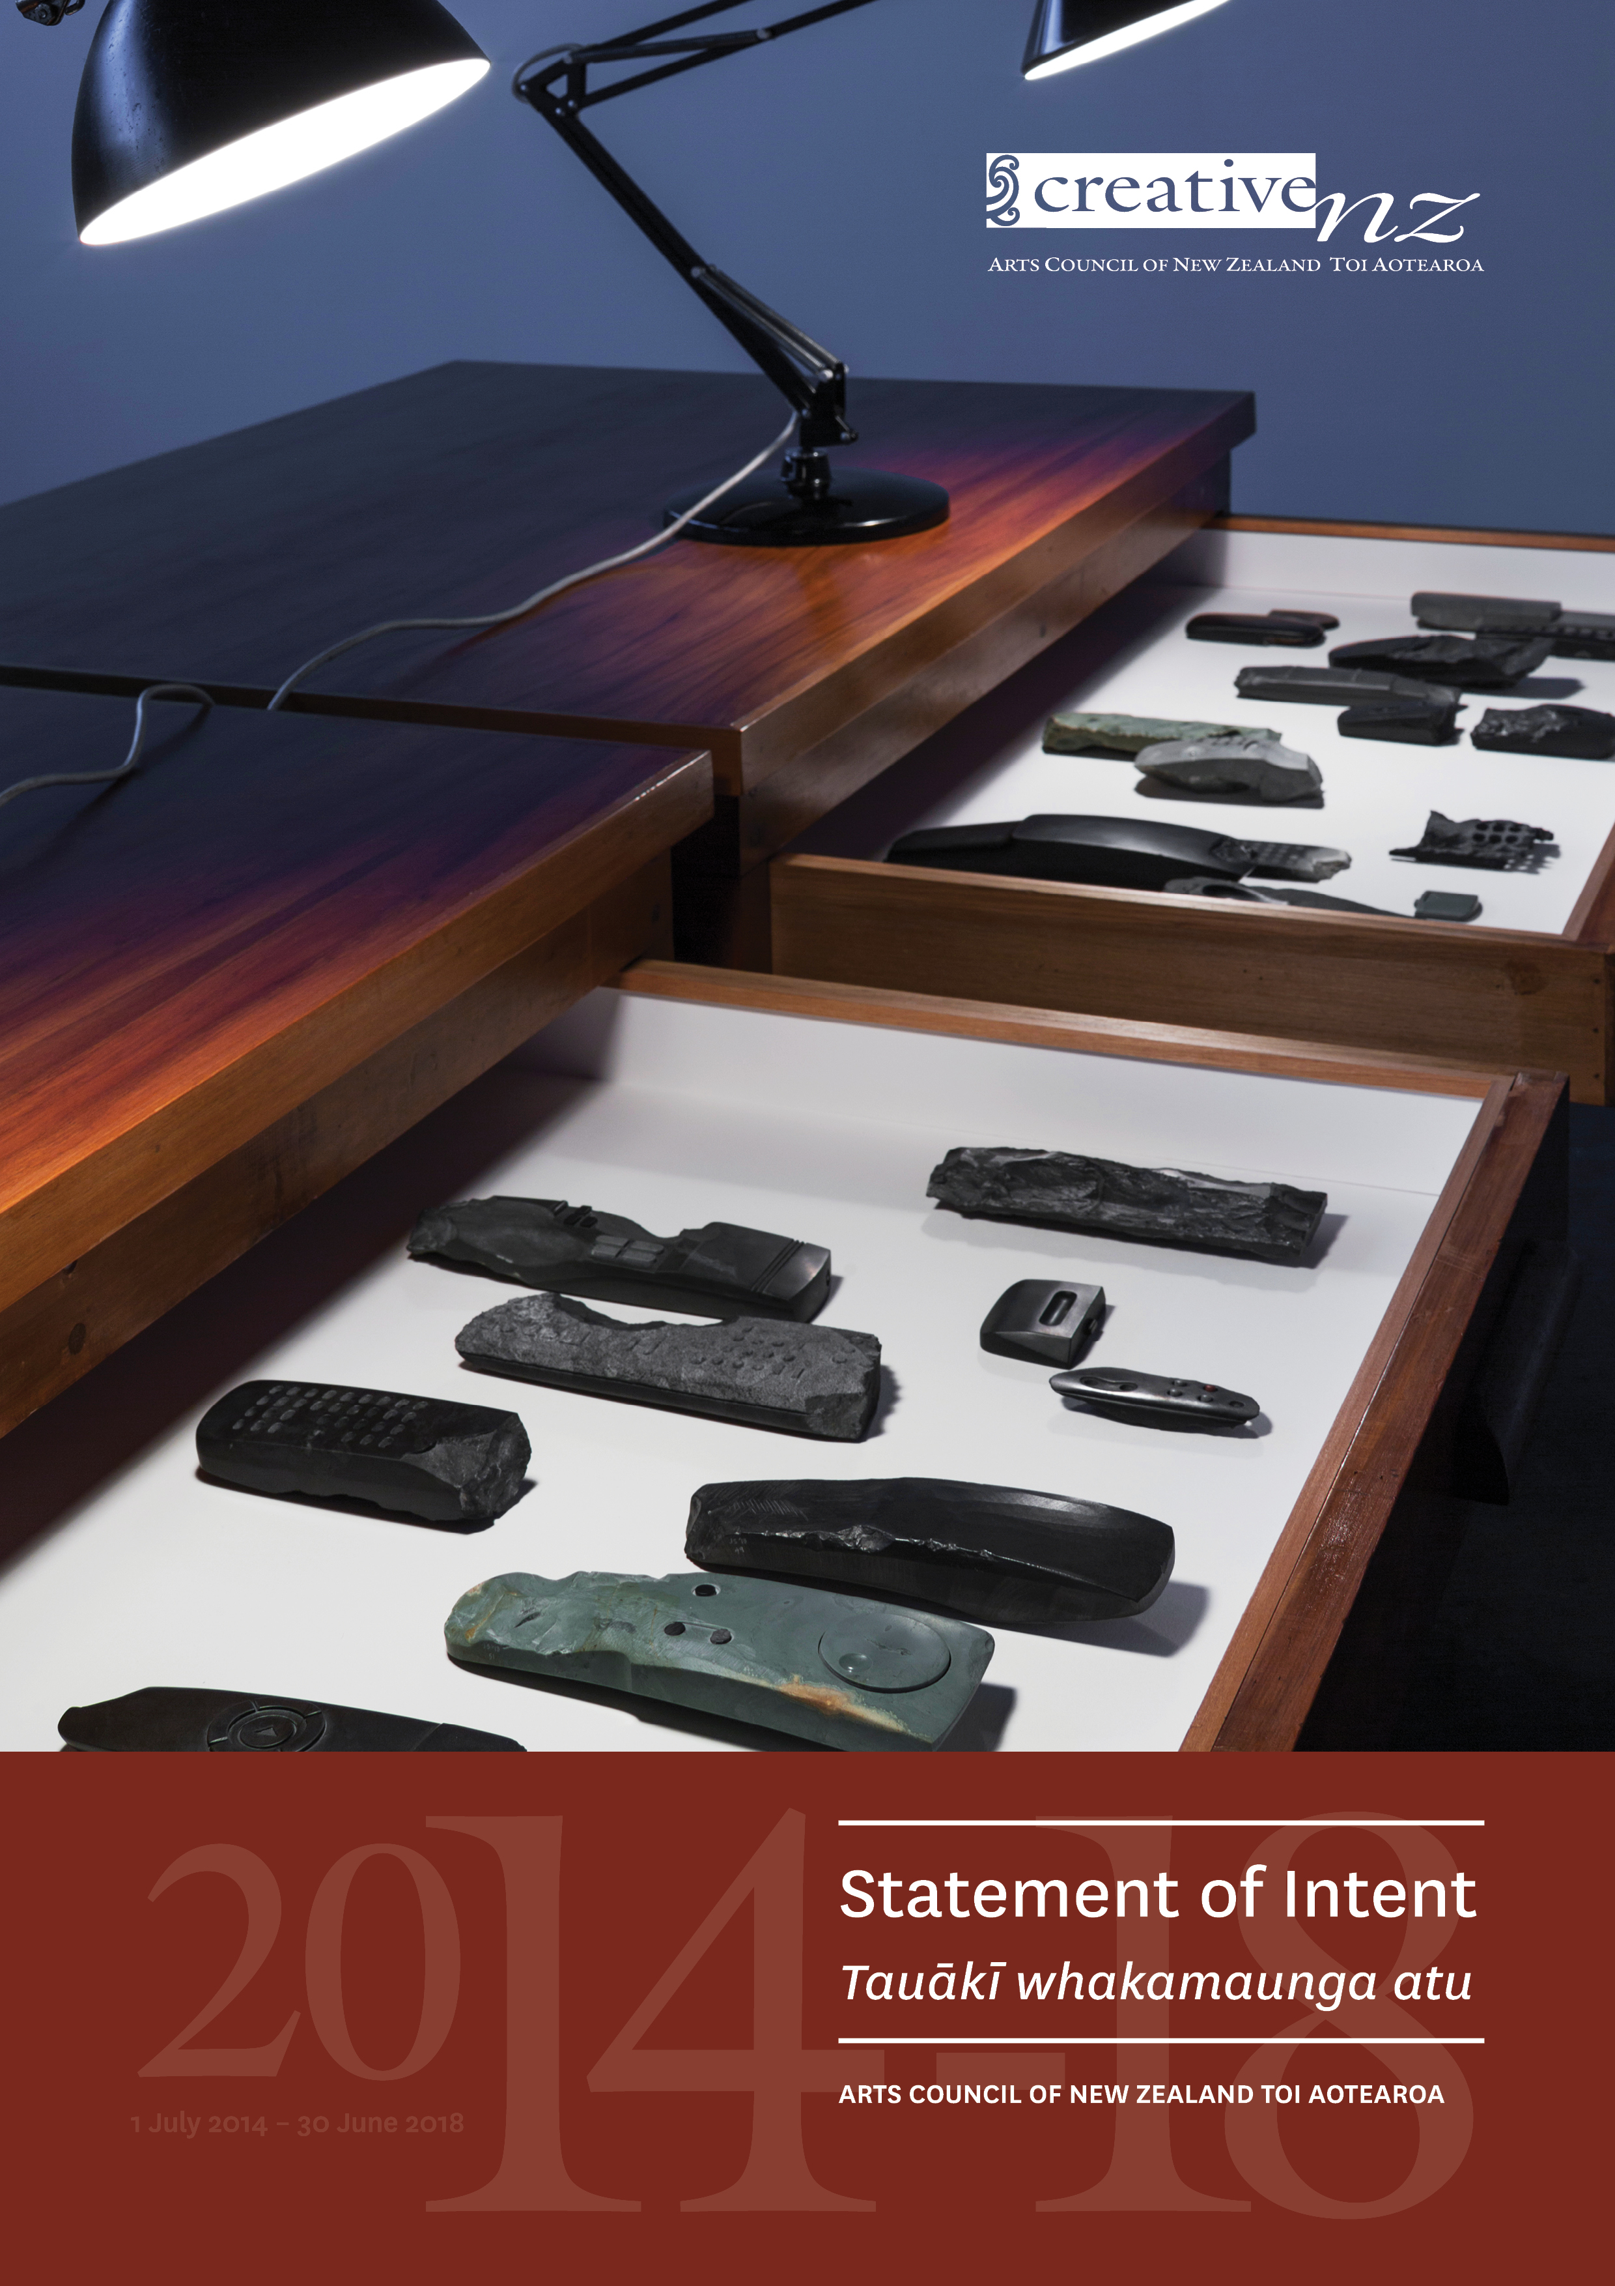

Foreword by the Chair and Chief Executive | Kupu whakataki nā te Manukura me te Tumu Whakarae 6
Marking a series of ‘firsts’ 6
Building on past work 6
Improving our systems and services 6
Telling stories of the arts better 7
Engaging with the arts sector 7
Acknowledgements 7
Creative New Zealand – Who we are | Toi Aotearoa – Ko wai mātou 8
Our purpose 8
Our services 8
Investing in the arts 8
Developing the arts 9
Advocating for the arts 9
Other initiatives 9
Where our funding goes 10
Our strategic intentions 2014–18 | Te whakatinana i ngā mahi 2014–18 11
Working towards our vision for the arts 11
Our outcomes 13
Contributing to government priorities and strategy 15
What we will do to achieve our intentions | Pehea to mātou tutuki i ngā mahi 16
Business as usual 16
Service delivery 16
Policy development and implementation 16
Collaboration 16
Setting direction 17
Our improvement priorities 18
Improving our internal operations 18
The influencing agenda 19
Managing our organisational health and capability | Te whakahaere i te ora o te tari me te āheitanga 21
Governance 21
Operational policy and internal processes 21
Staffing 22
Assets and capital investment 22
Assessing our performance | Te aromatawai e pehea ana mātou 23
Contextual measures 23
Outcome measures 23
Health of the arts sector measures 24
Measures from the Strategic Plan 2013–16 24
Service delivery measures 24
Organisational health and capability measures 25
Reporting on our performance 25
Analysis of our outcome and service delivery results 25

ISSN 2357-1683 (PDF)
ISSN 2357-1675 (Print)

 Crown copyright ©. This copyright work is licensed under the Creative Commons Attribution 3.0 New Zealand licence. In
essence, you are free to copy, distribute and adapt the work, as long as you attribute the work to Creative New Zealand and abide by the other licence terms. To view a copy of this licence, visit http://creativecommons.org/licenses/by/3.0/nz/. Please note that neither the Creative New Zealand logo nor the New Zealand Government logo may be used in any way which infringes any provision of the Flags, Emblems, and Names Protection Act 1981 or would infringe such provision if the relevant use occurred within New Zealand. Attribution to Creative New Zealand should be in written form and not by reproduction of the Creative New Zealand or New Zealand Government logos.
This Statement of Intent represents the intentions and objectives of the Arts Council of New Zealand Toi Aotearoa (Creative New Zealand) for the period from 1 July 2014 to 30 June 2018. It is presented in accordance with sections 138 to 148 of the Crown Entities Act 2004.

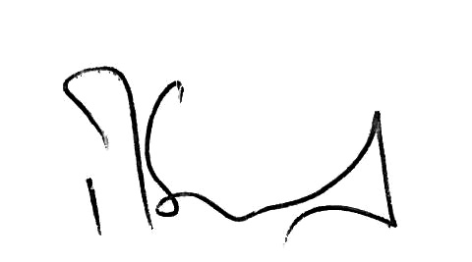
Richard Grant
Chair, Arts Council
10 June 2014

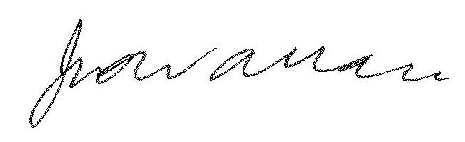
Jimmy Wallace
Member, Arts Council
10 June 2014

In accordance with section 149 of the Crown Entities Act 2004, I present this Statement of Intent to the House of Representatives.
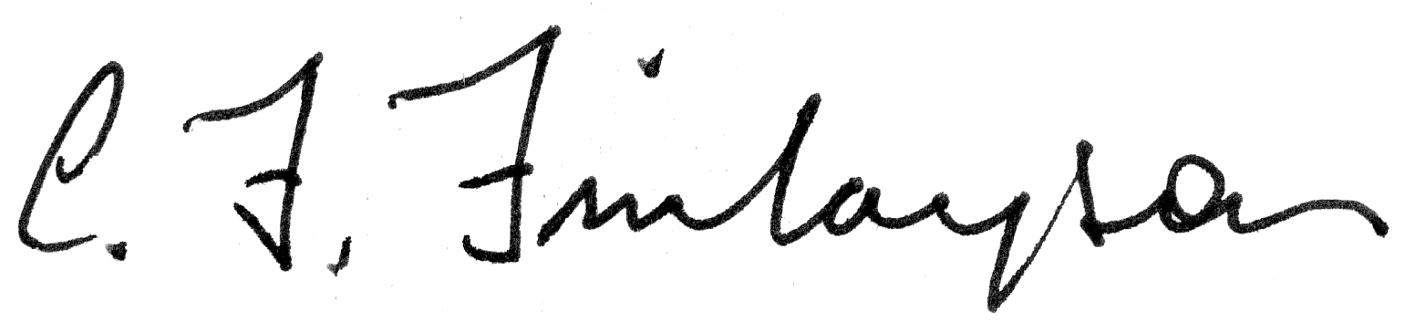
Hon Christopher Finlayson
Minister for Arts, Culture and Heritage
10 June 2014

Foreword by the Chair and Chief Executive |
Kupu whakataki nā te Manukura me te Tumu Whakarae

Marking a series of ‘firsts’
This Statement of Intent (SOI) marks a number of firsts for Creative New Zealand. It is the first under revisions to the Crown Entities Act passed in 2013, giving us a more strategic document with a longer-term focus and more flexible options for measuring progress towards our stated intentions. This will be our first SOI with a lifespan of up to three years.
And it is also the first time we have produced an annual Statement of Performance Expectations (SPE). Our SPE will be published on our website and with our Annual Report.
It is also the first under our new Strategic Plan. During 2012 and 2013, we consulted with the arts sector on our overall direction and focus through a series of focus groups and reviews and produced a three-year Strategic Plan 2013–16.
Thirdly, this SOI is the first under the Arts Council of New Zealand Toi Aotearoa Act 2014 and our new unitary governance structure.
Because of all of these firsts, this can be seen as a transitional SOI, taking Creative New Zealand from the previous legislative and governance regimes into new territory. As a result, the Arts Council, as the governing board, reserves the right to review it, as appropriate, at any point in its lifetime.

Building on past work
Notwithstanding the developments in our legislative and governance frameworks, this SOI is also a logical extension of our past work. Our consultation with the arts sector to develop the Strategic Plan gave us the clear message that we should continue our existing programmes and initiatives.
This SOI continues our medium-term strategic focus. It takes the key messages and directions from the Strategic Plan and incorporates them, together with specific material we are required to include in the SOI, into a single document. The measures we will use to assess our performance are the best of past trends and new key indicators under development.

Improving our systems and services
A key focus of the next four years is improving our systems and services. This includes implementing a new grants and customer management system, providing for online applications and client reporting, shortening our grants decision making timeframes and making the decision process more transparent.
We expect this to bring reduced costs to both our customers and ourselves.

Telling stories of the arts better
While our mandate for supporting the arts remains national, there are specific challenges we will focus on over the lifetime of this SOI: ensuring that the arts remain at the heart of rebuilding Christchurch and meeting the challenges of Auckland’s rapid growth and increasing diversity.
We are developing evidence-based resources to help the arts sector and us advocate for the value of the arts and key messages to support using the evidence.

Engaging with the arts sector
We hold a great deal of data on the work that we fund. One of our key priorities is to enhance our analysis of the data and share this information with the arts sector, providing new information for everyone to use.
We will also continue with our programme of artform reviews involving sector consultation to ensure that our programmes and artform priorities reflect current needs and practices.

Acknowledgements
We can only do our work and achieve our strategic intentions by having the trust, confidence and resources provided to us by the Crown, through the Ministry for Culture and Heritage, and the New Zealand Lottery Grants Board. We also acknowledge our partners across the 67 territorial local authorities and the other agencies we work with to support the arts in New Zealand. Finally, we congratulate the artists, arts practitioners and arts organisations who work so hard to develop and deliver New Zealand arts, here and overseas.

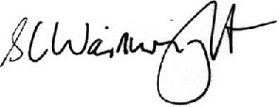

Richard Grant Stephen Wainwright
Chair, Arts Council Chief Executive

Creative New Zealand – Who we are |
Toi Aotearoa – Ko wai mātou
Creative New Zealand is the trading name of the Arts Council of New Zealand Toi Aotearoa, established by the Arts Council of New Zealand Toi Aotearoa Act 2014.
We are New Zealand’s arts development agency, responsible for delivering government support for the arts. We are funded through Vote: Arts, Culture and Heritage and through the New Zealand Lottery Grants Board (NZLGB) to deliver on agreed arts outcomes for New Zealanders. Our monitoring department is the Ministry for Culture and Heritage.
By arts development, we mean not just funding artists and arts organisations but also building their professional and artistic development and promoting the ongoing capability, sustainability and vitality of the arts sector.

Our purpose
Under the Arts Council of New Zealand Toi Aotearoa Act 2014, Creative New Zealand’s purpose is ‘... to encourage, promote and support the arts in New Zealand for the benefit of all New Zealanders’ (section 3).
Section 3 lays down the principles to be followed in all activities under the Act, including recognising:
- the cultural diversity of the people of New Zealand
- in the arts the role of Māori as tangata whenua
- the arts of the Pacific Islands’ peoples of New Zealand.
The Act also requires us to recognise and uphold the principles of participation, access, excellence and innovation, professionalism and advocacy.

Our services

Investing in the arts
We operate a number of complementary funding programmes. In many cases, we are just one of a number of funders and our funding helps to leverage additional revenue from other sources.
The principal funding programmes from 2014 onwards are:
- Arts Leadership (Toi Tōtara Haemata) and Arts Development (Toi Uru Kahikatea) investment programmes that provide funding for up to five years to significant arts organisations
- Project-based grants and special opportunities, including Arts Grants, Quick Response Grants, and a variety of awards, residencies, bursaries and scholarships
- Creative Communities Scheme – a small grants scheme devolved to local councils
- Initiatives that support the presentation of New Zealand arts internationally, such as exhibitions at the Venice Biennale and participation in the four-yearly Festival of Pacific Arts.
- one-off individual initiatives such as funding for the Auckland Theatre Company’s Waterfront Theatre project and to support the centenary of the First World War
- a number of targeted initiatives, including supporting Māori and Pasifika heritage arts, the recovery of the arts in Christchurch and touring to regional centres.
Detailed information on all of the funding programmes is available in the Funding and Programmes Guide available from our website.

Developing the arts
We assist arts organisations and individual artists and practitioners to deliver their work in the best possible way, by building their skills and capability. Capability development initiatives are reviewed annually to ensure they continue to meet client need. They currently include:
- strategic planning and strategic change
- audience development and market development programmes, aimed both nationally and internationally
- diversifying sources of income from fundraising, philanthropy and sponsorship
- initiatives to meet the specific needs of Māori and Pasifika arts practitioners.

Advocating for the arts
We advocate on behalf of the arts to central and local government and to other interested parties. We carry out research for the benefit of the arts sector, deliver other resources to the sector, make submissions on issues affecting the sector or Creative New Zealand and collaborate with other agencies on areas of mutual interest.
A key part of this work is our input into planning for the Christchurch recovery.

Other initiatives
When we are the best-placed agency to respond, we do simple, practical things such as providing support to Christchurch organisations affected by the earthquakes.

Where our funding goes
Nearly 85% of our total expenditure goes direct to the arts sector in grants and investments, building capability, advocacy and other initiatives. Figure 1 shows the distribution in 2012/13.
Figure 1: Distribution of expenditure to services and overheads, 2012/13
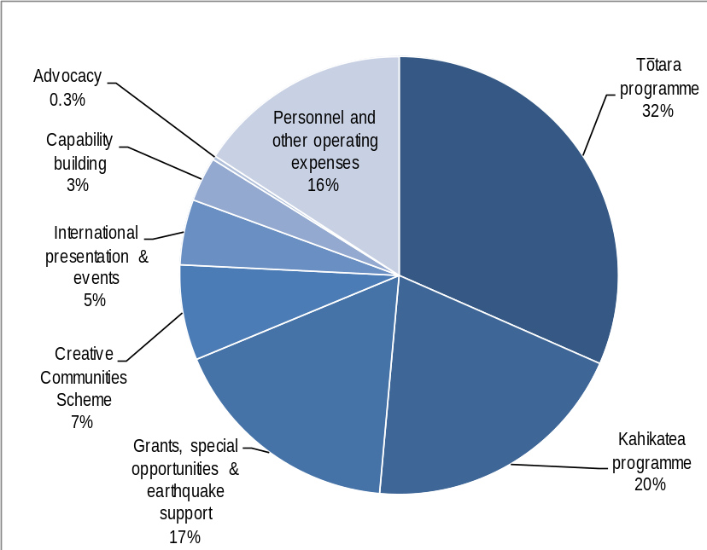

Our strategic intentions 2014–18 |
Te whakatinana i ngā mahi 2014–18

Working towards our vision for the arts
Our vision is ‘Dynamic and resilient arts valued in Aotearoa and internationally’. Our vision is aspirational and requires work by others as well as by us. Progress against the vision is not always explicitly measurable but, based on the feedback we received during our consultation with the arts sector and other stakeholders in 2012 and 2013, we feel confident that our direction and achievements are positive.
However, there are still areas where further developments can be made to support the arts in New Zealand and our Strategic Plan 2013–16 has identified specific areas for us to focus on.
In supporting our vision, our basic premise is as follows:
- our improvement priorities are designed to enhance our use of limited resources
- if we use our resources more effectively, we will continue to improve our services and how we deliver them
- by investing in the arts sector, developing capability and skills and providing advocacy, we will achieve our outcomes and contribute to government priorities
- by achieving our outcomes and contributing to government priorities, we will achieve our vision
- by achieving our vision, we will fulfil our statutory purpose and contribute to the wider government vision and outcomes for the arts and cultural sector.
Figure 2 shows how all this fits together and aligns to the vision and outcomes for the arts sector which are set by the Ministry of Culture and Heritage.

Figure 2: Creative New Zealand outcomes framework
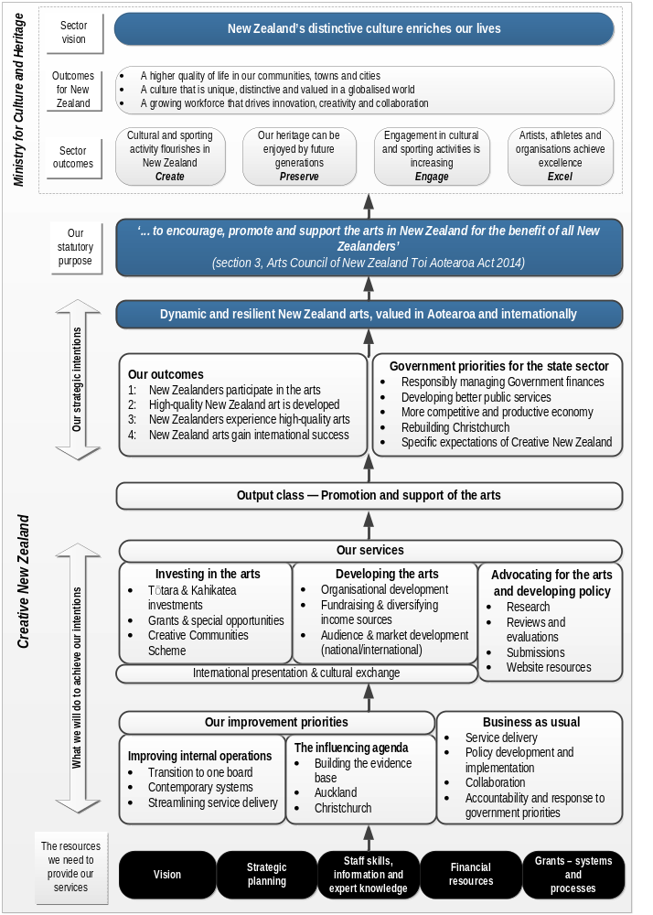

Our outcomes
Creative New Zealand has four outcomes describing the long term effects on New Zealand arts we wish to contribute to. These were recently confirmed as valid and appropriate.

Outcome | What we are seeking to achieve | How we go about this
New Zealanders participate in the arts | New Zealanders have the chance to participate in the arts.  This includes opportunities to:  - celebrate, practise and transmit their diverse artistic traditions and cultural heritage  - develop links between communities that improve cross-cultural understanding. | We provide a range of opportunities through:  - Creative Communities Scheme which funds community arts projects and activities within each territorial local authority area  - Arts Grants and Quick Response Grants for specific projects focused on community arts and participation  - requiring organisations in the Tōtara and Kahikatea investment programmes to undertake projects and activities aimed at encouraging people to participate in the arts.
High-quality New Zealand art is developed | Artists, arts practitioners and arts organisations have the opportunity to fulfil their potential by:  - continually developing their artforms, the quality of their work and their artistic skills and capabilities  - having opportunities to experiment, be innovative and take risks. | Our Tōtara organisations provide leadership, develop talent and support innovation and artistic risk. The Tōtara key roles that we fund complement the investments made by central and local government.  Our Arts Grants and Quick Response Grants support individual artists, arts practitioners and arts organisations to create new works and develop their artistic skills.
New Zealanders experience high-quality arts | Audiences are vital to a vibrant arts sector. We aim to broaden the opportunities for all New Zealanders to experience the arts, providing them with access to a diverse range of artistic experiences. | Creative New Zealand:  - supports arts organisations to provide arts experiences across the country and across all artforms  - provides targeted capability building initiatives to help artists, arts practitioners and arts organisations to address identified development needs  - undertakes research that can be used to analyse and respond to trends in New Zealanders’ attendance at arts events
New Zealand arts gain international success | Selected New Zealand artists, arts practitioners and arts organisations develop international audiences, readers and viewers.  This helps increase their income, assists them to engage with the international arts environment and promotes New Zealand and its arts to international audiences. | Creative New Zealand:  - takes selected artists to markets and fairs to display their works and introduce them to potential buyers or distributors  - brings key overseas managers and directors to New Zealand to experience our art in its local context  - provides capability building in engaging with international markets and audiences  - supports applications from artists and organisations wanting to undertake international projects  - leads initiatives stemming from invitations to the New Zealand Government, such as the Venice Biennale
Figure 3 shows how we have distributed our investment to the outcomes over the years 2010/11 to 2012/13.
Figure 3: Average investment by outcome, 2010/11 to 2012/13 (all programmes)
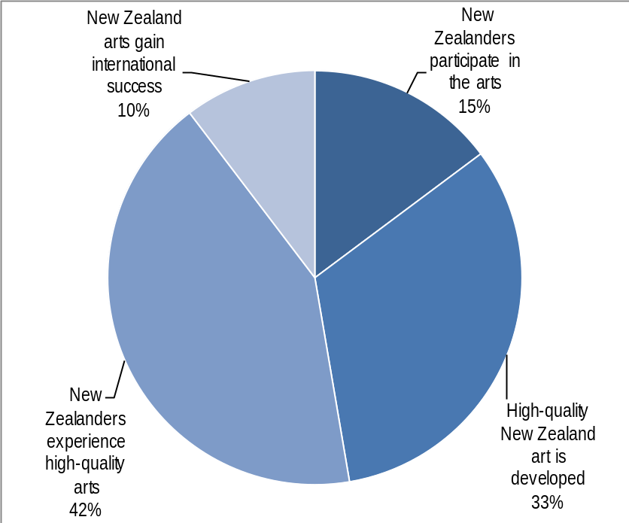

Contributing to government priorities and strategy

Government’s goals for the economy and the state sector
We will support the government’s four priorities by ensuring:
- we continue to assist and promote the recovery of the arts sector in and around Christchurch (Rebuilding Christchurch)
- our services contribute to a strong and sustainable arts sector that plays an active part in the economy (Building a more competitive and productive economy)
- we continue to manage our operating costs and increase the effectiveness and efficiency of our processes, to ensure good value for money (Responsibly managing the Government’s finances)
- our services to clients are the best possible and are delivered in ways that are appropriate to the groups we support (Developing better public services within tight financial constraints).

What we will do to achieve our intentions |
Pehea to mātou tutuki i ngā mahi
During the consultation on the Strategic Plan and our reviews of support and priorities for ngā toi Māori and Pacific arts, we received a clear message from the arts sector that it supports all our current areas of activity. So we will continue to build upon our past work as well as working on some additional priorities for improving our performance.

Business as usual

Service delivery
- Investing in and developing the arts will remain the core of our work in 2014–18.
- We will focus on providing investment and building skills to help arts organisations succeed in a time of limited economic growth and fiscal constraint, where the arts are vulnerable to rising costs, static or declining income and a potential downturn in participation and audience numbers.
- We will support the development and presentation of new work and the taking of artistic risk, innovative and cost effective use of digital technology to create and distribute high-quality work, collaboration between arts organisations, and building audiences and markets for New Zealand arts everywhere.

Policy development and implementation
- We will deliver our rolling, five-year programme of artform reviews focusing on identifying the needs of the sector and priorities for support, including reviewing the key roles we ask our Tōtara investment programme organisations to fulfil. All artform reviews include research and consultation with the sector. The programme is:
- 2014/15 – visual arts, craft/object art, literature
- 2015/16 – theatre, opera
- 2016/17 – a review of the review methodology, including design, process, outcomes
- 2017/18 – decision on the review pattern to be used in the future
- We will implement the review recommendations, including any reallocation of resources needed, and report on the implementation process. The completed reviews of Māori arts, Pacific arts, digital arts and music will be a particular focus in the first years of this SOI.
- We will support community arts, the maintenance and transmission of cultural traditions and opportunities for the arts by, with and for young people.

Collaboration
- We will work closely with central and local government to make a greater impact with our limited resources.
- We will work with individual territorial authorities to focus on significant issues affecting their regions and encourage them to provide planning and support for professional and community arts to meet the needs and opportunities in different parts of the country.
- We will work with the Ministry for Culture and Heritage on a shared policy and funding framework to support initiatives for young people and the arts.
- We will continue to work with the Ministry and other agencies on initiatives to build private sector support for philanthropic giving.
- We will continue to work with the Ministry for Culture and Heritage to implement a joint policy and funding framework for central government support for orchestras, consistent with the Final Report of the New Zealand Professional Orchestra Sector Review (February 2013).
- We will develop and implement pilot programmes to identify and enhance regional artists’ and audiences’ access to arts funding and arts experiences.

Setting direction

Our budget decision making
The enduring nature of our core programmes (Tōtara and Kahikatea, Grants and special opportunities, Creative Communities Scheme) and the long term nature of much of our funding mean that the Council is never in a zero-based budgeting position.
Budget allocations are informed by our institutional sector knowledge, sector and wider public consultation on our Strategic Plan, ongoing consultation with the arts sector and other key stakeholders – including territorial authorities – and regular reviews of artform policies and specific programmes; for example, the 2011/12 review of our capability building programme and a recent evaluation of New Zealand’s participation in the last three Venice Biennales.
We strive to be nimble and responsive to changes in the environment. Analyses of trends in demography and applications, and our assessment of clients’ performance (for example, audience trends and financial results) also inform our budget setting. Budget decisions respond to the identification of gaps in the arts infrastructure and delivery; for example, the results of our review of Pacific arts led to new internships for Pacific arts and significantly increased funding for Pacific heritage arts.

How we assess quality
Two of our outcomes include the term “high-quality” as a description for New Zealand art.
Creative New Zealand receives requests for up to four times as much money as we have available. Our application processes are designed to assess the quality of each proposal, both against our outcomes and priorities and against other applications in each funding round, using both inhouse expertise and – for the more substantial grants – peer assessment.
When assessing quality, we look for strong and well developed ideas supported by suitably experienced key creative personnel, an appropriate creative process and a realistic budget.
Applicants make a case to us for the quality of their proposals; we assess this against outlined criteria and give specific consideration to:
- the key creative people involved in the activity
- the creative process to be used
- the strength of the applicant’s ideas
- the reality and soundness of the budget.
When assessing proposals for the Tōtara investment programme, we also consider the extent to which a future programme proposal will deliver to the activities expected for the key role associated with the proposal.
The same assessment criteria and scales are used by staff and external assessors and applied across all areas of arts practice. Funding recommendations and decisions are made based on the results of these assessments.

Our improvement priorities
The consultation process leading to the development of our Strategic Plan 2013–16 identified two new areas of focus: improving internal operations and increasing the effectiveness of our advocacy.

Improving our internal operations

Transition to one board
The Arts Council of New Zealand Toi Aotearoa Act became effective on 1 May 2014. The Act replaced the former Arts Council, Arts Board, Te Waka Toi and Pacific Arts Committee with a single governing board, responsible for policy, strategy, budget allocation and making funding decisions.
Our existing commitments to Māori and Pasifika arts, using assessment and decision making processes which draw upon peer expertise within the sector and reflect tikanga Māori and kaupapa Pasifka, will remain as these derive from our legislative responsibilities.
We expect the single board structure will more efficient, freeing up people, time and financial resources which can be redirected to support for the arts sector.

Contemporary systems and streamlined service delivery
Our current grants processes are largely paper based and can be time consuming and resource intensive, for applicants and for us. We are building a new grants and customer management system to automate processes that are currently manual and provide for online applications and assessments. The benefits of the new system include:
- reduced costs of processing a grant application (both for our clients and for us)
- shorter decision making timeframes
- more transparent decision making processes, as applicants will be able to monitor the progress of their applications.
The new system will also enable online reporting by our clients and will provide us with more easily accessible and better targeted information. We will use this information to:
- continue to guide future decision making – for individual grant decisions, budget setting and assessing the performance of both grant recipients and our funding programmes
- improve our reporting – internally, to government and to the sector, by providing increased analysis and information back to clients and stakeholders.
The new system will also help us to review our requirements for reporting by clients to better match reporting to the level of our investment and risk.
Our customer service survey in 2010/11 showed that, although those using our services were generally satisfied with the results, there is room for improvement. We will re-run the survey to ascertain how well our new systems and processes are working for our clients and to identify new areas of service delivery to target for improvement.

The influencing agenda

Building the evidence base for the value of the arts
We want to build the evidence base demonstrating the economic, social and cultural value of the arts and share the results with others in the arts and cultural sector, and beyond. Using the evidence, we will develop targeted messages so that we and the sector can:
- better promote the value of the arts to key influencers and decision makers
- encourage increased private giving and philanthropy to the arts.
We will continue to commission research such as our three-yearly New Zealanders and the arts survey, deliver key awards and events celebrating success in the arts and collaborate with others to develop and advocate for the arts.
Our advocacy work will respond in particular to two contemporary and compelling features of the New Zealand arts ecology: the rapid growth of Auckland and the cultural recovery in Christchurch.

Auckland
Auckland is growing fast, is spread out, increasingly attractive to arts practitioners and very culturally diverse, with growing Māori, Pasifika and Asian communities. We have been lifting our presence and investment in Auckland for some time in response to the growing arts offering and number of creative people making art there.
However, we need to be increasingly responsive to Auckland’s rapidly changing demography and are developing a strategy to ensure we are meeting the changing needs of the city effectively. We are also working closely with the Auckland Council on the development and implementation of its Arts and Culture Strategic Action Plan.

Christchurch
The arts community in Christchurch has done a great deal to fill the gaps caused by the loss of artists and much of the purpose-built infrastructure for the arts in the wake of the earthquakes. We have seen great examples of innovative arts practice and creative responses to the physical environment and loss of venues.
We are committed to the one-off opportunity for the arts and the Christchurch region afforded by the transition period as Christchurch is rebuilt.
We have done a lot of good tactical work in Christchurch and our focus is now on the long term recovery plan. We will continue to work alongside key players like the Canterbury Earthquake Recovery Authority, Christchurch Central Development Unit, the Ministry for Culture and Heritage and Christchurch City Council to ensure that:
- Christchurch citizens’ strong support for arts and culture is reflected in the new city
- provision for the arts lies at the heart of the rebuild.

Managing our organisational health and capability | Te whakahaere i te ora o te tari me te āheitanga
For Creative New Zealand to be successful at achieving its vision and outcomes, it must have the following characteristics:
- a successful governance structure
- valid and appropriate operational policies
- effective and efficient internal processes
- capable and engaged staff.

Governance
The Arts Council of New Zealand Toi Aotearoa Act 2014 came into effect on 1 May 2014, providing for a streamlined governance model for Creative New Zealand. The successful transition from a four-board to unitary board governance structure is a key focus for us during 2014.
Successful governance is not simply about structure but also ensuring:
- board members have appropriate and timely information to make decisions
- board members are knowledgeable about and engaged with the operations of Creative New Zealand
- decisions are made at the appropriate organisational level, reflecting their importance, risk and the need for timeliness
- management and staff provide appropriate support to the board.
The transition programme implemented from early 2014 will ensure that the transition is seamless from the perspective of our clients, and produces effective and efficient decision making structures and processes without any loss of quality or perspective.

Operational policy and internal processes
In addition to our programme of artform reviews, we also undertake regular reviews of internal policies, covering such issues as finance, human resources, conflict of interest.
In each review, we consider the appropriateness of existing policy, best practice examples from similar organisations and compliance with legislation.
We will measure the success of our improvements around grants applications, decision making and reporting processes through the responses to our customer satisfaction survey, to be rerun in 2014/15. We also have a formal complaints management system and monitor informal feedback from applicants and clients through social media and daily interaction with staff that provide us with ongoing customer feedback.

Staffing
Creative New Zealand relies on having a skilled and engaged staff in order to achieve its vision and outcomes.
We will recruit, and work to retain, skilled staff. All staff will be offered training and development across a range of areas, including software applications, financial reporting, communications and presentations and project management.
We will meet our ‘good employer’ obligations (section 118 of the Crown Entities Act 2004) by maintaining and reporting against a personnel policy that includes reference to the seven key good employer elements.
We also include in our personnel policy and reporting specific commitments to the aims, aspirations and employment requirements of Māori, ethnic or minority groups, women and people with disabilities.

Assets and capital investment
Creative New Zealand does not rely on the performance of significant assets to meet its objectives.
Our financial reserves are invested in bank balances and term deposits with high credit ratings (AA).

Assessing our performance |
Te aromatawai e pehea ana mātou
Creative New Zealand will use a variety of measures to assess its performance drawing on internal information, client reporting, survey responses and reviews of policy and process.
Figure 4 on page 26 shows the matrix of primary measures we will use to assess our performance against our outcomes framework.
These measures are also included in our Statement of Performance Expectations (SPE), which is published as a separate document.

Contextual measures
At the highest level, we believe that we will be successful in achieving our vision if New Zealanders have positive attitudes to the arts, engage with the arts and perceive New Zealand arts to be high quality. We will measure this using data from the three-yearly New Zealanders and the arts survey, including:
- trends in attitudes to the arts
- level of engagement (participation and attendance) with the arts
- perceptions of the quality of participants’ most recent New Zealand arts attendance.
The survey is undertaken every three years and results will be compared with those from 2005, 2008 and 2011. Data from the survey is used to inform our artform policy reviews and to provide a context for viewing Creative New Zealand’s contribution to the arts sector.

Outcome measures
Each outcome has one key performance measure as a proxy indicating performance. These are drawn from the reports given to us by our clients and include:
- the level of participation in projects or events funded by Creative New Zealand – this measure is new and implementation is dependent on the new grants management system
- the number of new New Zealand works developed – this is an existing measure, based on client reporting from our investment programmes and Arts and Quick Response grants
- levels of attendance at presentations funded by Creative New Zealand – this is an existing measure currently based on investment clients only. The measure will be expanded to include other clients as systems permit
- an analysis of international presentations and events funded by Creative New Zealand over time – this includes the total dollars invested, numbers of artists or arts organisations and the number of presentations/events, and is based on client reporting.

Health of the arts sector measures
For us to be successful, the arts sector must be resilient and producing dynamic arts.
In our Strategic Plan 2013–16, we committed to reporting on the health of the arts sector. We will do this through aggregated reporting using our Tōtara and Kahikatea investment clients as a proxy for the resilience and success of the arts sector as a whole.
We will begin with snapshots of these clients in the 2013/14 financial year, based on their six-monthly reports to us. Over the next four years, we will build up our knowledge of sector success.

Measures from the Strategic Plan 2013–16
The Strategic Plan 2013–16 contains a number of performance milestones for:
- improving decision-making timeframes
- implementing the grants management system
- creating and extending online advocacy resources
- support for the recovery of the arts in Christchurch and the Auckland Arts and Culture Strategic Action plan
- improving results from the customer satisfaction survey against the 2011 survey.

Service delivery measures
Each of our key areas of service has individual success measures.
- Investing in the arts:
- programme success rates – the extent to which our funding programmes are meeting their defined objectives. This is a new measure, introduced in 2014/15, based on new programme metrics. This measure will be implemented programme by programme, as metrics are developed, beginning with the Kahikatea investment programme
- the success of clients in meeting or exceeding the expectations of their funding agreements – this is an existing measure based on inhouse analysis of client reporting.
- Developing the arts – the percentage of those participating in capability building initiatives who improve their skills as a result. This is an existing measure using our annual Organisational Development Model survey of the Tōtara and Kahikatea investment clients
- Advocating for the arts – the arts sector is using available resources as indicated by the website usage.

Organisational health and capability measures
We also need to assess our own ability to deliver our services effectively and efficiently.
Key measures include:
- the successful transition to the new unitary governance structure in 2014
- undertaking policy reviews and successfully implementing their planned outcomes, against milestones in the Strategic Plan
- reviewing our internal processes and policies against external standards and benchmarks
- benchmarking our performance against other state sector organisations through the annual audit process, Benchmarking Administrative and Support Services (BASS) programme and Best Workplaces survey.

Reporting on our performance
Creative New Zealand will report on its performance against these performance measures in its SPE, which will be published:
- on the Creative New Zealand website as soon as possible after the SPE has been approved by the Minister for Arts, Culture and Heritage
- as part of the Annual Report for each year, showing both past achievements and future projections of performance as a continuum.

Analysis of our outcome and service delivery results
In addition to aggregated results for our outcome and service delivery measures, we are able to analyse our data by the following criteria:
- artform
- region
- funding programme or initiative
- ethnicity of the artist or organisation (where declared)
- cultural focus of the project (where declared).
This enables us to monitor our performance through different lenses and identify gaps in our support (for example the needs of Māori and Pasifika arts and changing demography).
Figure 4: Matrix of performance measures and targets
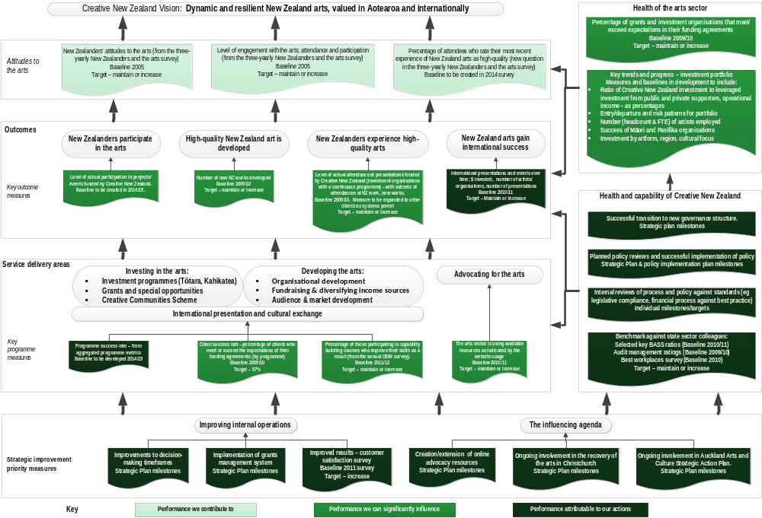

Creative New Zealand receives annually $15.7 million from Vote funding and 15 percent of the total profits from the Lotteries Commission, through the NZLGB. This latter figure varies each year. The annual dollar value of our funding through the Vote and the NZLGB is included in our Statement of Performance Expectations (SPE), published on our website, www.creativenz.govt.nz.
Referred to as the Tōtara and Kahikatea programmes.
www.creativenz.govt.nz
We consulted on our direction and outcomes during the development of the Strategic Plan 2013–16.
By ‘participate’, we mean the direct involvement of individuals, groups and/or communities in making or presenting art.
The three-yearly New Zealanders and the arts survey.
Milestones for the delivery of the new system are included in our SPE. The system includes provisions for artists who are not connected to the internet.
The customer service survey invites responses from investment clients, successful and unsuccessful applicants for grants funding, participants in capability building initiatives, and other key stakeholders such as local council administrators working with the Creative Communities Scheme.
Leadership, accountability and culture; Recruitment, selection and induction; Employee development, promotion and exit; Flexibility and work design; Remuneration, recognition and conditions; Harassment and bullying prevention; Safe and healthy environment.
For measures associated with dynamic and resilient arts, see Health of the arts sector measures (below).
Six-monthly reporting for Tōtara and Kahikatea investment clients and at the completion of projects for grants and special opportunities and international clients.

