G.11

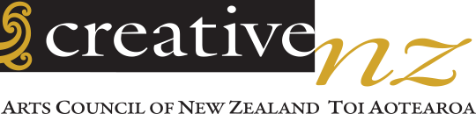

ARTS COUNCIL OF NEW ZEALAND TOI AOTEAROA
TAUĀKĪ MAHI HUA
STATEMENT OF PERFORMANCE EXPECTATIONS
2021/22

Contact us

Website: www.creativenz.govt.nz

Email: info@creativenz.govt.nz

Wellington Office
Level 2, 2–12 Allen Street
PO Box 3806
Wellington 6011
T: 04 473 0880

Auckland Office
Level 1, Southern Cross Building
Cnr High and Victoria Streets
PO Box 1425
Auckland 1140
T: 09 373 3066

ISSN XXX-XXXX (Print)
ISSN XXX-XXXX (Online)

Crown copyright ©. This Statement of Performance Expectations is licensed under the Creative Commons Attribution 4.0 International licence. In essence, you are free to copy, distribute and adapt the work, if you attribute the work to the Arts Council of New Zealand Toi Aotearoa (Creative New Zealand) and abide by the other licence terms. To view a copy of this licence, visit http://creativecommons.org/licenses/by/4.0/

This Statement of Performance Expectations documents planned activity, performance targets and forecast financial information for the Arts Council of New Zealand Toi Aotearoa (Creative New Zealand) for the period 1 July 2021 to 30 June 2022.
It is presented in accordance with sections 149B to 149M of the Crown Entities Act 2004.

Caren Rangi ONZM
Chair—Tiamana, Arts Council of New Zealand Toi Aotearoa
30 June 2021

Michael Prentice
Member—Kaikaunihera, Arts Council of New Zealand Toi Aotearoa
30 June 2021

Ngā ihirangi
Contents
INTRODUCTION 3
KUPU ARATAKI
Foreword 4
Kupu whakataki
About our plan 5
Ta tātau mahere
Our strategic context 6
Tā mātou horopaki rautaki
The year ahead 10
Te tau kei mua i a tātou
NON-FINANCIAL PLANNING AND PERFORMANCE 14
WHAKAMAHERE UTU KORE MAHI
Our performance framework 15
Te tūtuki i a mātau mahi
Our goals 18
A mātou whāinga
FINANCIAL PLANNING AND PERFORMANCE 34
WHAKAMAHERE PŪTEA MAHI
OUR ORGANISATION 51
TŌ TATOU TARI

KUPU ARATAKI
INTRODUCTION

Kupu whakataki

Foreword
We are pleased to present our Statement of Expectations for 2021/22, the third annual plan under our Statement of Intent 2019–2029.
While the COVID-19 pandemic is certainly not finished around the world, here, in Aotearoa and at Creative New Zealand, we are approaching the year with a feeling of ‘cautious optimism’.
The 2021/22 performance year is the final in the first three-year cycle under our current Statement of Intent 2019–2029. The strategic direction this 10-year plan sets out remains broadly relevant in the context of the COVID-19 pandemic, although some shifts in emphasis will continue.
The Minister for Arts, Culture and Heritage has outlined specific expectations for Creative New Zealand in 2021/22. These are consistent with our strategic direction and align well with the Arts Council’s thinking in relation to the year ahead, including delivering the multi-year initiatives under the Government’s Arts and Culture COVID Recovery Programme.
We are unwavering in our support for the arts sector, from emerging artists through to well-established organisations. However, the unpredictable funding environment, combined with the long tail of COVID-19 and increased demand for our services, presents a challenge for how we support the sector most effectively.
We are continuing to focus on recovery, resilience, and renewal in 2021/22. In response to the continuing challenges we face, our priorities this year are to:
- deliver a fit-for-purpose 12-month investment programme to support the arts sector to continue to survive, recover, and thrive in a COVID-19 world
- deliver multi-year initiatives under the Government’s Arts and Culture COVID Recovery Programme
- continue to deliver our key kaupapa-based strategies: Te Hā o ngā Toi—Māori Arts Strategy 2019–2024 and the Pacific Arts Strategy 2018–2023, and the Investment Strategy Te Ara Whakamua 2018–2023.
- make sure our support for the arts is inclusive of, and accessible to, New Zealand’s diverse communities
- support the arts sector to maximise the opportunities associated with digital technologies
- work to improve the sustainability of the arts sector and arts sector careers
- advance our Te Kaupapa o Toi Aotearoa programme – aimed at making sure we have the organisational culture, competencies and practices that will let us meet our aspirations under Te Tiriti o Waitangi (the Treaty of Waitangi) and deliver public value for all New Zealanders.
The arts matter to New Zealanders. Our most recent New Zealanders and the arts research helps us understand how people intend to re-engage with the arts. New Zealanders are increasingly recognising the benefits of the arts to themselves, their communities, their identities, and the country. While attendance has declined due largely to the COVID-19 pandemic, participation has held steady, and how we want to attend the arts is evolving.
We thank New Zealanders for supporting and taking part in the arts in communities across the country. Over the coming year, we will keep promoting the value of the arts to New Zealanders’ lives.
Inspired by our arts community, we will meet the challenges – and the opportunities – the next year will bring with dedication, heart, and manaaki.
Mā whero, mā pango ka oti ai te mahi
With red and black the work will be complete

Caren Rangi ONZM
Chair—Tiamana, Arts Council of New Zealand
Toi Aotearoa
30 June 2021

Stephen Wainwright
Chief Executive—Tumu Whakarae, Creative New Zealand
30 June 2021

Ta tātau mahere

About our plan
The Statement of Performance Expectations (SPE) sits under the Statement of Intent 2019–2029 (SOI). It describes how this year’s work will contribute to achieving the strategic direction set out in the SOI. Each year, we publish an SPE that outlines our planned activity, performance targets, and forecast financial information for the relevant performance year.
This SPE covers the 2021/22 financial year (that is, 1 July 2021 to 30 June 2022). Because of the impact of the COVID-19 pandemic on the arts sector, our focus is on the short- to medium-term needs of artists and arts organisations, and this is reflected in the plan.
The plan has three parts.
- Overview of the year ahead – our strategic context, ongoing delivery to the Government’s Arts and Culture COVID Recovery Programme, and opportunities and challenges within a COVID-19 context.
- Non-financial planning and performance – describes our work for the year ahead through our performance framework (page 14). The framework is based on our 10-year strategic direction and explained in further detail on page 6. We will measure our progress in 2021/22, and our measures and indicators are explained in further detail on pages 14–33.
- Financial planning and performance – provides our financial statements for the 2021/22 year and the notes to those statements.
We will report against our plan in the Annual Report for 2021/22.
Creative New Zealand has one output class – Promotion and support of the arts – which is a reportable class for the purposes of the Crown Entities Act 2004. Under this, we will work to achieve our four goals and create value for New Zealanders (see Our strategic direction for 2019–2029 – Creating value for New Zealanders on page 9).
No output classes have been given reporting exemptions by the Minister of Finance. We do not propose supplying any output classes in 2021/22 that are not a reportable class of outputs.
We operate under one central government output expense: Promotion and Support of the Arts and Film. Manatū Taonga Ministry for Culture and Heritage is our monitoring department.
We are mainly funded through Vote: Arts, Culture and Heritage and the New Zealand Lottery Grants Board Te Puna Tahua (NZLGB). In 2021/22, Creative New Zealand expects to receive:
- $24.444 million from the Crown through Vote: Arts, Culture and Heritage (comprising $16.589 million in baseline funding and additional initiative-based funding of $6 million under the Government’s Arts and Culture COVID Recovery Programme, and $1.755 million for the Mātauranga Māori Te Awe Kōtuku Initiative
- an estimated $46.5 million from the NZLGB.
Revenue from the NZLGB for 2021/22 is based on Lotto New Zealand’s mid-range budgeted profit for 2021/22. The final expected 2021/22 payment from the NZLGB will be confirmed in July 2021 and revised during the year.
The level of funding we receive from the NZLGB and the timing of funding advice, with respect to our own planning and reporting cycle, could change.

Tā mātou horopaki rautaki

Our strategic context

Our strategic framework – the public value creation model
In 2019, the Arts Council adopted a new public value model (Creating value for New Zealanders) for describing how Creative New Zealand creates long-term value for New Zealanders through its support for the arts. Using this model, the Council has articulated the value it believes the arts deliver for individuals, whānau, communities, and society. We have considered what we need to do to increase that value and make sure all New Zealanders – regardless of where they live and who they are – share in those benefits.
Creating value for New Zealanders describes, through the four perspectives and seven segments, the environment we operate in, the relationships between the parts of the system, and how they work together to deliver value. At the heart is our vision, our purpose, our values, and Te Waka Toi Pātaka (our Mātauranga Māori Framework).
The model should be read as a ‘virtuous circle’, where strengthening one segment will lead to the strengthening of the next and so on. Overtime, our aim is to strengthen and grow each segment of the circle, to increase the value the arts can deliver for all New Zealanders.

The model can be explained simply through the graphic below (the full model is represented in the diagram on page 9).

Outcomes and value perspective |  | Mana and support perspective
The difference we want our work to make and the value we create for New Zealanders through our support for the arts | → | The mechanisms and entities that guide our strategic intentions and whose support influences our resources and authority
↑ |  | ↓
Sector perspective |  | Creative New Zealand perspective
The artists and arts organisations, collaborators, and partners we work with and who contribute to our outcomes | ← | The strategies and policies that guide our work and strategic intentions, the resources we have, and the services we deliver

Our goals
As part of a new 10-year strategy (set out in our Statement of Intent 2019–2029), the Council established four goals, that will enable us, by working with the sector and our partners, to achieve our outcomes. Further detail on how we will work toward our goals is on pages 14–33).

Goal: We can clearly articulate how our work and engagement in the arts deliver value for all New Zealanders
Goal: We grow the confidence of others in us, and attract greater resources for the arts, recognising their contribution to the wellbeing of New Zealanders
Goal: We have the strategies, services and operational capacity to drive development of the arts in New Zealand
Goal: We work collaboratively with others developing a dynamic and resilient arts sector, and building support for New Zealand arts in Aotearoa, Te Moana-nui-a-Kiva, and the world

Our key strategies and policies

In addition to the strategic direction set in our SOI, Creative New Zealand has four main strategies that guide its work in specific areas, or in the case of its two kaupapa-based strategies (Te Hā o ngā Toi—Māori Arts Strategy 2019–2024 and the Pacific Arts Strategy 2018–2023), that are grounded in a deeper set of aspirations for areas of significance, spanning all our work.
We also have policies that govern how we go about our work, including our Diversity in the Arts Policy 2015.

Investment Strategy Te Ara Whakamua 2018–2023
In 2018 Creative New Zealand released its Investment Strategy Te Ara Whakamua 2018–2023, which outlines the direction the organisation’s investment in the arts will take over the five years to 2023. The strategy was put in place to empower the Arts Council to develop an arts investment portfolio fit for the future needs of the arts in New Zealand.
The investment strategy recognises and responds to how Aotearoa is changing, such as demographic changes, including increasing diversity, the role of iwi and Māori, the imperative to deliver to under-served communities, and the disruptive effects of technology.
The strategy comprises seven investment principles and three investment features to guide our investment direction and choices. Over time, our investment will increasingly emphasise the strategy’s three features – Diversity and reach, Dynamic arts, Resilient arts sector – and be characterised by the seven principles.
Since it was launched, Creative New Zealand has reviewed its programmes against the principles and features. This has resulted in changes across our major investment categories including the Investment programmes (Toi Tōtara Haemata and Toi Uru Kahikatea), Grants and the Creative Communities Scheme.

Te Hā o ngā Toi—Māori Arts Strategy 2019–2024
Te Hā o ngā Toi is our strategy to advance the aspirations of ngā toi Māori artists and practitioners, for the benefit of all New Zealanders, over the five years to 2024. It outlines how we will focus our development efforts to shift hearts and minds and partner for effective outcomes, so that ngā toi Māori thrives at home and on the global stage. Te Hā o ngā Toi is underpinned by Te Waka Toi Pātaka (our Mātauranga Māori Framework), which incorporates knowledge: knowledge creativity, knowledge transfer, and knowledge reclamation.
The strategy’s moemoeā, or vision, is: Ngā toi Māori is visible everywhere and highly valued, as part of New Zealand’s distinct identity, which is admired globally.
The strategy has two strands: Joining with others and Effecting change ourselves.
Joining with others
- Partner with other Crown organisations and leading cultural agencies
Working together to co-create an ecosystem that supports ngā toi Māori.
Effecting changes ourselves
- Advance ngā toi Māori practice development
Strengthening ngā toi Māori and the reputation of ngā toi Māori practitioners for excellence.
- Increase public engagement with ngā toi Māori
Promoting engagement, access, and visibility.
- Build a stronger sector to advance ngā toi Māori aspirations
Developing the sector’s support for ngā toi Māori and mātauranga Māori.

Pacific Arts Strategy 2018–2023
The Pacific Arts Strategy 2018–2023 informs how we direct and prioritise our investment in Pacific arts for the five years to 2023, to better support the Pacific arts community. The strategy embraces the essence of Pasifika peoples and cultures, with a vision for: Powerful Pacific arts, led by passionate and skilled Pasifika people, for Aotearoa, Te Moana-nui-a-Kiva, and the world.
The strategy also looks to achieve three main outcomes.
- Pacific arts are bold and dynamic and have a big impact on the lives of the people they touch.
- Pacific arts are nurtured and nourished through a connected, resilient Pacific arts community in Aotearoa.
- Pacific arts reach, inspire, and are valued by more people and communities, everywhere.
The strategy embraces the essence of Pasifika peoples and cultures, gathered around four concepts. These strategic pou provide a living map to guide us in a continuing journey, from ancient navigation towards the future.
- Tagata – the people, the heart of the strategy.
- Vaka – the vessels for our journey and the potential for more vaka to join our fleet in the future.
- Va – the meaningful spaces between people, places, cultures, time and dimensions, tangible, and intangible. Adorning this space includes accepting talanoa that may challenge how things are done, to enable new ways and new thinking to emerge, and to innovate for the benefit of Pasifika peoples and wider communities.
- Moana – Te Moana-nui-a-Kiva, the ocean homeland of Pasifika peoples that is the fluid bridge between a new home in Aotearoa, other lands, and opportunities, and to the global digital moana of new tools and technology.

Advocacy Strategy 2016–2021
The Advocacy Strategy 2016–2021 sets the high-level direction that Creative New Zealand will take – working together with the arts sector – to make the case for the arts.
The strategy has three aims.
- New Zealanders are highly engaged with the arts.
- Support for the arts is broadened.
- The arts sector’s voice is further empowered.
Under the strategy, we work with our allies to deliver messages around the value of the arts to our identified audiences. These messages seek to positively influence our audiences’ actions, and, in turn, help meet the strategy’s aims. The strategy sets out five main advocacy messages that cover the range of positive impacts the arts have on our lives.
The strategy is due to be reviewed in 2021/22.

Diversity in the Arts Policy 2015
The Diversity in the Arts Policy states Creative New Zealand’s commitment to recognise, promote and celebrate diversity in the arts. It has two main components, each with a set of specific actions.
- Creative New Zealand encourages, promotes, and supports a diverse range of arts, and seeks to:
- make sure that funding and services are fair, equitable, and non-discriminatory and keep pace with rapid demographic changes in New Zealand society
- acknowledge the increasingly diverse ethnic make-up of many communities in New Zealand as well as the way individual New Zealanders may relate to multiple ethnicities, while maintaining our special recognition for ngā toi Māori and Pacific arts.
- Creative New Zealand encourages, promotes, and supports the arts for the benefit of all New Zealanders, and seeks to:
- make sure the benefits of the arts that it supports are available to all New Zealanders, irrespective of age, gender, ethnic affiliations, physical or other disability, sexual orientation, or religion
- make sure that diversity in the arts applies both to the artists and practitioners it supports as well as to the individuals, groups, and communities who access and benefit from participating in, and experiencing, the arts activities that it supports.

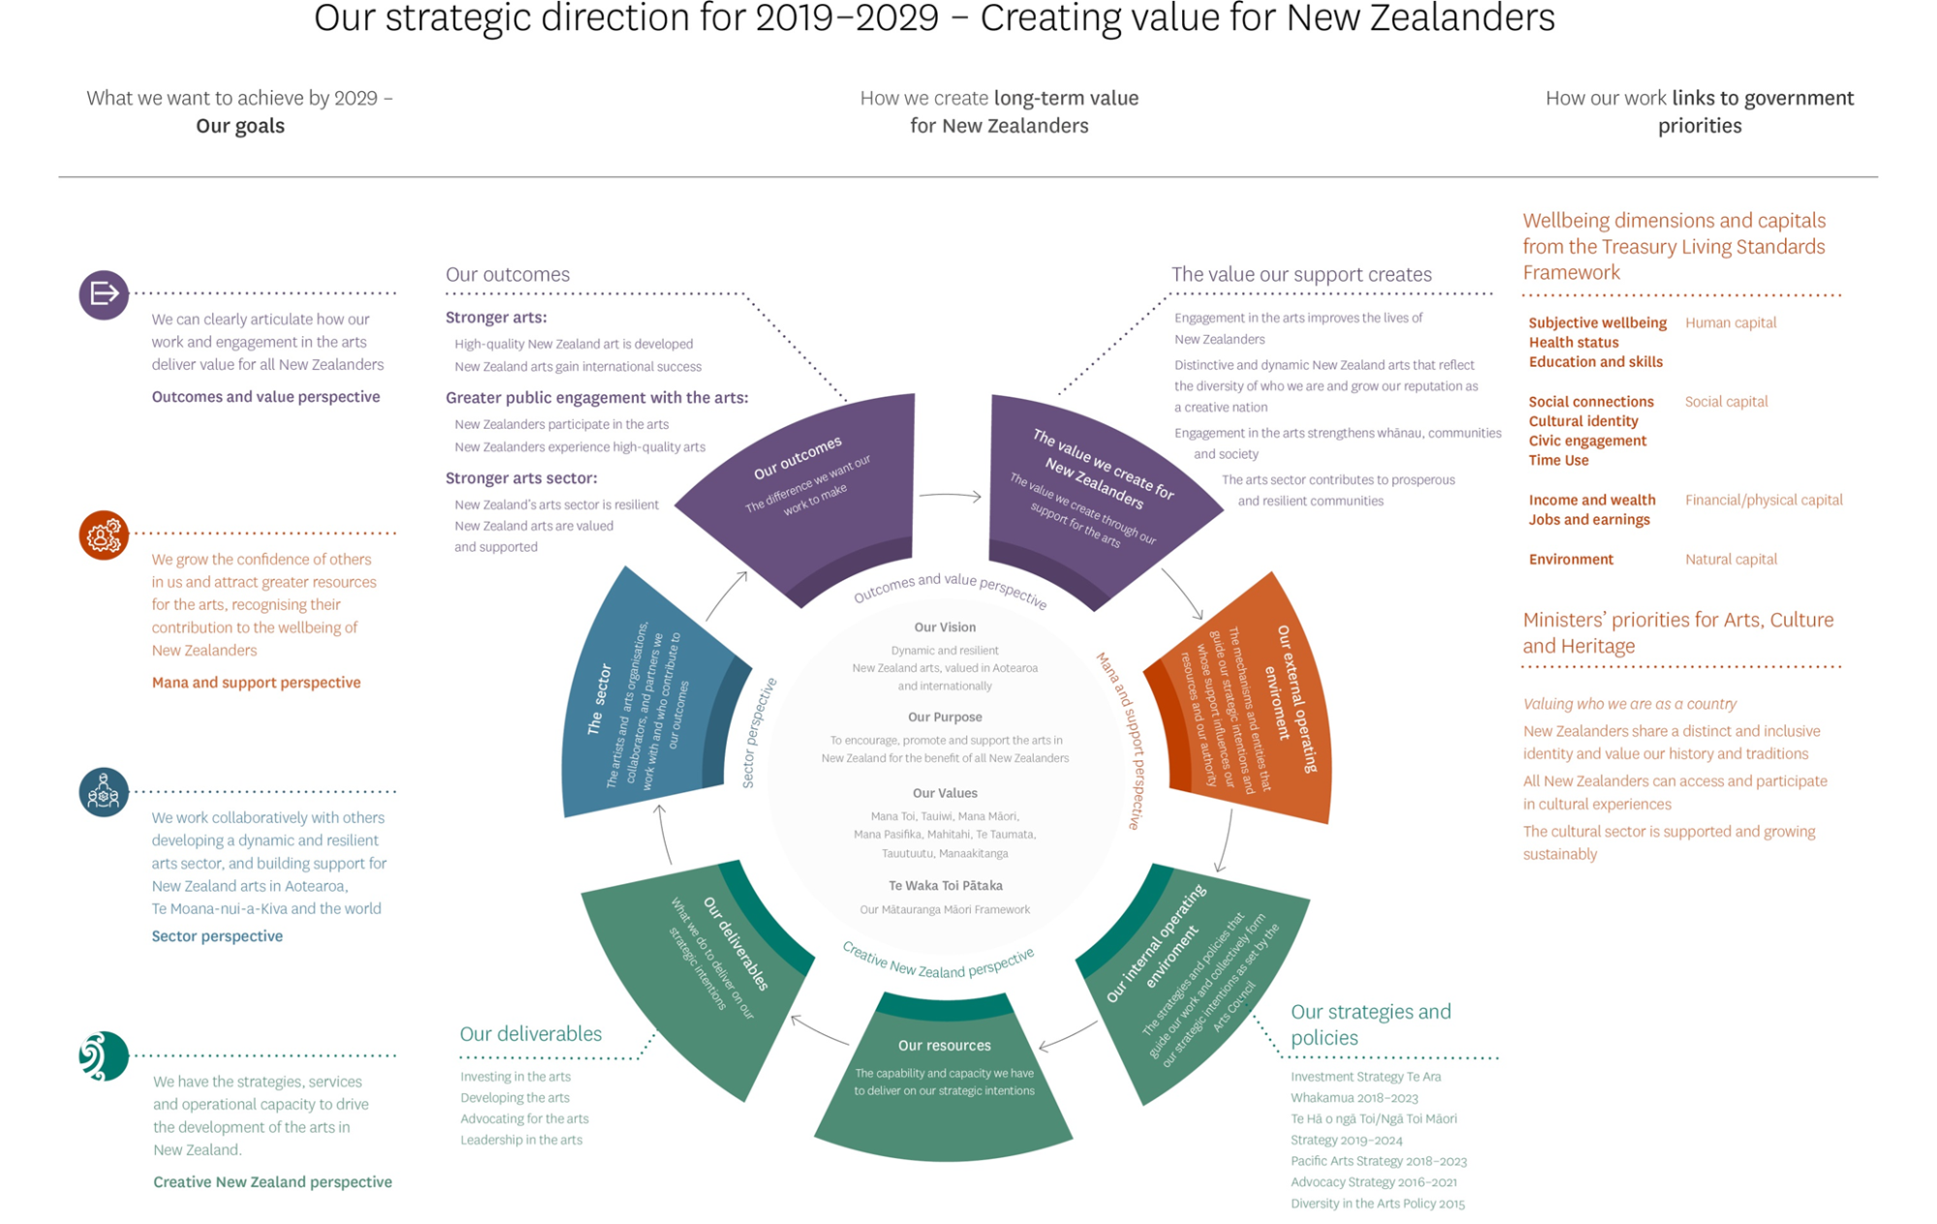

Te tau kei mua i a tātou

The year ahead

Ministerial expectations for 2021/22
By convention, the Minister for Arts, Culture and Heritage writes to the Arts Council each year outlining the Government’s expectations for the forthcoming performance year.
Creative New Zealand received the Minister’s 2021/22 expectations by letter in February 2021.

Aligning with government and sector priorities
We recognise we have an important role in delivering to the Government’s outcomes, specifically Ministers’ priorities for arts, culture, and heritage.
Building on the foundations laid in the first term, the Government has identified three overarching priorities:
- keeping New Zealanders safe from COVID-19
- accelerating our economic recovery
- laying the foundations for a better future.
To achieve these, three cultural sector priority outcomes have been identified with support from Ministers, agencies, and the sector:
- economic recovery
- vibrant, innovative sectors
- better access and participation.
Creative New Zealand has a vital role in contributing to these, both independently and in collaboration with others.
The increased investment through Budget 2020 has helped Creative New Zealand better position the arts sector to survive the COVID-19 crisis, adapt to the changing environment, and engage audiences in new ways. Creative New Zealand will continue to focus its resources on supporting the sector through the impacts of the COVID-19 pandemic and work with Manatū Taonga Ministry for Culture and Heritage on monitoring and evaluating initiatives under the COVID-19 response fund.
Creative New Zealand will continue to manage the Pasifika Festivals Initiative ($12 million over three years) to support Pasifika festivals throughout New Zealand.
We will continue to support the implementation of the Mātauranga Māori Te Awe Kōtuku Fund, including allocation through our own initiatives to support iwi, hapū, whānau, and Māori communities with projects that will protect their mātauranga and taonga from the impact and ongoing threat of COVID-19.
We will progress work started in 2020/21 under the Cultural Sector Capability Fund to support the arts sector to have the necessary industry, technical, and business capability to meet the challenges of a COVID-19 environment.

Creative New Zealand-specific priorities
The Minister for Arts, Culture and Heritage has outlined specific expectations for Creative New Zealand in 2021/22. These are consistent with our ongoing operations and align well with the Council’s thinking in relation to the year ahead.
Specific expectations for Creative New Zealand in 2021/22 are that it will:
- deliver the initiatives for which it received COVID-19 response funding on time and within budget
- make sure the Board employs effective financial management practices to respond to the post-COVID-19 needs of the sector
- undertake an independent evaluation of governance practices and provide a report to Manatū Taonga Ministry for Culture and Heritage.
- continue to embed Te Hā o ngā Toi—Māori Arts Strategy 2019–2024 and look for opportunities to lift the capability and representation of Māori arts and artists in a post-COVID-19 environment
- continue to embed the Pacific Arts Strategy 2018–2023 and look for opportunities to lift the capability and representation of Pasifika arts and artists in a post-COVID-19 environment
- explore how disadvantaged and underserved communities can be supported, to make sure they are not disproportionately affected by the impacts of the COVID-19 pandemic
- make sure Creative New Zealand’s stakeholder communications and response to sector feedback is fit for purpose and allows a process of continuous improvement.
Regarding Creative New Zealand governance and reporting in 2021/22:
- the Council will continue to oversee the performance and long-term strategic direction of Creative New Zealand and provide best practice governance. This will include monitoring Creative New Zealand’s financial wellbeing and long-term viability and making sure Creative New Zealand has robust risk awareness and management processes in place. Council will undertake an independent evaluation of governance practices in the 2021/22 year
- the Council will provide information on performance against planning documents, and quality and timely information on risks and opportunities.
An overarching expectation is that of ‘no surprises’. We are committed to informing the Minister in a timely manner about matters of significance as they relate to the arts.

Challenges, opportunities, and priorities in the year ahead

Challenges facing Creative New Zealand
Challenges | Implications
The long tail of COVID-19 | Ongoing uncertainty and disruption associated with the COVID-19 pandemic.
Increasing demand and new expectations | Increasing demand for our services and new expectations generated through our COVID-19 response work.
Creative New Zealand’s 2021/22 financial outlook | Lower revenue and financial reserves due to the significant investment in our COVID-19 emergency response and cessation of most of the additional COVID-related government funding.
Funding instability | Variability in New Zealand Lottery Grants Board funding making long-term investment decisions difficult.

The long tail of COVID-19
Despite significant progress in tackling the COVID-19 pandemic, the impacts continue to be felt across the arts sector and the nation.
The arts sector cannot operate viably above Alert Level 1, and border closures continue to affect those previously reliant on international touring and an international labour force.
As a result of Creative New Zealand’s reserves being depleted through its emergency response to COVID-19, and one-off Budget 2020 funding being exhausted, we expect to have limited capacity to respond to further COVID-19-related disruption.
In response, through our planning for 2021/22, we have sought to develop a fit-for-purpose and affordable programme for 2021/22 that recognises the current COVID-19 environment and ongoing changing nature of our operating environment.

Increasing demand for our services and new expectations
Creative New Zealand is experiencing strong demand for funding, particularly through its grants programmes. This accelerated during the COVID-19 restrictions in 2020/21 as artists, arts practitioners, and arts organisations (outside of the Investment programmes) sought to maintain their practice and generate income.
Funding for grants was increased in 2020/21 because of additional government investment directly related to COVID-19. This let us better meet the strong demand and make sure high-quality applications could be supported.
In 2020/21 Creative New Zealand sought to prioritise investment into grants to reduce the risks to artists, arts practitioners, and organisations reliant on grant funding. This has resulted in some targeted special opportunities and initiatives that were paused during the COVID-19 restrictions in 2020/21 remaining on hold.

Funding instability
In a typical year, Creative New Zealand receives around a 30:70 split through Vote: Arts, Culture and Heritage funding and funding from the New Zealand Lotteries Commission via the NZLGB. The NZLGB funding changes year to year in both forecasts and the actual payments.
Funding instability makes it challenging for Creative New Zealand to plan for long-term investment in the arts, deliver on its strategic intentions, and to confidently enter long-term funding arrangements with arts organisations.
To manage this risk, the Arts Council will continue its equity policy aimed at reducing the risks associated with the changing NZLGB revenue.

Sector-facing challenges
Challenges | How we are responding
Upskilling the sector for the digital world | Exploring ways to build the capability of the sector to maximise the opportunities associated with digital technologies.
Improving the sustainability of arts sector careers | Developing a remuneration principles policy.
 | Considering the development of industry-led pay guidelines.
Increasing the diversity and reach of those accessing and benefiting from our services | Ongoing reporting against our Diversity in the Arts Policy 2015.
 | Considering priorities and actions arising from our diversity reporting.
 | Continuing to implement our key strategies, including Te Hā o ngā Toi—Māori Arts Strategy 2019–2024 and the Pacific Arts Strategy 2018–2023.
 | Advancing our Te Kaupapa o Toi Aotearoa programme.
Embedding the value of the arts | Implementing the Advocacy Strategy and plans.
From a sector perspective, the economic and social impacts of COVID-19 have highlighted areas of work that need to be progressed to meet the challenges of a COVID world. We believe the following gaps or challenges need our attention over the next year.
- Addressing digital creation, distribution, access, and capability: Considering how we can support the arts sector to better develop and take advantage of the opportunities associated with digital creation, distribution, and audience engagement in the arts. This will work will be progressed over 2021/22.
- Progressing work on sustainable careers and the resilience of the sector: Developing our understanding of, and support for, resilience in the arts sector, both organisational and individual, including progressing initiatives aimed at improving the sustainability of arts sector careers.
Initiatives that will be progressed over 2021/22 include:
  - developing a remuneration principles policy to establish best-practice principles for those working in the arts (to complement our existing fair pay guidelines for grants)
  - considering the development of pay guidelines to set benchmarks for what creative professionals in different roles and at different career stages should be paid.
- Further addressing the diversity, reach and inclusivity of who is accessing and benefitting from our services: Based on our Diversity in the Arts Policy 2015, building our understanding of the diversity and reach of who and what we fund, and considering how we can address issues around equity and access to support, and more broadly around access to the arts.
- Continuing to implement key strategies: Including Te Hā o ngā Toi—Māori Arts Strategy 2019–2024 and the Pacific Arts Strategy 2018–2023.
- Embedding the value of the arts across government – with a wellbeing focus: Building on the advocacy work undertaken as part of Creative New Zealand’s COVID-19 response, with a focus on the role of the arts in supporting wellbeing. Over 2021/22 we will also review the Advocacy Strategy 2016–2021.
- Advancing our Te Kaupapa o Toi Aotearoa programme: This internally focused programme was launched in 2020/21 and aims to make sure we have the organisational culture, competencies, and practices that will help us to meet our aspirations under Te Tiriti o Waitangi (the Treaty of Waitangi) and deliver public value for all New Zealanders.

Opportunities

Sector-facing opportunities
Opportunities | How we can help
Consider the impact of the COVID-19 pandemic on the future of the arts, and how the sector can leverage off the disruption | Facilitate a future-focused conversation with the arts sector on the challenges and opportunities of a world.
Government’s Arts and Culture COVID Recovery Programme | Continue to support Manatū Taonga Ministry for Culture and Heritage as it rolls out the Cultural Sector Regeneration Fund and ensure alignment and complementarity of funding.
Opportunities arising from the current environment include:
- facilitating a future-focused conversation with the arts sector: Following the disruption of COVID-19, and as we look to refresh our Statement of Intent ahead of 2022/23, we are planning to begin a conversation with the sector about issues facing the arts into the future and what role we might have as the national arts development agency in addressing them
- maximising the opportunities associated with the Arts and Culture COVID Recovery Programme: This programme represents the most significant investment in the arts sector in 20 years. The Arts Council is committed to supporting Manatū Taonga Ministry for Culture and Heritage as it carries out the programme and making sure Council funding is complementary.

Our priorities
To respond to the challenges and opportunities ahead, the Arts Council’s priorities for the year ahead, are:
- delivering the multi-year initiatives under the Government’s Arts and Culture COVID Recovery Programme on time and within budget
- delivering a fit-for-purpose and affordable 12-month investment programme to support the arts sector to continue to survive, recover, and thrive in a COVID-19 world (Creative New Zealand’s Phase 3 COVID-19 Response Programme)
- continuing to deliver our key kaupapa-based strategies Te Hā o ngā Toi—Māori Arts Strategy 2019–2024 and the Pacific Arts Strategy 2018–2023, and the Investment Strategy Te Ara Whakamua 2018–2023.
- increasingly considering and showing how Creative New Zealand’s support for the arts is inclusive of, and accessible to, New Zealand’s diverse communities
- supporting the arts sector to maximise the opportunities associated with digital technologies, for the benefit of the sector and all New Zealanders, in a way that recognises the unique cultural context of Aotearoa
- working to improve the sustainability of the arts sector, including the sustainability of arts sector careers, contributing to the wider Government Arts and Culture COVID Recovery Programme, and aligning our resources to make sure of the best outcomes for the arts sector
- advancing our Te Kaupapa o Toi Aotearoa programme.
WHAKAMAHERE UTU KORE MAHI
NON-FINANCIAL PLANNING AND PERFORMANCE

Te tūtuki i a mātau mahi

Our performance framework
Our Statement of Intent outlines Creative New Zealand’s strategic direction over the 2019 to 2029 period. Our performance framework is based on that strategic direction.
The performance framework in this SPE outlines what we will be measuring in 2021/22. This will be a mix of measures that, when taken together, provide a balanced picture of our performance. We will report against these measures in our 2021/22 Annual Report.
Our measures are a combination of two things.
- Annual priorities – these are a mix of new projects and ongoing work and tend to be more innovative or high-profile in nature than core activities. Each SPE has different annual priorities as we make progress towards meeting our goals.
- Core activities – these are more business-as-usual activities, such as running investment and grants programmes, delivering capability building initiatives, and carrying out advocacy or leadership activities. We have also included internally focused measures because we aim to show how our internal operating capability directly contributes to the value we provide for our clients.
We will track our progress and report against our annual priorities and core activities, as well as talk about how these are helping us reach our goals.
Over 2021/22, we will also monitor and report on progress against our major strategies and policies, including the Investment Strategy Te Ara Whakamua 2018–2023, Te Hā o ngā Toi—Māori Arts Strategy 2019–2024, the Pacific Arts Strategy 2018–2023, the Advocacy Strategy 2016–2021, and the Diversity in the Arts Policy 2015.
These strategies and policies contribute directly to our outcomes, and we will show how their implementation is progressing through our quarterly reporting to the Minister and in our Annual Report 2021/22.
We measure the broader results of our work under our outcomes. For example, the Greater public engagement with the arts outcome is shown by:
- New Zealanders participating in the arts (ie, reported participant numbers across our major funding programmes)
- New Zealanders experiencing high-quality arts (ie, audience numbers from activity funded through our major funding programmes).
We also monitor significant areas of interest that can be used to show change over time. For example, under the Sector perspective of the Creating value for New Zealanders model, we track the health of the sector. This is an area that is not necessarily within Creative New Zealand’s control but where movement may prompt us to act.
We continuously seek to improve the quality of our measures. For example, measures relating to New Zealand arts gaining international success (under the Stronger arts outcome) currently focus on the level of activity we support rather than whether the outcome has been achieved. We are looking to make these measures more meaningful and relate them directly to the outcomes we are seeking.
In our reporting, we will also talk about how our day-to-day work links to our vision, to Ministers’ priorities for the Arts, Culture and Heritage portfolio, as well as how our work contributes to the creation of public value through the Creating value for New Zealanders’ model.

Te tūtuki i a mātau mahi 2020/21

Our performance framework 2021/22

OUR VISION | What we want to achieve by 2029 – Our goals | How will we achieve our goals?  We’ll create long-term value through four perspectives | How will we know we’re successful?  We’ll monitor the impact of our work to measure our success
Dynamic and resilient New Zealand arts, valued in Aotearoa and internationally | Goal: Mana and support perspective – We grow the confidence of others in us and attract greater resources for the arts, recognising their contribution to the wellbeing of New Zealanders | Mana and support perspective | Indicators of confidence in Creative New Zealand’s performance
 |  | Our external operating environment: The mechanisms and entities that guide our strategic intentions and whose support influences our resources and authority | Maintain or improve audit management ratings for management control, financial systems, and service performance information  Percentage of clients who are satisfied with the overall customer satisfaction with service received from Creative New Zealand  Rating on the Colmar Brunton Corporate Public Sector Reputation Index
 | Goal: Creative New Zealand perspective – We have the strategies, services, and operational capacity to drive the development of the arts in New Zealand for the benefit of all New Zealanders | Creative New Zealand perspective
 |  | Our deliverables – What we do to deliver on our strategic intentions | Core activity measures | Annual priorities
 |  | Investing in the arts – Investing in artists, art practitioners, and arts organisations and their projects in a fair, transparent, and strategic way | Percentage of Tōtara and Kahikatea organisations that meet or exceed performance expectations set out in funding agreements  Percentage of completed projects that meet or exceed expectations in funding agreements | Delivering the multi-year initiatives under the Government’s Arts and Culture COVID Recovery Programme according to funding agreements and budget:  - Pasifika Festivals Initiative – deliver funding according to agreed parameters  - Mātauranga Māori Te Awe Kōtuku Initiative – meet objectives in funding agreement  - Cultural Sector Capability Fund – develop a business case for a digital arts and culture development initiative  Developing a remuneration principles policy to support the sustainability of arts sector careers
 |  | Developing the arts – Developing the arts sector’s capacity to succeed and undertaking initiatives to develop the arts | Percentage of clients who agree capability building programmes align with their needs and priorities  Percentage of clients who rank capability building initiatives as extremely or very effective, relevant, and helpful  Percentage of completed projects for targeted initiatives to develop the arts delivered to the sector that have met or exceeded our expectations
 |  | Advocating for the arts – Promoting the value of the arts and empowering the arts sector to make the case for the arts | Percentage of advocacy actions described in the annual advocacy action plan that have met or exceeded our expectations
 |  | Leadership in the arts – Providing leadership to ensure the arts sector is well positioned collectively to respond to change | Overall participant satisfaction with Creative New Zealand-led events  Number of Creative New Zealand-commissioned research projects that advance knowledge or discussion about the arts in New Zealand
 |  | Our resources – The capability and capacity we have to deliver on our strategic intentions
 |  | Public money | Total level of investment by Creative New Zealand in the arts  Percentage of operating costs from total expenditure in line with policy set by the Arts Council (being between 15 and 16 percent of total expenditure)
 |  | Our people and expertise | Improve on the Workplace survey overall performance index | Advancing our Te Kaupapa o Toi Aotearoa programme, which aims to build organisational culture, competencies, and practices that will enable us to meet our aspirations under Te Tiriti o Waitangi and deliver public value for all New Zealanders
 |  | Our operational capacity | Percentage of funding decisions made within specified timeframes  Percentage of applications externally assessed
 |  | Our internal operating environment – The strategies and policies that guide our work and collectively form our strategic intentions as set by the Arts Council
 |  | The strategies and policies that guide our work and collectively form our strategic intentions | Deliver actions set out in approved implementation plans for key kaupapa-based strategies:  - Te Hā o ngā Toi—Māori Arts Strategy 2019–2024  - Pacific Arts Strategy 2018–2023 | Increasing our understanding of the diversity of those who access or benefit from our services
 | Goal: Sector perspective – We work collaboratively with others developing a dynamic and resilient arts sector, and building support for New Zealand arts in Aotearoa, Te Moana-nui-a-Kiva, and the world | Sector perspective | Indicators of sector health and performance
 |  | The sector: The artists and arts organisations, collaborators, and partners we work with and who contribute to our outcomes | Artistic health  Percentage of Tōtara and Kahikatea organisations that meet or exceed expectations for quality of artistic programme measures
Financial health
Percentage of Tōtara and Kahikatea organisations that meet or exceed expectations for financial health measures
Funding
Average private support (sponsorship, philanthropy, and trust funding) per investment organisation
Our relationships
Number of active relationships (including co-investment, regular meetings, shared projects) Creative New Zealand maintains with organisations or collectives that have shared interests, including government, local government, trusts, and other partners
 | Goal: Outcomes and value perspective – We can clearly articulate how our work and engagement in the arts deliver value for all New Zealanders | Outcomes and value perspective
 |  | Our outcomes – The difference we want our work to make | Outcome measures
 |  | Stronger arts | High-quality New Zealand art is developed  Number of new New Zealand works developed
New Zealand arts gain international success
Number of artists and arts organisations funded by Creative New Zealand to engage internationally
Number of international arts activities and events funded by Creative New Zealand
 |  | Greater public engagement with the arts | New Zealanders participate in the arts  Number of participants in arts activities funded by Creative New Zealand
New Zealanders experience high-quality arts
Number of attendances at arts activities and events funded by Creative New Zealand
 |  | Stronger arts sector | New Zealand’s arts sector is resilient  Percentage of Tōtara and Kahikatea organisations that meet or exceed expectations set in their funding agreements across the three dimensions of: quality of artistic programme, financial health, organisational health
New Zealand arts are valued and supported
Average percentage of ‘other’ (non-Creative New Zealand) investment across the Tōtara and Kahikatea organisations’
Index rating for how New Zealanders perceive the value of the arts to New Zealand (New Zealanders and the Arts survey data)

A mātou whāinga

Our goals

Mana and support perspective
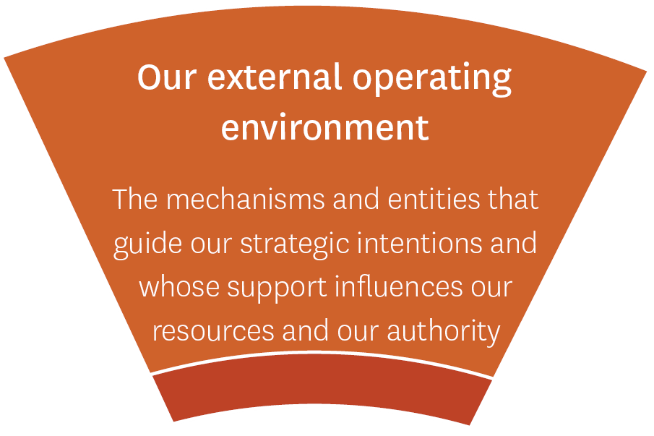
Goal: We grow the confidence of others in us, and attract greater resources for the arts, recognising their contribution to the wellbeing of New Zealanders

Why this goal?
This goal recognises the entities and mechanisms that grant us the legitimacy and authority we need to do our work, and whose support influences our resources. Never has it been so important to grow others’ confidence in us, so we will be in a stronger position to advocate for greater resources and support for the arts when our artists, practitioners, and organisations need it most. We are extremely grateful for the confidence Ministers have shown in Creative New Zealand’s mahi over the past year, including its ability to distribute resources to artists, arts practitioners, and arts organisations through the COVID-19 crisis.
We know we have a strong leadership role to continue to play, highlighting the challenges facing the arts community and supporting action. Through our leadership and advocacy roles in 2021/22, we will proactively champion the arts across central and local government, the private sector, and other partners. Where appropriate, we will also provide advice to Ministers on matters relating to Creative New Zealand’s functions.
How will we measure progress under this goal?
We aim to show the mana we hold with those who support us: New Zealanders, the arts sector, our clients and partners, our funders, our Ministers, and the agencies responsible for making sure we operate effectively and efficiently. We will monitor the feedback from our clients, Audit New Zealand, and the New Zealand public and work to improve our performance over time so their confidence in us grows.
No. | Measure/indicator | Data source | 2019/20  Actual | 2020/21  Forecast | 2021/22  Target | Rationale
I1.1 | Audit management ratings for management control, financial systems, and service performance information | Audit Management Report – annual | Good  Very good  Good | Very good  Very good  Very good | Very good  Very good  Very good | This measure provides objective assurance to members of the public for them to have confidence in Creative New Zealand.
I1.2 | Overall satisfaction with Creative New Zealand’s service | Creative New Zealand Satisfaction Survey – annual | 68.4% | ≥65% | ≥68% | Measures our reputation with our clients, customers, and the sector.
I1.3 | Rating on the Colmar Brunton Public Sector Reputation Index (PSRI) | Colmar Brunton PSRI – annual | 104 | ≥103 | ≥104 | Measures our reputation with the New Zealand public.

Creative New Zealand perspective
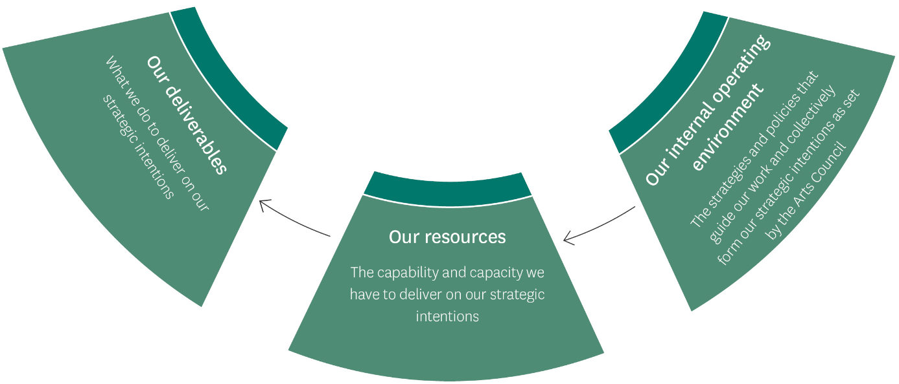
Goal: We have the strategies, services, and operational capacity to drive development of the arts in New Zealand, for the benefit of all New Zealanders

Why this goal?
It is vital we have strategies and policies to guide our work and the capability and capacity to deliver on our strategic intentions.
Our internal operating environment describes the strategies and policies that collectively form our strategic intentions as set by the Arts Council. It includes our Statement of Intent 2019–2029, alongside the strategies and policies we have developed together with the sector (pages 7–8).
We have reviewed our strategies and their 2021/22 implementation plans. We are prioritising our resources so we can provide practical support to sustain the arts sector (artists, practitioners, arts organisations including groups and collectives) through the year ahead.
Our resources describe the capability and capacity we have as an organisation to deliver on our strategic intentions. This includes the public money we receive, our people and expertise, and our operational capacity.
Our deliverables are what we will do to meet our goals and contribute to our outcomes. We have changed these to meet the needs of the arts sector in 2021/22. Across all our deliverables, we often work in partnership with others to benefit from pooled expertise and resources. We have four deliverables, as explained below.
Investing in the arts | Investing in artists, art practitioners, and arts organisations and their projects in a fair, transparent, and strategic way.  Creative New Zealand funding supports professional development opportunities as well as the creation, presentation, and distribution of art throughout New Zealand and overseas. We will deliver most of our funding through our main investment programmes. Our 2021/22 investment priorities include:  - delivering investment to programmes and initiatives that support the sector to respond to the COVID-19 context  - delivering funding for specific COVID-19 response programmes (Mātauranga Māori Te Awe Kōtuku Initiative and Pasifika Festivals Initiative)  - maintaining investment to support the implementation of Te Hā o ngā Toi—Māori Arts Strategy 2019–2024 and the Pacific Arts Strategy 2018–2023.
Developing the arts | Developing the arts sector’s capacity to succeed and undertaking initiatives to develop the arts.  Creative New Zealand provides opportunities for arts organisations, individual artists, and practitioners to build their skills and capability, with the goal of developing the arts sector’s capacity to succeed. Our 2021/22 priorities include:  - delivering targeted capability building initiatives to support the needs of arts organisations using Poutama as a developmental framework  - developing a business case, with funding from the Cultural Sector Capability Fund, for a digital arts and cultural development initiative  - adapting the International Capability Building Programme to build sector capability and networks to operate in the 2021/22 context.
Advocating for the arts | Promoting the value of the arts and empowering the arts sector to make the case for the arts.  Creative New Zealand advocates for the benefits of the arts to different audiences, including government agencies and local authorities. We also provide research and resources to the arts sector, to help allies carry out their own advocacy around those benefits. In 2020/21 we encouraged New Zealanders to continue to engage with arts and culture and showed how important the arts are for our wellbeing during a time of crisis. Our 2021/22 priorities include:  - putting in place ongoing national arts advocacy campaigns and/or engagement mahi – public-facing and arts community focused, including continued media advocacy  - delivering ongoing advocacy and working with local government, given its mandate for improving communities’ social and cultural wellbeing  - talking about the value of the arts, with a focus on their positive effects on the social wellbeing of communities  - convening an external advisory group, Te Rōpu Mana Toi, to inform and advance our advocacy work and collective advocacy on matters of national significance  - reviewing our Advocacy Strategy 2016–2021.
Leadership in the arts | Providing leadership to ensure the arts sector is well positioned collectively to respond to change.  As a national body, we have a role in providing leadership in the arts, by tracking trends and developments across the sector, identifying and responding to issues, and bringing the sector together to address challenges or respond to opportunities. In 2020/21 we had an important role in contributing to the Government’s wider cultural recovery package outcomes, specifically Ministers’ priorities for arts and culture.  We encourage those in the sector to work together, to organise and discuss issues and goals through events such as Nui te Kōrero, develop the research, strategies and policies that seek to advance the arts, and provide advice to government on matters affecting our functions.  Our 2021/22 priorities include:  - communicating the results of our triennial New Zealanders and the arts and Audience Atlas research, which looks at attitudes, attendance, and participation in the arts, and enhancing the role of this research as an important advocacy and development tool for the arts sector  - leading engagement with artists, communities, the sector, and stakeholders to identify significant impacts, issues, and opportunities, including through our annual conference Nui te Kōrero.

How will we measure progress under this goal?
Annual priorities
Our annual priorities cover a mix of new projects and ongoing work across our deliverables, internal operating environment, and resources, and tend to be more innovative or high profile in nature than core activities. This year, four main pieces of work will support our overarching priorities for the year. We will report progress quarterly in 2021/22.
A1. Delivering the multi-year initiatives under the Government’s Arts and Culture COVID Recovery Programme according to funding agreements and budget:
- Pasifika Festivals Initiative – deliver funding according to agreed parameters
- Mātauranga Māori Te Awe Kōtuku Initiative – meet objectives in funding agreement
- Cultural Sector Capability Fund – develop a business case for a digital arts and cultural development initiative.
A2. Developing a remuneration principles policy to support the sustainability of arts sector careers.
A3. Advancing our Te Kaupapa o Toi Aotearoa programme, which aims to build organisational culture, competencies, and practices that will enable us to meet our aspirations under Te Tiriti o Waitangi and deliver public value for all New Zealanders.
A4. Increasing our understanding of the diversity of those who access or benefit from our services.
Core activity measures
No. | Name | 2019/20 Actual | 2020/21 Forecast | 2021/22  Target | Notes
Deliverables
Investing in the arts
D2.1 | Tōtara and Kahikatea investment organisations meet or exceed expectations against performance expectations set in individual funding agreements (overall performance of Tōtara and Kahikatea organisations) | 96% | ≥99% | 96% | Calculates the average percentage of ‘Met’ or ‘Exceeded’ expectations across the organisations, to measure their overall performance for the period.
D2.2 | Completed projects meet or exceed expectations set in funding agreements | 98% | ≥99% | 99% | Reports on ‘Met’ or ‘Exceeded’ expectations for project-based funding: Project-funded Kahikatea clients; Grants and special opportunities; International and capability building programme grants; and other project-based funding.
Developing the arts
D2.3 | Clients agree the capability building programme aligns with their needs and priorities | 91% | ≥90% | 90% | Measures assessment of the immediate results of individual capability building initiatives against the relevant objectives set for each initiative.
D2.4 | Clients rank capability building initiatives as extremely or very effective, relevant, and helpful | 79% | ≥75% | ≥75%
D2.5 | Capability building initiatives delivered to the sector that met or exceeded our expectations | 98% | ≥92% | ≥92%
Advocating for the arts
D2.6 | Annual advocacy actions that meet or exceed our expectations | 50% | ≥75% | ≥75% | Measures assessment of the immediate results of individual advocacy actions for the period.
Leadership in the arts
D2.7 | Overall participant satisfaction with Creative New Zealand-led events | 73% | 73% | ≥73%
Our resources
Public money
D2.8 | Total level of investment by Creative New Zealand in the arts | $70.238  million | $82.272 million  (forecast) | $64.853 million  (budget) | Measures actual investment delivered for the period against budget.
D2.9 | Maintain operating costs in line with policy set by the Arts Council | 12.5 % | ≤16% | ≤16% | Arts Council policy sets the operating costs between 15 percent and 16 percent of total expenditure.
Our people and expertise
D2.10 | Improve on Workplace survey overall performance index | 74.8% | ≥74% | ≥75% | Averages survey section scores, covering areas like quality and performance focus, communication and co-operation, and learning and development.
Our operational capacity
D2.11 | Funding decisions are made within specified timeframes | 100% | 100% | 100% | Both measures are proxy indicators for fairness and transparency within our funding decision-making processes. External peer assessment supports and informs decision-making on our contestable funding opportunities.
D2.12 | Percentage of applications externally assessed | 100% | 100% | 100%

- Sector perspective
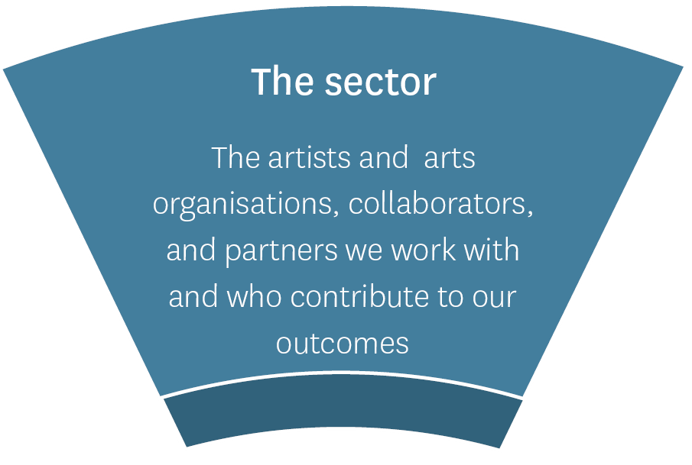
Goal: We work collaboratively with others developing a dynamic and resilient arts sector, and building support for New Zealand arts in Aotearoa, Te Moana-nui-a-Kiva, and the world
Why this goal?
The sector perspective describes who we work with: the players who help achieve our outcomes and help us deliver value for New Zealanders. When we talk about ‘the sector’, we mean the clients, collaborators, and partners we work with. Our clients are the artists, arts practitioners, and arts organisations that receive our funding and create artworks, deliver activities, and provide services.
We know these are challenging times. The arts community is diverse and dispersed, and we understand the challenges it has faced and will keep facing. It has been heartening to see artists, practitioners, and arts organisations coming together to support each other. We have seen how the sector is connecting and working together in so many ways.
This year, we will continue to champion the role that artists (individually and collectively) and the arts can play in supporting communities in Aotearoa to recover from the COVID-19 crisis. While we realise our collaborators and partners will be experiencing their own challenges, their support is valued and has an effect. Now, more than ever, we will advocate for ongoing support for and investment in the arts at all levels of government, from other funders, and members of the public.

How will we measure the value created under this goal?
Creative New Zealand supports 83 arts organisations through the Toi Tōtara Haemata and Toi Uru Kahikatea Investment programmes. Using these clients as a proxy for the arts sector, we will monitor artistic health, financial health, and revenue streams.
No. | Indicator | 2019/20  Actual | 2020/21 Forecast | 2021/22 Target | Notes
Artistic health
I1.4 | Tōtara and Kahikatea organisations meet or exceed expectations for quality of artistic programme | 100% | 100% | 100% | The quality of our Tōtara and Kahikatea organisations’ artistic programmes is a proxy measure of artistic quality in New Zealand. Maintaining excellence in this area has a material impact on the health of the sector.
Financial health
I1.5 | Tōtara and Kahikatea organisations meet or exceed expectations for financial health | 98% | ≥100% | ≥98% | Tōtara and Kahikatea organisations receive around two-thirds of Creative New Zealand’s investment in the arts. Their financial health is a proxy measure of the financial health of the arts sector. The 2020/21 target reflects the expected impact of the COVID-19 pandemic.
Funding
I1.6 | Average private support (sponsorship, philanthropy, and trust funding) per investment organisation | 72.9% | ≥62.1% | ≥63% | Increasing support from private investment indicates a valued and supported sector.
Our relationships
I1.7 | Number of active relationships (including co-investment, regular meetings, shared projects) Creative New Zealand maintains with organisations that have shared interests | 175 | ≥100 | ≥175 | Through our collaborations, we will share knowledge and resources with key partners to achieve our goal of developing a dynamic and resilient arts sector.

Monitoring the state of the sector over time
To support the sector perspective indicators on the previous page, Creative New Zealand will also monitor the following areas to better understand the state of the sector and changes over time. These are not performance measures Creative New Zealand will be held accountable for, because change in these areas is often out of Creative New Zealand’s control and is affected by significant challenges, like those brought about by the COVID-19 crisis. We will keep monitoring them, however, to see where we can contribute through our programmes and advocacy and policy work. We will provide snapshots of sector trends in our Annual Report 2021/22.
Trend monitored | Data source | Rationale
Employment
Median chief executive salary in a small (arts) organisation compared with the not-for-profit median | Arts organisation remuneration survey 2019 | This indicator shows pay rates within surveyed arts organisations versus the not-for-profit sector. While Creative New Zealand does not have a direct impact on salaries, its work in arts policy and advocacy, often in collaboration, aims to contribute to growth in the sector in these areas.
Median total income for creative professionals versus median total income for New Zealanders earning a salary or wage | Profile of Creative Professionals survey 2019 | The median total income for New Zealanders earning a salary or wage is $51,800. While Creative New Zealand does not have a direct impact on salaries, its work in arts policy and advocacy, often in collaboration, aims to contribute to growth in the sector in these areas.
Funding
Annual level of local authority investment in ‘culture’ | Stats NZ local authority statistics – annual | These indicators provide a picture of funding to the arts through three main revenue streams: private investment and local and central government. Increasing support from all three areas indicates a valued and supported sector. Creative New Zealand will continue working in its advocacy and leadership roles to show the value of the arts.
Average annual government per person expenditure on arts | Creative New Zealand desk research
The market
Percentage of New Zealanders in the market for culture | Audience Atlas survey 2020 – three yearly | These indicators track the New Zealand public’s appetite for arts in New Zealand. Through ensuring diversity and reach, access, and dynamic arts, we aim to increase New Zealander’s appetite for the arts in New Zealand.
Percentage of New Zealanders engaged in the arts | New Zealanders and the Arts survey 2020 – three yearly

- Outcomes and value perspective

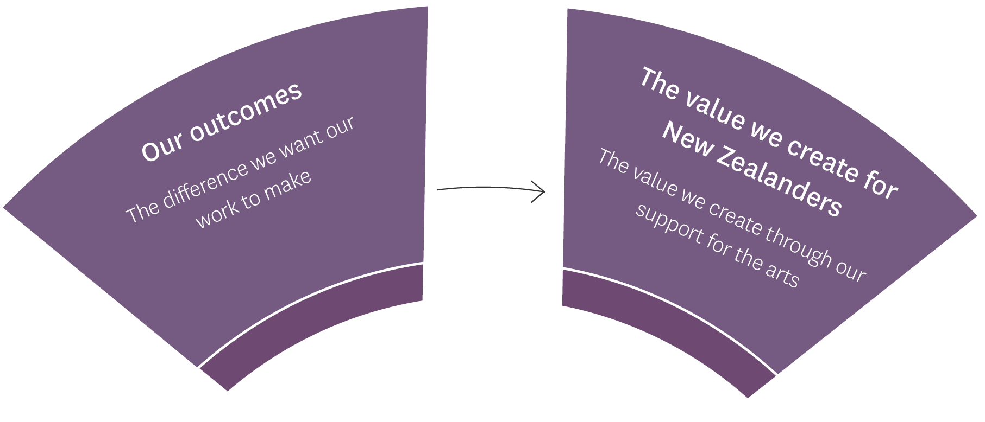

Goal: We can clearly articulate how our work and engagement in the arts deliver value for all New Zealanders

Why this goal?
Our outcomes describe the difference we want our work to make. As an arts development agency, we achieve our outcomes by working with others. We do this through investing in artists, arts practitioners, and arts organisations that deliver arts experiences and services to New Zealanders, and through our work developing, advocating for, and providing leadership in the arts.
Because of the ongoing impact of the COVID-19 pandemic, we will continue to focus on the short- to medium-term needs of our artists and arts organisations. We will concentrate on sustainability and resilience for the sector and deliver directly to Creative New Zealand’s Stronger arts sector outcome in the SOI.
We will continue linking to government priorities and align our work with Ministers’ priorities for the Arts, Culture and Heritage portfolio. We will also keep working with Manatū Taonga Ministry for Culture and Heritage to understand Creative New Zealand’s role in supporting the wider arts and culture initiatives.
What we hope to achieve under our three outcomes shifted last year, and we remain focused on the Stronger arts sector outcome in 2021/22 because the COVID-19 pandemic is still a significant factor. We are also focused on making sure that the arts we support deliver to all New Zealanders. The table on page 27 summarises our outcomes and the impact of the COVID-19 crisis on these outcomes.

 | Outcome: Stronger arts  as shown by: |  | Outcome: Greater public engagement with the arts  as shown by: |  | Outcome: Stronger arts sector  as shown by
 | High-quality New Zealand art is developed | New Zealand arts gain international success | New Zealanders participate in the arts | New Zealanders experience high-quality arts | New Zealand’s arts sector is resilient | New Zealand arts are valued and supported
Why this outcome? | Strong arts come from artists, arts practitioners, and arts organisations that have the ability and opportunity to generate high-quality work that reflects who we are as a nation and engages audiences in New Zealand and internationally. | International engagement contributes to strong arts by strengthening New Zealand arts practice and broadening the reach of our arts. | This outcome has always aspired to make sure New Zealanders have as many opportunities as possible to take part in the arts, to express themselves artistically, to celebrate, practise, transmit, and develop diverse artistic traditions and cultural heritage, and develop links between communities. | We have continuously worked to broaden opportunities for all New Zealanders to experience high-quality arts. This includes making sure New Zealanders have access to a different arts experiences and investing in under-served communities. | A strong arts sector is the foundation on which artists, arts practitioners, and arts organisations can produce high-quality arts and provide opportunities for public engagement with the arts. Never has it been so important to support a sustainable and resilient arts sector. | The arts create value and contribute to the wellbeing of New Zealanders. We are only one player in the arts ecosystem; however, we are interested in monitoring how benefits are realised through engagement with the arts.
The impacts of the COVID-19 pandemic on our outcomes in 2020/21 | In 2020/21, many creative practitioners were unable to work in the ways they are used to due to restrictions under Alert Levels 4, 3 and 2, and the related loss of income. Work was cancelled, deferred, or delayed due to the length of the crisis.  Arts organisations that rely on international touring for a large part of their revenue, or those that rely on an international workforce, have faced restrictions on travel, and significant elements of Creative New Zealand’s International Programme, in its traditional form, have needed to be reframed or suspended again in 2021/22. |  | The arts sector relies at its core on live engagement with audiences and participants in arts activities. Significant impacts on the sector are mainly related to the cancellation of domestic performances because of restrictions on gatherings and the closure of venues above Alert Level 1.  Again, while both artists and audiences have embraced digital platforms for making and experiencing arts, we need to be prepared for the possibility of reduced participation and engagement in 2021/22. |  | The value New Zealanders place on the arts is critical for building the resilience of the sector. Artists and arts organisations that, at the best of times, generally operate on thin margins were significantly affected in 2020/21.  While we saw artists adjust to Alert Level restrictions in various ways, we will continue to work to reduce the financial impact throughout 2021/22.
How our priorities contribute to our outcomes in 2021/22 | - Delivering a fit-for-purpose and affordable 12-month investment programme to support the arts sector to continue to survive, recover, and thrive in a COVID-19 world (Creative New Zealand’s Phase 3 COVID-19 Response Programme).  - Continuing to deliver our key kaupapa-based strategies, Te Hā o ngā Toi—Māori Arts Strategy 2019–2024 and the Pacific Arts Strategy 2018–2023, and the Investment Strategy Te Ara Whakamua 2018–2023.
 | - Increasingly considering and showing how Creative New Zealand’s support for the arts is inclusive of, and accessible to, New Zealand’s diverse communities.  - Supporting the arts sector to maximise the opportunities associated with digital technologies, for the benefit of the sector and all New Zealanders, in a way that recognises the unique cultural context of Aotearoa. |  |  |  | - Working to improve the sustainability of the arts sector, including the sustainability of arts sector careers.  - Delivering the multi-year initiatives under the Government’s Arts and Culture COVID Recovery Programme on time and within budget.

Measuring progress towards our outcomes
The outcome measures below will show our achievements for the year, when reported in the 2021/22 Annual Report.
Ref. | Measure | 2019/20 Actual | 2020/21 Forecast | 2021/22  Target | Notes
Outcome: Stronger arts
G1.1 | High-quality New Zealand art is developed: New New Zealand works are developed | 2,078 | ≥3,500 | ≥3,500 | Includes works funded through the Tōtara, Kahikatea, and Grant’s investment categories. This target is affected by available funding, applications received, and funding requested.
G1.2 | New Zealand arts gain international success: Individuals and organisations are funded by Creative New Zealand to engage internationally | 188 | ≥50 | 50–80 | Tracks the number of New Zealand artists and arts organisations presenting successfully on the world stage, however, does not reflect online digital engagement.
G1.3 | New Zealand arts gain international success: International arts activities and events are funded by Creative New Zealand | 1,637 | ≥800 | 200–250
Outcome: Greater public engagement in the arts
G1.4 | New Zealanders participate in the arts: Participants in arts activities funded by Creative New Zealand | 164,813 | ≥150,000 | ≥200,000 | Participation includes the active involvement of individuals, groups, and/or communities in the making or presentation of art. It applies to professional, emerging, and non-professional artists, including those involved in cultural and recreational activities.
G1.5 | New Zealanders experience high-quality arts: Attendances at arts activities and events funded by Creative New Zealand | 5,367,685 | ≥5 million | ≥5 million | Attendance refers to audience numbers, including paid audiences, readers, viewers, and attendances at free events.
Outcome: Stronger arts sector
G1.6 | New Zealand’s arts sector is resilient: Tōtara and Kahikatea organisations meet or exceed expectations set in their funding agreements across three dimensions: quality of programme; financial health; organisational health. | 100% | ≥100% | ≥100% | Using our investment clients as a proxy for the arts sector, we can show a resilient arts sector.
G1.7 | New Zealand arts are valued and supported: Average percentage of ‘other’ (non-Creative New Zealand) investment across Tōtara and Kahikatea organisations | 72.9% | 62.1% | ≥62% | Using our investment clients as a proxy for the arts sector, we can show support for the sector by measuring the level of revenue organisations generate from sources other than Creative New Zealand.
G1.8 | Index rating for how New Zealanders perceive the value of the arts to New Zealand | 53% | ≥59% | ≥59% | This rating is based on the results of three measures in the New Zealanders and the Arts 2020 survey.

Monitoring the value the arts create for New Zealanders
The statements below highlight ways the arts create value and add to the wellbeing of New Zealanders. These are not performance measures Creative New Zealand will be held accountable for, because change in these areas is often out of Creative New Zealand’s control and is affected by significant challenges, like those brought about by the COVID-19 crisis. However, we will keep monitoring them to see where we can contribute through our programmes and advocacy and policy work. We will provide snapshots of sector trends in our Annual Report 2021/22. We will communicate the results of our New Zealanders and the arts and Audience Atlas 2020 research this year, which looks at attitudes, attendance, and participation in the arts, and enhance the role of this research as important advocacy and development tools for the arts sector.
Value perspective | Trends monitored | Data source
Engagement in the arts improves the lives of New Zealanders as shown by:  The arts contribute to personal wellbeing.  The arts contribute to healthier people.  The arts contribute to education and skills development.  The arts create a more highly skilled workforce.  The arts develop creative people who provide new approaches to solving problems. | Life satisfaction correlated to engagement in cultural activity | Stats NZ General Social Survey – biennial
 | Rating for the ‘arts improve how I feel about life in general’ | New Zealanders and the Arts survey data 2020 – three yearly
Distinctive and dynamic New Zealand arts that reflect the diversity of who we are and grow our reputation as a creative nation as shown by:  The arts contribute to our diverse identities and shared sense of national identity. | Index rating for how New Zealanders perceive the quality of our arts | New Zealanders and the Arts survey data 2020 – three yearly
 | Rating for the arts help define who we are as New Zealanders | New Zealanders and the Arts survey data 2020 – three yearly
 | Rating of importance of art and artistic achievements in defining New Zealand | Stats NZ General Social Survey – biennial
Public Value Statement: Engagement in the arts strengthens whānau, communities, and society as shown by:  The arts contribute to social inclusion and cohesion by connecting people and communities.  The arts contribute to our identity as individuals, whānau, community(ies), and to our identity as a nation.  The arts support a strong democracy. | Index rating for correlation of belonging to a group, club or organisation to a sense of life satisfaction and feeling that life is worthwhile | Stats NZ General Social Survey – biennial
 | Index rating for how engagement in the arts strengthens communities, society, and our identity | New Zealanders and the Arts survey data 2020 – three yearly
Public Value Statement: The arts sector contributes to prosperous and resilient communities as shown by:  The arts sector provides jobs and careers for artists and practitioners.  The arts play a role in rejuvenating and making cities and communities great places to live.  The arts contribute to New Zealand’s economy. | Percentage of total employment (arts-related industries) | Census 2018
 | Percentage of territorial authorities with an arts and culture policy | Creative New Zealand survey data – annual
 | Rating for the arts contribute positively to the economy | New Zealanders and the Arts survey data 2020 – three yearly
 | Household spending on the arts | Stats NZ Household Economic Survey – June 2019
 | Arts-related industries’ contribution to gross domestic product | An economic profile of the arts in New Zealand – Stats NZ 2015
 |  | Infometrics Arts and Creative sector profile

Measuring Budget 2020-funded initiatives
Along with 2020/21 baseline funding, Creative New Zealand has received an extra $27 million over two years through Budget 2020 to retain core arts infrastructure and deliver arts projects in the community. The sector received $25 million in the 2020/21 year. Work began on funding received under the Cultural Sector Capability Fund ($2 million) over 2020/21 and 2021/22. Extra funding was also allocated to Creative New Zealand to manage the Pasifika Festivals Initiative ($12 million over three years) and to provide support directly to iwi and Māori through the Mātauranga Māori Te Awe Kōtuku Initiative ($2.8 million over two years). In 2021/22 we will continue to deliver these initiatives and monitor our progress through quarterly reporting to the Minister of Arts, Culture and Heritage.

Funding component | 2021/22 budget | Outcomes sought | Performance measure 2021/22
Pasifika Festivals Initiative | $4 million | - Pasifika festivals experiencing financial hardships due to the direct impact of the COVID-19 pandemic remain viable.  - Pasifika festivals have the technical ability and management capability to operate in a post-COVID-19 environment.  - Key stakeholders that form part of the Pasifika festival ecosystem are considered in any funding considerations. | Percentage of completed projects that meet or exceed expectations as set out in funding agreements.  In addition, a post-completion evaluation survey will be designed together with partners.
Mātauranga Māori Te Awe Kōtuku Initiative | $1,755,500 | - Support whānau, hapū, iwi, and Māori communities to protect mātauranga related to arts, culture, and heritage from the impact and ongoing threat of the COVID-19 pandemic.  - Excellence in mātauranga Māori achieved through all the initiatives.  - Greater engagement with mātauranga Māori and its arts, culture, and heritage expressions.  - Strengthened taonga tuku iho, toi Māori infrastructure (people and places), skills, and capacity to retain, protect, and revitalise mātauranga Māori. | Along with the SPE 2021/22 performance measures below, post-completion analysis will be designed together with partners.
Tārai Waka | $375,000 | - To support the retention and revitalisation of critically endangered Tārai Waka mātauranga (waka building knowledge), working in partnership with tohunga and emerging practitioners. | Percentage of completed projects that meet or exceed expectations as set out in funding agreements.
Taonga Pūoro | $330,000 | - To support the retention and revitalisation of critically endangered Taonga Pūoro mātauranga, working in partnership with tohunga and emerging practitioners. | Percentage of completed projects that meet or exceed expectations as set out in funding agreements.
Contestable Funds – Toi Ake – Mātauranga Māori Te Awe Kōtuku Fund | $515,000 | - To boost the existing Toi Ake contestable fund to support the retention of mātauranga toi and heritage ngā toi Māori artforms from iwi, hapū, and marae to foster their distinctive arts and cultural practices. Funding will let pūkenga, artists, practitioners, and iwi and hapū to keep their artform mātauranga. | Percentage of completed projects that meet or exceed expectations as set out in funding agreements.
Regional Partnerships – Te Tairāwhiti Arts Festival | $250,000 | - Creative New Zealand will work with established regional partners to address the pressures on traditional knowledge holders and Māori arts practitioners because of the COVID-19 pandemic. | Percentage of completed projects that meet or exceed expectations as set out in funding agreements.
Regional Partnerships – Toi Ngāpuhi | $285,500 |  | Percentage of completed projects that meet or exceed expectations as set out in funding agreements.
Funding component | 2021/22 budget | Outcomes sought | 2021/22 milestones
Cultural Sector Capability funding | $950,000 | The arts sector has the necessary industry, technical, and business capability to meet the challenges of a post-COVID-19 environment. | A business case scoping a new digital arts and cultural development initiative will be completed by 30 September 2021.  Recommendations from the business case will be progressed through to 30 June 2022.

WHAKAMAHERE PŪTEA MAHI
FINANCIAL PLANNING AND PERFORMANCE

Whakamahere pūtea mahi

Financial planning and performance
This section provides our prospective financial statements for 2021/22 and the notes to those statements.
The prospective financial statements in this section are based on policies and approvals in place as at 30 June 2021 and are exclusive of goods and services tax (GST) (except for payables and receivables, which are GST inclusive).
The prospective financial statements form part of the SPE and the basis for end-of-year reporting in the financial statements contained in the Annual Report. Actual results presented in the Annual Report may vary from the information presented here, and the variations may be material.
Figures shown in these prospective financial statements are based on the following:
- June 2020 – actual figures from the 2019/20 Annual Report
- June 2021 – forecast figures based on the actual figures as of 31 May 2021
- June 2022 – budget based on the budget approved by the Arts Council on 21 April 2021.

Financial planning and performance context

Forecast for 2020/21
Creative New Zealand expects to end the year 2020/21 with a net surplus of $9.4 million, $12.7 million over the budgeted net deficit published the Statement of Performance Expectations 2020/21. This better-than-expected result is mostly driven by the significantly higher revenue from Lotto New Zealand, via the NZLGB, by $9 million. We are estimating some underspends in the baseline funding of around $1 million and an underspend in the Cultural Sector Capability Fund of $1 million, deferred to 2021/22.
The 2020/21 forecast expenses are above the overall investment Creative New Zealand made in the arts sector in 2019/20 ($81.8 million compared with $70.2 million). This increased investment includes the significant new Crown investment in Creative New Zealand of $31.1 million in 2020/21 through Budget 2020. This money is being invested to help:
- retain core arts infrastructure, deliver arts projects in communities, and support the delivery of key strategies including Te Hā o ngā Toi—Māori Arts Strategy 2019–2024 and the Pacific Arts Strategy 2018–2023 ($25 million in 2020/21)
- set up the Cultural Sector Capability Fund so the arts sector has the necessary industry, technical, and business capability to meet the challenges of a post-COVID-19 environment ($2 million over two years)
- manage the new Pasifika Culture and Heritage Fund ($12 million over three years) to support Pasifika festivals throughout New Zealand. This funding will be used to support Pasifika festivals facing financial hardship brought about by the COVID-19 crisis, as well as develop their capability so they can operate in a post-COVID-19 environment
- deliver to programmes under the Mātauranga Māori Te Awe Kōtuku Initiative ($1.1 million in 2020/21 and $1.7 million in 2021/22), in particular: to support the retention and revitalisation of critically endangered Tārai Waka mātauranga (waka building knowledge), and Taonga Pūoro mātauranga, to boost the existing Toi Ake contestable fund to support the retention of mātauranga and heritage ngā toi Māori artforms, and to develop regional partnerships to support mātauranga Māori artform practitioners.
Creative New Zealand’s accumulated funds are forecast to increase to $21.7 million from the budgeted $8.9 million due to the welcome windfall from NZLGB profits. In the previous financial year Creative New Zealand used a significant portion of its equity reserves to respond to the COVID-19 crisis and reduced accumulated funds to $12.2 million, as shown in figure 1.

Budget 2021/22
Creative New Zealand planned and budgeted in a dynamic way for 2020/21 and will continue to do so for 2021/22, in response to changes in the external operating environment. This budget is prepared while the organisation continues to respond to the COVID-19 pandemic and plans for Phase 3 of its response. In the year ahead, we are focusing on economic recovery, a vibrant, innovative arts sector, and better access to and participation in the arts.
The Phase 3 COVID-19 Response Plan is a fit-for-purpose and affordable 12-month investment programme to support the arts sector to continue to survive, recover, and thrive in a COVID-19 world. The plan and budgets for 2021/22 and 2022/23 were developed considering the following:
- no additional revenue through Vote: Arts, Culture and Heritage above what has already been committed for specific initiatives under the Manatū Taonga Ministry for Culture and Heritage-led Arts and Culture COVID Recovery Programme
- specific tagged initiatives under the Government’s Arts and Culture COVID Recovery Programme (i.e., the Pasifika Festivals Initiative, Cultural Sector Capability Funding, and the Mātauranga Māori Te Awe Kōtuku Initiative)
- revised revenue from the NZLGB for 2020/21 of $54 million (advised on 1 April 2021), an increase by $9 million compared with budget, allowing continued increased investment into the arts sector
- the minimum equity level at $6 million at the end of the second year of any budgeting cycle (equity policy agreed by the Arts Council in February 2021). The equity policy is designed to help reduce the organisation’s exposure to adverse financial circumstances
- noting that further work is required on budget allocation for some programmes and initiatives included in the Phase 3 COVID-19 Response Plan.
As a result, the 2021/22 budgeted expenses are under the overall investment Creative New Zealand made into the arts sector in 2020/21, $64.9 million compared with $81.8 million, but are still significantly higher than in 2018/19, being the last pre-COVID year, as shown in figure 2. Having stayed at the same level for 10 years, our operating costs have increased as we have developed more specialist skills within the organisation. Because of the increased investment in the sector in 2019/20 and 2020/21, our operating costs are well below the minimum range of our operating cost policy range of 15 percent to 16 percent of total expenses, at around 12 percent.
The 2021/22 budget focuses on the following priorities for Creative New Zealand:
- continuing to deliver our key kaupapa-based strategies, Te Hā o ngā Toi—Māori Arts Strategy 2019–2024 and the Pacific Arts Strategy 2018–2023, and the Investment Strategy Te Ara Whakamua 2018–2023
- increasingly considering and showing how our support for the arts is inclusive of, and accessible to, New Zealand’s diverse communities
- supporting the arts sector to maximise the opportunities associated with digital technologies, for the benefit of the sector and all New Zealanders, in a way that recognises the unique cultural context of Aotearoa New Zealand
- working to improve the sustainability of the arts sector, including:
- the sustainability of arts sector careers
- contributing to the wider Government Arts and Culture COVID Recovery Programme and aligning our resources to make sure of the best outcomes for the arts sector
- advancing our Te Kaupapa o Toi Aotearoa programme aimed at making sure we have the organisational culture, competencies, and practices that will help us to meet our aspirations under Te Tiriti o Waitangi and deliver public value for all New Zealanders.
Creative New Zealand will continue to adopt a dynamic approach to planning and budgeting, with the next budgets developed around June 2021 and August 2021, to reflect Lotto New Zealand’s profit targets for 2021/22 and any wash-up payment for 2020/21 (generally advised in August). These budgets will also reflect further work undertaken on the Phase 3 COVID-19 Response Plan.
Figure 1: Surplus/deficit versus minimum equity versus accumulated funds 2011/12–2020/21
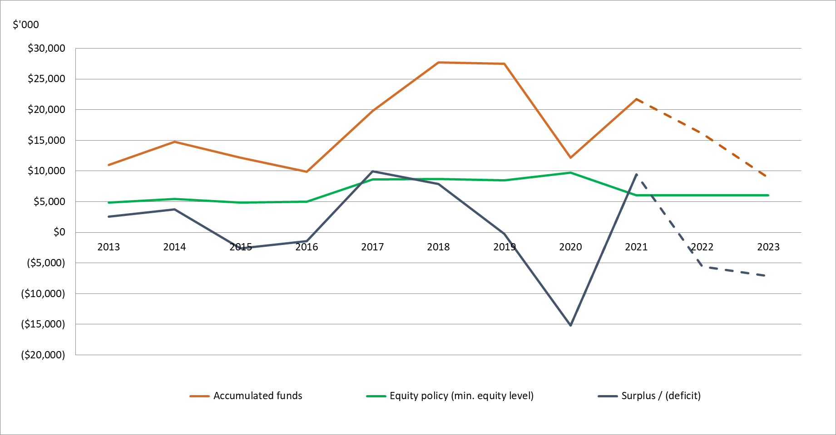
Figure 2: Revenue and expense trends 2012/13–2022/23
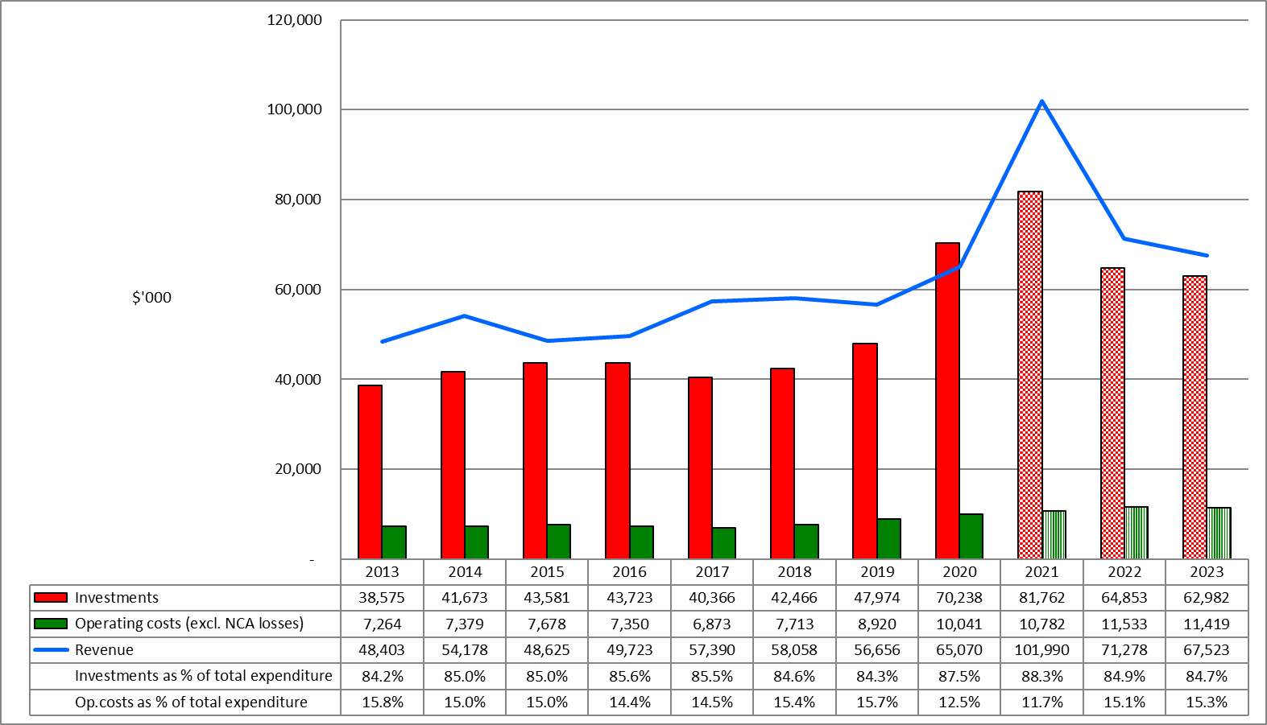
Note: Investments include our deliverables: Investing in the arts, Developing the arts, Advocating for the arts and Leadership in the arts
2021 = forecast result for 2019/20
2022 and 2023 = current budgets for 2021/22 and 2022/23 – subject to change
NCA = Non-current assets

Whakatakoto pūrongo pūtea

Prospective financial statements

Prospective statement of financial performance

FOR THE YEAR ENDING 30 JUNE

 | NOTE | ACTUAL | FORECAST | BUDGET
 |  | 2020 | 2021 | 2022
 |  | $000 | $000 | $000
Revenue
Revenue from the Crown | 2 | 16,689 | 46,762 | 24,444
Revenue from the New Zealand Lottery Grants Board |  | 47,008 | 54,001 | 46,500
Interest revenue |  | 861 | 241 | 120
Other revenue |  | 512 | 986 | 214
TOTAL REVENUE |  | 65,070 | 101,990 | 71,278
Expenses
Investing in the arts | 3 | 67,126 | 66,440 | 55,202
Developing the arts | 3 | 2,373 | 14,567 | 7,879
Advocating for the arts | 3 | 647 | 658 | 1,152
Leadership in the arts | 3 | 92 | 97 | 620
 |  | 70,238 | 81,762 | 64,853
Operating costs
Personnel expenses |  | 6,801 | 7,838 | 8,009
Depreciation and amortisation |  | 386 | 408 | 365
Other expenses |  | 2,854 | 2,536 | 3,159
 |  | 10,041 | 10,782 | 11,533
TOTAL EXPENSES |  | 80,279 | 92,544 | 76,386
NET OPERATING SURPLUS/(DEFICIT) |  | (15,209) | 9,446 | (5,108)

Prospective statement of comprehensive revenue and expense

FOR THE YEAR ENDING 30 JUNE
 | ACTUAL | FORECAST | BUDGET
 | 2020 | 2021 | 2022
 | $000 | $000 | $000
Net operating surplus/(deficit) for the year | (15,209) | 9,446 | (5,108)
Other comprehensive revenue and expense
Revaluation of works of art | (13) | 746 | –
Total other comprehensive revenue and expense | (13) | 746 | –
TOTAL COMPREHENSIVE REVENUE AND EXPENSE | (15,222) | 10,192 | (5,108)

Prospective statement of changes in net assets and equity

FOR THE YEAR ENDING 30 JUNE
 | ACTUAL | FORECAST | BUDGET
 | 2020 | 2021 | 2022
 | $000 | $000 | $000
Total equity as at 1 July | 29,296 | 14,074 | 24,266
Net operating surplus/(deficit) for the year | (15,209) | 9,446 | (5,108)
Other comprehensive revenue and expense | (13) | 746 | –
Total comprehensive revenue and expense | (15,222) | 10,192 | (5,108)
TOTAL EQUITY AS AT 30 JUNE | 14,074 | 24,266 | 19,158

Prospective statement of financial position

AS AT 30 JUNE
 | ACTUAL | FORECAST | BUDGET
 | 2020 | 2021 | 2022
 | $000 | $000 | $000
ASSETS
Current assets
Cash and cash equivalents | 4,693 | 7,242 | 8,839
Investments in term deposits | 10,000 | 22,000 | 15,000
Receivables | 16,440 | 18,356 | 11,925
Prepayments | 174 | 200 | 200
Total current assets | 31,307 | 47,798 | 35,964
Non-current assets
Property, plant, and equipment | 557 | 510 | 490
Works of art | 1,027 | 1,773 | 1,773
Intangible assets | 1,226 | 966 | 1,080
Total non-current assets | 2,810 | 3,249 | 3,343
TOTAL ASSETS | 34,117 | 51,047 | 39,307
LIABILITIES
Current liabilities
Grants payable | 19,054 | 24,630 | 19,000
Payables and deferred revenue | 326 | 1,565 | 569
Employee entitlements | 565 | 467 | 480
Total current liabilities | 19,945 | 26,662 | 20,049
Non-current liabilities
Lease incentive | 30 | 57 | 38
Employee entitlements | 68 | 62 | 62
Total non-current liabilities | 98 | 119 | 100
TOTAL LIABILITIES | 20,043 | 26,781 | 20,149
NET ASSETS | 14,074 | 24,266 | 19,158
EQUITY
Accumulated funds | 12,184 | 21,682 | 16,574
Revaluation reserves | 1,027 | 1,773 | 1,773
Restricted reserves (special purpose funds) | 863 | 811 | 811
TOTAL EQUITY | 14,074 | 24,266 | 19,158

Prospective statement of cash flows

FOR THE YEAR ENDING 30 JUNE
 | ACTUAL | FORECAST | BUDGET
 | 2020 | 2021 | 2022
 | $000 | $000 | $000
CASH FLOWS FROM OPERATING ACTIVITIES
Cash was provided from:
Revenue from the Crown | 16,689 | 47,762 | 23,444
Revenue from the New Zealand Lottery Grants Board | 40,518 | 51,509 | 52,875
Interest received | 1,086 | 331 | 126
Grant retirements and gains | 123 | 424 | 200
Other revenue | 461 | 132 | 14
Net goods and services tax | – | 622 | –
Cash was applied to:
Payments of grants | (66,885) | (75,892) | (70,433)
Payments to employees | (6,539) | (7,888) | (7,978)
Payments of operating expenses | (3,120) | (2,350) | (3,192)
Net goods and services tax | (447) | – | –
NET CASH FLOWS FROM OPERATING ACTIVITIES | (18,114) | 14,650 | (4,944)
CASH FLOWS FROM INVESTING ACTIVITIES
Cash was provided from:
Term deposits maturing (with maturities over 3 months) | 32,500 | 10,000 | 22,000
Cash was applied to:
Purchase of property, plant, equipment, and intangible assets | (261) | (101) | (459)
Investment in term deposits (with maturities over 3 months) | (10,000) | (22,000) | (15,000)
NET CASH FLOWS FROM INVESTING ACTIVITIES | 22,239 | (12,101) | 6,541
NET INCREASE (DECREASE) IN CASH HELD | 4,125 | 2,549 | 1,597
Cash and cash equivalents at the beginning of the year | 568 | 4,693 | 7,242
CASH AND CASH EQUIVALENTS AT THE END OF THE YEAR | 4,693 | 7,242 | 8,839

Notes to the prospective financial statements

1. Statement of accounting policies

FOR THE YEARS ENDING 30 JUNE 2021 AND 30 JUNE 2022

Reporting entity
The Arts Council of New Zealand Toi Aotearoa was established on 1 July 1994 by the Arts Council of New Zealand Toi Aotearoa Act 1994. The Council has chosen to operate under the name Creative New Zealand.
Creative New Zealand is a Crown entity as defined by the Crown Entities Act 2004 and is domiciled and operates in New Zealand. As such, Creative New Zealand’s ultimate parent is the New Zealand Crown.
Its purpose, as defined under the current governing legislation, the Arts Council of New Zealand Toi Aotearoa Act 2014, is to encourage, promote, and support the arts in New Zealand for the benefit of all New Zealanders. Creative New Zealand does not operate to make a financial return. Accordingly, Creative New Zealand has designated itself as a public benefit entity (PBE) for financial reporting purposes.

Basis of preparation
These prospective financial statements have been prepared on a going concern basis, and the accounting policies have been applied consistently throughout the period.

Statement of compliance
These prospective financial statements have been prepared in accordance with the Crown Entities Act 2004, which includes the requirement to comply with generally accepted accounting practice in New Zealand (NZ GAAP) and Financial Reporting Standard 42.
They have been prepared in accordance with Tier 1 PBE accounting standards and comply with PBE accounting standards.

Presentation currency and rounding
These prospective financial statements are presented in New Zealand dollars (NZ$) and are rounded to the nearest thousand dollars ($000), unless otherwise stated.

Significant accounting policies
The following specific accounting policies, which materially affect the measurement of financial performance and financial position, have been applied consistently to all periods presented in these prospective financial statements.

Revenue
The specific accounting policies for significant revenue items are explained below.

Revenue from the Crown
Creative New Zealand receives funding from the Crown, which is restricted in its use for the purpose of Creative New Zealand meeting the objectives specified in its governing legislation and the scope of the relevant appropriations of the funder.
Creative New Zealand considers there are no conditions attached to the funding (a condition refers to an enforceable legal right of return of the transferred asset if it is not used for the specific intended purpose). The funding is recognised as revenue at the point of entitlement. The fair value of revenue from the Crown has been determined to be equivalent to the amounts due in the funding arrangements.

Revenue from the New Zealand Lottery Grants Board
Creative New Zealand receives most of its funding from the NZLGB. The NZLGB allocates part of Lotto New Zealand’s profit to Creative New Zealand through the Gambling Act 2003. The funding allocation for the year is based on 15 percent of Lotto New Zealand’s forecast profit for the financial year. Creative New Zealand also receives a 15 percent share in Lotto New Zealand’s available funding over and above the forecast (the additional profit allocation), which is dependent on the actual audited results for the year. One-off funding allocations from reserves are also based on this 15 percent share.
Creative New Zealand uses the funding for the purpose of meeting its objectives, as specified in the governing legislation. Creative New Zealand considers there are no conditions attached to the funding. The funding is recognised as revenue at the point of entitlement. The fair value of revenue from the NZLGB has been determined to be equivalent to the amounts due in the funding arrangements.

Other grants
Grants are recognised as revenue when they become receivable unless an obligation in substance is in place to return the funds if conditions of the grant are not met. If there such obligation is in place, the grants are initially recorded as grants received in advance and are recognised as revenue when conditions of the grant are satisfied.

Interest revenue

Interest revenue is recognised by accruing on a time proportion basis the interest due for the investment.

Donated assets
Where a physical asset is gifted to or acquired by Creative New Zealand for nil consideration or at a subsidised cost, the asset is recognised at fair value and the difference between the consideration provided and fair value of the asset is recognised as revenue.
The fair value of donated assets is determined as follows.
- For new assets, fair value is usually determined by reference to the retail price of the same or similar assets at the time the asset was received.
- For used assets, fair value is usually determined by reference to market information for assets of a similar type, condition, and age.

Grant retirements
Grants committed in previous years are retired and recognised as revenue in the Statement of Financial Performance when:
- they are not collected by the recipients within a year of being offered
- they are no longer required for the purpose for which they were approved
- partial or full repayment is received from a grant recipient.

Grant expenses
Discretionary grants are those grants where Creative New Zealand has no obligations to award on receipt of the grant application. For discretionary grants without substantive conditions, the total committed funding is expensed when the grant is approved by Creative New Zealand and the approval has been communicated to the applicant. Discretionary grants with substantive conditions are expensed at the earlier of the grant payment date or when the grant conditions have been satisfied. Conditions usually include milestones that must be met to be eligible for funding.
When multi-year funding agreements are entered into, amounts granted under these agreements are recognised in the Statement of Financial Performance to the extent that they relate to the current financial year. The agreed funding for the out years is conditional on the programme and budget being agreed within the timeframes and any special conditions for the drawdown of funding being met.
The liability disclosed in the Statement of Financial Position represents financial grants to New Zealand artists and arts organisations approved by Creative New Zealand but not paid at balance date.
Non-discretionary grants are grants that are awarded automatically if the grant application meets the specified criteria, that is, Creative Communities Scheme funding to territorial authorities. This funding is expensed annually when communicated and distributed because there is no application process, and no substantive conditions need to be fulfilled to receive the grant.

Personnel expenses

Salaries and wages
Salaries and wages are recognised as an expense because employees provide services.

Defined contribution scheme
Obligations for contributions to KiwiSaver and the State Sector Retirement Savings Scheme are accounted for as defined contribution superannuation schemes and are recognised as an expense in the Statement of Financial Performance as incurred.

Leases

Operating leases
An operating lease is a lease that does not transfer substantially all the risks and rewards incidental to ownership of an asset. Lease payments under an operating lease are recognised as an expense on a straight-line basis over the lease term.

Foreign currency transactions
Foreign currency transactions are translated into New Zealand dollars using the spot exchange rates at the dates of transactions. Foreign exchange gains and losses resulting from the settlement of such transactions and from the translation at year-end exchange rates of monetary assets and liabilities denominated in foreign currencies are recognised in the Statement of Financial Performance.

Cash and cash equivalents
Cash and cash equivalents include cash at bank and on hand, deposits held on call with banks, and other short-term highly liquid investments with original maturities of three months or less.

Investments in term deposits
Investments in bank term deposits with original maturities of between three months and one year are initially measured at the amount invested. Interest is subsequently accrued and added to the investment balance. A loss allowance for expected credit losses is recognised if the estimated loss allowance is not trivial.

Receivables
Short-term receivables are recorded at the amount due, less an allowance for credit losses. Creative New Zealand applies the simplified expected credit loss model of recognising lifetime expected credit losses for receivables.
In measuring expected credit losses, short-term receivables have been assessed on a collective basis because they possess shared credit risk characteristics. They have been grouped based on the days past due. Short-term receivables are written off when there is no reasonable expectation of recovery. Indicators that there is no reasonable expectation of recovery include the debtor being in liquidation.

Property, plant, and equipment
Property, plant, and equipment consist of the following asset classes: leasehold improvements, furniture, equipment and fittings, and computer equipment.
Property, plant, and equipment asset classes are measured at cost, less accumulated depreciation, and impairment losses.

Additions
The cost of an item of property, plant, and equipment is recognised as an asset only when it is probable that future economic benefits or service potential associated with the item will flow to Creative New Zealand and the cost of the item can be measured reliably.
Work in progress is recognised at cost less impairment and is not depreciated.
In most instances, an item of property, plant, and equipment is initially recognised at its cost. Where an asset is acquired through a non-exchange transaction, it is recognised at its fair value as at the date of acquisition.
Costs incurred after initial acquisition are capitalised only when it is probable that future economic benefits or service potential associated with the item will flow to Creative New Zealand and the cost of the item can be measured reliably.
The costs of day-to-day servicing of property, plant, and equipment are recognised in the Statement of Financial Performance as they are incurred.

Disposals
Gains and losses on disposals are determined by comparing the proceeds with the carrying amount of the asset. Gains and losses on disposals are reported net in the Statement of Financial Performance.
When revalued assets are sold, the amounts included in asset revaluation reserves in respect of those assets are transferred to accumulated funds.

Depreciation
Depreciation is provided on a straight-line basis on all property, plant, and equipment at rates that will write off the cost (or valuation) of the assets to their estimated residual value over their useful lives.
The useful lives and associated depreciation rates of major classes of assets have been estimated as follows:
Leasehold improvements (Auckland) | 6 years | 16.7%
Leasehold improvements (Wellington) | 9 years | 11.1%
Furniture, equipment, and fittings | 10 years | 10.0%
Computer equipment | 4 years | 25.0%
Leasehold improvements are depreciated over the shorter of the unexpired period of the lease and the estimated useful life of the assets.

Works of art
Creative New Zealand owns a ‘furnishing works of art collection’ with items on display in Creative New Zealand offices. These items are rotated on a regular basis with items held in storage. Some items are also on loan to other organisations, including museums and other arts organisations.
Works of art are revalued with sufficient regularity to make sure the carrying amount does not differ materially from fair value and at least every three years. Fair value is determined from market-based evidence by an independent valuer. The results of revaluing works of art are credited or debited to an asset revaluation reserve for that class of asset, in the same way as land and buildings.
Works of art are not depreciated because they have an indeterminate useful life and may appreciate in value over time. The carrying values of revalued works of art are assessed annually to make sure they do not differ materially from the assets’ fair values.

Intangible assets

Software acquisition and development
Acquired computer software is capitalised based on the costs incurred to acquire and bring to use the specific software.
Costs that are directly associated with the development of software for internal use are recognised as an intangible asset. Direct costs include the software development costs.
Employee costs, staff training costs, and relevant overheads are recognised as an expense when incurred. Costs associated with maintaining computer software are recognised as an expense when incurred.

Amortisation
The carrying value of an intangible asset with a finite life is amortised on a straight-line basis over its useful life. Amortisation begins when the asset is available for use and stops at the date the asset is derecognised. The amortisation charge for each period is recognised in the surplus or deficit.
The useful lives and associated amortisation rates of major classes of intangible assets have been estimated as follows.
Computer software: Grants Management System and Customer Relationship Management system | 8 years | 12.5%
Computer software: other | 4 years | 25.0%

Impairment of property, plant and equipment and intangible assets
Creative New Zealand does not hold any cash-generating assets. Assets are considered cash-generating where their main objective is to generate a commercial return.

Non-cash generating assets
Property, plant and equipment, and intangible assets held at cost that have finite useful lives are reviewed for impairment whenever events or changes in circumstances indicate that the carrying amount may not be recoverable. An impairment loss is recognised for the amount by which the asset’s carrying amount exceeds its recoverable amount. The recoverable amount is the higher of an asset’s fair value less costs to sell and value in use.
Value in use is determined using an approach based on either a depreciated replacement cost approach, restoration cost approach or a service units approach. The most appropriate approach used to measure value in use depends on the nature of the impairment and availability of information.
If an asset’s carrying amount exceeds its recoverable service amount, the asset is regarded as impaired and the carrying amount is written down to the recoverable amount. The total impairment loss is recognised in the surplus or deficit.
The reversal of an impairment loss is recognised in the Statement of Financial Performance.

Financial instruments
Creative New Zealand is party to non-derivative financial instruments as part of its normal operations. These financial instruments include cash at bank and on hand, deposits held on call with banks, short-term deposits, debtors and other receivables, and creditors and other payables.
Except for those items covered by a separate accounting policy, all financial instruments are initially recognised in the Statement of Financial Position at fair value, and all revenues and expenses in relation to financial instruments are recognised in the surplus or deficit.
Creative New Zealand does not use derivative financial instruments.

Creditors and other payables
Short-term creditors and other payables are recorded at the amount payable. The amounts are unsecured and usually paid within 30 days of recognition; therefore, the carrying value of creditors and other payables approximates their fair value.

Employee entitlements

Short-term employee entitlements
Employee entitlements expected to be settled within 12 months of balance date are measured at undiscounted nominal values based on accrued entitlements at current rates of pay. These include salaries and wages accrued up to balance date, annual leave earned but not yet taken at balance date, long service leave entitlements expected to be settled within 12 months, and time in lieu accrued up to balance date. Creative New Zealand has no liability for sick leave entitlements.

Long-term employee entitlements
Employee entitlements that are due to be settled beyond 12 months, such as long service leave, have been calculated on an actuarial basis. The calculations are based on:
- likely future entitlements accruing to staff, based on years of service, years to entitlement, the likelihood that staff will reach the point of entitlement, and contractual entitlements information
- the present value of the estimated future cash flows.
Expected future payments are discounted using the weighted average of interest rates for government stock with terms to maturity like those of the relevant liabilities. The inflation factor is based on the expected long-term increase in remuneration for employees.

Provisions
A provision is recognised for future expense of uncertain amount or timing when there is a present obligation (either legal or constructive) because of a past event, when it is probable that an outflow of future economic benefits will be required to settle the obligation, and when a reliable estimate can be made of the amount of the obligation.
Provisions are measured at the present value of the expense expected to be required to settle the obligation using a pre-tax discount rate that reflects current market assessments of the time value of money and the risks specific to the obligation. The increase in the provision due to the passage of time is recognised as an interest expense and is included in ‘finance costs’.

Goods and services tax
All items in the financial statements are exclusive of GST, except for receivables and creditors and other payables, which are stated inclusive of GST. GST is not recoverable because input tax is recognised as part of the related asset or expense.
The net amount of GST recoverable from, or payable to, the Inland Revenue Department is included as part of receivables or creditors and other payables in the Statement of Financial Position.
The net GST paid to, or received from, the Inland Revenue Department, including the GST relating to investing and financing activities, is classified as an operating cash flow in the Statement of Cash Flows.
Commitments and contingencies are disclosed exclusive of GST.

Income tax
Creative New Zealand is a public authority and consequently is exempt from the payment of income tax in accordance with the Income Tax Act 2007. Accordingly, no provision has been made for income tax.

Equity
Equity is measured as the difference between total assets and total liabilities. Equity is disaggregated and classified into the following components:
- accumulated funds
- revaluation reserve
- restricted reserve.
Revaluation reserve relates to the revaluation of works of art.
Restricted reserve consists of donations and bequests entrusted to Creative New Zealand to administer for a stipulated purpose (special purpose funds).

Changes in accounting policies
No changes have occurred in accounting policies since the date of the last audited financial statements, other than the impact of NZ GAAP. These policies have been applied on a basis consistent with previous years.

Significant estimates and assumptions concerning the future
Revenue from the NZLGB for 2021/22 is based on Lotto New Zealand’s projections at the start of 2020/21. The final expected 2021/22 payment from the NZLGB will be confirmed in July 2021 and revised during the year.
It is assumed the timing of baseline funding will be the same for each of the financial years.
All significant assumptions relating to expenses have been based on historical data, existing business practices or actual business plan projections for each financial year.
The timing of expenses under Creative New Zealand’s funding programmes can be variable after each funding round. A best estimate of the timing of these expenses has been made, which may vary from the timing of the actual expenses.
It is assumed that staffing levels will not significantly change in each of the financial years.

Revenue from the Crown
 | ACTUAL | FORECAST | BUDGET
 | 2020 | 2021 | 2022
 | $000 | $000 | $000
Vote: Arts, Culture and Heritage – core funding | 16,689 | 16,689 | 16,689
COVID-19 response funding
Core infrastructure and arts delivery | – | 25,000 | –
Cultural Sector Capability Fund* | – | – | 2,000
Pasifika Festivals Initiative | – | 4,000 | 4,000
Mātauranga Māori Te Awe Kōtuku Initiative | – | 1,073 | 1,755
 | 16,689 | 46,762 | 24,444
The significant new Crown investment in Creative New Zealand through Budget 2020 also includes $4 million in 2022/23 for the Pasifika Festivals Initiative.
* Creative New Zealand received $1 million in 2020/21 to set up the Cultural Sector Capability Fund so the arts sector has the necessary industry, technical and business capability to meet the challenges of a COVID-19 environment. We will progress this work in 2021/22. This revenue will be rephased across the period it was appropriated for (two years) and, at 30 June 2021, recognised as deferred revenue on Statement of Financial Position.

Expenses by investment category
 | ACTUAL | FORECAST | BUDGET
 | 2020 | 2021 | 2022
 | $000 | $000 | $000
INVESTING IN THE ARTS
Toi Tōtara Haemata Investment programme | 15,665 | 15,888 | 16,088
Toi Uru Kahikatea Investment programme | 16,203 | 15,913 | 16,303
Grants and special opportunities | 5,636 | 8,885 | 13,110
Creative Communities Scheme | 3,945 | 3,943 | 3,995
International programme | 1,852 | 227 | 1,436
Initiatives and pilots | 150 | – | –
COVID-19 emergency response
Toi Tōtara Haemata short-term relief | 797 | 166 | –
Toi Uru Kahikatea short-term relief | 942 | 164 | –
Grants and special opportunities– Arts Continuity Grants | 11,993 | 4,043 | –
Initiatives and pilots – Emergency Relief Grants | 9,943 | 30 | –
COVID-19 Crown funding*
Toi Tōtara Haemata – Resilience Fund | – | 150 | –
Toi Uru Kahikatea – Resilience Fund | – | 200 | –
Creative Communities Scheme | – | 1,800 | –
Grants and special opportunities – Arts Grants | – | 10,761 | –
Grants and special opportunities – Mātauranga Māori Te Awe Kōtuku | – | 470 | 470
Initiatives and pilots – Pasifika Festivals Initiative | – | 3,800 | 3,800
 | 67,126 | 66,440 | 55,202
DEVELOPING THE ARTS
Capability building – national programme | 116 | – | 559
International programme – capability building | 572 | 278 | 495
Initiatives and pilots | 1,685 | 2,142 | 3,785
COVID-19 Crown funding*
Toi Tōtara Haemata – Adaptation Fund | – | 3,187 | –
Toi Uru Kahikatea – Adaptation Fund | – | 3,595 | –
Capability building – national (Capability Fund Tōtara and Kahikatea) | – | 642 | –
Capability building – national (Revenue Generation Fund Tōtara and Kahikatea) | – | 2,971 | –
Capability building – national (Cultural Sector Capability Fund) | – | – | 1,800
Initiatives and pilots – Mātauranga Māori Te Awe Kōtuku | – | 558 | 1,240
Initiatives and pilots – Ngā Toi a Rohe Fund | – | 1,194 | –
 | 2,373 | 14,567 | 7,879
ADVOCATING FOR THE ARTS
Advocacy | 647 | 658 | 1,152
 | 647 | 977 | 1,152
LEADERSHIP IN THE ARTS
Grants and special opportunities | 75 | – | –
Capability building | 1 | 97 | 120
Advocacy | 16 | – | 500
 | 92 | 97 | 620
Creative New Zealand does not allocate personnel costs directly to deliverables: Investing in the arts, Developing the arts, Advocating for the arts, and Leadership in the arts.
* This includes the significant new Crown investment in Creative New Zealand of $31.073 million in 2020/21, $6.8 million in 2021/22 and $4.0 million in 2022/23 through Budget 2020. Of the $31.073 million provisioned to be received and expensed in 2020/21, $0.845 million has been provisioned to go towards resources needed to help with the administration of this investment (operating costs).

TŌ TATOU TARI
OUR ORGANISATION

Tō tatou tari

Our organisation

Governed by the Arts Council, Creative New Zealand is an autonomous Crown entity operating under the Arts Council of New Zealand Toi Aotearoa Act 2014.
We are committed to continually improving the capability of our organisation. This includes having a robust governance structure, appropriate operational policies, effective and efficient internal processes, and capable and engaged staff.

Our purpose
Our purpose is set out in the Arts Council of New Zealand Toi Aotearoa Act 2014.
To encourage, promote, and support the arts in New Zealand for the benefit of all New Zealanders.
Encouraging, promoting, and supporting the arts effectively align with our four deliverables:
- Investing in the arts
- Developing the arts
- Advocating for the arts
- Leadership in the arts.

Our values
Our eight values describe the actions and behaviours the arts sector, our partners, and the public can expect from us as we work with them. They guide our conduct and decision-making.
Mana Toi – we champion the role of the arts and the contribution artists make to our lives.
Tauiwi – we recognise New Zealand’s distinctive cultural and social diversity and work to make sure arts opportunities are available for all.
Mana Māori – we recognise and support the role of Māori as tangata whenua in the arts.
Mana Pasifika – we recognise the arts of the Pacific peoples of New Zealand.
Mahitahi – we work together with others so we can achieve more, including exploring the big picture and sharing what we learn.
Te Taumata – we set high standards for our work.
Tauutuutu – we are open, frank, and respectful in our relationships.
Manaakitanga – we are welcoming and responsive to all.

Te Waka Toi Pātaka – our Mātauranga Māori Framework
Our Mātauranga Māori Framework – Te Waka Toi Pātaka – enables a Māori worldview to guide how we work and make decisions.
Developed in 2018, Te Waka Toi Pātaka guides how we deliver our four goals, especially as they relate to ngā toi Māori.
Te Waka Toi Pātaka highlights areas of particular importance and responsibility (such as maintaining connections to Papatūānuku and tūpuna, building resilience and potential, and supporting and advocating for communities) when advancing our work and initiatives in partnership with others.
Te Waka Toi Pātaka anticipates a wider view of wellbeing, incorporating the social, cultural, environmental, and economic value of ngā toi Māori, and responds to the aspirations of the ngā toi Māori sector.
Te Waka Toi Pātaka is included in Te Hā o ngā Toi—Māori Arts Strategy 2019–2024, which is available on our website.
In 2020/21, Creative New Zealand launched a new programme Te Kaupapa o Toi Aotearoa aimed at making sure it has the organisational culture, competencies, and practices that will help it to meet its aspirations under Te Tiriti o Waitangi and deliver public value for all New Zealanders. This programme will continue over 2021/22.

What we do
Our work is structured around eight investment categories, which represent the major programmes we run:
- Toi Tōtara Haemata Investment programme
- Toi Uru Kahikatea Investment programme
- Grants
- Creative Communities Scheme
- International Programme
- Capability Building Programme
- Advocacy
- Initiatives and pilots.
These categories represent our four deliverable areas of: Investing in the arts, Developing the arts, Advocating for the arts, and Leadership in the arts.
We invest in arts activity by New Zealand artists, arts practitioners, and arts organisations, both within New Zealand and internationally. This is where most of the money we get is spent.
We invest across a variety of artforms: craft/object, community arts, dance, inter-arts, literature, multi-disciplinary, music, ngā toi Māori, Pacific arts, theatre, and visual arts.
Within our Grants, Toi Tōtara Haemata and Toi Uru Kahikatea investment categories, we allocate funding across three streams: General, Māori, and Pacific. Proposals are assessed on their appropriateness to the artform and programme criteria. Applications to the Māori and Pasifika streams are also assessed on whether mātauranga Māori or kaupapa Pasifika is evident in the practice and the results of the proposal.
Māori and Pasifika artists can apply through the Māori or Pacific streams, or the General stream.
From time to time, special arts development opportunities are available that are open to all artists and practitioners. Others, such as internships and cultural exchanges, are specific to artforms (for example, the Prime Minister’s Awards for Literary Achievement), Māori or Pasifika artists and practitioners, or other criteria.
More information on our funding programmes is available at: https://www.creativenz.govt.nz/find-funding.
We also support the development of the arts, by building the capability of arts organisations across a range of needs, as well as developing initiatives to address gaps.
Complementing our funding and development work, we also advocate for the value of the arts and provide leadership in the arts, for example, by undertaking research, making submissions on matters affecting the arts, convening the sector to address challenges or opportunities, and providing advice to the Minister for Arts, Culture and Heritage on matters relating to Creative New Zealand’s functions.
In carrying out our work, we recognise:
- in the arts, the role of Māori as tangata whenua
- the arts of the Pacific peoples of New Zealand
- the cultural diversity of the people of New Zealand.
We also recognise and uphold the principles of participation, access, excellence and innovation, professionalism, and advocacy in our work.

Our relationships
We work with many stakeholders, including the Minister for Arts, Culture and Heritage and Associate Ministers, Manatū Taonga Ministry for Culture and Heritage, the NZLGB, government departments and entities, iwi and Māori, Pasifika groups, local government, individual artists and practitioners, arts organisations and, more broadly, the diverse communities of Aotearoa. We consult with stakeholder groups when developing strategy and reviewing policies that affect the arts sector.
We also have links to international arts councils, and we are an active member of the International Federation of Arts Councils and Culture Agencies.

The Arts Council
Our governing body, the Arts Council, has responsibility for policy, strategy, and investment decision-making. It comprises 13 members.
Council members have a range of skills and experience. The Council has a minimum of four members with knowledge of ngā toi Māori (Māori arts), te ao Māori (the Māori world), and tikanga Māori (Māori protocol and culture). These members are appointed in consultation with the Minister for Māori Development. Under our Act, they form a committee to advise the Council on matters relevant to the Council’s functions in relation to Māori, and any other functions the Council delegates to the committee.
Two Arts Council members are appointed with knowledge of the arts and traditions, or cultures, of Pasifika peoples of New Zealand, in consultation with the Minister for Pacific Peoples.
We work to make sure that:
- Council members have appropriate and timely information to make decisions
- Council members are knowledgeable about and engaged with Creative New Zealand’s work
- decisions are made at the appropriate organisational level, reflecting their importance, risk, and the need for timeliness
- management and staff provide appropriate support to the Council.

Policies and processes
We undertake regular reviews of internal policies, covering areas like finance, human resources, conflicts of interest, and delegations. In each review, we consider the appropriateness of existing policy, best practice examples from similar organisations, and compliance with legislation.
We also have a strong focus on improving the services we deliver, particularly around investment decision-making and reporting processes.
One of our four goals for this period is that: ‘We have the strategies, services and operational capacity to drive development of the arts in New Zealand’.
Under this goal, we are interested not just in the efficiency and effectiveness of our processes but the extent to which they are fair, equitable, and accessible to all New Zealanders.
As a part of that goal, we will regularly assess with the arts sector whether we are performing to the standards we have set ourselves. We also have a formal complaints management system and monitor informal feedback from applicants and clients through social media and daily interaction with staff, who provide ongoing client feedback.

Our staff
We rely on having skilled and engaged staff to achieve our strategic aims. As of 30 June 2021, we have 77 staff (71 full-time equivalent staff), based in Dunedin, Wellington, and Auckland and principally working across five groups: Arts Development Services; Business Services; Māori Strategy and Partnerships; Pacific Arts; and Strategy and Engagement.
Our staff have experience across a range of artforms, international market development and cultural exchange, audience development, project management, and corporate and business services. Staff are also employed for their knowledge and practice of mātauranga Māori and mātauranga Pasifika. All staff are offered training and development across a variety of areas.
We show our commitment to our ‘good employer’ obligations by maintaining and reporting against a personnel policy that includes reference to the seven main good employer elements, those being:
- leadership, accountability, and culture
- recruitment, selection, and induction
- employee development, promotion, and exit
- flexibility and work design
- remuneration, recognition, and conditions
- harassment and bullying prevention
- safe and healthy environment.
We also include, in our personnel policy and reporting, specific commitments to the aims, aspirations, and employment requirements of Māori, ethnic or minority groups, women, and people with disabilities.

More information
Further details about Creative New Zealand are on the website at: www.creativenz.govt.nz/about-creative-new-zealand

Targets set for the 2020/21 year were low, due to the expected significant impact of the COVID-19 pandemic. Forecasts have been provided in line with information collated as at 31 December 2020.
Targets set for the 2020/21 year were low, due to the expected significant impact of the COVID-19 pandemic. Forecasts have been provided in line with information collated as at 31 December 2020.
Targets set for the 2020/21 year were low due to the expected significant impact of COVID-19. Forecasts have been provided in line with information collated as at 31 December 2020.
‘Arts activities’ capture a variety of works that Creative New Zealand funds (for example, plays, concerts, dance performances, exhibitions, workshops, masterclasses, publications). ‘Events’ capture the number of opportunities audiences have to experience arts activities (for example, each time a play, concert, dance performance, workshop, masterclass occurs; each day an exhibition is open to the public; each sale or publication).
The three measures are: The arts should receive public funding; My community would be poorer without the arts; and The arts help improve New Zealand society.
Includes $200,000 for operational costs across a three-year period.
Includes $45,000 for operational costs.
Te Hā o ngā Toi—Māori Arts Strategy 2019-2024. Available at: www.creativenz.govt.nz/news/creative-new-zealand-releases-maori-arts-strategy-te-ha-o-nga-toi

