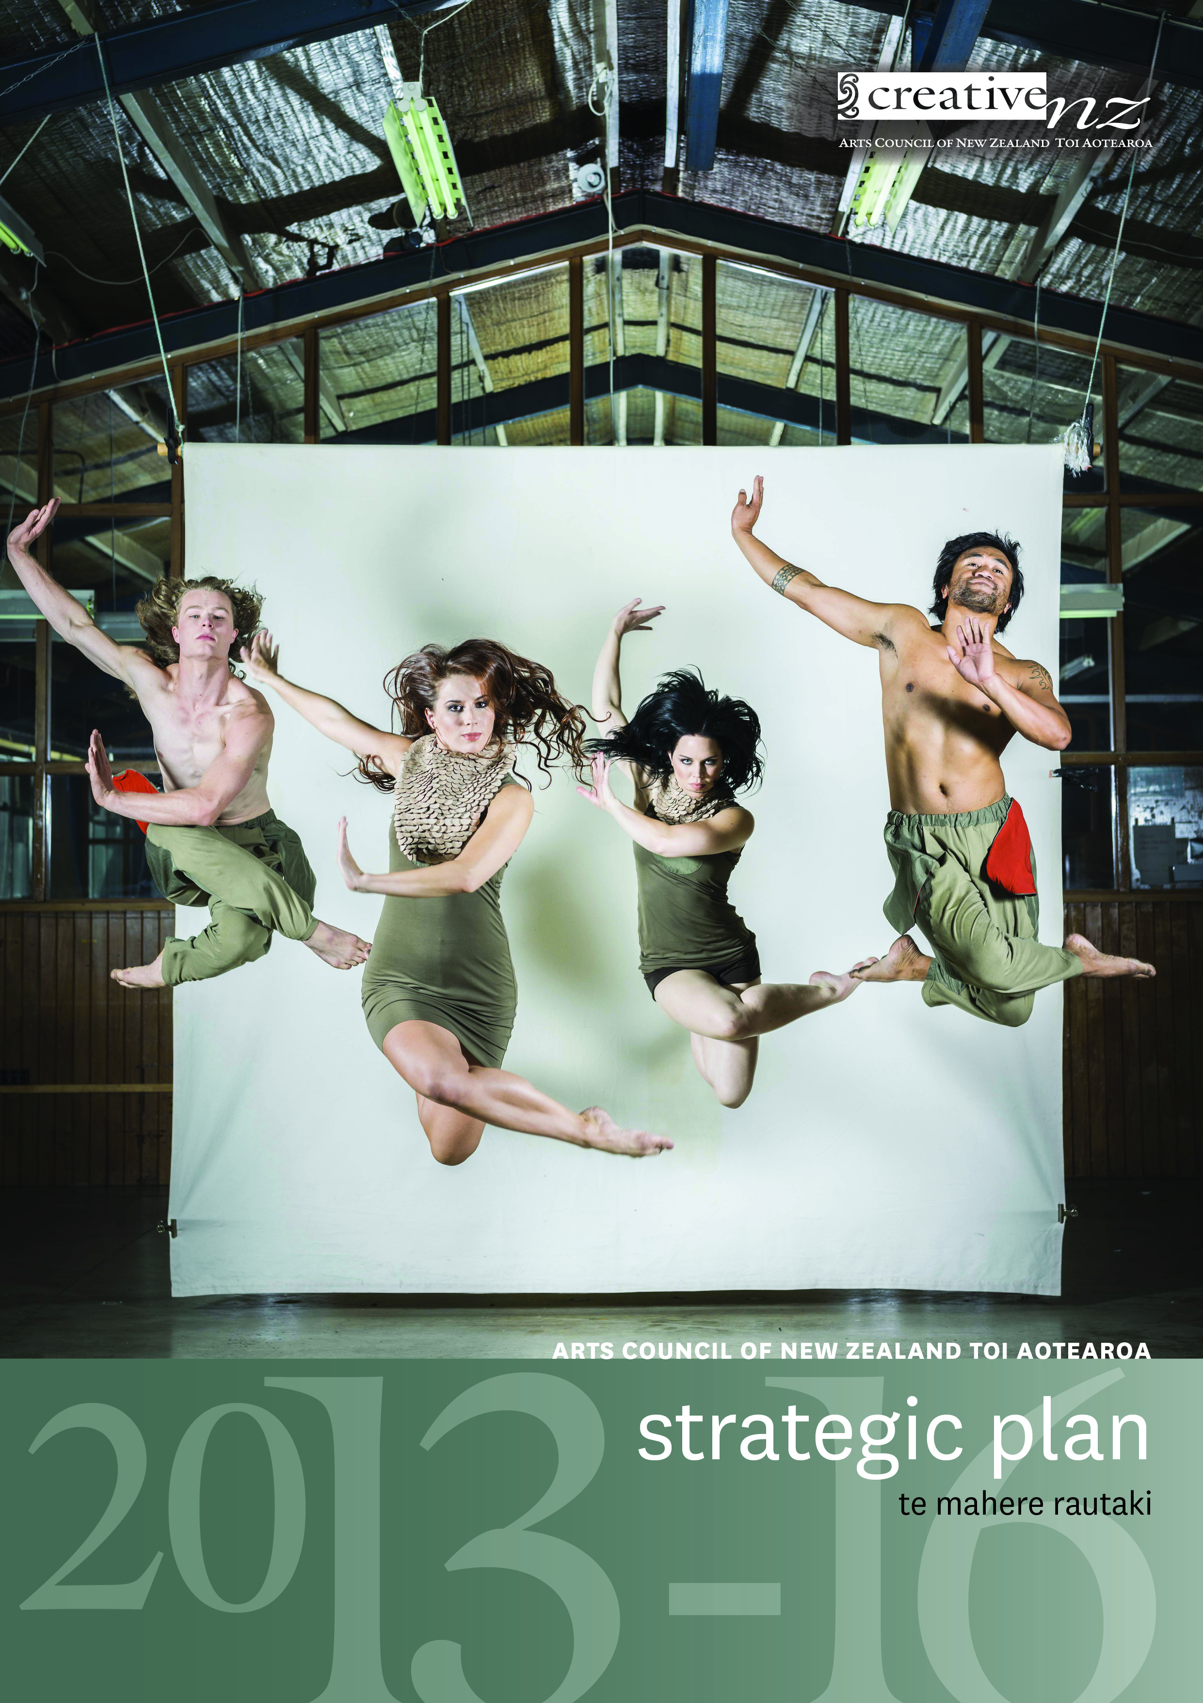

Contact us
Website: www.creativenz.govt.nz
Wellington Office
Level 10
Aorangi House
85 Molesworth Street
PO Box 3806
Wellington 6140
T: 04 473 0880
F: 04 471 2865
E: info@creativenz.govt.nz
Auckland Office
Third Floor
Southern Cross Building
Cnr High and Victoria Streets
PO Box 1425
Auckland 1140
T: 09 373 3066
F: 09 377 6795
E: northern@creativenz.govt.nz
Christchurch Contact
E: southern@creativenz.govt.nz

Front cover: Image courtesy of The New Zealand Dance Company, 'Language of Living 2013'. Dancers (L to R): Gareth Okan, Lucy Lynch, Hannah Tasker-Poland and Tupua Tigafua. Photographer John McDermott

CONTENTS | NGĀ IHIRANGI
Executive summary | Kupu whakataki 4
Purpose of this plan 4
Maintaining continuity 4
Introducing new priorities 5
Improving our internal operations 5
The influencing agenda 5
Our role in the arts | To mātou tūnga i roto i ngā mahi toi 7
Our purpose 7
Vision 8
Values 8
How it all fits together 9
Our ongoing priorities 10
Programme delivery 10
Policy development and implementation 11
Collaboration 11
Accountability and response to government priorities 11
Our improvement priorities 12
Improving our internal operations 12
The influencing agenda 13
Proof of progress 13
What we do 17
How this plan differs from the Strategic Plan 2010–13 | Pehea te rerekētanga o tēnei mahere ki te Mahere Rautaki o ngā tau 2010–13 18
Progress against our previous Strategic Plan 2010–13 18
Creative New Zealand – Who we are | Toi Aotearoa – Ko wai mātou 20
What we want to achieve – Our outcomes 20
Outcome 1: New Zealanders participate in the arts 20
Outcome 2: High-quality New Zealand art is developed 20
Outcome 3: New Zealanders experience high-quality arts 21
Outcome 4: New Zealand arts gain international success 21
Our services 22
Funding 22
Capability building 22
Advocacy 22
Project delivery 23
Our structure 23

Executive summary |
Kupu whakataki
Strategy makes most sense when it is connected both to the past and to the current environment. The principles and functions in our legislation will be the same in 2013–16 as they were in 1994, because they remain sound and relevant. How we deliver on those principles has, however, changed over 20 years, and will evolve further over the next three years.
During 2012 and 2013, we consulted our stakeholders, the arts sector (through invited focus groups), and Māori and Pasifika peoples (through our reviews of Māori and Pacific arts) about how we support the arts in New Zealand. The feedback we have received indicates that significant change to our current strategic direction and activities is not required.
Feedback indicates that our current outcomes, and our strategy and approach of providing funding, capability building and advocacy services all remain valid and appropriate. However, we are aware that there are a number of things that our stakeholders and customers would like us to do more of, or to do differently.
Accordingly, this plan is a mix of existing activities which we will continue and new areas of focus.

Purpose of this plan
The purpose of this document is to indicate the Arts Council’s strategic direction over the period 2013–16. The plan does not include everything we plan to do over the next three years and the detail of much of our ongoing work is not explicitly covered in the document. Instead, it highlights areas of activity which are new or of particular significance over the next three years. It is intended to:
- set out where we will focus our particular attention over the medium term (three years) and signal our priorities and intentions to our customers, partners, stakeholders, the wider arts sector and the public
- provide a basis against which we can measure the success of our strategies in achieving our intentions.
This plan is intended to cover a transitional period during which the new unitary Arts Council structure can be embedded and new Arts Council members become familiar with their roles and our operations. The new Council will have the right to review this plan at any time.

Maintaining continuity
During the period covered by the plan, we will continue our broad funding and policy programmes. We will continue to deliver funding to artists, organisations and communities through our key funding programmes. These have all been subject to major reviews during the period covered by the previous plan and together make up 96 percent of our budget for funding and initiatives. The funding programmes will continue to be complemented by our capability building programme and major initiatives, including those which showcase New Zealand art overseas.
Our programme delivery is funded by public investment in Creative New Zealand by the New Zealand Government and the New Zealand Lottery Grants Board (NZLGB), and it remains a priority for us to maintain the confidence of the Crown in our work and in the value of arts and culture more broadly. Thanks to increased funding from NZLGB, we have been able to increase our annual investment in the arts over the three years to 2013.
The Arts Council has committed to a cycle of policy reviews to ensure that what we are doing addresses contemporary issues and priorities. While there is sometimes an overlap between one strategic plan and the next, the implementation of our reviews of ngā toi Māori, Pacific arts and music, including the Government’s review of the professional orchestral sector, will largely take place in the 2013–16 strategic cycle. We will also continue to consult and work with a range of local and central government agencies and other funders where we have mutual interests, and coordinate efforts for best results.
While our key programmes are set in advance, our strategy is designed to respond to both the unpredictable and new opportunities. For example, the Creative Giving philanthropy pilot, designed to broaden the base of arts support, is a special project that continues into this strategic plan, while our Earthquake Recovery grants are designed to assist the arts in and around Christchurch to return to pre-quake vibrancy and activity levels.

Introducing new priorities

Improving our internal operations
The Government expects to pass the Arts Council of New Zealand Toi Aotearoa Bill (our Bill) in the final quarter of 2013. The Bill creates a unitary board replacing the current Arts Council, Te Waka Toi, Arts Board and Pacific Arts Committee. A successful transition to one board is vital, and explicit in this is a fresh look at delegations and decision making.
We process funding proposals and receive reports on all the programmes we deliver. We have begun shifting from a paper-based to a digital and online environment. Building a new grants and customer relationship management system is central to improving the customer experience and how we do our work. We know that users find our processes complicated, and our objective is to minimise complication while maintaining fairness, transparency and rigour. We are committed to streamlining our processes, improving decision making and reporting, and becoming better at analysing and sharing the information we collect.
The new system will help us do all this.

The influencing agenda
The Minister for Arts, Culture and Heritage has asked us to enhance our leadership role and feedback from the arts sector indicates the sector also wants us to increase our advocacy. Respondents to the Strategic Plan consultation also emphasised advocacy as a priority. Our next steps include the development of an advocacy plan comprising an evidence-based toolkit for the sector to use when advocating for the public value of the arts.
The arts community has an influential role to play with advocacy and we can help with sound research, data and tools. We will pay particular attention to the advocacy role Creative New Zealand can play in responding to the requirements and characteristics of Auckland and Christchurch which stand out as presenting unique opportunities and needs.

National mandate with a focus on Auckland and Christchurch
Our national mandate, programmes and distribution of staff in Christchurch, Wellington and Auckland give us an overview of the artistic life of the nation. Without losing sight of Wellington, Dunedin or regional or rural communities, this plan marks that Auckland and Christchurch will be a focus of the Arts Council attention and efforts for different reasons.
We expect the 2013 Census data to confirm our observations that Auckland is fast growing, spread out and very culturally diverse, with expanding Māori, Pasifika and Asian communities. It is a priority for us to ensure our investment, services and operations remain fit for purpose in the context of this rapidly changing demography. We will be working closely with the Auckland Council on the development of its Arts and Culture Strategic Action Plan.
The recovery of Christchurch is a government priority. We will work alongside key players like the Canterbury Earthquake Recovery Authority, Christchurch City Council and the Ministry for Culture and Heritage to ensure the strong support for arts and culture by Christchurch citizens is borne out in the new city.
The ‘What we do’ diagram on page 16 shows the links between past, present and future activities, highlighting the new areas of focus in our strategy.

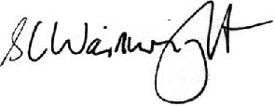
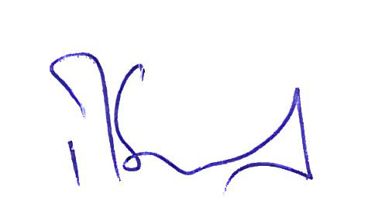

Dr RS Grant Stephen Wainwright
Chair, Arts Council Chief Executive

Our role in the arts |
To mātou tūnga i roto i ngā mahi toi
The arts have always been a vital aspect of the lives of individuals and their communities. New Zealanders place a high value on the arts and have consistently high levels of participation and attendance. Even with this support, however, the arts in New Zealand have always relied on government intervention to flourish.
Successive governments have supported the arts because of the many benefits that a vibrant arts sector provides. The arts help us define and express ourselves and engage with each other in our communities; they are also powerful levers for promoting positive social and economic outcomes.
A key area of work we will advance through this plan is building evidence-based resources which we, the arts sector and other arts advocates can draw on to demonstrate the value of the arts.

Our purpose
Under the Arts Council of New Zealand Toi Aotearoa Act 1994, Creative New Zealand’s purpose is ‘... to encourage, promote and support the arts in New Zealand for the benefit of all New Zealanders’ (section 4).
Section 5 of the Act lays down the principles to be followed in all activities under the Act, including recognising:
- the cultural diversity of the people of New Zealand
- in the arts the role of Māori as tangata whenua
- the arts of the Pacific Islands’ peoples of New Zealand.
Section 5 also requires us to recognise and uphold the principles of participation, access, excellence and innovation, professionalism and advocacy.
Our purpose statement is derived from the Act, as follows:
Creative New Zealand is the national arts development agency developing, investing in and advocating for the arts
By ‘arts development’ we mean not just funding artists and arts organisations, but also supporting their professional and artistic development and contributing to the ongoing capability, resilience and vitality of the arts sector.
We achieve our purpose through supporting:
- the creation and presentation of high-quality and innovative art
- the careers and work of individual artists and practitioners
- the growth and strengthening of New Zealand’s arts infrastructure, arts communities and audiences.

Vision
We have amended our vision statement slightly to reflect our environment and priorities for the next three years.
Dynamic and resilient arts valued in Aotearoa and internationally

Values
Our values describe the behaviours our clients, partners and stakeholders can expect from Creative New Zealand in our work with them, and that we expect of them in return.
- Mana Māori – we will recognise and support the role of Māori as tangata whenua in the arts.
- Mana Pasifika – we will recognise the arts of the Pasifika peoples of New Zealand.
- Mahitahi – we will work together with others so we can achieve more.
- Tauutuutu – we will be open, frank and respectful in our relationships.
- Manaakitanga – we will be welcoming and responsive to all.
- Mana Toi – we will champion the role of the arts and the contribution artists make to our lives.
- Te Taumata – we will set high standards for our work.

How it all fits together
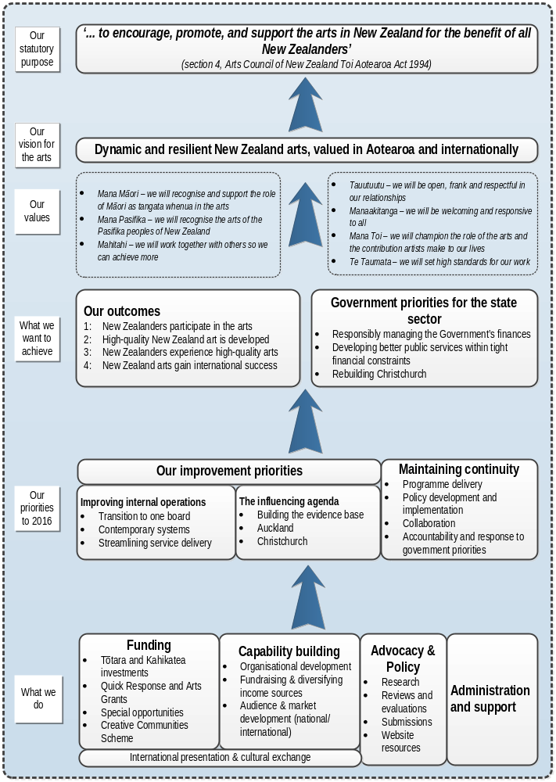
Our priorities for 2013–16 |
A mātou kaupapa matua 2013–16
In this plan we are prioritising our work into two streams:
- Our ongoing priorities: the programmes and services that we will continue delivering to the arts sector and our development and implementation of policy and research
- Our improvement priorities:
- improving our internal operations
- our influencing agenda.

Our ongoing priorities
Through the focus groups which contributed to the early development of this plan, and our recent reviews of support and priorities for ngā toi Māori and Pacific arts, we have received a clear message from the arts sector that there is nothing which we have been doing they want us to stop doing.
So we will continue to build upon our past work in the following ways:
- improving the resilience of the arts – both professional arts and community arts
- supporting new work and contemporary arts practice
- developing and implementing policy
- remaining accountable and responsive to government.

Programme delivery
Over the period of our previous strategic plan, we spent a lot of energy improving our key programmes. The distribution of funding to artists, organisations and communities via the Creative Communities Scheme, Arts Grants and Quick Response funding and the Tōtara and Kahikatea investment programmes remains at the centre of our work for 2013–16, complemented by initiatives like the Festival of Pacific Arts and the Venice Biennale.
In a time of limited economic growth and fiscal constraint, the business of the arts is vulnerable; to rising costs, static or declining income and a potential downturn in participation and in audience numbers. In these circumstances, the focus for Creative New Zealand is on providing investment and building skills to help arts organisations succeed in a competitive environment. In 2011/12, we reviewed our capability programmes to ensure that what we deliver responds best to our client organisations’ changing needs.
Over the next three years we will continue to build our work in supporting the development and presentation of new work and the taking of artistic risk. In particular, we will support new work, innovative and cost effective use of digital technology to create and distribute high-quality work, collaboration between arts organisations, and building audiences and markets for New Zealand arts, both within New Zealand and overseas.

Policy development and implementation
We have committed to a rolling, five-year programme of artform reviews to ensure our support to infrastructure is aligned with current needs and developments in the sector. The reviews focus on identifying the needs of the sector and priorities for Creative New Zealand support. This includes reviewing the key roles we ask our Tōtara investment programme organisations to fulfil. All artform reviews include research and consultation with the sector.
We will implement the recommendations arising from the reviews, including any necessary reallocation of resources. In particular, during the lifetime of this plan, the focus will be on implementing the results of the reviews of Māori arts, Pacific arts, digital arts and music, including the government’s review of the professional orchestral sector.
We will continue to extend our existing work to support community arts, the maintenance and transmission of cultural traditions and to ensure that there are opportunities for the arts by, with and for young people. We will continue to encourage local authorities to support arts and culture through planning and support for professional and community arts.

Collaboration
Creative New Zealand’s resources are limited. It makes sense, therefore, to work collaboratively to increase support for the arts. We will continue to work closely with central and local government, including the Ministry for Culture and Heritage and territorial authorities, to make a greater impact.
Over the period of this plan we will work with individual territorial authorities to focus on significant issues affecting their regions and to work on the needs and opportunities for the arts in different parts of the country. For example, we will continue our work with Wellington City Council to support this important centre for artistic endeavour, including collaborating on a review of the infrastructure needs and funding priorities of the Wellington Theatre sector.
We will also develop and implement pilot programmes to identify and deliver ways of supporting participation in the arts in the regions. The pilot programmes will focus on enhancing regional artists’ and audiences’ access to arts funding and arts experiences.

Accountability and response to government priorities
The Minister for Culture and Heritage has set a number of priorities for Creative New Zealand which are built into this plan. We will continue to respond to government priorities, to be accountable for our public funding and to be both effective and efficient in our operations.

Our improvement priorities

Improving our internal operations

Transition to one board
The Government expects to pass the Arts Council of New Zealand Toi Aotearoa Bill in the last quarter of 2013. The Bill replaces the Arts Council, the Arts Board, Te Waka Toi and the Pacific Arts Committee with a single governing board, which will be responsible for policy, strategy, budget allocation and making funding decisions.
A successful transition to one board is vital and so we are reviewing our delegations and decision making to ensure the new structure operates as effectively as possible. We expect the single board structure will free up people, time and effort which can be redirected to support for the arts sector.

Contemporary systems
Our current grants processes are largely paper based and can be time consuming and resource intensive, for applicants and for us. During 2013, we are building a new grants and customer management system. This will improve our systems by automating processes which are currently manual and providing for online applications and assessments. The benefits of the new system will include:
- reduced timeframes and reduced costs of processing a grant application (both for our customers and for us)
- more transparent decision making processes.
The new system will also enable online reporting by Creative New Zealand clients and will provide our staff and stakeholders with easily accessible and better targeted information. We will use this information to improve our internal reporting and our reporting to government and to the sector.

Streamlining service delivery
Over the course of this strategic plan we will systematically improve the speed of our granting processes, and review our requirements for reporting by clients to better match reporting to the level of our investment and risk. We will also communicate more analysis and information back to customers and stakeholders from the reports they have provided to us.
Our customer service survey conducted in 2010/11 showed that, although those using our services were generally satisfied with the results, there is room for improvement, especially around a number of key processes. During this plan, we will re-run the survey to ascertain how well our new systems and processes are working for our customers and to identify new areas of service delivery to target for improvement.

The influencing agenda

Building the evidence base for the value of the arts
We want to build the evidence base demonstrating the economic, social and cultural value of the arts and share the results with others in the arts and cultural sector and beyond. We will develop targeted messages so that we and the sector can better promote the value of the arts to key influencers and decision makers.
We will continue to commission key research such as our three-yearly New Zealanders and the arts survey; deliver key awards and events celebrating success in the arts and collaborate with others to develop and advocate for the arts

National mandate
Our advocacy work will respond in particular to two contemporary and compelling features of the New Zealand arts ecology: the opportunities afforded by the rapid growth of Auckland and its increasing attraction for arts practitioners; and the cultural recovery in Christchurch - a city where the arts community has done a great deal to fill the many gaps caused by the loss of artists and much of the purpose-built infrastructure for the arts in the wake of the earthquakes. We are committed to the one-off opportunity for the arts and the Christchurch region afforded by the transition period as Christchurch is rebuilt.

Auckland
Auckland is growing fast, is spread out and is very culturally diverse with growing Māori, Pasifika and Asian communities. It is a priority for us to ensure our investment, services and operations remain fit for purpose and we need to respond in fresh ways to this rapidly changing demography. We will use the Census 2013 data to confirm our observations about the makeup of Auckland and to provide the basis for work on ascertaining specific needs.
We’ve been lifting our presence and investment in Auckland for some time in response to the growing arts offering and number of creative people making art there. We will also work closely with the Auckland Council on the development and implementation of its Arts and Culture Strategic Action Plan.

Christchurch
As Christchurch recovers, we have seen great examples of innovative arts practice and creative responses by the arts community to the physical environment and loss of venues.
We’ve done a lot of good tactical work in Christchurch and our focus is now turning to the long term recovery plan. We will work alongside key players like the Canterbury Earthquake Recovery Authority, Christchurch Central Development Unit, the Ministry for Culture and Heritage and Christchurch City Council to ensure that:
- Christchurch citizens’ strong support for arts and culture is reflected in the new city
- provision for the arts lies at the heart of the rebuild.

Proof of progress
To ensure that we measure how we are achieving the objectives in the plan we will report regularly on progress: to the Arts Council, the Minister and in our Annual Report. These reports will be made available to the arts sector and the general public through our website. We will use the following key measures to show the success of our overall strategy.

High level measures
- From the three-yearly survey, New Zealanders and the arts, indicators of New Zealanders’ attitudes to the arts.
- An annual analysis of our total investment in the arts over time and the level of investment in key arts organisations (from our Tōtara and Kahikatea investment programmes) compared with the amounts they leverage from commercial activities and other funders, including private giving.
- An annual analysis of the success of Māori and Pasifika organisations in the investment programmes, and of the success of Māori and Pacific arts projects.

Business as usual measures
- Providing assurance of our financial fitness via independent external audit.
- Ensuring our staff are highly engaged, using the Best Workplaces survey to measure engagement and identify areas for improvement.
- Ensuring our services are effective, efficient and benchmarked against other agencies in the state sector.

Milestone deliveries
The table on the pages 15 and 16 shows the milestone results we expect to deliver over the lifetime of the plan. Lines in italics are dependent on our Bill passing through Parliament.

WHY | WHAT | HOW
Customers’/Users’ Experience of Creative New Zealand
In the digital era, customers expect the Crown to be quick and efficient | Faster decision making | Speed up the decision making cycle across our funding programmes
Our Internal Processes
Users of our services expect to be able to easily access and navigate our services online | Modernise and streamline service delivery | In the next three years we will migrate core services from paper to online
Resources are scarce so lowering compliance benefits everyone | Modernise and streamline service delivery | Reduce complexity for users as a result of streamlining forms, processes, reporting etc.
Our Investment Portfolio – Kahikatea and Tōtara organisations
Openness and transparency underpin great systems | Better transparency, information sharing and analysis | Systematically share feedback on performance with the organisations in the portfolio
Organisations want to be able to benchmark their progress compared with their peers | Better transparency, information sharing and analysis | Report back on key trends and progress across the whole portfolio
Customers need clarity and confidence about how the future system will work in the unitary Arts Council model. | Build understanding of investment rationale and funding system under unitary Council | Systematically communicate changes and build engagement
Our Organisation
An engaged unitary Arts Council is critical to its direction setting role and stakeholder confidence | Successfully implement new governance structure | Implement transition plan  Thorough unitary Council induction
The change to a unitary Arts Council will change how we work | Give our people clarity about how to succeed in the unitary Council context | Re-frame accountabilities, expectations and delegations
Our Influencing Agenda
Research on the arts is scarce and valuable, and we are uniquely placed to fill this void | Develop research and advocacy tools | Collaborate with Ministry for Culture and Heritage (MCH) on research agenda  Make online advocacy toolkits available
Key opportunity to work across the Auckland region with Auckland Council | Collaborate with Auckland Council on responsive and effective arts delivery in Auckland. | Together with MCH, work with the Auckland Council on its Arts and Culture Strategic Action Plan
Decisions about the shape and place of Christchurch’s culture and arts will occur over the life of this plan | Targeted support for the recovery of arts and culture in Christchurch in collaboration with key government and funding agencies | Via MCH Cultural Recovery Plan for Canterbury  Via our Earthquake recovery support and other funding and capability building programmes

MILESTONES – 2013/14 | MILESTONES – 2014/15 | MILESTONES – 2015/16
Quick Response, 6 → 5 weeks  Arts Grants, 12 → 11 weeks | Quick Response, 5 → 4 weeks  Arts Grants, 11 → 10 weeks  Kahikatea, 12 → 11 weeks  Tōtara, 12 → 11 weeks | To be confirmed  Arts Grants, 10 → 9 weeks  Kahikatea, 11 → 10 weeks  Tōtara, 11 → 10 weeks
Quick Response and Arts grants online | Special opportunities, Kahikatea and Tōtara online | All programmes online
Complexity for Quick Response and Arts Grants reduced | Complexity for Special opportunities, Kahikatea and Tōtara reduced  Customer satisfaction survey | Complexity reduced for all programmes
Beginning with feedback on six-monthly reports | Feedback on six-monthly reports | Feedback on six-monthly reports
First Kahikatea and Tōtara annual survey/report | Second Kahikatea and Tōtara annual survey/report | Third Kahikatea and Tōtara annual survey/report
Begins three months from notification of the legislative change

Approved by outgoing Council

Within two months of unitary Council being appointed
Within six months of legislation being implemented

By 30 June 2014  Online toolkits available | Extending online advocacy resources | Extending online advocacy resources
Draft Auckland Council Arts and Culture Strategic Action Plan incorporating Creative New Zealand input (draft is due March 2014) | Ongoing implementation of plan | Ongoing implementation of plan
Ongoing involvement in planning  Ongoing support for the recovery of the arts in Christchurch | Ongoing involvement in planning  Ongoing support for the arts in Christchurch to recover | Ongoing involvement in planning  Ongoing support for the arts in Christchurch to recover

What we do
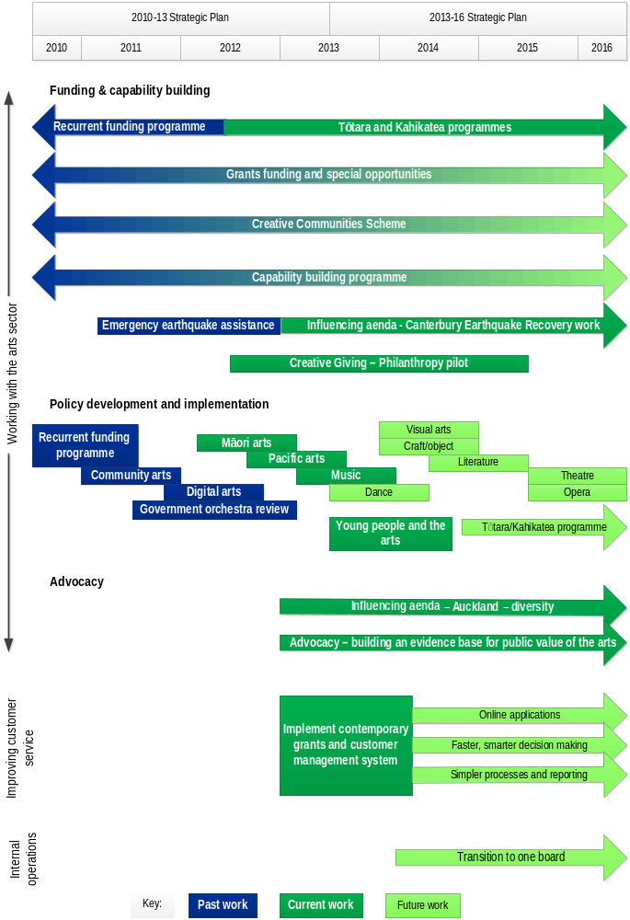

How this plan differs from the Strategic Plan 2010–13 |
Pehea te rerekētanga o tēnei mahere ki te Mahere Rautaki o ngā tau 2010–13
This plan has many similarities to the 2010–13 Strategic Plan. It keeps the same Purpose and four Outcomes; the Vision is essentially similar and the range of services we provide falls under the same three headings of funding, capability building and advocacy.
However, there are some differences as well. We recognise that the environment we operate in has changed in many ways. The economy is in a period of restricted growth, artists and arts organisations are competing for increasingly limited funding and discretionary spending for many people has constricted. There are huge challenges to restoring Christchurch post-earthquakes. Digital media have permeated New Zealand life in ways that affect how we create, participate in and experience the arts. The country’s ethnic and cultural mix is becoming more diverse, particularly in Auckland, and the national population is aging.
And we have changed. Thanks to increased funding from NZLGB, we are investing much more in the arts sector that we were four years ago, without increasing our staffing; our funding and capability building programmes have all been reviewed and modified to better meet the needs of the arts sector; we restructured our operations to make it simpler for our customers to interact with us and we have moved more of our staff resources to Auckland, following our customer base.
In addition, once our Bill is passed through Parliament, we will simplify our decision making and reporting arrangements by reducing the Creative New Zealand statutory bodies from four to one.

Progress against our previous Strategic Plan 2010–13
Outcomes of key initiatives identified in our previous strategic plan are as follows:
- Reviewing the Recurrent Funding programme. This review was completed in 2010/11 and led to the development and implementation of the Arts Leadership Investment (Toi Tōtara Haemata) and Arts Development Investment (Toi Uru Kahikatea) programmes from 1 January 2012. The review also led to the development of our programme of artform reviews.
- Implementing the outcomes of research into the health of Māori and Pacific heritage arts. The research projects, conducted in 2009, identified priorities, led to targeted support for heritage arts over the last three years and informed our recent reviews of Māori and Pacific arts.
- Developing a community arts policy. The policy is now in place and is implemented through this strategic plan.
- Progressing projects on young people and the arts which looked at our role in arts in education, and at young and emerging artists. The research about young and emerging artists has been completed and a framework for supporting arts by, with and for young people is in development.
- Developing a digital arts strategy. Support for media arts was reviewed and consulted on in order to establish priorities for supporting the New Zealand arts sector’s use of digital technologies across all art forms.
- Developing an advocacy strategy. The advocacy strategy was not developed in the 2010–13 period and remains a priority for this strategic plan.
- Reviewing our diversity policy. This project was deferred and will be addressed in 2014/15.
- Reviewing our capability building programmes. Our capability building programme was reviewed and arts organisations were surveyed on their development needs. As a result of this review, we now offer an annual programme of targeted initiatives to meet identified needs. The programme includes audience and market development, organisational development and international presentation skills development.

Creative New Zealand – Who we are |
Toi Aotearoa – Ko wai mātou
Creative New Zealand is the trading name of the Arts Council of New Zealand Toi Aotearoa, established by the Arts Council of New Zealand Toi Aotearoa Act 1994.
We are New Zealand’s arts development agency responsible for delivering government support for the arts. We are funded through Vote: Arts, Culture and Heritage and through the New Zealand Lottery Grants Board to deliver on agreed arts outcomes for New Zealanders.

What we want to achieve – Our outcomes

Outcome 1: New Zealanders participate in the arts

What are we seeking to achieve?
By “participate”, we mean the direct involvement of individuals, groups and/or communities in making or presenting art. This includes opportunities to:
- celebrate, practise and transmit their diverse artistic traditions and cultural heritage
- develop links between communities that improve cross-cultural understanding.

What we do
We provide opportunities for communities throughout New Zealand to participate in a diverse range of artforms and arts practices.
The Creative Communities Scheme is a key means by which we support New Zealanders’ participation in the arts. It is a grants scheme, devolved to all territorial authorities for delivery, which funds community arts projects and activities within the local area of a territorial authority.
Through our Arts Grants and Quick Response funding programmes, we fund specific projects focused on community arts and participation. We also require a number of organisations in the Tōtara and Kahikatea investment programmes to undertake projects and activities aimed at encouraging people to participate in the arts.

Outcome 2: High-quality New Zealand art is developed

What are we seeking to achieve?
Creative New Zealand seeks to ensure that artists, arts practitioners and arts organisations have the opportunity to fulfil their potential by:
- continually developing their artforms, the quality of their work, and their artistic skills and capabilities, and
- having opportunities to experiment, be innovative, and take risks.
We are committed to developing and strengthening New Zealand artistic work. As the national arts development agency, we take a lead role in achieving this outcome providing funding across all artforms and supporting a diverse range of individuals and arts organisations.

What we do
Creative New Zealand makes a substantial investment towards this outcome through the Tōtara and Kahikatea investment programmes. Our Tōtara organisations play a vital role in supporting this outcome, through providing leadership, developing talent, and supporting innovation and artistic risk. The key roles that we fund through this programme complement the investments made by central and local government.
In addition, our Arts Grants and Quick Response funding supports individual artists, arts practitioners and arts organisations to create new works and develop their artistic skills.

Outcome 3: New Zealanders experience high-quality arts

What are we seeking to achieve?
Audiences are vital to a vibrant arts sector. Creative New Zealand aims to broaden the opportunities for all New Zealanders to experience the arts, providing them with access to a diverse range of artistic experiences.

What we do
We support arts organisations to provide arts experiences across the country and across all artforms.
We provide targeted capability building initiatives to help artists, arts practitioners and arts organisations to address identified development needs.
Our research, such as our three-yearly New Zealanders and the arts survey, supports audience development, by providing data that can be used to analyse and respond to trends in New Zealanders’ attendance at arts events.
Creative New Zealand primarily supports this outcome through the Tōtara and Kahikatea investment programmes and through the Arts Grants and Quick Response funding programmes.

Outcome 4: New Zealand arts gain international success

What are we seeking to achieve?
International interventions connect high-quality artists with global markets and audiences through presentation, touring, relationship building and collaborative projects, including cultural and artistic exchange.

What we do
Creative New Zealand’s international networks and targeted programmes mean that we can bring international buyers to New Zealand and take New Zealand work to designated, receptive international markets.
We take selected artists to markets and fairs to display their works and introduce them to potential buyers or distributors; we bring key overseas managers and directors to New Zealand so that they can experience New Zealand art in its local context and we provide capability building for those wanting to develop skills to engage with international markets and audiences. We also respond to applications from artists and organisations wanting to undertake international projects.

Our services
Creative New Zealand’s support for the development of the New Zealand arts sector is provided primarily through our funding programmes. We also deliver a range of programmes to build the capability of individuals and organisations, advocate for the arts and lead key projects.

Funding
We operate a number of complementary funding programmes, ranging from investment funding for significant arts organisations, project-based grants to individuals and organisations, through to funding devolved to local councils for smaller community arts projects. In many cases, we are just one of a number of funders and our funding helps to leverage additional revenue from other sources.

Capability building
We assist arts organisations and individual artists and practitioners to deliver their work in the best possible way, by building their skills and capability, including in community engagement.
Capability building initiatives are reviewed annually and currently include:
- strategic planning and strategic change
- audience development and market development programmes, aimed both nationally and internationally
- applying audience research
- a pilot programme to build skills around diversifying sources of income from fundraising and sponsorship
- initiatives to meet the specific needs of Māori and Pasifika arts practitioners.

Advocacy
We advocate on behalf of the arts to central and local government and to other interested parties.
Our advocacy work includes carrying out research for the benefit of the arts sector, delivering other resources to the sector, making submissions on issues affecting the sector or Creative New Zealand and collaborating with other agencies on areas of mutual interest. A key part of this work is our input into planning for the Christchurch recovery.

Project delivery
In addition to our investment work, we lead several significant initiatives stemming from invitations to the New Zealand Government, including events such as the Venice Biennale and four-yearly Festival of Pacific Arts.
Further, when we are the best-placed agency to respond, we do simple, practical things such as providing support to Christchurch organisations affected by the earthquakes.

Our structure
Creative New Zealand’s governance structure currently consists of:
- the Arts Council, which is responsible for setting Creative New Zealand’s policy and strategic direction, allocating funds to the arts boards, and monitoring our overall performance
- the Arts Board and Te Waka Toi (the Māori Arts Board), which invest funds, deliver tailored programmes and initiatives and monitor funding decisions
- the Pacific Arts Committee, which is a committee of the Arts Board delivering funding and initiatives for Pacific arts.

Subject to the passage of the Arts Council of New Zealand Toi Aotearoa Bill which is currently before Parliament.
All expenditure excluding personnel and overhead costs.
Māori arts.
These ongoing attitude and engagement trends are shown in our series of New Zealanders and the arts reports from 2005, 2008 and 2011. For copies of these reports, see www.creativenz.govt.nz.
See ‘What we do’ diagram on page 16 for the scheduled timing of the reviews.
For a full list, see page 12 of our Statement of Intent 2013–16, available from www.creativenz.govt.nz
Provision for artists who are not connected to the internet will be made in the new system.
In 2012, a background paper summarising the key trends and issues for Creative New Zealand and the arts sector was prepared. It is available at http://creativenz.govt.nz/assets/paperclip/publication_documents/documents/312/original/background_information_for_consultation_process-strategic_plan.pdf?1372047002. It is anticipated that the 2013 Census data, once available, will confirm observed trends, especially in Auckland.
Referred to throughout this plan as the Tōtara and Kahikatea investment programmes.

