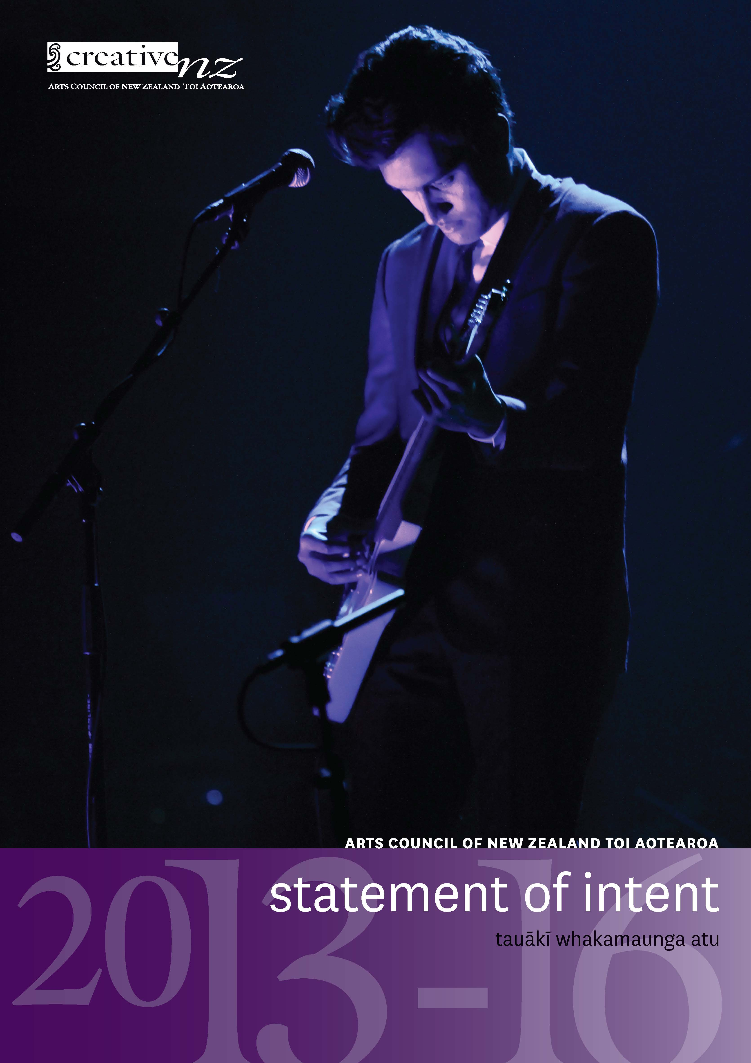

Contact us
Website: www.creativenz.govt.nz
Wellington Office
Old Public Trust Building
131–135 Lambton Quay
PO Box 3806
Wellington 6140
T: 04 473 0880
F: 04 471 2865
E: info@creativenz.govt.nz
Auckland Office
Third Floor
Southern Cross Building
Cnr High and Victoria Streets
PO Box 1425
Auckland 1140
T: 09 373 3066
F: 09 377 6795
E: northern@creativenz.govt.nz
Christchurch Contact
E: southern@creativenz.govt.nz

Front cover: Seth Haapu perfroms in ‘Everything is Ka Pai’
Commissioned by the 2013 Auckland Arts Festival;
Photo by Gate Photography.

This Statement of Intent represents the intentions and objectives of the Arts Council of New Zealand Toi Aotearoa (Creative New Zealand) for the period from 1 July 2013 to 30 June 2016. It is presented in accordance with sections 138 to 148 of the Crown Entities Act 2004.

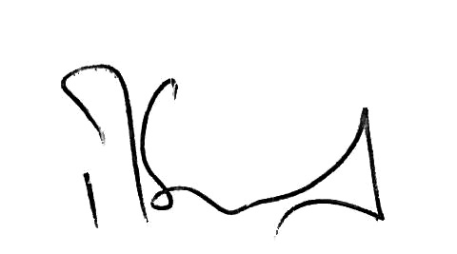
Richard Grant
Chair, Arts Council
11 June 2013

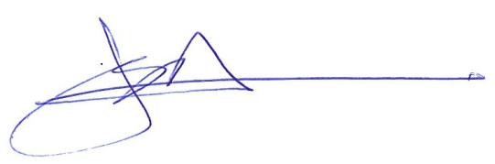
Erima Henare
Member, Arts Council
11 June 2013

In accordance with section 149 of the Crown Entities Act 2004, I present this Statement of Intent to the House of Representatives.
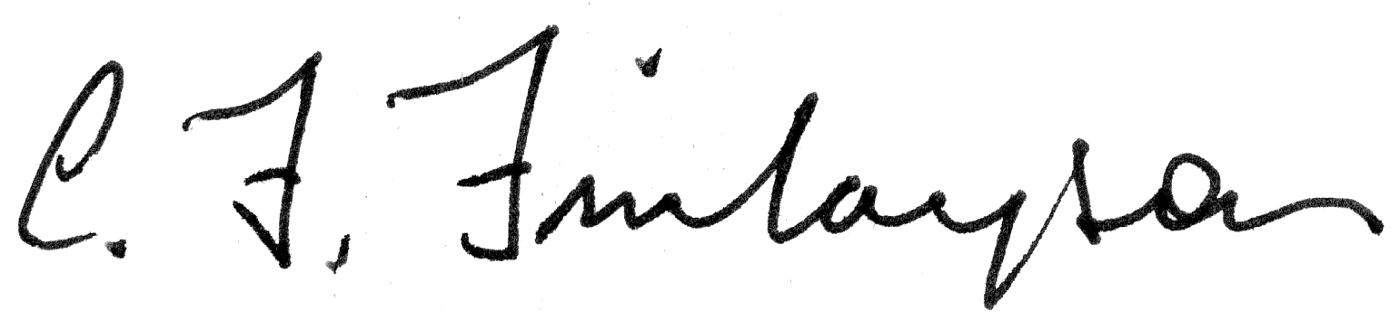
Hon Christopher Finlayson
Minister for Arts, Culture and Heritage
11 June 2013

CONTENTS | NGĀ IHIRANGI

Foreword by the Chair and Chief Executive |
Kupu whakataki nā te Manukura me te Tumu Whakarae 6
Part 1: About Creative New Zealand |
Ngā kōrero mō Toi Aotearoa 9
Creative New Zealand – Who we are |
Toi Aotearoa – Ko wai mātou 10
Our legislation 11
What we do 11
Project delivery 12
Our structure 12
What we want to achieve – Our outcomes |
He aha a mātou tūtukitanga – A mātou hua 13
Part 2: Medium-term Outlook 2013–16 |
Te titiro ki te waenganui o te wā 2013–16 16
Our external operating environment |
ō mātou ao mahi a waho 17
Government’s goals for the economy and the state sector 17
The economic climate 17
Increasing expectations of government agencies 18
Impact of the Christchurch earthquakes 19
Demand for Creative New Zealand funding 19
Treaty of Waitangi claims 20
Changing demographics 20
Use of digital technology 20
Our operating intentions 2013–16 |
Te whakatinana i ngā mahi 2013–16 22
Contributing to government priorities and strategy 22
Key projects 23
Measuring our performance against our outcomes 26
Outcome 1: New Zealanders participate in the arts 28
Outcome 2: High-quality New Zealand art is developed 30
Outcome 3: New Zealanders experience high-quality arts 32
Outcome 4: New Zealand arts gain international success 34
Managing our organisational health |
Te whakahaere i te ora o te tari 36
Building Creative New Zealand’s organisational strength 36
Being a good employer 37
Managing our capital assets 38
Part 3: Annual Outlook – Forecast Performance for the Period 1 July 2013 – 30 June 2014 |
Ngā whakatūtukinga ā tau te wāhanga 1 Hurae 2013 – 30 Hune 2014 40
Forecast service performance |
Te matapae whakatūtukitanga 41
Output area 1: Funding for artists, arts practitioners and arts organisations 43
Output area 2: Capability building for artists, arts practitioners and organisations 48
Output area 3: Advocacy for the arts 50
Forecast financial statements |
Ngā matapae pūrongo pūtea 51
Statement of accounting policies 51
Prospective Statement of Financial Performance 61
Prospective Statement of Comprehensive Income 62
Prospective Statement of Changes in Equity 62
Prospective Statement of Financial Position 63
Prospective Cash Flow Statement 64
Appendices 65
Appendix 1: Creative New Zealand – Who we are |
Toi Aotearoa – Ko wai mātou 66
Functions of the Arts Council 66
Functions of the arts boards 66
Management and staff 67
Appendix 2: Consultation and reporting to the Minister |
Ngā kōrero me ngā whakatakoranga ki te Minita 68
Appendix 3: Mitigating risks |
Te whakangawari ngā tūpono 69

Foreword by the Chair and Chief Executive |
Kupu whakataki nā te Manukura me te Tumu Whakarae
Over the course of the 2013–16 Statement of Intent Creative New Zealand will systematically overhaul how it does its business of granting to minimise compliance and modernise how users interact with it.
This includes streamlining application systems and processes, so our day-to-day business is less time consuming for our clients, and to ensure the reporting we ask of clients is more consistent with the level of funding provided to them.
This three-year period will continue to be fiscally constrained. However, we are fortunate to have the support of the Lottery Grants Board, which has increased its funding to Creative New Zealand from $31.02 million in 2012/13 to a forecast $31.5 million for 2013/14.
Over the next three years, Creative New Zealand will continue to deliver its core business of funding, capability building and advocacy consist with its legislation. There are also some particular priorities we will be focusing on over this period.

Simplifying our systems and organizational structure
A top priority will be continuing to simplify our application forms and guidelines. We are introducing a new grants management system so applicants can apply and provide support materials online for the first time. The new system will also simplify the collation of information for reporting to stakeholders.
Further streamlining will be possible with the passing of The Arts Council of New Zealand Toi Aotearoa Bill, which will replace Creative New Zealand's existing governance structure of one council and three funding bodies with a single council of 13 members.

The rebuild continues
Another priority is continuing our work over the last two years to support the recovery of the arts sector in Christchurch. We will keep working with the Ministry for Culture and Heritage in the development and implementation of its Christchurch Cultural Recovery Programme. We will also continue our work with the Ministry and key recovery agencies to help keep the arts integral to the Christchurch recovery.
Creative New Zealand will also maintain its direct support for the recovery of the arts in and around Christchurch. The focus of Creative New Zealand’s response has shifted from emergency to recovery as we help artists and arts organisations to remain in or return to the city.
Our revised Earthquake Recovery Grants programme will support proposals that make it easier for artists and arts organisations to make and present art in the city, such as performances in unusual or temporary venues or the subsidising of tickets to attract diverse audiences.

While there is much to achieve, Christchurch people are responding with enthusiasm to the increasing number of arts events now available.
For example, in 2012 attendance levels for Christchurch Symphony Orchestra and The Court Theatre had returned to pre-earthquake levels. The arts sector is overcoming the difficulties of performing in a severely damaged city to ensure their community is entertained and inspired.
“When times are tough, art is salve for the ache.”

Our international reputation
Another significant area of work for Creative New Zealand over the next three years will be acting as an agent of the Crown to support major government-to-government initiatives. In 2013, Creative New Zealand is funding and managing Bill Culbert’s exhibition for the New Zealand Pavilion at the Venice Biennale contemporary visual art exhibition. This year’s exhibition has support from Te Papa, Christchurch Art Gallery, Massey University and Auckland Art Gallery. Patrons have raised a record level of funds to support the exhibition and, for the first time, a programme of public events at home will coincide with the exhibition in Venice.
Creative New Zealand has also committed support for New Zealand’s presence at the 2015 Biennale. In 2016, we will fund and manage New Zealand’ delegation to the 12th four-yearly Festival of Pacific Arts in Guam.

Engagement with the arts sector
As well as delivering on significant priorities and initiatives, Creative New Zealand will continue to deliver its ongoing funding, capability and advocacy programmes and maintain a series of rolling artform reviews to inform its programmes and decision making. This engagement with the sector about priorities for their individual artforms means our policies and funding criteria remain contemporary and relevant.
We are implementing the recommendations of the recently completed review of ngā toi Māori (Māori arts). These include introducing six-month internships to help Māori producers, curators, and arts administrators and managers to upskill and setting aside funding to support emerging Māori artists.
Following the report from the Minister’s Cultural Philanthropy Taskforce, Creative New Zealand began implementing its Creative Giving programme in 2012. Through the programme’s new Matched Funding Scheme more than $223,000 has been raised by arts organisations from the private sector and matched under the Scheme.
Creative Giving also provides advice, mentoring and support to organisations so they can diversify and increase the funding they receive from individual donors, businesses, trusts and foundations. We anticipate increasingly positive results as arts organisations become more experienced and confident in their fundraising.

Acknowledgements
We can only achieve results with the trust, confidence and resources provided to us by the Crown, through the Ministry for Culture and Heritage, and the New Zealand Lottery Grants Board. We acknowledge our partners across the 67 territorial authorities and the artists and arts organisations who work so hard to maintain and deliver arts in New Zealand and overseas.

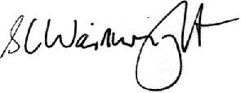

Richard Grant Stephen Wainwright
Chair, Arts Council Chief Executive

Part 1: About Creative New Zealand |
Ngā kōrero mō Toi Aotearoa

Creative New Zealand – Who we are |
Toi Aotearoa – Ko wai mātou
The arts have always been a vital aspect of the lives of individuals and their communities. New Zealanders place a high value on the arts and have consistently high levels of participation and attendance. Even with this support, however, the arts in New Zealand have always relied on government intervention to flourish.
Successive governments have supported the arts because of the many benefits that a vibrant arts sector provides. The arts not only help us define and express ourselves and engage with each other in our communities – they are also powerful levers for promoting positive social and economic outcomes.
Creative New Zealand is the government agency responsible for delivering government funding for the arts. We are funded through Vote: Arts, Culture and Heritage ($15.689 million in 2013/14) and through the New Zealand Lottery Grants Board (NZLGB) (forecast as $31.500 million in 2013/14) to deliver on agreed arts outcomes for New Zealanders.
Creative New Zealand is New Zealand’s arts development agency. By this, we mean not just funding artists and arts organisations but also building their professional and artistic development and promoting the ongoing capability, sustainability and vitality of the arts sector.
We describe this arts development role in our vision and purpose statements.

Our vision | Our purpose
Strong and dynamic New Zealand arts, valued in Aotearoa and internationally. | Creative New Zealand is the national arts development agency developing, investing in and advocating for the arts.
We achieve our purpose through supporting:
- the creation and presentation of high-quality and innovative art
- the careers and work of individual artists and practitioners
- the growth and strengthening of New Zealand’s arts infrastructure, arts communities and audiences.
We are unique among New Zealand arts funders because we provide grants and support to individuals as well as to organisations, and we support a diverse range of activity in the arts sector across all artforms.

Our legislation
‘Creative New Zealand’ is the trading name of the Arts Council of New Zealand Toi Aotearoa. It was established by the Arts Council of New Zealand Toi Aotearoa Act 1994. Under the Act, Creative New Zealand’s purpose is ‘... to encourage, promote and support the arts in New Zealand for the benefit of all New Zealanders’ (section 4).
The Act (section 5) requires Creative New Zealand to:
- recognise the cultural diversity of the people of New Zealand
- recognise in the arts the role of Māori as tāngata whenua
- recognise the arts of the Pacific Islands’ peoples of New Zealand
- recognise and uphold the principles of: participation; access; excellence and innovation; professionalism; and advocacy for the arts.

What we do
Creative New Zealand supports the development of the New Zealand arts sector primarily through its funding programmes. We also deliver a range of programmes to build the capability of individuals and organisations, and we advocate for the arts.

Funding
Creative New Zealand operates a range of complementary funding programmes, ranging from multi-year investment funding for significant arts organisations, project-based grants to individuals and organisations, through to funding devolved to local councils for smaller community arts projects. In many cases, we are one of a number of funders and our funding helps to leverage additional revenue from other sources.
Details of our funding programmes can be found under Output area 1 on page 43.

Capability building
We build the skills and capability of arts organisations and individual artists and practitioners so they can deliver their work in the best possible way.
Capability building initiatives include:
- audience and market development programmes, aimed both nationally and internationally
- programmes to build skills, for both national and international operations
- a pilot programme to develop skills around private philanthropy.
Details of our capability building initiatives can be found under Output area 2 on page 48.

Advocacy
We advocate on behalf of the arts to central and local government and to other funders and decision-makers.
Our advocacy work includes carrying out research and delivering advocacy resources to the arts sector, making submissions on issues affecting the sector or Creative New Zealand and collaborating with other agencies to support the arts. A key part of this work is our assistance for and promotion of the arts in the Christchurch recovery.
Details of our advocacy work can be found under Output area 3 on page 50.

Project delivery
In addition to our investment work, we lead several significant initiatives stemming from invitations to the New Zealand Government, including the 2013 Venice Biennale.
Further, when we are the best-placed agency to respond, we do simple things such as providing practical support to Christchurch artists and arts organisations affected by the earthquakes. This may be in the form of funding, capability building, advocacy or administration support.

Our structure
Creative New Zealand’s structure currently consists of:
- the Arts Council, which is responsible for setting Creative New Zealand’s policy and strategic direction, allocating funds to the arts boards and monitoring overall performance
- the Arts Board and Te Waka Toi (the Māori Arts Board), which invest funds, develop specific initiatives and deliver tailored programmes
- the Pacific Arts Committee, which is a committee of the Arts Board delivering funding and initiatives for Pacific arts.
A government bill to streamline Creative New Zealand’s governance structure is currently before Parliament. The changes are designed to improve our effectiveness and free up resources that would be better directed towards our work to support the arts sector.
The new bill – the Arts Council of New Zealand Toi Aotearoa Bill – proposes to replace the Arts Council, the Arts Board, Te Waka Toi and the Pacific Arts Committee with a single governing board, which would be responsible for policy, strategy and funding.

What we want to achieve – Our outcomes |
He aha a mātou tūtukitanga – A mātou hua

Creative New Zealand’s Strategic Plan 2010–2013 identifies the outcomes (long term goals) and impacts (short to medium term goals) it seeks to achieve on behalf of all New Zealanders. We explain these in Part 2 of this Statement of Intent (see page 28 onwards).
A new strategic plan is being developed during 2013 and, depending on the final content, may require an update to this Statement of Intent.
Figure 1 shows how our grants and initiatives budget is distributed across our four outcomes.
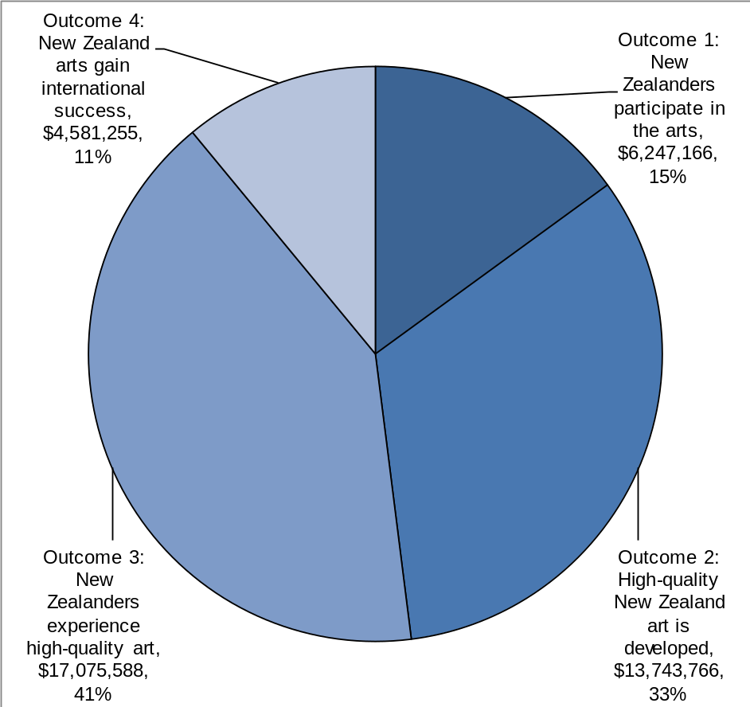
Figure 1: Distribution of grants and initiatives budget 2013/14 by outcome
Outcome budgets are indicative only. They are based on a mixture of known commitments and historical projections.
These outcomes are supported by the output areas (or services) that we deliver. Our output areas are explained in detail in Part 3 (see page 40 onwards) of this Statement of Intent.
Figure 2 shows how our total budget is distributed across our output areas and overheads.
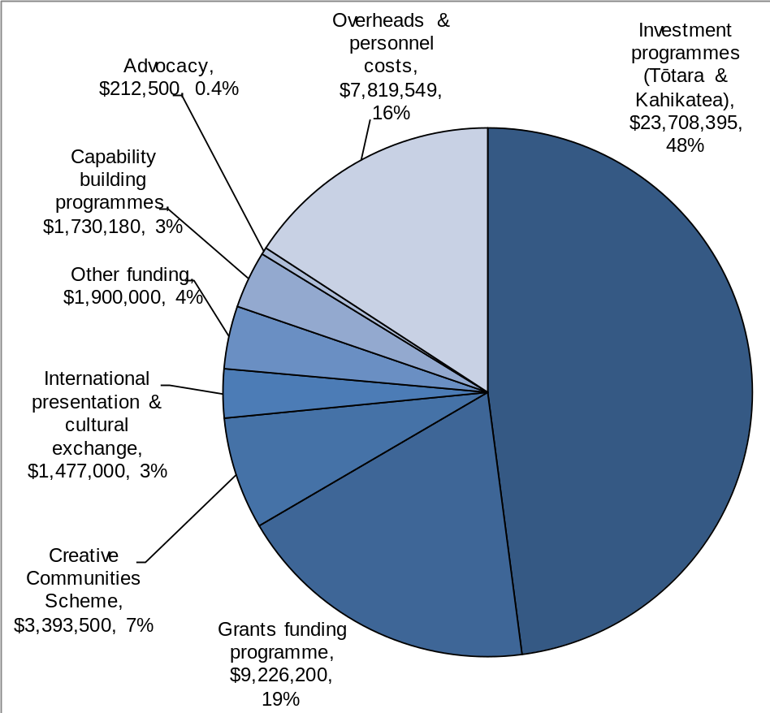
Figure 2: Distribution of total 2013/14 budget by activity
Creative New Zealand also contributes to, and is guided by, the outcomes framework that the Ministry for Culture and Heritage has identified for the broader cultural sector.
Figure 3 below shows the relationships between Creative New Zealand’s vision, outcomes, impacts and output areas, and the Government’s wider outcomes for the cultural sector.
Figure 3: Alignment of Creative New Zealand outcomes and activities to the sector outcomes
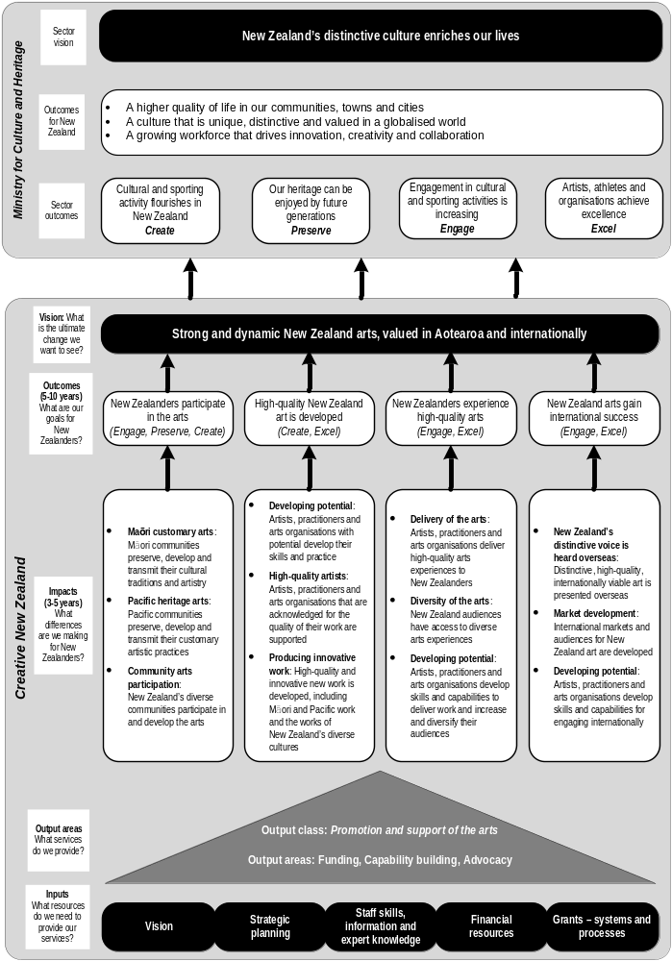

Part 2: Medium-term Outlook 2013–16 |
Te titiro ki te waenganui o te wā 2013–16

Our external operating environment |
Tō mātou ao mahi a waho
This section gives an overview of the context in which Creative New Zealand operates.

Government’s goals for the economy and the state sector
The Government has the following four priorities:
- responsibly managing the Government’s finances
- building a more competitive and productive economy
- developing better public services within tight financial constraints
- rebuilding Christchurch.
Creative New Zealand will support these priorities by ensuring that:
- it continues to assist and promote the recovery of the arts sector in and around Christchurch
- its services contribute to a strong and sustainable arts sector that plays an active part in the economy
- it continues to manage its operating costs and to increase the effectiveness and efficiency of its processes, to ensure good value for money
- its services to clients are the best possible and are delivered in ways that are appropriate to the groups we support.
Our response to specific government priorities for Creative New Zealand is outlined on page 22.

The economic climate
The arts sector continues to face financial challenges: central government funding is unlikely to increase, and raising private support for the arts remains challenging. It is also expected that, in tight economic circumstances, New Zealand households may have less discretionary spending. The challenge for Creative New Zealand and the arts sector is to continue to increase our operational efficiency and to maximise income for the sector from non-government sources.
Our income from Vote: Arts, Culture and Heritage is not expected to grow over the next three to five years, although we may have increased income from the NZLGB available to us. If there is increased income from NZLGB, we expect to engage in dialogue with the Minister for Arts, Culture and Heritage to decide on priorities for this funding.
Our Audience Atlas New Zealand 2011 report estimates the total market value for arts-related expenditure as $2.31 billion per annum. Based on the results of the survey, 95 percent of New Zealanders are in the market for arts events. We know that our funding is the cornerstone for the survival of our Tōtara and Kahikatea investments clients. One way we measure our economic impact is by aggregating the total funding received, from all sources, by Tōtara and Kahikatea organisations against the direct investment we make in them.
We will monitor and report on the trends in the total market value for the arts and our economic impact.

Creative New Zealand’s revised suite of capability building initiatives is a key part of its response to these challenges. These initiatives help arts organisations to be more efficient and effective in their operations, by providing them with targeted assistance in governance, planning and audience development. Our Creative Giving pilot programme seeks to increase skills in building private philanthropic support for the arts as part of our range of programmes to help organisations diversify their income sources and effectively market themselves.
Like other agencies in the cultural sector, Creative New Zealand is exploring opportunities for sharing resources and services, as well as encouraging similar collaboration between arts organisations. Examples of Creative New Zealand’s approach to sharing resources and services include:
- its continuing partnership with all territorial authorities (TAs) to deliver the Creative Communities Scheme
- a partnership with the ASB Community Trust that has leveraged an additional $200,000 for the Creative Giving programme
- building on its previous work with the Canterbury Earthquake Recovery Authority, Christchurch City Council and the local arts sector to ensure that the arts remain at the heart of the Christchurch rebuild
- working with the Auckland Council and Christchurch City Council to develop arts and cultural strategies for these areas
- sharing and co-ordinating research across the wider cultural sector
- working with government agencies and other funders of ngā toi Māori to encourage co-ordination of funding
- collaborating with other cultural agencies on increasing participation in cultural activity and building the funding base.
Creative New Zealand is also increasing its own efficiency. We will continue to actively manage our overheads and personnel costs; our forecast for these costs as a percentage of our total budget in 2013/14 is similar to 2005/06.
Key areas we are targeting for efficiencies are described in detail on page 25 (see ‘Improving our performance’).

Increasing expectations of government agencies
In 2012, the Government released the report Better Public Services Advisory Group Report. The report makes a series of recommendations under the headings of:
- Better results
- Better services and more value-for-money
- Stronger leadership, the right culture and capability.
All state sector organisations are expected to meet the recommendations in appropriate ways. We will do so by:
- implementing new computer systems to improve application processes and decision-making timeframes
- continuing to benchmark the efficiency and effectiveness of our administrative and support services against other areas of the state sector
- measuring our staff engagement and customer satisfaction through benchmarked external surveys.

Impact of the Christchurch earthquakes
The task of rebuilding the arts infrastructure in Christchurch continues to present a major challenge. The arts have a critical role to play in rebuilding Christchurch, both physically and to maintain a vibrant, resilient community. Creative New Zealand is working closely with the arts sector and Christchurch recovery agencies to restore the cultural life of Christchurch and promote the place of the arts in the planning for the rebuild of the city.
Creative New Zealand’s Earthquake Emergency Response Fund has supported artists and organisations affected by the earthquakes by distributing $2.2 million in grants up to 31 December 2012. The focus of the fund changed in 2012/13 to support the recovery of the arts (as opposed to providing emergency assistance). The fund is budgeted at $3 million over four years to 2014.

Demand for Creative New Zealand funding
Over the next three years, there is likely to be less funding for the arts sector from community trusts and similar bodies and from corporate and other private sponsors. There will also be ongoing pressures on local government to restrict its funding. Demand for funding from Creative New Zealand is therefore likely to increase.
We will increasingly have to make hard decisions about how we allocate our resources in this period of limited funding, and ensure that we use our financial reserves wisely to support key activities. We will continue to review our funding programmes and strategic priorities to ensure our resources are effectively targeted to best support the arts sector. We will also continue to ensure that artists are clear about our funding priorities and criteria.
Through initiatives such as the Creative Giving Matched Funding scheme, we will leverage funding and other support for our customers.

Treaty of Waitangi claims
As iwi engage with the Crown, Treaty of Waitangi settlements will allow them to put their own strategies in place for the long-term development of the arts.
Iwi are also collaborating more closely with partners to realise shared artistic visions. This includes not only Creative New Zealand but also other government agencies and international partners. We are engaging with iwi to ensure we co-ordinate funding and leverage resources to best support ngā toi Māori.

Changing demographics
Major demographic changes have occurred in New Zealand over the past 20 to 30 years. These include increasing Māori, Pacific and Asian populations, the continued growth of Auckland City and an overall aging of the population.
Creative New Zealand needs to be flexible and adaptive to respond to these trends. We also need to ensure the organisations we support are responsive to these changes. As an example, we ask clients of our new investment programmes to show how their activities and programmes will deliver to Māori artists, arts organisations and communities.
One outcome of Creative New Zealand’s review of its multi-year investments in significant arts organisations was a 20 percent increase in investments in significant Māori and Pacific arts organisations, and a similar increase in funding to Auckland-based organisations.
In response to the changing needs of community arts, Creative New Zealand is now targeting more funding and resources to community arts projects. Following the artform reviews of ngā toi Māori and Pacific arts we will implement the recommendations to ensure that we have appropriate support available to Māori and Pacific Island artists, arts practitioners and arts organisations.
More broadly, Creative New Zealand continues to support New Zealand’s diverse arts throughout the country.

Use of digital technology
Digital arts practice and the arts sector’s use of digital platforms are rapidly evolving and significantly altering the ways in which:
- people view, access and participate in the arts
- people buy artworks or tickets to arts events
- artists and arts organisations promote and distribute the arts
- artists create and present artworks.
Our review of digital arts in 2011 looked at how we can best support the arts community’s use of digital media and platforms. The conclusion we reached was that the use of digital media and tools is so prevalent across all artforms it cannot be treated as a separate artform in itself. Instead, we have prioritised support for the arts sector’s use of digital technologies.
Creative New Zealand is already actively supporting digital art and the use of digital tools.
- Our Optimise programme helps arts organisations take advantage of the power of online marketing to attract new audiences and increase returns.
- Our website continues to be enhanced and redeveloped in response to feedback from our customers, and it now includes links to social media and an active blog.

Our operating intentions 2013–16 |
Te whakatinana i ngā mahi 2013–16
This section explains Creative New Zealand’s operating intentions for the next three years. It sets out what we intend to do to achieve our outcomes (long-term goals) and associated impacts (short- to medium-term goals). It also sets out our key performance indicators.

Contributing to government priorities and strategy
The Minister for Arts, Culture and Heritage has set a number of priorities for Creative New Zealand. During 2013–16, we will:
- enhance the leadership role we play in the cultural sector by:
- working collaboratively with other funders and cultural agencies on matters of common interest, including policy development, contemporary popular music and digital delivery
- participating in initiatives to explore the economic possibilities of New Zealand’s creative industries
- continuing to deliver initiatives such as the National Arts Conference
- ensure the successful transition to a unitary governance structure once the Arts Council of New Zealand Toi Aotearoa Bill is passed by Parliament and report to the Minister on progress six months after the legislation comes into force
- improve our application and reporting processes to ensure the costs of compliance and time are appropriate to different levels of funding and report to the Minister on progress by 31 December 2013
- contribute to the First World War Centenary programme, assisting the arts sector to identify relevant funding avenues for WW100 projects
- report to the Minister on the implementation and results to date of the Tōtara and Kahikatea investment programmes by 30 June 2014
- continue work started on projects in 2012/13, including:
- supporting the Christchurch arts community to restore the cultural life of Christchurch
- delivering a new strategic plan, informed by consultation with the arts sector
- continuing the pilot programme to foster philanthropy and private giving to the broader arts, culture and heritage sector, and working with the Ministry on the overall cultural philanthropy work programme
- delivering better public services
- changing performance measurement and reporting to provide an improved understanding of trends over time, the costs of delivering services and how performance can be compared with other organisations.

Key projects

Ensuring the successful transition to a unitary governance structure
A key focus for the next two to three years is ensuring the successful transition from the current four-board governance model to a unitary structure. The change, which is dependent on the Arts Council of New Zealand Toi Aotearoa Bill completing its passage through Parliament, will reduce the number of governors from the current 28 to 13.
The new structure will provide a more streamlined and efficient decision making structure, with fewer meetings requiring staff support and a clearer line of sight between governance and management. Resources freed up by more efficient and effective governance will be reallocated to the arts sector.

Reviewing our strategic plan
Creative New Zealand’s current strategic plan was drafted in 2009/10 and has effect until 30 June 2013.
The development of our new strategic plan has been delayed pending the passage of the Arts Council of New Zealand Toi Aotearoa Bill, and this will be a major focus in the 2013 calendar year. Early consultation with arts sector focus groups was undertaken in May 2012, and public consultation on the draft plan is expected to take place in July–August 2013. The new plan will be effective from late 2013.

Grants and customer management systems
During 2013, we are building a new computerised grants and customer management system that will support us to improve our processes by:
- implementing online applications and reporting, making processes more timely
- simplifying our decision making
- reducing decision-making times for grants
- improving our matching of applicant reporting to the level of our investment and risk.
The new systems are scheduled to go live in December 2013.

Major events to deliver
On behalf of the Government, and via government-to-government initiatives, Creative New Zealand is involved in the delivery of a number of major international events.
- The 55th Venice Biennale 2013 is entitled Il Palazzo Enciclopedico – The Encyclopedic Palace, in honour of 1950s artist Marino Auriti, whose dream was to build a utopian Encyclopedic Palace containing all the greatest human discoveries. This year, the New Zealand Pavilion is at the Istituto Santa Maria della Pietà (La Pietà) opening on to the main lagoon; the artist is Bill Culbert, sculptor, photographer and ‘master of light’; while Jenny Harper has been reappointed as the Commissioner. Creative New Zealand supports New Zealand’s presence at this prestigious international contemporary arts event through funding and administrative support.
- Frankfurt Book Fair legacy project – following on from New Zealand’s status as Guest Country of Honour at the 2012 Book Fair, we are funding a programme of activities and participation at the Leipzig Book Fair in 2013 to leverage results obtained in 2012.

Our new investment programmes
The 2013/14 financial year will be the first full year of funding under our two new investment programmes.
- Arts Leadership Investment (Toi Tōtara Haemata) programme
- Arts Development Investment (Toi Uru Kahikatea) programme
The new programmes provide greater clarity, stability and flexibility in the way we support New Zealand’s arts infrastructure. We expect the following specific outcomes from these new programmes:
- greater diversity in the range of activities and artforms funded, with a focus on Māori and Pacific arts for many organisations within the Tōtara programme
- improved organisational planning by arts organisations on the basis of our long term funding commitment
- changes over time as to which organisations are funded through the Tōtara and Kahikatea programmes, reflecting an increased flexibility in our support and a greater ability to respond to changes in demographics and the overall environment for the arts.
Since the initial implementation of the programmes in January 2012, the number of organisations funded has grown, with 24 Tōtara and 56 Kahikatea organisations (compared with 34 in 2011 in the previous Recurrent Funding programme). In particular, we welcome the increasing numbers of Māori and Pacific organisations joining the Kahikatea programme.
More information about Tōtara and Kahikatea investments is given in Part 3 of this report (page 43) and is also available at www.creativenz.govt.nz.

Developing and implementing new policies and strategies
Creative New Zealand is developing and implementing the following policies and strategies to guide its operations and decision-making.
- Artform priorities and key roles – We will continue our programme of five-yearly rolling reviews of the key roles we want organisations to perform under the Tōtara programme, and of artform priorities across our other funding programmes. These reviews are designed to ensure that our artform key roles and policies meet the needs of the arts sector. In 2013/14, we plan to complete our reviews of Pacific Island arts and music and begin reviews of dance and opera. Visual arts, craft/object art, literature and theatre are also planned for the period covered by this Statement of Intent.
- Young people and the arts – Our working group with the Ministry for Culture and Heritage and the Ministry of Education to develop a joint framework for supporting the arts by, with and for young people will report back in early 2013/14. The same theme will be carried through to Creative New Zealand’s 2013 National Arts Conference.
- Philanthropy – 2013/14 will be the second year of this three-year pilot aimed at increasing private sector support for the arts. The focus is on facilitating and developing relationships of mutual benefit between the arts/cultural sector and private donors and businesses.
Aspects of the programme relating to philanthropic giving are designed for the broader arts, culture and heritage sector.
- Capability building initiatives – Building on the 2011/12 review to assess the effectiveness of our capability building initiatives in meeting the needs of the arts sector, we will use our development research to ensure that our new initiatives continue to meet the needs of the sector.

Advocacy initiatives
Creative New Zealand is committed to increasing the advocacy work that it undertakes on behalf of the sector. By advocacy, we mean consulting with the sector on our priorities, providing resources and information through our website, undertaking research to demonstrate the value of the arts, making submissions on legislation and policy and plans of interest to the sector, and collaborating with other agencies and the sector on issues of common interest.
A key focus for Creative New Zealand’s advocacy work in 2013/14 will be on the public and key stakeholder consultation for the new strategic plan. After its publication, focus will switch to ensuring that our direction and strategies for the plan’s lifetime are understood by our customers, colleagues and other key stakeholders.
Another key strand of activity is collaboration with other organisations to achieve common goals. Examples of such collaboration include:
- a programme of public events at Te Papa, Christchurch Art Gallery, Auckland Art Gallery and Dunedin Public Art Gallery and a series of educational programmes at Te Papa focused on New Zealand’s presence at the Venice Biennale
- continuing work with NZ On Air, the New Zealand Music Commission and other music support agencies on the support for contemporary popular music.
The third area of focus will be on building a base of evidence to demonstrate the economic and social value of the arts that we, and other advocates, can draw upon.

Improving our performance
Creative New Zealand is committed to ensuring its programmes are effective and provide good value for money. Responding to the increased government focus on efficiencies and value for money, we have identified opportunities to improve our performance and maximise the efficiency of our operations over the next three years.
- Reviewing our personnel costs and overheads – We actively manage these costs to identify possible savings. Overheads, including personnel costs, have increased slowly (as shown by the trend lines in Figure 4) and have remained relatively constant as a percentage of total expenditure.

Figure 4: Trends in actual and budgeted total expenditure, 2001–16
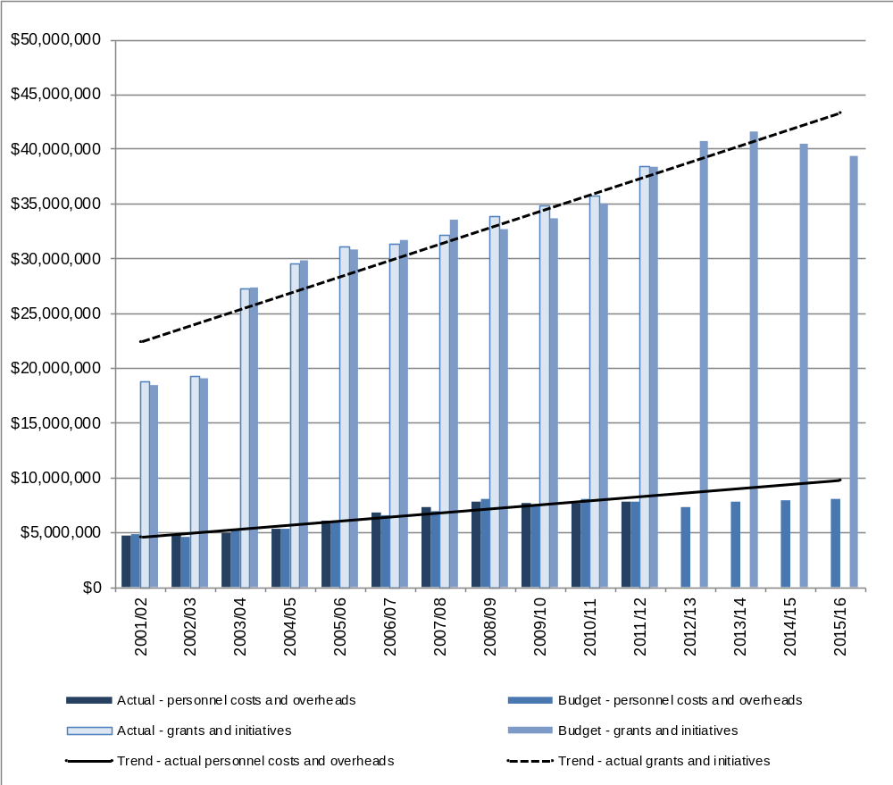
- Improved information systems – We are introducing a more effective and efficient system to improve our grants management and customer information. We expect this to reduce processing times, costs of compliance and costs to our customers. The first stage of the system is expected to go live in December 2013.
- Digital technology – We continue to work to improve our use of digital technology, particularly for dealing with funding applications and external assessments. Increased automation will reduce our administration costs and simplify application and reporting processes, with benefits for us and applicants. Improvements to our website and the use of social media and blogs will improve our ability to communicate with our customers and stakeholders.
- Better governance structure – The planned streamlining of our governance structure (see page 12) could result in savings of $200,000 each year and will free up staff resources that can instead be focused on delivering services to the arts sector.

Measuring our performance against our outcomes
The following pages describe:
- our four outcomes and their associated impacts
- the performance measures we have selected for each of these; and
- the activities or services, both general and specific, that contribute to each outcome.

Evaluating completion reports
Each individual or organisation that receives funding for a project under the Grants funding programme is required to provide a ‘completion report’ at the end of their project. When reports are received, they are evaluated against:
- the objectives and deliverables stated in the initial application for funding; and
- the terms of the funding contract agreed between them and Creative New Zealand.
Results are recorded as ‘Met expectations’, ‘Exceeded expectations’ or ‘Did not meet expectations’.
We carry out an annual audit of evaluations to ensure there is consistency across all the evaluation processes.

Performance measures and targets for outcomes and impacts
The performance measures and targets shown in figures 5 to 8 have been set on the following bases:
- unless otherwise specified, the measures cover all three years of this Statement of Intent
- actual results from 2011/12 are shown in round brackets against the targets for 2013–16
- targets for numbers of grants completed are calculated on the basis of historical patterns. However, these targets are indicative only, as they are a reflection of demand at the time the grant was awarded.
Outcome budgets are based on a mixture of known commitments and historical projections. However, since a proportion of expenditure is responsive (a reflection of the applications received), those provided can only be indicative.
Creative New Zealand expects to use most of its financial reserves over the next few years to maintain current levels of support for its clients and to respond to specific opportunities and government priorities.
In this environment, we do not believe that increasing targets is always appropriate. For example, without an increase in our funding, more grants would simply mean smaller grants, with the accompanying risk that projects would fail because of lack of funding.

Outcome 1: New Zealanders participate in the arts

What are we seeking to achieve?
By ‘participate’, we mean being actively involved in creating and presenting the arts. Achieving this outcome provides New Zealanders with the opportunity to:
- celebrate, practise and preserve their diverse artistic traditions and cultural heritage
- develop links between communities that improve cross-cultural understanding
- create artistic works for their own and others’ pleasure, or for sale
- acquire skills in creating art or in arts administration.

What we do
We provide opportunities for communities throughout New Zealand to participate in a diverse range of artforms and arts practices through our Grants funding and Investment programmes.
The Creative Communities Scheme (CCS) is a key means by which we support New Zealanders’ participation in the arts. It is a small grants scheme funding community arts projects and activities that take place within the local area of a TA. In 2013/14, Creative New Zealand will provide $3.39 million in funding for the scheme (out of a total indicative budget of $6.25 million for Outcome 1).

Our focus for 2013–16
Over the next three years, we will:
- assist TAs to make the best use of the CCS to support the arts within their local communities
- implement the recommendations from the artform reviews of ngā toi Māori and Pacific arts.
Figure 5 shows the links between Outcome 1, the impacts that contribute to it, the activities we undertake to support these impacts and the ways in which we will measure our performance.

Figure 5: Outcome 1 – Links
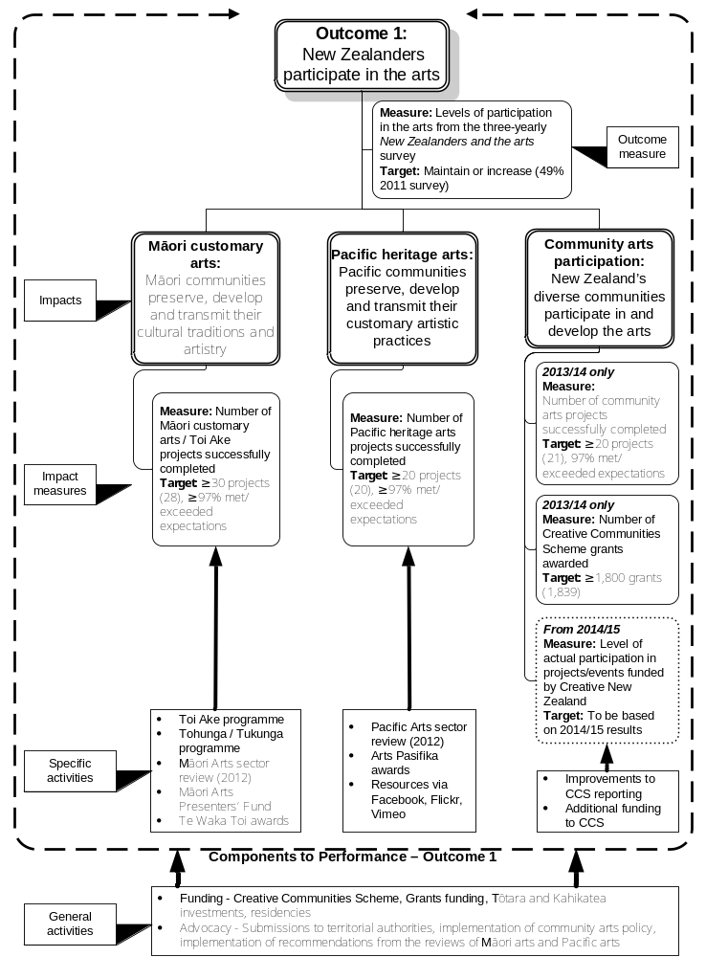

Outcome 2: High-quality New Zealand art is developed

What are we seeking to achieve?
Creative New Zealand seeks to ensure that artists, arts practitioners and arts organisations can fulfil their potential by:
- continually developing their artforms, the quality of their work and their artistic skills and capabilities; and
- having opportunities to experiment, be innovative and take risks.
We are committed to developing and strengthening New Zealand artistic work. As the only national arts development organisation providing funding across all artforms and supporting individuals as well as organisations, we take a leading role in achieving this outcome.

What we do
Creative New Zealand makes a substantial investment towards this outcome through the Tōtara and Kahikatea investment programmes, and through its Grants funding programme. Our Tōtara organisations play a vital role in supporting this outcome, through providing leadership, developing talent and supporting innovation and artistic risk.
In 2013/14, we will provide $10.74 million in funding to these programmes under Outcome 2 (out of a total indicative budget of $13.74 million for this Outcome).

Our focus for 2013–16
Over the next three years, we will:
- continue to support the best projects and organisations in order to develop high-quality, innovative new works
- recognise the contribution of high-quality artists through awards and residencies
- support the development of artistic skills and practices
- carry out sector reviews for the following specific artforms: music, dance, opera, visual arts, craft/object art, literature, and theatre
- carry out a full review of the Tōtara and Kahikatea investment programmes to ensure they are achieving the intended outcomes.
Figure 6 shows the links between Outcome 2, the impacts that contribute to it, the activities we undertake to support these impacts and the ways in which we will measure our performance.

Figure 6: Outcome 2 – Links
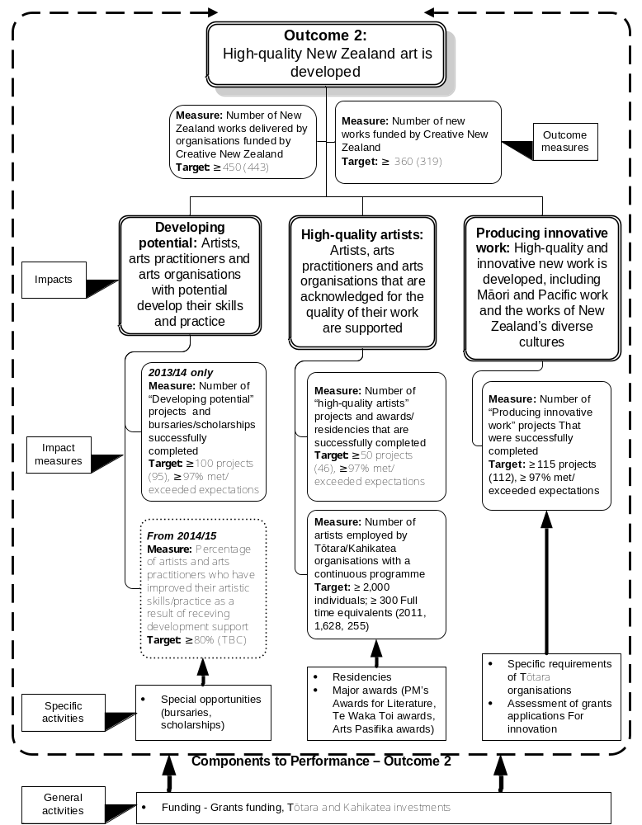

Outcome 3: New Zealanders experience high-quality arts

What are we seeking to achieve?
Audiences are vital to a vibrant arts sector. Creative New Zealand aims to broaden the opportunities for all New Zealanders to experience the arts, providing them with access to a diverse range of artistic experiences.

What we do
We support arts organisations to provide arts experiences across the country and across all artforms – from music concerts and theatre, to craft and traditional ngā toi Māori.
We also provide capability building initiatives to help artists, arts practitioners and arts organisations develop the skills to run their organisations well and engage more effectively with their audiences.
Our research, such as our three-yearly New Zealanders and the arts survey, supports audience development, by providing data that can be used to analyse and respond to trends in New Zealanders’ attendance at arts events. The 2011 survey showed that New Zealanders remain keen attenders of the arts: 80 percent of the population aged 15 or older had attended at least one arts event over the previous 12 months, and 32 percent had attended more than 10 events. Attendance is highest among women (34 percent), young people under 30 (36 percent), Māori and Pacific peoples (50 and 46 percent respectively) and those with high household incomes (41 percent). These results are in line with previous surveys, once the effects of the Christchurch earthquakes are taken into account.
Creative New Zealand makes a substantial investment towards this outcome through the Tōtara and Kahikatea investment programmes and the Grants funding programme. This investment will total $16.07 million in 2013/14 (out of a total indicative budget of $17.08 million for Outcome 3).

Our focus for 2013–16
Over the next three years, we will:
- continue to support arts events outside the main centres, and support the organisations that deliver them, through our Distribution Strategy and our grants and investments programmes
- offer a menu of capability building services and activities targeted at the priority needs of our client organisations, as identified through the use of an organisational development modelling tool, and focusing on needs that other suppliers cannot meet.
Figure 7 shows the links between Outcome 3, the impacts that contribute to it, the activities we undertake to support these impacts and the ways in which we will measure our performance.

Figure 7: Outcome 3 – Links
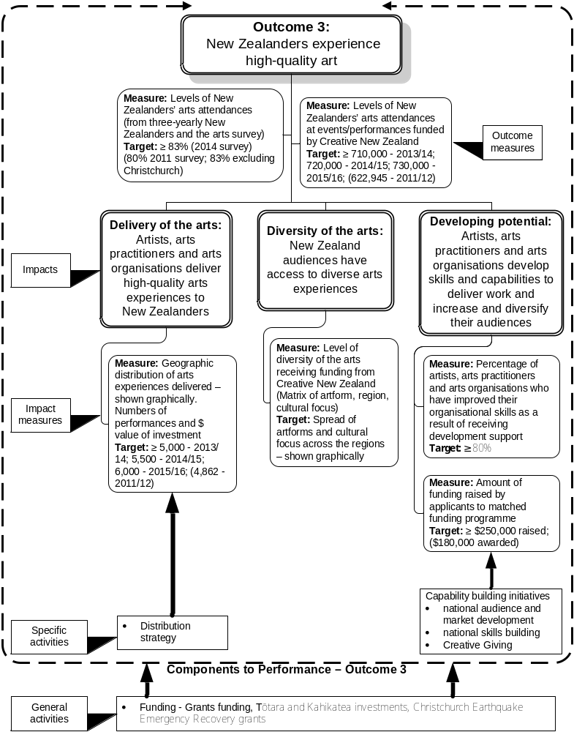

Outcome 4: New Zealand arts gain international success

What are we seeking to achieve?
Creative New Zealand aims to position New Zealand’s best artists, arts practitioners and arts organisations to develop audiences for their overseas performances and exhibitions. This helps increase income for our artists and arts organisations and promotes New Zealand and its arts offshore.
International exposure also helps grow New Zealand talent, by allowing artists to develop their practice through observing and interacting with overseas colleagues. Success overseas can also inspire other New Zealand artists to raise their sights and promote a better understanding of international standards.

What we do
Creative New Zealand’s international networks and targeted programmes mean that it can bring international buyers to New Zealand and take New Zealand work to international markets.
We take selected artists to markets and fairs to display their works and introduce them to potential buyers or distributors; we bring key overseas managers and directors to New Zealand so that they can experience New Zealand art in its local context and we provide capability building for those wanting to develop skills to engage with international markets and audiences. We also respond to applications from artists and organisations wanting to undertake projects and residencies or study internationally.
The total indicative investment in this outcome in 2013/14 is $4.58 million.

Our focus for 2013–16
Over the next three years, we will:
- work with the arts sector to leverage international exposure for New Zealand arts through key events such as the Venice Biennale 2013, Edinburgh Festivals 2014 project and the legacy 2012 Frankfurt Book Fair project
- continue to support individuals and organisations invited to present their work overseas
- implement changes to our international capability building initiatives to meet the identified priority needs of our client organisations that want to be successful internationally.
Figure 8 shows the links between Outcome 4, the impacts that contribute to it, the activities we undertake to support these impacts and the ways in which we will measure our performance.

Figure 8: Outcome 4 – Links
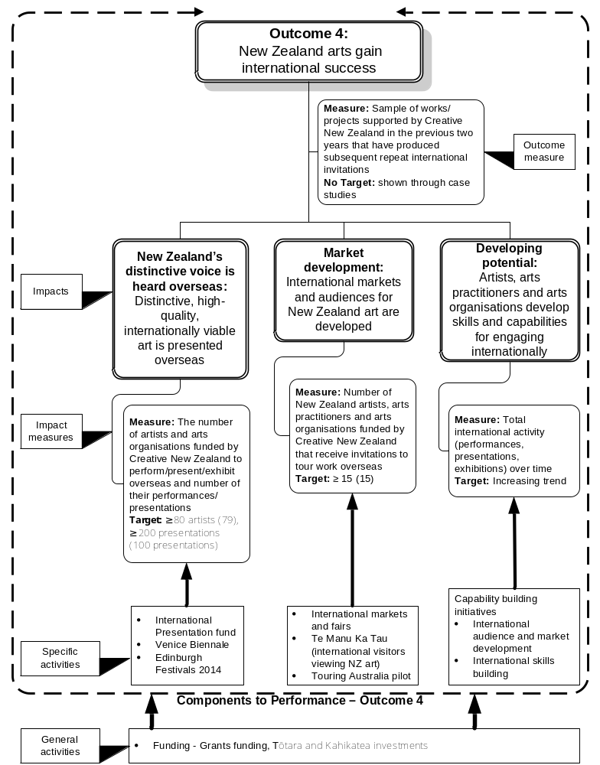

Managing our organisational health |
Te whakahaere i te ora o te tari
At Creative New Zealand we recognise our ability to achieve our four outcomes depends in large part on our organisational culture, our people, our systems and processes, the quality of our decision-making and the relationships we forge with the arts sector and other stakeholders.

Building Creative New Zealand’s organisational strength

People and organisational culture
- All staff will be offered training and development across a range of areas, including software applications, financial reporting, communications and presentations, and project management.
- We will continue to take part in the annual Best Workplaces survey and to use the feedback we obtain from it to improve our organisational culture.

Relationships
- Using the feedback from the customer satisfaction survey carried out in 2010/11, we will continue to make changes in those areas identified by the survey as needing improvements. In 2012/13, we undertook a major update of our website and expanded our social media presence, including a Facebook page and a blog.
- We will re-run the survey in 2014/15 and improve our overall satisfaction ratings, particularly in areas around our granting systems and processes.

Thinking and decisions
- We are reviewing our strategic direction, as we develop a new strategic plan. We expect the new plan will be effective from late 2013.
- In December 2013, we will produce an interim report on the performance of the new Tōtara and Kahikatea investment programmes, which were implemented from 1 January 2012. A full formal review of the programmes will be undertaken in 2016.
- We will begin monitoring the effectiveness of our new capability building initiatives, using our development research to provide trend data.

Governance and management
- We will ensure a successful transition to the new unitary governance structure, once the bill has passed through Parliament (refer page 12), and we will report on progress to the Minister for Arts, Culture and Heritage six months after implementation.
- Members of the new unitary Arts Council will receive the necessary training and support to govern Creative New Zealand effectively and make sound funding decisions.
- Pending the implementation of the unitary structure, any new members of the Arts Council, arts boards and Pacific Arts Committee will receive induction training and support as required.

Structures and processes
- We will implement our new grants and customer-relationship management information systems. This is a major focus for us in the 2013/14 year, with the systems expected to go live in December 2013.

Proof of performance
 | Notes | 2011/12 Actual | 2012/13 Forecast | 2013/14 Forecast | 2014/15 Forecast | 2015/16 Forecast
Quality
Percentage of staff attending one or more training courses |  | 100% | 100% | 100% | 100% | 100%
Overall performance indicator (Best Workplaces survey) | 1 | 77% | 78% | 79% | 80% | 80%
Common Measurements Tool – overall quality | 2 | 77% | No survey | No survey | 80% | No survey
Notes to the table above
1. This is the overarching measure from the annual Best Workplaces survey.
2. From the Creative New Zealand customer satisfaction survey undertaken in 2010/11. The Common Measurements Tool is used to compare Creative New Zealand with other organisations. The comparative external benchmark is 69 percent.

Being a good employer
Creative New Zealand will meet its ‘good employer’ obligations (in section 118 of the Crown Entities Act 2004) by maintaining and reporting against a personnel policy that includes reference to the seven key good employer elements.
We also include in our personnel policy and reporting specific commitments to:
- the aims, aspirations and employment requirements of Māori
- the need for involvement of Māori as employees
- the aims and aspirations of ethnic or minority groups and recognition of their employment requirements and cultural differences
- the employment requirements of women
- the employment requirements of people with disabilities.

Managing our capital assets
Creative New Zealand’s significant capital assets include:
- part ownership of the Old Public Trust Building, 131–135 Lambton Quay, Wellington.
- a 197-piece collection of New Zealand art and craft work.
- client relationship and grants management system.

The Old Public Trust Building
This building, which is the site of Creative New Zealand’s main Wellington office, is registered as a Category 1 Historic Place by the New Zealand Historic Places Trust Pouhere Taonga and is subject to a Heritage Order. We acknowledge the need to adopt the highest professional conservation standards to protect and preserve this building. The building is insured and administered by the Old Public Trust Building Body Corporate.
The building is officially categorised by Wellington City Council as ‘earthquake prone’ under the Building Act 2004. Reports on what needs to be done to strengthen the building and the costs, plus the costs of alternative accommodation (bought or rented) have been commissioned. A decision on whether Creative New Zealand will remain in the building will be made by the Arts Council in 2013. A decision on the earthquake strengthening will be made by the Body Corporate in 2013.
The estimated costs to strengthen the building, repair the building’s façade, relocate to alternative premises while this work is carried out, and then fit-out the building on completion range between $4.61 million and $9.41 million. Based on Unit Entitlements, Creative New Zealand would be responsible for 64.28 percent of these costs.
The value of our ownership interest in the building, as reported in the Annual Report to 30 June 2012, was $1.85 million, a decrease of approximately $2.35 million since 2009/10. The decline in valuation is a reflection of the need to strengthen the building.

Our art collection
Creative New Zealand’s art collection consists mostly of works collected in the 1970s and 1980s. Currently, we are not actively adding to or removing items from the collection.
The collection consists of 197 works. The value of the collection was reported at $1.163 million in the 30 June 2012 Annual Report. The collection is insured, professionally managed and independently valued every three years.
Most of the collection is on display at the Wellington office, with some works on display in our Auckland office and some on loan to other organisations or to museums and galleries.

Client relationship and grants management system
Creative New Zealand signalled in its 2011–14 Statement of Intent that it wanted to increase the efficiency of its grants management, information gathering and reporting through the use of improved technology.
As a result, we have purchased the Pivotal CRM solution supplied by Fusion 5 Limited. Through this solution, we will be able to operate our granting programmes, capability building activities and better manage our clients and other stakeholders. Both efficiency and effectiveness gains will be realised.
The Pivotal CRM solution will automate a number of our current manual grants processes. This will reduce the time between a funding round closing date and applicants being notified of decisions, as well as reduce our current costs to process a grant application.
Applicants will be able to apply for Creative New Zealand funding through a web portal. Once their application has been accepted, applicants will be able to log-in and see where in the grants process their application is. This will increase the transparency of our processes. The same technology will be available for external assessors; they will be able to log-in to the web portal, read applications and complete their assessments online.
Automation of the registration and application stages of the grants process will benefit applicants through cost savings from not having to make and deliver multiple copies of their grant applications.
Through the use of the CRM functionality, Creative New Zealand will be able to better target information to clients including advice on new funding opportunities.
The system is currently in development with the go-live date expected to be in December 2013.
Part 3: Annual Outlook – Forecast Performance for the Period 1 July 2013 – 30 June 2014 |
Ngā whakatūtukinga ā tau te wāhanga
1 Hurae 2013 – 30 Hune 2014

Forecast service performance |
Te matapae whakatūtukitanga
Creative New Zealand operates under one central government output expense: Promotion and Support of Arts and Film. Funding is received from the Government through Vote: Arts, Culture and Heritage and from the NZLGB. Our monitoring department is the Ministry for Culture and Heritage.
In 2013/14, Creative New Zealand will receive:
- $15,689,000 through Vote: Arts, Culture and Heritage; and
- an estimated $31,500,000 from the NZLGB.
Creative New Zealand has one output class: Promotion and support of the arts. Within that are three main output areas:
- Funding for artists, arts practitioners and arts organisations
- Capability building for artists, arts practitioners and arts organisations
- Advocacy for the arts.
The table below shows the revenue we expect to earn and the expenses we propose to incur for key activities contributing to the three output areas.

 | Notes | 2012/13 Forecast  ($) | 2013/14 Budget  ($) | 2014/15 Budget  ($) | 2014/15 Budget  ($)
Income
Vote: Arts, Culture and Heritage |  | 15,689,000 | 15,689,000 | 15,689,000 | 15,689,000
New Zealand Lottery Grants Board |  | 31,024,104 | 31,500,000 | 31,500,000 | 31,500,000
Other income |  | 1,006,000 | 781,500 | 664,000 | 664,000
Total income |  | 47,719,104 | 47,970,500 | 47,853,000 | 47,853,000
Expenditure
Funding
- Investment programmes (Tōtara and Kahikatea) |  | 23,104,878 | 23,708,395 | 24,208,395 | 24,208,395
- Grants funding programme | 1 | 8,821,961 | 9,226,200 | 8,226,200 | 8,226,200
- Creative Communities Scheme |  | 3,211,627 | 3,393,500 | 3,393,500 | 3,393,500
- International presentation and cultural exchange | 2 | 2,053,834 | 1,477,000 | 2,622,000 | 1,742,000
- Other funding | 3 | 1,644,350 | 1,900,000 | 0 | 0
Capability building | 4 | 1,817,266 | 1,730,180 | 1,585,180 | 1,580,180
Advocacy |  | 131,072 | 212,500 | 412,500 | 212,500
Total funding, capability building and advocacy | 5 | 40,784,988 | 41,647,775 | 40,447,775 | 39,362,775
Operating expenses |  | 7,291,811 | 7,819,549 | 7,933,170 | 8,043,170
Total expenditure |  | 48,076,799 | 49,467,324 | 48,380,945 | 47,405,945
Net operating surplus/(deficit) |  | (357,695) | (1,496,824) | (527,945) | 447,055
Notes to the table above
1. The Grants funding programme includes: Arts grants, Quick Response grants, Distribution Strategy activities; the Toi Ake and Tohunga/Tukunga programmes; the Prime Minister’s Awards for Literary Achievement; residencies, bursaries and scholarships; Christchurch earthquake support and the Flexible funding portfolio.
2. This includes funding for the Venice Biennale, Festival of Pacific Arts and the International Presentation fund.
3. ‘Other funding’ includes El Sistema funding through the Auckland Philharmonia Orchestra and Auckland Theatre Company capital funding.
4. ‘Capability building’ includes national and international skill building, the Creative Giving programme, audience and market development.
5. No personnel costs are included in ‘Funding, capability building or advocacy’.

Output area 1: Funding for artists, arts practitioners and arts organisations

Overview of Output area 1
In 2013/14, $39.7 million will be distributed to the community through investments or grants. This is approximately 80 percent of Creative New Zealand’s total budgeted expenditure of $49.5 million. We are often a partial investor only: additional funding or other resources come from local government, other central government agencies, corporate sponsorship, community and gaming trusts, ticket sales, volunteers, private philanthropy and donations.
Since 2009, we have carried out detailed reviews of all of our funding programmes to ensure that they are fit for purpose and complement each other. We now monitor their impact against what they are intended to achieve.

Forms of financial support that we provide
Creative New Zealand provides financial assistance to artists, arts practitioners and arts organisations and their projects. We do this in a variety of ways:
- multi-year funding for organisations (Investment funding)
- grants in response to applications that meet published criteria (Grants funding)
- through initiatives established in response to specific needs (Grants funding, International presentation and cultural exchange)
- by devolving funds to partners for them to distribute (the Creative Communities Scheme).

Investment funding
From 1 January 2012, Creative New Zealand implemented two new programmes: the Arts Leadership Investment (Toi Tōtara Haemata) programme and the Arts Development Investment (Toi Uru Kahikatea) programme – known as the Tōtara and Kahikatea programmes respectively. Kahikatea applications are considered annually but funding can be for up to three years. Funding under the Tōtara programme is for periods of up to five years. The application process for both programmes involves the use of external peer assessments.
This activity contributes to all four of our outcomes.
The investment programmes support the development of a sustainable infrastructure in the arts sector by funding key arts organisations for a fixed term. With this support, arts organisations are able to plan programmes of activity rather than just single projects.
The organisations are contracted to deliver specific services and their performance is monitored against agreed objectives. If any problems are identified, we provide targeted assistance to support the organisation in addressing them.
We also make incentive funding available to organisations in the investment programmes, to support specific activities.

Performance measures
 | Notes | 2011/12 Actual | 2012/13 Forecast | 2013/14 Forecast | 2014/15 Forecast | 2015/16 Forecast
Quantity
Number of organisations contracted to deliver programmes of activity:  Tōtara  Kahikatea | 1 | 34 (former RFOs)  24  49 | 24  56 | 23–26  45–60 | 23–26  45–60 | 23–26  45–60
Quality
Proportion of organisations that meet or exceed the agreed expectations in their funding contracts | 2 | 86% | ≥ 92% | ≥ 94% | ≥ 94% | ≥ 94%
Proportion of Creative New Zealand obligations to customers under funding contracts that are met | 3 | 100% | 100% | 100% | 100% | 100%
Notes to the table above
1. This is an activity measure that describes the Investment funding programme. It is included to provide context for measuring the programme’s performance. RFOs refer to Recurrently Funded Organisations (now replaced by the Tōtara and Kahikatea investment programmes).
2. Tōtara and Kahikatea organisations are monitored against performance criteria tailored to each organisation and set in individual funding contracts. Monitoring uses a mixture of internal assessment and information provided by the organisation itself.
3. This performance measure reflects the importance Creative New Zealand places on both partners to the funding relationship meeting their obligations. The measure includes our obligations to ensure that the quality of all organisations’ services or performances is assessed and that payments are made on a timely basis.

Grants funding
Creative New Zealand provides Grants funding through a range of programmes, where it selects the best artists, practitioners or organisations and their projects. For the past four years, between 500 and 600 projects have been supported annually through Grants funding. However, this number is expected to reduce following the incorporation of Arts Investment and Sector Investment grants into the Investment funding programmes and the likely reduction in the number of Earthquake Recovery grants.
Our Grants funding programme contributes to all four of our outcomes.
There are two main types of grants available through Grants funding:
- Quick Response Grants – up to $7,500 can be awarded through three funding rounds each year. Applications are assessed internally by Creative New Zealand staff and decisions are made within six weeks of the closing date.
- Arts Grants – grants of up to $65,000 are awarded through two funding rounds each year. Applications are assessed by external peer assessors and Creative New Zealand staff and decisions are made within 12 weeks of the closing date.

How grant applications are assessed
All applications under our Grants funding programme are assessed for quality on a seven-point scale across four areas:
- The idea: What is it that you want to do?
- The process: How will you carry out the project, where and when will it occur, and how will you evaluate the completed project?
- The people: Who is involved?
- The budget: How much will it cost?
Proposed projects are also assessed against how they meet one or more of Creative New Zealand’s outcomes and, where relevant, for their contribution to cultural diversity, innovation and community arts participation. Where appropriate, a culturally specific assessment is also applied – for example, Mātauranga Māori for ngā toi Māori applications by Māori, for Aotearoa and the world; and Kaupapa Pasifika for Pasifika arts applications.

Other support under the Grants funding programme
The Grants funding programme also includes:
- all special opportunities (bursaries, scholarships, residencies and awards, including the Te Waka Toi and Arts Pasifika awards)
- activities funded through the Toi Ake and Tohunga/Tukunga programmes, Māori Arts Presentation fund and tagged funding for the preservation of heritage arts
- regional touring funded through the Distribution Strategy
- Earthquake Emergency and Recovery grants from the Christchurch Earthquake Emergency Response Fund.
Each of these types of grants has specific criteria and decision-making processes.
Information about Creative New Zealand’s Grants funding is available on its website at www.creativenz.govt.nz.

Performance measures
 | Notes | 2011/12 Actual | 2012/13 Forecast | 2013/14 Forecast | 2014/15 Forecast | 2015/16 Forecast
Quantity
Number of projects funded | 1 | 529 | 450 | 450 | 450 | 450
Quality
Project completion rate | 2 | 99% | 99% | 99% | 99% | 99%
Percentage of completed projects that are evaluated against the approved application and the funding agreement | 3 | 98% | 100% | 100% | 100% | 100%
Proportion of grants that are processed within published timeframes | 4 | 100% | 100% | 100% | 100% | 100%
Notes to the table above
1. This is an activity measure and is demand driven. However, it provides context for measuring the performance of the Grants funding programme. In 2013/14, we expect that the number of grants will decrease from the 2011/12 level, which included 57 grants from the Christchurch Earthquake Emergency Response Fund and some grants that are now included in the Kahikatea investment programme.
2. A project is completed when Creative New Zealand has received a project completion report by the agreed due date. Because a project may not be completed in the same year as it is funded, the project completion rate presented here includes all Grants funding projects funded across previous financial years. Completion rates have been steady at 99 percent since 2009/10.
3. We monitor the results of projects and evaluate each project’s delivery by comparing the outcomes of the project, as set out in the project completion report, against the initial grant proposal and the funding agreement. The possible results of the evaluation are: ‘Exceeded expectations’, ‘Met expectations’ or ‘Did not meet expectations’. Information from the evaluation process is used to inform our future granting decisions.
4. This measure has been included to reflect the importance that we place on timely application and assessment processes. Funding timeframes are published in our Funding and Programmes Guide, published each year and available at www.creativenz.govt.nz.

Creative Communities Scheme
Established in 1995, the Creative Communities Scheme is a small grants scheme that supports community arts projects and activities that take place within the local area of a TA. Funding under the scheme is devolved by Creative New Zealand to the 67 TAs, which administer the scheme themselves or through suitable third parties.
Local assessment committees consider applications for funding under the scheme. Funding decisions are made on the basis of three criteria set by Creative New Zealand. New criteria and reporting requirements for TAs took effect from 1 July 2010, and a review of the funding formula in 2011 resulted in a $360,000 boost to the budget (to $3.26 million) in 2012/13.
This programme directly supports Outcome 1: New Zealanders participate in the arts.

Performance measures
 | Notes | 2011/12 Actual | 2012/13 Forecast | 2013/14 Forecast | 2014/15 Forecast | 2015/16 Forecast
Quantity
Number of TAs contracted to manage the Scheme in their area | 1 | 67 | 67 | 67 | 67 | 67
Number of projects funded | 2 | 1,839 | ≥ 1,800 | ≥ 1,800 | ≥ 1,800 | ≥ 1,800
Quality
Proportion of TAs that meet the requirements of their contracts as administrators of the Scheme | 3 | 99% | ≥ 96% | ≥ 97% | ≥ 97% | ≥ 97%
Notes to the table above
1. This is an activity measure.
2. This is an activity measure and is demand driven. Together with the ‘Number of TAs …’ measure above, it provides context for measuring the performance of the Creative Communities Scheme. New criteria for the scheme, implemented from 1 July 2010, removed a previous spending cap. Local assessment committees have taken advantage of this to support fewer, and larger-scale, projects. The average value of a grant under the scheme increased from $1,209 in 2009/10 to $1,789 for the first nine months of 2012/13.
3. The requirements are: running the appropriate number of funding application rounds; awarding grants based on Creative New Zealand’s criteria; reporting as required; and distributing the scheme funds at agreed levels within the required period.

International presentation and cultural exchange
Through this set of initiatives, Creative New Zealand identifies opportunities to market and present New Zealand work at key international events and markets. We select and invest in individual artists and arts practitioners, and in organisations or clusters of artists, through a range of initiatives. This includes specific events such as the Venice Biennale and the Edinburgh Festival. It does not include attendance at overseas markets (these are included in Output area 2: Capability building).
International presentation and cultural exchange initiatives are additional to funding provided for projects through the Grants funding programme and to funding provided under our Tōtara or Kahikatea investment programmes to support organisations in presenting works overseas.
The delivery of these initiatives is specific and targeted and directly supports Outcome 4: New Zealand arts gain international success.

Performance measures
 | Notes | 2011/12 Actual | 2012/13 Forecast | 2013/14 Forecast | 2014/15 Forecast | 2015/16 Forecast
Quantity
Number of projects funded | 1 | 20 | ≥ 25 | ≥ 25 | ≥ 25 | ≥ 25
Quality
Project completion rate | 2 | 99% | 99% | 99% | 99% | 99%
Percentage of completed projects that are evaluated against the approved application and the funding agreement | 3 | 100% | 100% | 100% | 100% | 100%
Notes to the table above
1. This is an activity measure and is demand driven. However, it provides context for measuring the performance of the International funding programme.
2. A project is completed when Creative New Zealand has received a project completion report by the agreed due date. Because a project may not be completed in the same year as it is funded, the project completion rate presented here includes all Grants funding projects funded across previous financial years. Completion rates have been steady at 99% since 2009/10.
3. We monitor the results of projects and evaluate each project’s delivery by comparing the outcomes of the project, as set out in the project completion report, against the initial grant proposal and the funding agreement. The possible results of the evaluation are: ‘Exceeded expectations’, ‘Met expectations’ or ‘Did not meet expectations’. Information from the evaluation process is used to inform our future granting decisions.

Output area 2: Capability building for artists, arts practitioners and organisations
Creative New Zealand delivers capability building initiatives to artists, arts practitioners and arts organisations in several areas, including governance, strategic planning, fundraising, internal organisational systems and processes, audience development, market development and international engagement.
In 2013/14, $1.73 million is budgeted for capability building initiatives.
There are three main categories of activity:
- skills building (both national and international)
- audience and market development (national and international)
- a pilot programme aimed at increasing private sector support for the arts by building capability in funding raising and philanthropic giving.
In 2011/12, we reviewed our capability building initiatives. As a result, we implemented a new programme from 1 January 2013, prioritising capability building initiatives that:
- are based on the needs of client organisations (as identified through an organisational development modelling tool)
- focus on needs that other suppliers cannot meet
- respond to changing artform needs, to cultural and demographic drivers, to audience interests and to the specific needs of any at-risk organisations
- build on market and audience intelligence
- encourage collaboration and draw on the experience of successful organisations and individuals.
Because this new programme will involve changes to the initiatives offered in past years, some of our targets for 2013–16 are different from previous years (see the notes to the ‘Performance measures’ table below).
Information about Creative New Zealand’s capability building programmes is available on its website at www.creativenz.govt.nz.
The delivery of the programmes is usually targeted towards organisations in the investment programmes. This output area supports all four of our outcomes, but is particularly associated with the ‘Developing potential’ impacts under Outcome 3: New Zealanders experience high-quality arts and Outcome 4: New Zealand arts gain international success.

Performance measures
 | Notes | 2011/12 Actual | 2012/13 Forecast | 2013/14 Forecast | 2014/15 Forecast | 2015/16 Forecast
Quantity
Number of capability building initiatives delivered to the sector | 1 | 32 | ≥ 31 | ≥ 31 | ≥ 31 | ≥ 31
Number of person-days of workshop-based capability building delivered | 2 | 218 | 300 | ≥ 400 | ≥ 400 | ≥ 400
Number of participants in experiential capability building initiatives | 3 | 128 | ≥ 94 | ≥ 94 | ≥ 94 | ≥ 94
Quality
Proportion of participants who find the workshop-based capability building initiatives to be relevant and helpful | 4 | 94% | ≥ 96% | ≥ 97% | ≥ 97% | ≥ 97%
Proportion of participants in experiential initiatives who find them to be relevant and effective | 5 | 100% | ≥ 96% | ≥ 97% | ≥ 97% | ≥ 97%
Notes to the table above

As a result of its 2011/12 review, Creative New Zealand implemented a new capability building programme from January 2013 that will better reflect the needs of the arts sector and limit its initiatives to needs that cannot be met by other suppliers. Because we have limited our focus, we are forecasting a decrease in some quantity measures for 2013–16 compared with 2011/12 results (see notes 2 and 3 below).
1. This is an activity measure, but it provides context for measuring the performance of Creative New Zealand’s capability building initiatives. It also includes several initiatives where participation cannot be quantified or quality measured in any other way (for example, online forums).
2. This measure provides direct comparisons of multi-day workshop initiatives with part-day events. A ‘person-day’ means one person for one full day (so four person-days could be two people for a two-day course, eight people for a half-day course or one person for a four-day course). Numbers of workshops and attendees are expected to decline under our new capability building programme, and this target has been reduced from ≥ 600 in 2012/13 to ≥ 400 in 2013/14.
3. This measure separates the experiential initiatives (such as attendance at international markets and fairs) from those that are workshop based. As with the measure discussed in note 2, numbers of activities are forecast to decline as a result of our 2011/12 review of this output area.
4. This measure is based on feedback obtained from participants immediately after the workshop.
5. This measure is based on feedback obtained from participants immediately after the experiential learning.

Output area 3: Advocacy for the arts
The aims of our advocacy programme are to raise awareness of the role and contribution of the arts and of key issues affecting the arts sector, and to change the environment for the benefit of the arts. This output area supports all four of our outcomes.
All Creative New Zealand staff play a role in advocating for and promoting the arts. Because of this, the only costs budgeted for this output area are for external charges. We have budgeted $212,500 for Advocacy in 2013/14.
Our advocacy programme includes the following types of activities:
- carrying out research for the benefit of the arts sector
- making submissions on issues affecting the arts sector or Creative New Zealand
- developing strategic partnerships to increase support for the arts
- participating in cross-government initiatives.

Performance measures
 | Notes | 2011/12 Actual | 2012/13 Forecast | 2013/14 Forecast | 2014/15 Forecast | 2015/16 Forecast
Quantity
Total number of research projects and other resources delivered to the sector | 1 | 6 | 3 | 3 | 3 | 3
Number of submissions made to government or local government on arts matters | 2 | 14 | 3 | ≥ 3 | ≥ 3 | ≥ 3
Quality
The arts sector is using available resources as indicated by the website usage | 3 | 419,549 unique page views | ≥ 450,000  unique page views | ≥ 450,000  unique page views | ≥ 450,000  unique page views | ≥ 450,000  unique page views
Notes to the table above
1. This is an activity measure that provides context for the quality measure in this table. To be included, research and resources need to be available to the arts sector, not just for internal use by Creative New Zealand. In 2011/12, the number of reports included the three triennial reports from the New Zealanders and the arts 2011 project.
2. This is an activity measure that provides context for measuring our performance in this output area. The number of submissions made is a reflection of the number of draft plans, policies and legislation that have been produced on topics of interest to us.
3. This performance measure was introduced in 2010/11 to provide us with a better understanding of which resources are most valuable to the arts sector.

Forecast financial statements |
Ngā matapae pūrongo pūtea

Statement of accounting policies
For the years ending 30 June 2013, 30 June 2014, 30 June 2015 and 30 June 2016.

1. Reporting entity
The Arts Council of New Zealand Toi Aotearoa was established on 1 July 1994 by the Arts Council of New Zealand Toi Aotearoa Act 1994. The Council has chosen to operate under the name Creative New Zealand.
Creative New Zealand is a Crown entity as defined by the Crown Entities Act 2004 and is domiciled in New Zealand. Creative New Zealand’s ultimate parent is therefore the New Zealand Crown.
Creative New Zealand’s purpose, as defined under the Arts Council of New Zealand Toi Aotearoa Act 1994, is to encourage, promote and support the arts in New Zealand for the benefit of all New Zealanders.
Accordingly, Creative New Zealand has designated itself as a public benefit entity for the purposes of New Zealand Equivalents to International Financial Reporting Standards (NZ IFRS).

2. Statement of compliance
These forecast financial statements are prepared in accordance with the requirements under Financial Reporting Standard 42 Prospective Financial Statements and sections 141 and 142 of the Crown Entities Act 2004.
The forecast financial statements have been prepared in accordance with NZ GAAP. They comply with New Zealand equivalents to IFRS and other applicable financial reporting standards as appropriate for public benefit entities.

3. Measurement base
These forecast financial statements have been prepared on an historical cost basis, except where modified by the revaluation of land and buildings, works of art and investment property.
The accrual basis of accounting has been used, unless otherwise stated.

4. Functional and presentation currency
These forecast financial statements are presented in New Zealand dollars ($) and are rounded to the nearest thousand dollars ($000). The functional currency of Creative New Zealand is the New Zealand dollar.

5. Accounting policies
The following specific accounting policies, which materially affect the measurement of financial performance and financial position, have been applied consistently to all periods presented in these forecast financial statements.

5.1 Recognition of revenue and expenditure
Revenue is recognised and measured at the fair value of consideration received or receivable to the extent that it is probable the economic benefits will flow to Creative New Zealand and the revenue can be reliably measured.

Revenue from the Crown
Creative New Zealand receives a significant amount of its funding from the Crown. It can use this funding only for the purpose of meeting its objectives as specified in the Statement of Intent.
Revenue from the Crown is recognised as revenue when earned and is reported in the financial period to which it relates.

Other grants
Creative New Zealand receives most of its funding from the NZLGB. This is recognised as revenue when it becomes receivable, unless there is an obligation to return the funds if conditions of the grant are not met. If there is such an obligation, the grants are initially recorded as grants received in advance and recognised as revenue when conditions of the grant are satisfied.
Revenue received from third parties on the condition that it is used for a particular purpose is recognised in the Statement of Financial Performance only when the funds are spent for the designated purpose. Any unspent funds at the reporting date are included within current liabilities in the Statement of Financial Position, and carried forward to the next financial year.

Interest
Interest income is recognised as it accrues on bank account balances and on-call and short-term deposits, using the effective interest method.

Rental income
Rental income is recognised in the Statement of Financial Performance on a straight-line basis over the term of the lease.

5.2 Recognition of grants and initiatives expenditure
Non-discretionary grants are grants that are awarded if the grant application meets the specified criteria. These grants are recognised as expenditure when an application that meets the specified criteria for the grant has been received.
Discretionary grants are those that Creative New Zealand has no obligation to award when it receives the grant application. These grants are recognised as expenditure when Creative New Zealand has approved the grant and communicated the approval to the applicant.
The liability disclosed in the Statement of Financial Position represents financial grants to New Zealand artists and arts organisations committed by Creative New Zealand but not uplifted at the balance date.
When grants that were committed by Creative New Zealand in previous years are no longer required for the purpose for which they were committed, they are retired and recognised as a gain in the Statement of Financial Performance.
During the year, funds may be set aside for projects, known as initiatives, led by the Arts Council or one of the arts boards. If these funds are not fully expended at the end of the financial year, they are carried forward to the next financial year within current liabilities in the Statement of Financial Position.

5.3 Foreign currency transactions
Foreign currency transactions are translated into New Zealand dollars using the exchange rates prevailing at the dates of the transactions. Foreign exchange gains and losses resulting from the settlement of such transactions and from the translation at year-end exchange rates of monetary assets and liabilities denominated in foreign currencies are recognised in the Statement of Financial Performance.

5.4 Leases
Creative New Zealand leases office premises in Auckland and Rotorua, video conferencing equipment, photocopiers, facsimile machines and printers.
These leases, where the lessor effectively retains substantially all the risks and benefits of ownership of the leased items, are classified as operating leases. Operating lease expenses are recognised in the Statement of Financial Performance on a systematic basis over the period of the lease.
Lease payments are recognised as an expense on a straight-line basis over the term of the lease in the Statement of Financial Performance.
Creative New Zealand does not have any finance lease arrangements.

5.5 Property, plant and equipment
Property, plant and equipment is shown at cost or valuation, less accumulated depreciation and impairment losses.

Revaluation
Land and buildings are revalued with sufficient regularity to ensure that the carrying amount does not differ materially from fair value and at least every three years. Fair value is determined from market-based evidence by an independent registered valuer. All other asset classes are carried at depreciated historical cost.
The carrying values of revalued assets are assessed annually to ensure that they do not differ materially from the assets’ fair values. No attempt has been made to estimate the impact of the revaluation of the Old Public Trust Building in the forecast financial statements.
The net revaluation results are credited or debited to other comprehensive income and are accumulated to an asset revaluation reserve in equity for that class of assets. Where this would result in a debit balance in the asset revaluation reserve, this balance is not recognised in other comprehensive income but is recognised in the Statement of Financial Performance. Any subsequent increase on revaluation that reverses a previous decrease in value recognised in the Statement of Financial Performance will be recognised first in the Statement of Financial Performance up to the amount previously expensed, and then recognised in other comprehensive income.

Additions
The cost of an item of property, plant and equipment is recognised as an asset only when it is probable that future economic benefits or service potential associated with the item will flow to Creative New Zealand and the cost of the item can be measured reliably.
Where an asset is acquired at no cost, or for a nominal cost, it is recognised at fair value when control over the asset is obtained.

Disposals
Gains and losses on disposals are determined by comparing the disposal proceeds with the carrying amount of the asset. Gains and losses on disposals are included in the Statement of Financial Performance.
When revalued assets are sold, the amounts included in asset revaluation reserves in respect of those assets are transferred to accumulated funds.

Subsequent costs
Costs incurred subsequent to initial acquisition are capitalised only when it is probable that future economic benefits or service potential associated with the item will flow to Creative New Zealand and the cost of the item can be measured reliably.
The costs of day-to-day servicing of property, plant and equipment are recognised in the Statement of Financial Performance as they are incurred.

Depreciation
Depreciation is provided on a straight-line basis on all property, plant and equipment, other than freehold land, at rates that will write off the cost (or valuation) of the assets to their estimated residual value over their useful lives.
The useful lives and associated depreciation rates of major classes of assets have been estimated as follows:

Land | Not depreciated
Building | 35 years | 2.9%
Building improvements | 10 or 35 years | 10% or 2.9%
Furniture, equipment and fittings | 10 years | 10%
Computer equipment | 4 years | 25%

5.6 Works of art
Works of art are revalued with sufficient regularity to ensure that the carrying amount does not differ materially from fair value and at least every three years. Fair value is determined from market-based evidence by an independent valuer. The results of revaluing works of art are credited or debited to an asset revaluation reserve for that class of asset, in the same way as land and buildings.
No attempt has been made to estimate the impact of the revaluation of the artworks in the forecast financial statements
Works of art are not depreciated as they have an indeterminate useful life and are expected to appreciate in value over time. The carrying values of revalued works of art are assessed annually to ensure that they do not differ materially from the assets’ fair values.

5.7 Investment property
Investment property consists of part of the Old Public Trust Building, on which rental income is earned (the ground floor).
The fair value of Creative New Zealand’s ownership of the premises is determined by an independent registered valuer using market-based evidence. In order to determine the fair value of the investment property, this valuation has been apportioned between the areas occupied by Creative New Zealand and the areas leased out on the basis of potential net rental income earning capacity of each area.
Any change in the fair value of investment property is recognised in the Statement of Financial Performance in the year of valuation.

5.8 Intangible assets

Software acquisition and development
Acquired computer software licenses are capitalised on the basis of the costs incurred to acquire and bring to use the specific software.
Costs that are directly associated with the development of software for internal use are recognised as an intangible asset. Direct costs include the software development, employee costs and an appropriate portion of relevant overheads.
Staff training costs are recognised as an expense when incurred. Costs associated with maintaining computer software are recognised as an expense when incurred.

Amortisation
The carrying value of an intangible asset with a finite life is amortised on a straight line basis over its useful life. Amortisation begins when the asset is available for use and ceases at the date the asset is derecognised. The amortisation charge for each period is recognised in the Statement of Financial Performance.
The useful lives and associated amortisation rates of major classes of intangible assets have been estimated as follows:
Web portal 4 years 25% straight line
Acquired computer software 1–4 years 25% straight line

5.9 Impairment of non-financial assets
Property, plant and equipment and intangible assets that have a finite useful life are reviewed for indicators of impairment whenever events or changes in circumstances indicate that the carrying amount may not be recoverable. An impairment loss is recognised for the amount by which the asset’s carrying amount exceeds its recoverable amount. The recoverable amount is the higher of an asset’s fair value less costs to sell and value in use.
Value in use is depreciated replacement cost for an asset where the future economic benefits or service potential of the asset are not primarily dependent on the asset’s ability to generate net cash inflows and where Creative New Zealand would, if deprived of the asset, replace its remaining future economic benefits or service potential.
If an asset’s carrying amount exceeds its recoverable amount, the asset is impaired and the carrying amount is written down to the recoverable amount. For revalued assets the impairment loss is recognised against the revaluation reserve for that class of asset. Where that results in a debit balance in the revaluation reserve, the balance is recognised in the Statement of Financial Performance.
For assets not carried at a revalued amount, the total impairment loss is recognised in the Statement of Financial Performance.
The reversal of an impairment loss on a revalued asset is credited to the revaluation reserve. However, to the extent that an impairment loss for that class of asset was previously recognised in the Statement of Financial Performance, a reversal of the impairment loss is also recognised in the Statement of Financial Performance.

5.10 Financial instruments
Creative New Zealand is party to non-derivative financial instruments as part of its normal operations. These financial instruments include bank accounts, on-call deposits, short-term deposits, trade and other receivables, and trade and other payables.
Except for those items covered by a separate accounting policy, all financial instruments are initially recognised in the Statement of Financial Position at fair value, and all revenues and expenses in relation to financial instruments are recognised in the Statement of Financial Performance.
Creative New Zealand does not use derivative financial instruments.

5.11 Cash and cash equivalents
Cash and cash equivalents held by Creative New Zealand include bank balances, on-call bank deposits and short-term deposits with original maturities of three months or less that are readily convertible to known amounts of cash and that are subject to an insignificant risk of changes in value.
Investments in bank deposits are initially measured at fair value plus transaction costs. After initial recognition, investments in bank deposits are measured at amortised cost using the effective interest method, less any provision for impairment.

5.12 Debtors and other receivables
Debtors and other receivables are recognised initially at fair value and subsequently measured at amortised cost using the effective interest method, less any allowance for impairment.
Collectability of receivables is reviewed on an ongoing basis. An impairment provision is recognised when there is objective evidence that Creative New Zealand will not be able to collect amounts due according to the original terms of the receivable. Significant financial difficulties of the debtor, probability that the debtor will enter into a bankruptcy, receivership or liquidation, and default in payments are considered indicators that the debt is impaired. The amount of the impairment is the difference between the asset’s carrying amount and the present value of estimated future cash flows, discounted using the original effective interest rate. The carrying amount of the asset is reduced through the use of an allowance account, and the amount of the loss is recognised in the surplus or deficit. When the receivable is uncollectable, it is written off against the allowance account for receivables.

5.13 Creditors and other payables
Creditors and other payables are initially measured at fair value, subsequently carried at amortised cost and, due to their short-term nature, they are not discounted. They represent liabilities for goods and services provided to Creative New Zealand prior to the end of the financial year that are unpaid, and they arise when Creative New Zealand becomes obliged to make future payments in respect of the purchase of these goods and services. The amounts are unsecured and are usually paid within 30 days of recognition.

5.14 Employee entitlements

Short-term employee entitlements
Employee entitlements expected to be settled within 12 months of balance date are measured at undiscounted nominal values based on accrued entitlements at current rates of pay. These include salaries and wages accrued up to balance date, annual leave earned, but not yet taken at balance date, retiring and long service leave entitlements expected to be settled within 12 months, time in lieu accrued up to balance date, and sick leave.
Creative New Zealand recognises a liability for sick leave to the extent that compensated absences in the coming year are expected to be greater than the sick leave entitlements earned in the coming year. The amount is calculated based on the unused sick leave entitlement that can be carried forward at balance date, to the extent Creative New Zealand anticipates it will be used by staff to cover those future absences.
Creative New Zealand recognises a liability and an expense for bonuses where it is contractually obliged to pay them or where there is a past practice that has created a constructive obligation.

Long-term employee entitlements
Employee entitlements that are due to be settled beyond 12 months, such as long service leave and retirement leave, have been calculated on an actuarial basis.
The calculations are based on:
- likely future entitlements accruing to staff, based on years of service, years to entitlement, the likelihood that staff will reach the point of entitlement and contractual entitlements information; and
- the present value of the estimated future cash flows.
Expected future payments are discounted using the weighted average of interest rates for government stock with terms to maturity similar to those of the relevant liabilities. The inflation factor is based on the expected long-term increase in remuneration for employees.

5.15 Superannuation scheme

Defined contribution scheme
Obligations for contributions to KiwiSaver and the State Sector Retirement Savings Scheme are accounted for as defined contribution superannuation scheme and are recognised as an expense in the Statement of Financial Performance as incurred.

5.16 Goods and services tax (GST)
All items in the financial statements are exclusive of GST, with the exception of accounts receivable and accounts payable, which are stated inclusive of GST. GST not recoverable as input tax is recognised as part of the related asset or expense.
The net amount of GST recoverable from, or payable to, the Inland Revenue Department is included as part of receivables or payables in the Statement of Financial Position.
The net GST paid to, or received from, the Inland Revenue Department, including the GST relating to investing and financing activities, is classified as an operating cash flow in the Cash Flow Statement.
Commitments and contingencies are disclosed exclusive of GST.

5.17 Income tax
Creative New Zealand is a public authority and consequently is exempt from the payment of income tax, in accordance with the Income Tax Act 2007. Accordingly, no charge for income tax has been provided.

5.18 Equity
Equity is measured as the difference between total assets and total liabilities. Equity is disaggregated and classified into the following components:
- accumulated funds
- revaluation reserve.

Revaluation reserve
This reserve relates to the revaluation of land and buildings and works of art.

6. Changes in accounting policies and estimates
There have been no changes in accounting policies since the date of the last audited financial statements, other than the impact of NZ IFRS. These policies have been applied on a basis consistent with previous years.

7. Standards or interpretations that have been issued but are not yet effective
The following new standards, amendments or interpretations that have been issued but are not yet effective may be relevant for Creative New Zealand’s financial statements in the future. These standards, amendments or interpretations have not been applied in these financial statements but could have had a material effect on these prospective financial statements if they had been applied.
- NZ IFRS 9 Financial Instruments, will eventually replace NZ IAS 39 Financial Instruments: Recognition and Measurement. NZ IAS 39 is being replaced in the following three main phases: Phase 1 Classification and Measurement, Phase 2 Impairment Methodology, and Phase 3 Hedge Accounting.
- Phase 1 on the classification and measurement of financial assets has been completed and has been published in the new financial instrument standard NZ IFRS 9. NZ IFRS 9 uses a single approach to determine whether a financial asset is measured at amortised cost or fair value, replacing the many different rules in NZ IAS 39. The approach in NZ IFRS 9 is based on how an entity manages its financial instruments (its business model) and the contractual cash flow characteristics of the financial assets. The financial liability requirements are the same as those of NZ IAS 39, except for when an entity elects to designate a financial liability at fair value through the surplus/deficit. The new standard is required to be adopted for the year ended 30 June 2016. However, as a new Accounting Standards Framework will apply before this date, there is no certainty when an equivalent standard to NZ IFRS 9 will be applied by public benefit entities.
- NZ IFRS 13 Fair Value Measurement centralises all requirements for the measurement of fair value. NZ IFRS 13 is effective for annual periods beginning on or after 1 January 2013. Creative New Zealand is currently investigating the impact of NZ IFRS 13 in conjunction with NZ IFRS 9.
The Minister of Commerce has approved a new Accounting Standards Framework (incorporating a Tier Strategy) developed by the External Reporting Board (XRB). Under this Accounting Standards Framework, Creative New Zealand is classified as a Tier 1 reporting entity and it will be required to apply full Public Benefit Entity Accounting Standards (PAS). These standards are being developed by the XRB based on current International Public Sector Accounting Standards. The effective date for the new standards for public sector entities is expected to be for reporting periods beginning on or after 1 July 2014. This means Creative New Zealand expects to transition to the new standards in preparing its 30 June 2015 financial statements. As the PAS are still under development, Creative New Zealand is unable to assess the implications of the new Accounting Standards Framework at this time.
Due to the change in the Accounting Standards Framework for public benefit entities, it is expected that all new NZ IFRS and amendments to existing NZ IFRS will not be applicable to public benefit entities. Therefore, the XRB has effectively frozen the financial reporting requirements for public benefit entities up until the new Accounting Standard Framework is effective. Accordingly, no disclosure has been made about new or amended NZ IFRS that exclude public benefit entities from their scope.

8. Purpose of forecast financial statements
The Statement of Intent is a public document. It enables the public to have a clear picture of Creative New Zealand, including where it is going, how it intends to get there and how it will know it has arrived. The forecast financial statements form part of the Statement of Intent. The forecast financial statements form the basis for end-of-year reporting in the financial statements contained in the Annual Report and the basis on which those statements are audited. It is likely that the actual financial statements presented in the Annual Report will differ from the forecast financial statements, and those differences may be material.

9. Significant assumptions
The users of these forecast financial statements should note that actual results achieved may differ from these statements in material ways, as a number of assumptions have been made in compiling these statements.
All significant assumptions relating to expenditure have been based on historical data, existing business practices or actual business plan projections for each financial year.
NZLGB funding has been estimated for the 2013/14, 2014/15 and 2015/16 years, based on the New Zealand Lottery Commission 2012–15 Statement of Intent and the projected income for the 2012/13 financial year.
It is assumed that the timing of baseline funding will be the same for each of the financial years.
The timing of expenditure under Creative New Zealand’s funding programmes can be variable after each funding round. A best estimate of the timing of this expenditure has been made, which may vary from the timing of the actual expenditure.
It is assumed that all creditors’ terms are net 30 days.
It is assumed that staffing levels will not significantly change in each of the financial years.

Prospective Statement of Financial Performance
For the years ended 30 June 2013, 30 June 2014, 30 June 2015 and 30 June 2016

 | Jun-12 | Jun-13 | Jun-14 | Jun-15 | Jun-16
 | $’000 | $’000 | $’000 | $’000 | $’000
INCOME
Vote: Arts, Culture and Heritage | 15,689 | 15,689 | 15,689 | 15,689 | 15,689
New Zealand Lottery Grants Board | 27,516 | 31,024 | 31,500 | 31,500 | 31,500
Interest received | 613 | 673 | 550 | 450 | 450
Retirement of grants | 275 | 187 | 200 | 200 | 200
Other income | 94 | 146 | 31 | 14 | 14
 | 44,187 | 47,719 | 47,970 | 47,853 | 47,853
EXPENDITURE
Funding | 37,039 | 38,837 | 39,705 | 38,450 | 37,570
Capability building | 1,127 | 1,817 | 1,730 | 1,585 | 1,580
Advocacy | 363 | 131 | 213 | 413 | 213
Organisational strengths
Salaries and staff costs | 4,909 | 4,763 | 4,973 | 5,073 | 5,173
Research and policy | 71 | 87 | 110 | 110 | 110
Stakeholder management | 62 | 37 | 71 | 71 | 71
Governance and compliance | 895 | 753 | 790 | 732 | 742
Information technology, office and building costs | 1,273 | 1,195 | 1,455 | 1,547 | 1,547
Depreciation and amortisation | 440 | 457 | 420 | 400 | 400
Asset revaluation loss | 307 | – | – | – | –
Loss on disposal of fixed assets | 881 | – | – | – | –
 | 47,367 | 48,077 | 49,467 | 48,381 | 47,406
NET SURPLUS/(DEFICIT) | (3,180) | (358) | (1,497) | (528) | 447

Prospective Statement of Comprehensive Income
For the years ended 30 June 2013, 30 June 2014, 30 June 2015 and 30 June 2016

 | Jun-12 | Jun-13 | Jun-14 | Jun-15 | Jun-16
 | $’000 | $’000 | $’000 | $’000 | $’000
Surplus/(deficit) for the year | (3,180) | (358) | (1,497) | (528) | 447
Other comprehensive income/(loss)
Revaluation of land and buildings | (1,010) | – | – | – | –
Revaluation of works of art | (48) | – | – | – | –
Total comprehensive income/(loss) | (4,238) | (358) | (1,497) | (528) | 447

Prospective Statement of Changes in Equity
For the years ended 30 June 2013, 30 June 2014, 30 June 2015 and 30 June 2016
 | Jun-12 | Jun-13 | Jun-14 | Jun-15 | Jun-16
 | $’000 | $’000 | $’000 | $’000 | $’000
Total public equity as at 1 July | 13,803 | 9,565 | 9,207 | 7,710 | 7,182
Net operating surplus/(deficit) for the year | (3,180) | (358) | (1,497) | (528) | 447
Other comprehensive income/(loss) | (1,058) | – | – | – | –
Total comprehensive income | (4,238) | (358) | (1,497) | (528) | 447
Total public equity as at 30 June | 9,565 | 9,207 | 7,710 | 7,182 | 7,629
Accumulated funds as at 1 July | 10,759 | 8,413 | 8,055 | 6,558 | 6,030
Gifting of work of art | 834 | – | – | – | –
Net operating surplus/(deficit) for the year | (3,180) | (358) | (1,497) | (528) | 447
Accumulated funds as at 30 June | 8,413 | 8,055 | 6,558 | 6,030 | 6,477
Revaluation reserve as at 1 July | 3,044 | 1,152 | 1,152 | 1,152 | 1,152
Revaluation of land and buildings | (1,010) | – | – | – | –
Revaluation of works of art | (48) | – | – | – | –
Gifting of works of art | (834) | – | – | – | –
Revaluation reserve as at 30 June | 1,152 | 1,152 | 1,152 | 1,152 | 1,152
TOTAL EQUITY AS AT 30 JUNE | 9,565 | 9,207 | 7,710 | 7,182 | 7,629

Prospective Statement of Financial Position
For the years ended 30 June 2013, 30 June 2014, 30 June 2015 and 30 June 2016

 | Jun-12 | Jun-13 | Jun-14 | Jun-15 | Jun-16
 | $’000 | $’000 | $’000 | $’000 | $’000
NON-CURRENT ASSETS
Property, plant and equipment | 2,109 | 2,109 | 2,109 | 2,109 | 2,109
Works of art | 1,163 | 1,163 | 1,211 | 1,211 | 1,211
Investment property | 312 | 312 | 312 | 312 | 312
Intangible assets | 558 | 692 | 652 | 552 | 452
CURRENT ASSETS
Cash and cash equivalents | 12,697 | 13,253 | 11,998 | 11,246 | 11,469
Debtors and other receivables
Interest receivable | 98 | 95 | 95 | 95 | 95
Sundry receivables | 71 | 330 | 80 | 80 | 80
GST receivable | 330 | 420 | 420 | 420 | 420
Income accrual | 6,510 | 6,903 | 6,903 | 6,903 | 6,903
Prepayments | 279 | 280 | 280 | 280 | 280
TOTAL ASSETS | 24,127 | 25,557 | 24,060 | 23,208 | 23,331
CURRENT LIABILITIES
Grants payable | 12,193 | 14,075 | 14,075 | 13,751 | 13,427
Accounts payable | 1,994 | 1,900 | 1,900 | 1,900 | 1,900
Employee entitlements | 375 | 375 | 375 | 375 | 375
 | 14,562 | 16,350 | 16,350 | 16,026 | 15,702
TOTAL NET ASSETS | 9,565 | 9,207 | 7,710 | 7,182 | 7,629
PUBLIC EQUITY
Revaluation reserve | 1,152 | 1,152 | 1,152 | 1,152 | 1,152
Reserves | 8,413 | 8,055 | 6,558 | 6,030 | 6,477
 | 9,565 | 9,207 | 7,710 | 7,182 | 7,629

Prospective Cash Flow Statement
For the years ended 30 June 2013, 30 June 2014, 30 June 2015 and 30 June 2016

 | Jun-12 | Jun-13 | Jun-14 | Jun-15 | Jun-16
 | $’000 | $’000 | $’000 | $’000 | $’000
CASH FLOWS FROM OPERATING ACTIVITIES
Cash was provided from:
Vote: Arts, Culture and Heritage | 15,689 | 15,689 | 15,689 | 15,689 | 15,689
New Zealand Lottery Grants Board | 21,006 | 30,631 | 31,500 | 31,500 | 31,500
Interest | 546 | 673 | 550 | 450 | 450
Other income | 333 | 333 | 231 | 214 | 214
Net GST received | – | – | – | – | –
 | 37,574 | 47,326 | 47,970 | 47,853 | 47,853
Cash was applied to:
Funding | 36,142 | 37,109 | 39,455 | 38,774 | 37,894
Capability building | 927 | 1,817 | 1,730 | 1,585 | 1,580
Advocacy | 363 | 131 | 213 | 413 | 213
Salaries and staff costs | 4,909 | 4,818 | 4,973 | 5,073 | 5,173
Research and policy | 71 | 87 | 110 | 110 | 110
Stakeholder management | 62 | 57 | 71 | 71 | 71
Governance and compliance | 895 | 817 | 790 | 732 | 742
Information technology, office and building costs | 1,173 | 1,253 | 1,455 | 1,547 | 1,547
Net GST paid | 1,321 | 90 | – | – | –
 | 45,863 | 46,179 | 48,797 | 48,305 | 47,330
NET CASH FLOW FROM OPERATING ACTIVITIES | (8,289) | 1,147 | (827) | (452) | 523
CASH FLOWS FROM INVESTING ACTIVITIES
Cash was applied to:
Purchase of fixed assets | 497 | 591 | 428 | 300 | 300
NET INCREASE (DECREASE) IN CASH | (8,786) | 556 | (1,255) | (752) | 223
Add opening cash brought forward:
Cash on hand and at bank | 29 | 30 | 30 | 30 | 30
Cash equivalents – short-term deposits | 21,454 | 12,667 | 13,223 | 11,968 | 11,216
BALANCE AT END OF PERIOD | 12,697 | 13,253 | 11,998 | 11,246 | 11,469
Represented by:
Closing cash carried forward:
Cash on hand and at bank | 30 | 30 | 30 | 30 | 30
Cash equivalents – short-term deposits | 12,667 | 13,223 | 11,968 | 11,216 | 11,439
 | 12,697 | 13,253 | 11,998 | 11,246 | 11,469

Appendices

Appendix 1: Creative New Zealand – Who we are |
Toi Aotearoa – Ko wai mātou
Creative New Zealand’s structure is determined by the Arts Council of New Zealand Toi Aotearoa Act 1994. It consists of:
- the Arts Council
- two arts boards: the Arts Board and Te Waka Toi; and
- the Pacific Arts Committee, which is a committee of the Arts Board.
The Arts Council has three committees that undertake work on its behalf:
- the Finance, Risk and Audit Committee
- the Chief Executive Performance Review Committee; and
- the Chairs’ Committee.

Functions of the Arts Council
The Arts Council’s principal functions (as set out in section 7 of the Act) are:
- to encourage, promote and support the arts in New Zealand for the benefit of all New Zealanders
- to recognise in the arts the role of Māori as tāngata whenua
- to promote the development of a New Zealand identity in the arts
- to encourage, promote and support the arts of the Pacific Islands’ peoples of New Zealand and the arts of New Zealand’s diverse cultures
- to determine the level of funding that should be available for each arts board to allocate
- to deliver funding in accordance with the allocation decisions of the arts boards
- to formulate policies for the direction of the arts boards
- to ensure that the arts boards encourage, promote and support professional and community arts
- to uphold and promote the rights of artists and the right to freedom in the practice of the arts
- to maintain relationships with other agencies and organisations
- to give advice to the Minister for Arts, Culture and Heritage on any matter relating to or affecting the Council’s functions.

Functions of the arts boards
The general functions of the arts boards reflect those of the Arts Council. The Act requires the boards to:
- encourage, promote and support the arts in New Zealand for the benefit of all New Zealanders
- recognise the role of Māori as tāngata whenua in the arts; and
- promote the development of a New Zealand identity in the arts.
In carrying out those general functions, the arts boards have these specific functions:
- to allocate available funding to arts projects for professional and community arts
(The Arts Board allocates funding for the arts in New Zealand generally, but also specifically for the arts of the Pacific peoples (through the Pacific Arts Committee) and for the diverse cultures of New Zealand. Te Waka Toi allocates funding for ngā toi Māori.)
- to establish mechanisms for peer assessment and guidelines for allocating funding
- to set guidelines for designated community arts providers; and
- to ratify and monitor funding decisions.

Management and staff
As of 31 March 2013, Creative New Zealand has 53 staff (50.6 full-time equivalents). Of these, six are on fixed-term employment agreements. There are 13 staff based in Auckland, one in Rotorua, two in Christchurch and 37 in Wellington.
Creative New Zealand’s senior leadership team comprises:
Stephen Wainwright, Chief Executive
Cath Cardiff, Senior Manager Arts Policy, Capability and International
Angus Evison, Senior Manager Business Services
Muriwai Ihakara, Senior Manager Māori Engagement
Gail Richards, Senior Manager Arts Funding
Sarah Tebbs, Senior Manager Planning, Performance and Stakeholder Relations

Appendix 2: Consultation and reporting to the Minister |
Ngā kōrero me ngā whakatakoranga ki te Minita

Creative New Zealand is an autonomous Crown entity, and the Crown Entities Act 2004 requires it to have regard to government policy when the Minister for Arts, Culture and Heritage directs it to do so. However, the Minister may not give directions to the Arts Council in relation to cultural matters (Arts Council of New Zealand Toi Aotearoa Act, section 7(3)).
Creative New Zealand will inform the Minister about any proposals to significantly change the way it invests in the arts sector and will, as appropriate, engage the Minister in discussion of those proposals. We must also comply with the reporting requirements in the Crown Entities Act and with specific expectations that the Minister communicates to us.
We provide advice to the Minister on matters affecting the arts, as part of our function of advocating for the arts.
The Minister contributes to the setting of Creative New Zealand’s strategic direction through the development of the Strategic Plan and Statement of Intent. The Crown Entities Act requires us to report annually to Parliament on our performance as judged against our Statement of Intent. We also provide three-monthly reports to the Minister on progress towards achieving our performance targets.

Appendix 3: Mitigating risks |
Te whakangawari ngā tūpono
The table below sets out the key risks for the next three years and the strategies we will adopt to mitigate them.
Risk type | Description of risk | Mitigation strategy
Operational risk | The risk of not delivering to strategic and business plans | - Ensure operational plans are aligned with the Strategic Plan 2010–13 and this Statement of Intent  - Undertake quarterly reporting against operational plans  - Report every two months on financial results to the Finance, Risk and Audit Committee (a committee of the Arts Council)
Occupancy risk | The risk of not being able to occupy the Old Public Trust Building following an emergency (such as earthquake, fire or tsunami) | - Make decisions on options and costs for earthquake strengthening  - Decide on alternative accommodation options
Compliance risk | The risk of failing to comply with legislation and service delivery obligations | - Carry out six-monthly compliance testing and report the findings to the Finance, Risk and Audit Committee
Reputation risk | The risk of losing the confidence and trust of stakeholders | - Enforce controls on governance, business and legal compliance  - Ensure that we communicate promptly and effectively with all stakeholders and the arts sector  - Maintain a high level of engagement with the arts sector  - Respond quickly to new uncertainties  - Maintain a reputation for making sound granting decisions
Technological risk | The risk of information technology resources and technology being inadequate to support our operations and business continuity | - Annually review information systems and technology to support operations and business continuity

Randy Cohen, Vice President of research and policy at Americans for the Arts, March 2013
These ongoing engagement trends are shown in our New Zealanders and the arts reports from 2005, 2008 and 2011. For copies of these reports, see www.creativenz.govt.nz.
Vote funding in 2011/12 was $15.689 million; New Zealand Lottery Grants Board (NZLGB) was $27.516 million.
Figure 1 does not include overheads and personnel costs, which are not allocated to outcomes. The allocation of our budget to outcomes is indicative only, because it is based partly on historical precedent and because the actual grants awarded are demand driven. The total budget shown in figures 1 and 2 is draft only. It will not be finalised until August 2013, when the funding from the NZLGB is confirmed.
Including tickets, souvenirs, food and drink. The market includes museums and film/cinema as well as the artforms we support.
Available from the State Services Commission website www.ssc.govt.nz.
Our New Zealanders and the arts report for 2011 shows that support for the arts in Christchurch is high. The great majority of Christchurch residents agree that “It’s important that Christchurch is recognised as a place that supports excellence in the arts” (94 percent agree) and that “Arts and culture have a role to play in the re-building of Christchurch’s future” (90 percent agree).
Digital arts refers to the use of digital technologies to create artwork and to make the resulting work available to audiences so that audiences can respond to and interact with the artwork and the artist. Digital platforms refers to the use of digital technologies as a medium for engaging and interacting with audiences, for promoting and discussing artwork, for documenting and archiving work and/or for distributing work and making it more widely available.
Our three yearly New Zealanders and the arts report for 2011 shows that: online ticket purchases have increased to 39 percent (29 percent in 2008); 51 percent have viewed artforms online (38 percent); and 23 percent have attended a live event as a result first seeing it online (15 percent).
The Kahikatea programme has nine Māori and three Pasifika organisations in 2012/13.
Although operating costs have risen over the period shown, the increase has been less than the rate of inflation, so there has been a decline in real operating costs.
In 2011/12, $3.311 million was spent on the Creative Communities Scheme out of a total of $5.75 million on Outcome 1.
In 2011/12, the investment programmes contributed $7.829 million to this outcome, out of a total of $12.778 million.
In 2012/13, we introduced a new measure for the ‘producing innovative work’ impact, which was a matrix of innovation and evaluation scores. However, a review of this data has not shown an analysable pattern of performance and the prior (2011–14 Statement of Intent) measure has been reinstated.
In 2011/12, the investment programmes and grants funding contributed $15.193 million to this outcome, out of a total of $15.946 million.
In 2011/12, the total investment in this outcome was $4.102 million.
In 2012, we achieved the highest rating for performance and engagement of the 30 state sector organisations participating in the Kenexa JRA Best Workplaces survey over the past 18 months.
See also the measure for ‘Developing potential’ under Outcome 3 (page 33).
Leadership, accountability and culture; Recruitment, selection and induction; Employee development, promotion and exit; Flexibility and work design; Remuneration, recognition and conditions; Harassment and bullying prevention; Safe and healthy environment.
Creative New Zealand receives 15 percent of the total profits from the Lotteries Commission, through the NZLGB. Projected totals are based on ‘stretch targets’ from the NZLGB. Funding from the NZLGB will not be confirmed for 2013/14 until August 2013.
These figures include all salary and wage costs. Staffing costs are not allocated to the outputs (Funding, Capability building or Advocacy) that they support.

