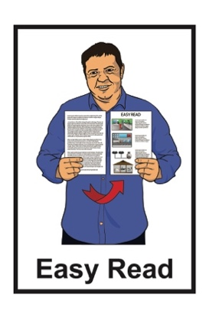
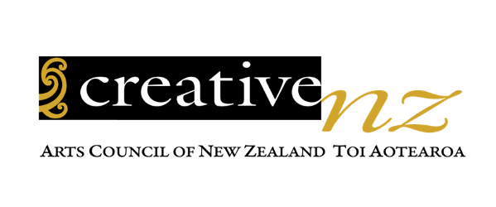

Summary: Pacific Arts Strategy

2023 – 2028

Published: October 2023

Before you start

Easy Read uses plain words / pictures to explain information.
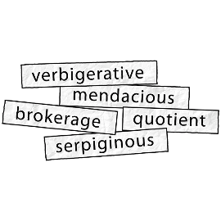

This document has some hard words.

These hard words are explained.

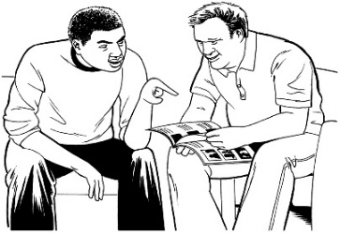
You may want to ask someone to support you while reading this document to understand some of these hard words.

What you will find in here

Page number:

What this document is about 4

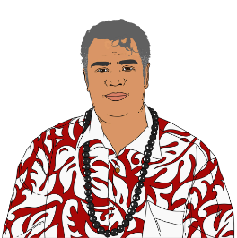
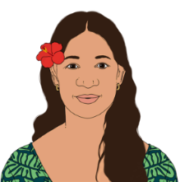
How this strategy was made 7

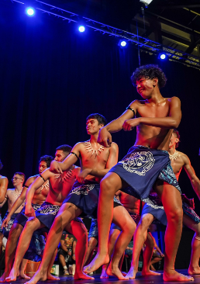
How Creative New Zealand works..11

What is the vision of Creative
New Zealand? 13

What are the focus areas of the Pacific Arts strategy? 15

Page number:

What Creative New Zealand
wants to see happen 21

How will the strategy work? 22

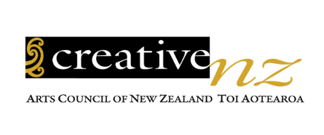
Where to find more information 24

What this document is about

Creative New Zealand has written a document called:

Pacific Arts Strategy 2023 – 2028

Creative New Zealand works to support the arts.
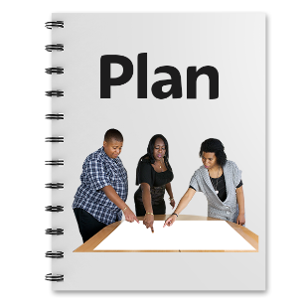

A strategy is a plan of how to make things happen.

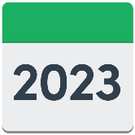
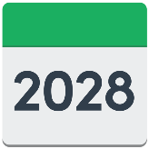
The Pacific Arts Strategy is a
5 year strategy that runs from 2023 to 2028.

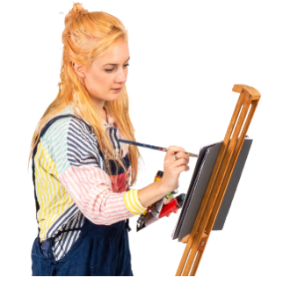
The arts means lots of things like:

painting
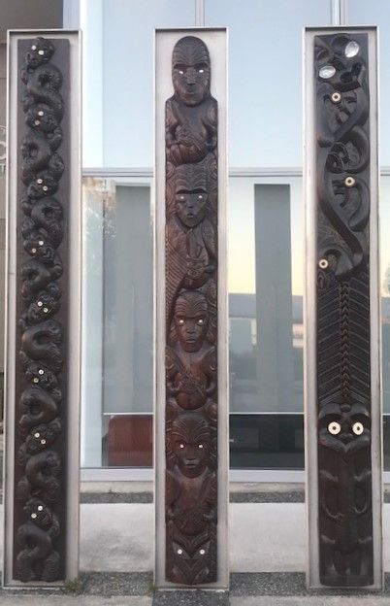
carving

weaving

writing

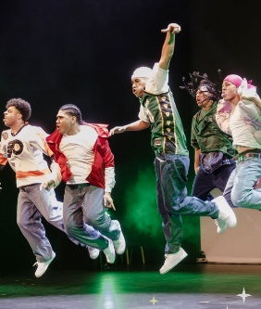
dancing

playing a musical instrument

singing
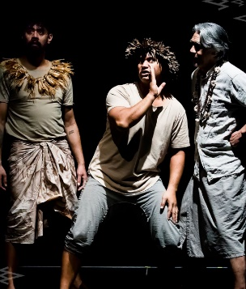
acting.

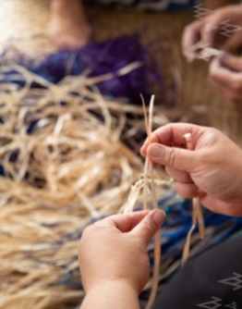
Pacific arts can also mean things like:
- making tapa cloth
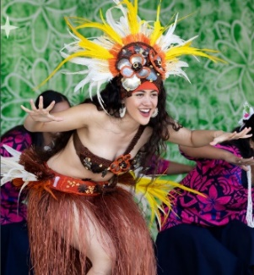
dance like tau'olunga and siva

festivals.

This is an Easy Read summary of the Pacific Arts Strategy.

A summary is:
shorter than the main strategy document
tells you the main ideas.

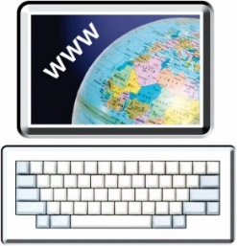
You can find the full Pacific Arts Strategy 2023-2028 on the Creative New Zealand website:
https://tinyurl.com/mrx2w8u6

How this strategy was made

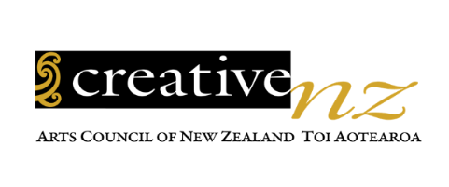
Creative New Zealand worked with Pasifika artists through:
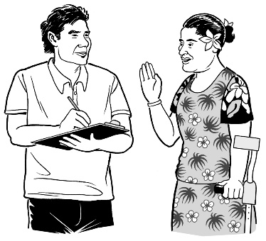
talanoa
fono.

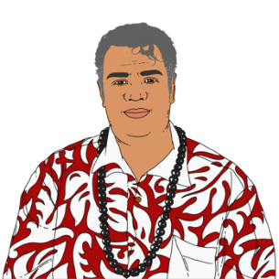
Pasifika means people who live in Aotearoa New Zealand who are:

- Samoan
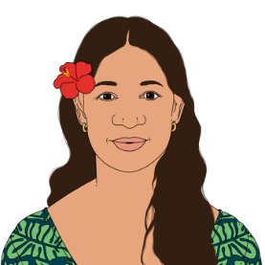
- Cook Island Māori

- Tongan
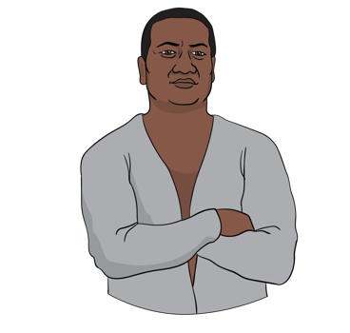
- Niuean

- Tokelauan.

Pasifika also means people who live in Aotearoa New Zealand who are:
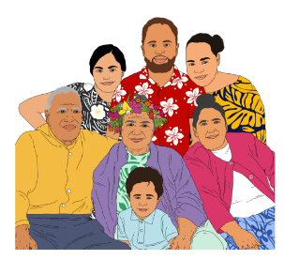
- Tuvaluan

- Fijian

- from any other Pacific Island.

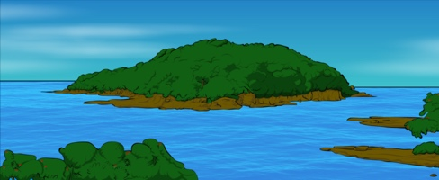
Pacific people could have been:

- born in the Pacific Islands
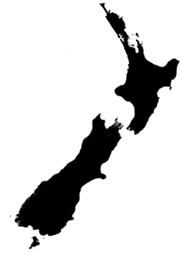
- born in Aotearoa New Zealand into Pacific aiga / families.

Talanoa means:
discussion
debate
spoken connection.

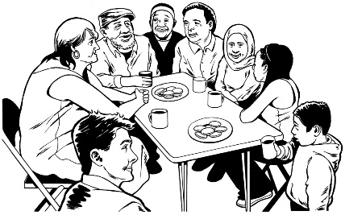
Fono means:
meeting
coming together.

The strategy was also inspired by stars that are used to navigate across:
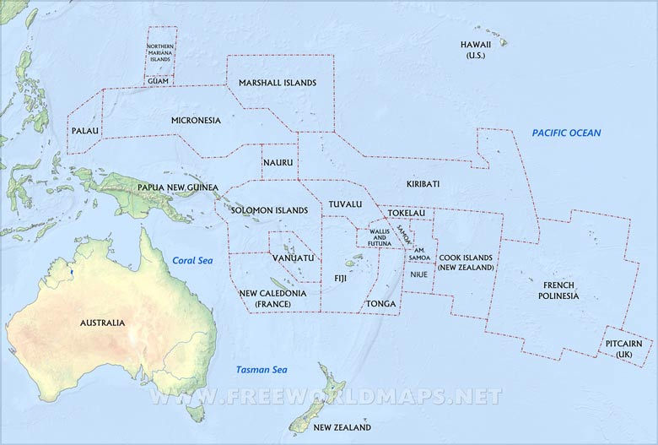
- Aotearoa New Zealand
- Te Moana-nui-a-Kiva / Oceania.

Inspire means to make people happy / interested about art.
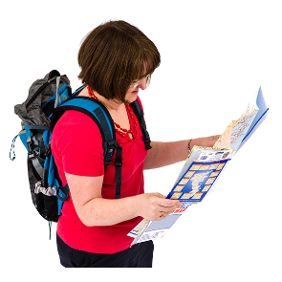

Navigate means to travel using a guide.

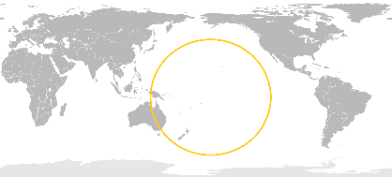
Te Moana-nui-a-Kiva means all the countries / cultures in the Pacific Ocean.

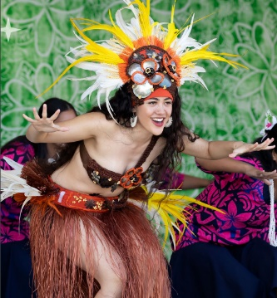
Creative New Zealand wants the Pacific arts community to lead the way.

How Creative New Zealand works

For this strategy Creative New Zealand works using Kaupapa Pasifika.

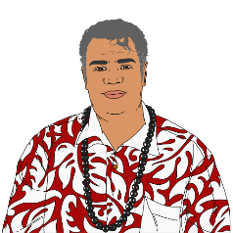
Kaupapa Pasifika means using Pacific principles / ideas.

Creative New Zealand knows there are different ways Pasifika artists uphold the mana of Pacific arts in Aotearoa New Zealand.

Mana means strength / power.

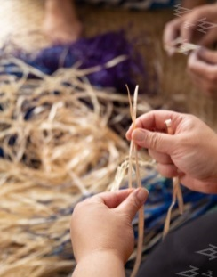
Creative New Zealand thinks Pacific arts are important to:
celebrate
connect with
grow
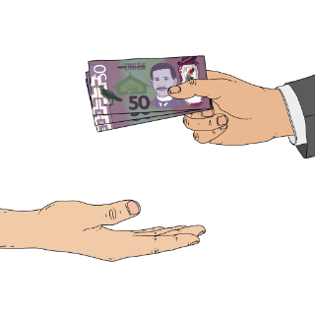
give money to.

What is the vision of

Creative New Zealand?

A vision is an idea for how Creative New Zealand wants things to be.

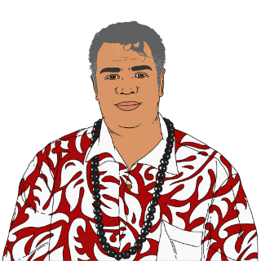
Creative New Zealand wants Pacific arts to be:
- powerful
- resilient.

Resilient means being strong for a long time.

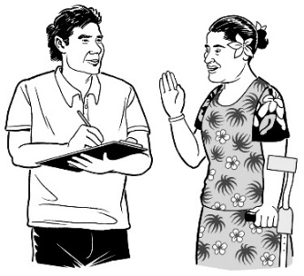
Creative New Zealand wants Pacific arts led by passionate and enterprising Pasifika people.

Enterprising means:
- thinking of new ideas
- trying new things
- knowing about business.

Creative New Zealand wants Pasifika artists to lead Pacific arts for:
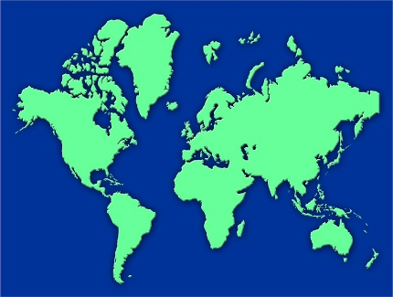
Aotearoa New Zealand
Te Moana-nui-a-Kiva / Oceania
the world.

What are the focus areas

of the strategy?

Creative New Zealand has 4 focus areas.

Focus areas means the things that are most important to do.

These focus areas are called guiding stars.

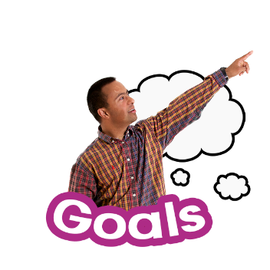
The guiding stars are ideas that support Creative New Zealand to do the things in the Pacific Arts Strategy.

These guiding stars are:
- Tagata / People
- Vaka / Canoe
- Moana / Ocean
- Va / The space between
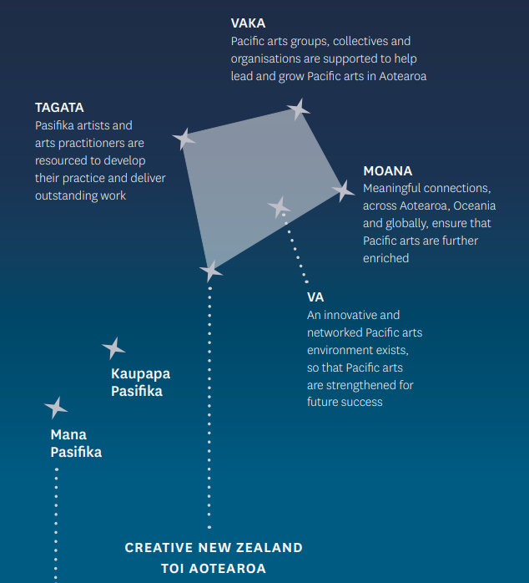

- Tagata / People

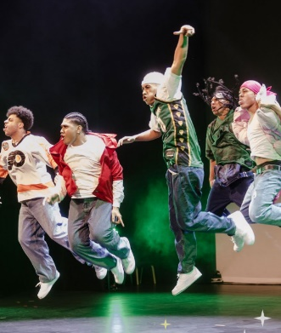
Tagata means:

- Pasifika artists

- people involved in Pacific arts work.

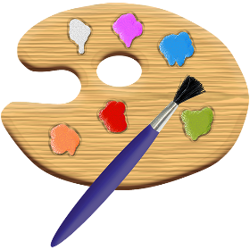
This means making sure that Pasifika artists have all the right tools they need to do their work.

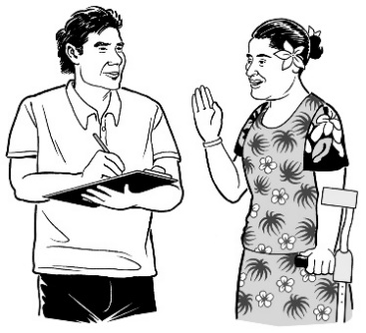
Tools means:

- knowledge / knowing things

- abilities / being able to do things.

Having the right tools means Pasifika artists can create excellent art / work.
2. Vaka / Canoe

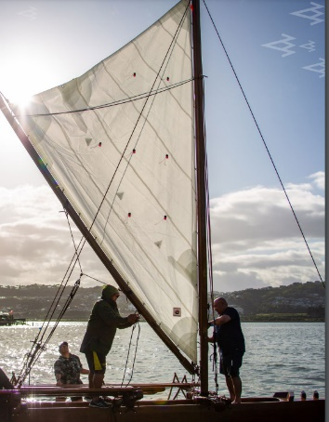
Vaka means the support Pasifika people need.

The Pacific arts community is supported to:
- be leaders in their art
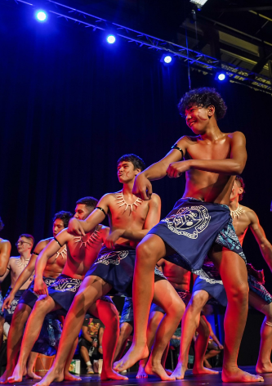
- grow their arts.

The Pacific arts community includes:
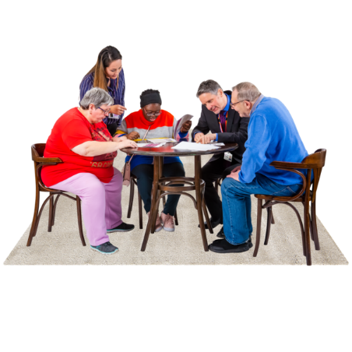
groups
collectives / groups working together
organisations.
- Moana / Ocean

Moana means people connecting across:
Aotearoa New Zealand
Te Moana-nui-a-Kiva /
Oceania.
the world.

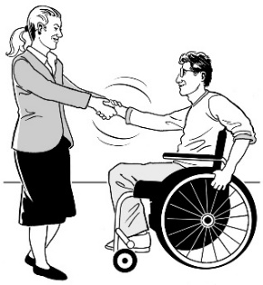
Creative New Zealand wants Pasifika artists to make meaningful connections.

Meaningful connections means:
- people working together
- having a feeling of belonging to something.
- Va / The space between

Va means making the connections in Pacific arts communities / spaces strong.

Creative New Zealand knows a good Pacific arts community exists.

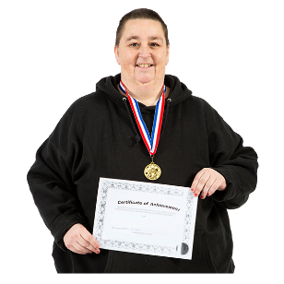
They want to make sure this community is kept strong for success in the future.

The future means a time that is yet to happen.

What Creative New Zealand

wants to see happen
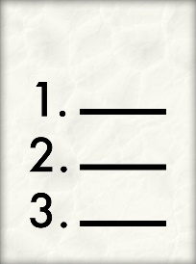

Creative New Zealand wants 3 things to happen:
- They want Pacific arts to be bold / enterprising.

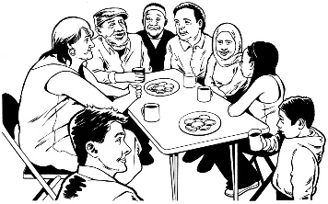
- They want Pacific arts to be connected using resilient communities.

- They want Pacific arts to inspire / influence people.

Influence means to show ways that people can be involved in art / culture.

How will the strategy work?

To make the Pacific Arts Strategy work well Creative New Zealand will work on 6 areas which are:
- making sure that Pacific arts include the whole village / all people
- building leadership / growing skills
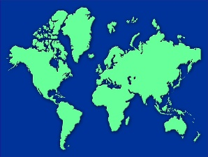
- growing Pacific arts around the world
- growing and building on important partnerships
- making Pacific arts resilient / sustainable
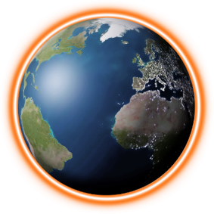
- supporting Pasifika artists who focus on climate change with their work.
Partnerships means people working together.

Sustainable means continuing to work well in the future / years ahead.

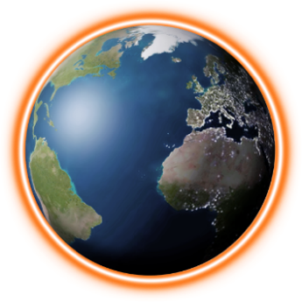
Climate change:
- is about changes in the weather that last a long time
- affects how we live now / in the years ahead.

Where to find more information

You can find the full Pacific Arts Strategy 2023 – 2028 on the Creative New Zealand website:
https://tinyurl.com/mrx2w8u6

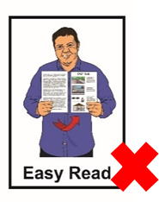
The website is not in Easy Read.

You can ask someone to read it with you.

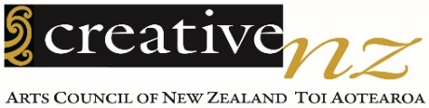
You can talk to someone at
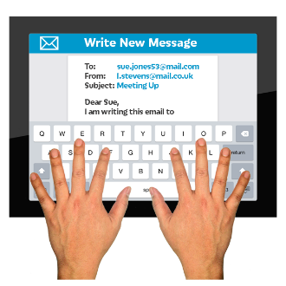
Creative New Zealand about this strategy by:
- email:

pacificarts@creativenz.govt.nz
- phone: 0800 273 284

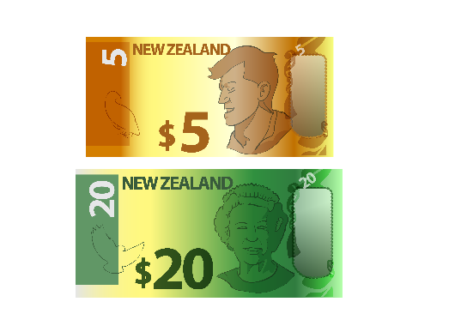
This is a free number which means it does not cost you any money to call.

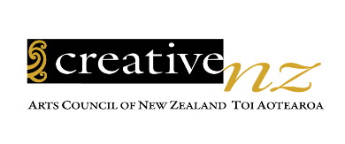
This information has been written by Creative New Zealand.

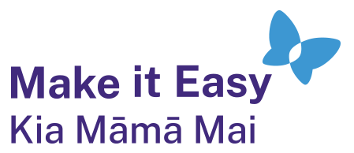
It has been translated into Easy Read by the Make it Easy Kia Māmā Mai service of People First New Zealand Ngā Tāngata Tuatahi.

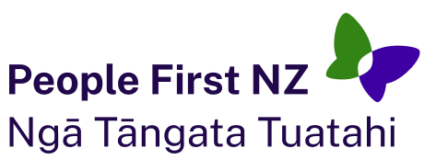
The ideas in this document are not the ideas of People First New Zealand Ngā Tāngata Tuatahi.

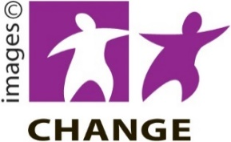
Make it Easy uses images from:

- Changepeople.org

            - Photosymbols.com

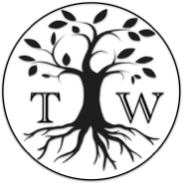
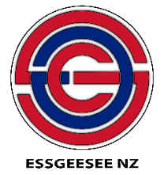
- SGC Image Works

- Huriana Kopeke-Te Aho

- T. Wood
Some images were also provided by Creative New Zealand.
All images used in this Easy Read document are subject to copyright rules and cannot be used without permission.

